Author: Samuel Gilbert (Candidate #9207 Centre #14770)

Table of Contents

2 Analysis 6

2.1 Background 6

2.2 Description of current system 7

2.2.1 Interview with Ann – the absence administrator for the company 7

2.3 Problem identification 10

2.3.1 Questionnaire to solicit feedback from current users of the system 10

2.3.2 Reponses 10

2.4 User identification 11

2.5 User needs and limitations 12

2.6 data sources and destinations 13

2.7 Data volumes 14

2.8 analysis data dictionary 14

2.9 Data flows 15

2.9.1 Existing data flows 15

2.9.2 Proposed data flows 16

2.10 Objectives 17

2.11 complexity 18

2.12 potential solutions 19

2.13 proposed solution 20

2.14 use of formal methods 20

2.15 entity relationship model 21

3 Design 22

3.1 Overall system design 22

3.2 Modular structure 23

3.3 Database structure AND VALIDATION 23

3.3.1 Public Holiday Table 24

3.3.2 Date Table 25

3.3.3 Approved Absence Booking Date Table 25

3.3.4 Approved Absence Booking Table 26

3.3.5 Absence Type Table 27

3.3.6 Employee Table 28

3.3.7 Ad Hoc Absence Request Table 29

3.3.8 Main Vacation Request Table 30

3.3.9 Company Role Table 31

3.4 file organisation and processing 32

3.5 database design and entity relationship model 32

3.6 PLANNED SQL QUERIES 34

3.6.1 TABLE SELECT 34

3.6.2 TABLE INSERT 34

3.6.3 TABLE UPDATE 35

3.6.4 TABLE DELETE 35

3.6.5 TABLE CREATE 35

3.7 storage media and format 39

3.8 algorithms DESIGN 40

3.8.1 Annual Leave required for a booking Algorithm 40

3.8.2 Annual Leave Remaining Algorithm 41

3.8.3 Has Sufficient Annual Leave Algorithm 41

3.8.4 Count Staff on Leave Algorithm 42

3.8.5 Are Sufficient Staff in Role to Grant Request Algorithm 43

3.8.6 Process Absence Request Algorithm 44

3.8.7 Main Vacation Requests Allocation Algorithm 45

3.8.8 Ad Hoc Request Processing Algorithm 46

4 user interface 47

4.1 Login Page 48

4.1.1 Index Page 49

4.2 Administrator Functions 50

4.2.1 Administrate Company Roles 50

4.2.2 Administrate Employees 50

4.2.3 Administrate Absence Types 51

4.2.4 Administrate Ad Hoc Requests 51

4.2.5 Administrate Approved Absence Bookings 52

4.2.6 Admin Vacation 52

4.3 Office Manager Functions 53

4.3.1 Office Manager Approved Absence Bookings 53

4.3.2 Office Manager Ad Hoc Request 53

4.4 Security and integrity of data 54

4.4.1 Data Security 54

4.4.2 Data Integrity 54

4.4.3 System Security 55

4.5 test strategy 56

4.5.1 Introduction 56

4.5.2 Top Down Based Approach 56

4.5.3 Trace Tables 56

4.5.4 Unit Testing 56

4.5.5 System and Integration Testing 56

4.5.6 Security Testing 57

5 technical solution 57

5.1 COMMON WEB PAGE HEADER 57

5.1.1 File: navbar.php 57

5.1.2 File: status.php 58

5.1.3 File: Style.css 59

5.2 Login 60

5.2.1 File: login.php 60

5.2.2 File: logout.php 62

5.3 SESSIONMANAGEMENT CODE 63

5.3.1 File: sessionmanagement.php 63

5.3.2 File: setup.php 64

5.4 Main Menu 67

5.4.1 File: Index.php 67

5.5 Employee Functions – Main Vacation Request 70

5.5.1 File: employeeMainVacationRequest.php 70

5.6 Employee Functions – Display Details 72

5.6.1 File: employeeDisplayDetails.php 72

5.6.2 File: editMainVacationRequest.php 76

5.6.3 File: editAdHocAbsenceRequest.php 78

5.7 Employee Functions – AdHoc Absence Request 81

5.7.1 File: employeeAdHocRequests.php 81

5.8 Office Manager – View Approved Absence Bookings 83

5.8.1 File: managerViewApprovedRequests.php 83

5.9 Administrator – Admin Company Roles 86

5.9.1 File: adminCompanyRoles.php 86

5.9.2 File: editCompanyRole.php 89

5.10 Administrator – Admin Employees 91

5.10.1 File: adminEmployeeTable.php 91

5.10.2 File: editEmployee.php 95

5.11 Administrator – Admin Main Vacation Requests 98

5.11.1 File: adminMainVacationRequests.php 98

5.12 Administrator – Admin Absence Types 101

5.12.1 File: adminAbsenceTypes.php 101

5.12.2 File: editAbsenceType.php 103

5.13 Administrator – Admin AdHoc Requests 106

5.13.1 File: adminAdHocAbsenceRequests.php 106

5.14 Administrator – Admin Approved Absence Bookings 109

5.14.1 File: adminApprovedAbsenceBookings.php 109

5.14.2 File: editApprovedAbsenceBooking.php 111

5.15 Administrator – Admin Approved Absence Booking Dates 113

5.15.1 File: adminApprovedAbsenceBookingDate.php 113

5.16 Administrator – Admin Dates 115

5.16.1 File: adminDates.php 115

5.17 Administrator – Admin Public Holidays 117

5.17.1 File: adminPublicHolidays.php 117

5.17.2 File: editPublicHolidays.php 119

5.18 Administrator – Admin Absence Requests 121

5.18.1 File: administerVacation.php 121

5.19 Server Database Processing 126

5.19.1 File: config.php 126

5.19.2 File: databaseFunctions.php 126

5.20 Key Algorithms 134

5.20.1 File: keyAlgorithms.php 134

5.21 Company Role Table 142

5.21.1 File: CompanyRoleTable.php 142

5.22 Main Vacation Request Table 147

5.22.1 File: MainVacationRequestTable.php 147

5.23 Employee Table 155

5.23.1 File: EmployeeTable.php 155

5.24 AdHoc Absence Table 164

5.24.1 File: AdHocRequestTable.php 164

5.25 AbsenceType Table 171

5.25.1 File: AbsenceTypeTable.php 171

5.26 Approved Absence Booking Table 178

5.26.1 File: ApprovedAbsenceBookingTable.php 178

5.27 Approved Absence Booking Date Table 185

5.27.1 File: ApprovedAbsenceBookingDateTable.php 185

5.28 Date Table 190

5.28.1 File: DateTable.php 190

5.29 Public Holiday Table 195

5.29.1 File: PublicHolidayTable.php 195

5.30 EMAIL Functions 201

5.30.1 File: mailFunctions.php 201

6 system testing 203

6.1 LOGIN 203

6.2 ADMIN COMPANY ROLES PAGE 205

6.3 ADMIN EMPLOYEES PAGE 212

6.4 ADMIN MAIN VACATION REQUESTS PAGE 228

6.5 ADMIN ABSENCE TYPES PAGE 228

6.6 ADMIN AD HOC REQUESTS PAGE 233

6.7 ADMIN APPROVED ABSENCE BOOKINGS PAGE 234

6.8 ADMIN PUBLIC HOLIDAYS PAGE 243

6.9 ADMIN VACATIONS PAGE 251

6.10 employee main vacation request PAGE 254

6.11 employee DISPLAY DETAILS PAGE 259

6.12 employee AD HOC REQUESTS PAGE 272

6.13 OFFICE MANAGER View approved bookings page 274

6.14 OFFICE MANAGER CREATE AD HOC REQUESTS PAGE 276

7 system maintenance 277

7.1 system Overview 277

7.2 Location of the source code 277

7.3 STRUCTURE OF the source code 278

7.3.1 Web Interface – root level 278

7.3.2 Web Interface – Options from index.php 279

7.3.3 Database Processing Files 280

7.3.4 Other files 281

7.4 example of a failed test fix 282

7.5 Detailed algorithm design 285

7.5.1 Algorithm – Calculate Annual Leave Required 285

7.5.2 Algorithm – Calculate Remaining Annual Leave 287

7.5.3 Algorithm - Has Sufficient Annual Leave 288

7.5.4 Algorithm – Count Staff on Leave 289

7.5.5 Are Sufficient Staff in Role to Grant Request Algorithm 291

7.5.6 Process Absence Request Algorithm 293

7.5.7 Main Vacation Requests Allocation Algorithm 296

7.5.8 Ad Hoc Request Processing Algorithm 298

7.6 procedure / function list and variables 299

7.6.1 File: AbsenceTypeTable.php 300

7.6.2 File: KeyAlgorithms.php 311

8 USER manual 313

Table of Contents 314

8.1 Introduction 315

8.2 SYSTEM REQUIREMENTS 315

8.2.1 Hardware Requirements 315

8.2.2 Software Requirements 315

8.3 INSTALLATION 316

8.3.1 Software Download 316

8.3.2 Database Configuration 319

8.3.3 First Time Run – Setting Up System Administrator Account 320

8.4 HOW TO Log on to the system 321

8.5 Administrator functions 323

8.5.1 Administrator – How to add new employees to the system 323

8.5.2 Employee – How to request an Ad-Hoc absence 329

8.6 Office manager functions 333

8.6.1 Employee – How to view staff absence 333

9 appraisal 336

9.1 Objectives evaluated. 336

9.2 USER FEEDBACK 338

9.3 FEEDBACK analysis 339

9.4 Further development 340

9.4.1 Password Reset 340

9.4.2 Automatic Logout 340

9.4.3 Simplified Installation 340

9.4.4 Tailor for mobile devices 340

9.4.5 Database Backup 340

**WORK PLAN**

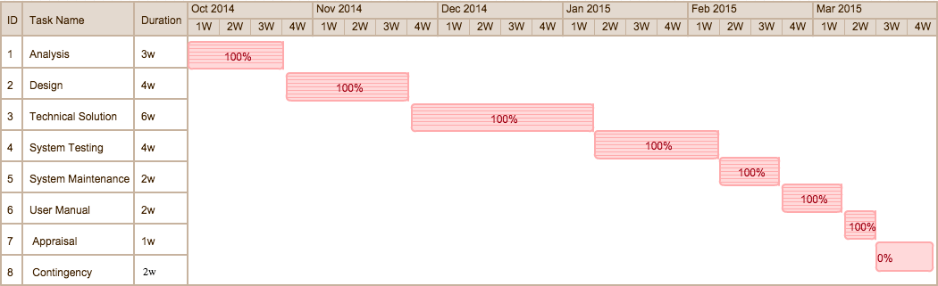

# Analysis

## Background

A local company, who does not wish to be named, needs to ensure that a minimum staffing level for each function within the business is maintained when reviewing and granting staff leave and other absence requests.

A member of the company, Ann, performs the role of absence administrator. Ann is a friend of my family and during a social event earlier this year I was discussing my A level work with her and the discussion turned to my Computing course and project.

During this discussion, Ann highlighted the current manual processes involved in administering the company’s’ absence requests and some of the problems with these processes. She asked if I would be able to create a computer system that would help to automate these manual procedures, simplifying and speeding up the current process.

This is the basis of my COMP 4 Project, as detailed in this report.

## Description of current system

To better understand the current system I spent an hour interviewing the person who performs the role of absence administrator. Q&A from this interview is detailed below.

### Interview with Ann – the absence administrator for the company

Q. Describe the current process that is used for handling staff absence requests.

A. There are two main parts to the process.   
  
Firstly, between October and November each year we ask all staff to write down their first and second choices for their main two-week vacation in the upcoming year. Once everyone has done this, it is my task to try and accommodate as many people’s requests as possible whilst ensuring that we keep to the minimum staffing levels needed for each role within the company.

Secondly, once everyone’s main two weeks leave have been allocated, for the rest of the year it is my job to handle ad-hoc absence requests from staff. My role is to check to see whether each absence request would take us below the minimum staffing level for the role that this person performs. If we are above the minimum staffing levels for the absence period requested, then the request is approved. If the request would take us below the minimum staffing level then the request is denied or passed to the office manager.

Q. What mechanism do you use to track who is absent and when?

A. We have a large paper based wall chart, which we record approved absences on.

Q. For the main two week vacation allocation in Oct / Nov, you mentioned that you try to   
 accommodate as many requests as possible. Could you describe how you do this?

A. All staff members write down the dates for their first and second choice for their main two weeks leave on a form and give this to me. I then sort these requests into an order based on each member of staff’s length of service with the company. The longest serving member of staff is top of the pile; the shortest serving member of staff is bottom of the pile.

I then go through the forms one at a time.

For each form I look at the first choice and check the wall chart to see how many people in the same role already have that time booked off. If the number of staff in the office during that period for that role is above the minimum needed, then I grant the first choice and record it on the chart.

If not, I repeat this check for the second choice. If the second choice can be granted I update the chart, otherwise I stop further work on the forms and go back to the person to ask them to give me another choice. I do not process any more forms until I have an agreed date for that person.

Q. Does everyone have to book a main two weeks? What if someone only wants to take one week   
 off? What if someone wants to take three weeks off?

A. Generally we ask everyone to select a main two weeks. If someone only wants to select a week they can, but their second week will have to be booked as part of the ad-hoc process once everyone else’s main two weeks have been granted.

Three-week vacations are discouraged, but sometimes do occur (e.g.: Long vacations for Weddings / Honeymoons etc.). Anyone requesting a longer leave period must first gain approval from the office manager prior to submitting his or her request.

Q. Can you describe how the ad-hoc process for requesting absence differs from what you’ve   
 described already?

A. After the main two weeks have been agreed for everyone (in October / November) we allow people to request any other absence they require throughout the year. People do this by filling in a simple form stating the dates they wish to book and then they place in my in-tray. I tend to process these requests once a week, although people sometimes ask me to process their request immediately if it is urgent.

The process is similar to the one for the main two weeks, although I process the request forms in the order I receive them (first submitted, first processed). Basically, for each form I check the date requested and if sufficient staff are available to cover the minimum level for the role, then I grant the request and add to the wall-chart, otherwise I reject. Either way, I let the person who requested the leave know either by email or by telling them directly.

It’s a bit different for non-annual leave absence requests?

Q. What other types of absence requests are there? How do they differ from annual leave   
 requests?

A. Annual leave forms the majority of requests for absence, but there are others, namely:

* Training Requests  
  Sometimes members of staff need to attend training courses. Such requests are handled in the same way as ad-hoc annual leave requests, IE: Only approving if minimum staffing levels for that persons role are maintained. The only difference between training requests and annual leave requests is that training days do not consume peoples annual leave entitlement.
* Sickness

Generally sickness is not something planned in advance. Usually it is only known about when a member of staff phones in to say they are sick and will not be at work. Sometimes sickness time is known in advance, for example if a person is undergoing an operation and has a date for when this will take place. We use the wall-chart to record absence due to sickness but unlike the annual leave and training, there is no approval/rejection of sickness.

Sickness can leave the company under resources for a given role. When recording sickness, if the number of people for a role will be below the minimum required I inform the office manager, who will decide what to do (usually hiring temporary staff to cover the shortfall).

Absence due to sickness does not use peoples annual leave entitlement. However, we do keep records of how many days each member of staff has taken sick each year.

* Compassionate Leave

Compassionate Leave is granted in the event of a distressing personal circumstance, typically a death of a close family member. A member of staff would inform the office manager of this, and the office manager will inform me.

In terms of process, this is identical to sickness, IE: it is not subject to approval / rejection and can leave us below the minimum resourcing level for a role, in which case I inform the office manager who will determine what to do.

Compassionate leave does not use peoples annual leave entitlement, but we do track how many days a person has taken due to compassionate leave each year.

* Emergency Leave

Emergency Leave refers to annual leave that has to be taken on the same day due to an emergency. An example would be if a member of staff had been burgled or had a burst pipe or childcare issues. The member of staff would phone the office manager to inform them they will be absent and the office manager will provide me with the details. As with Sickness and Compassionate leave, this may leave us below the minimum resourcing level for a role in which case I inform the office manager who decides what to do. Emergency leave does use up days from a persons annual leave entitlement.

Q. How many ad-hoc requests do you have to process each week?

A. It varies, but probably about 3 or 4 requests would be average.

Q. Can you describe what IT equipment the staff have access to?

A. Everyone has either a desktop or a laptop computer. We all have a company email account. There are laser printers in the office.

Q. What about internet access?

A. Yes. We have an internal intranet, but everyone also has access to the internet.

Q. You mentioned there are different roles in the company, is there a list?

A. Yes, but really just a list on my desk. The roles are Manager, Customer Advisor and Cashier. There needs to be a minimum of 1 manager, 2 customer advisors and 3 cashiers.

Q. How many people work in the company?

A. We have a manager, deputy manager and supervisor (all are considered to be manager roles), 4 customer advisors and 5 cashiers. I am the supervisor, and part of my job is absence administration.

Q. How many days annual leave do people get?

A. Everyone gets 25 days a year annual leave, plus of course public holidays and weekends

Q. What would you say was an average number of total days absence per year for each person?

A. It really does depend, as some absences can’t be foreseen, but as a rough figure I’d say:  
  
Annual Leave - including Emergency Leave ( 25 days )  
Sickness (5 days)  
Compassionate Leave (most people would not use this in a year, but if taken up to 5 days)

Q. So the system doesn’t cover bank holidays / weekends?

A. The office is not open at weekends or public holidays. Those are non working. No minimum staffing levels, and non working days that occur during a holiday period do not count as annual leave.

Q. Would you be ok for me to produce a short survey asking for feedback on the current system? Would you be able to complete this, and also get the office manager and some of the members of staff to complete this?

A. Yes, I’d be happy to.

## Problem identification

### Questionnaire to solicit feedback from current users of the system

The following text was sent to Ann, who then emailed these questions to the staff and office manager. Ann consolidated the responses and sent to me, also adding her own responses to the questions.

“*As you know, the current procedures for booking and tracking absence are quite manual and we are currently considering whether there may be an opportunity to make more use of technology in helping to improve these processes.*

*As part of the analysis of this, we would welcome your views based on a short set of questions below. Please could you email me back with your responses by the end of next week (Friday 12th September).*

*Q1. What do you like about the current process?*

*Q2. What do you dislike about the current process?*

*Q3. List the top two things you would like the new system to improve.”*

### Reponses

A consolidated set of response to these questions is given below:

*Q1. What do you like about the current process?*

* *The way in which we grant leave seems fair.*
* *Ann is always helpful.*
* *The wall-chart let’s me see whose in and who is off when.*

*Q2. What do you dislike about the current process?*

* *Sometimes it can be a bit frustrating waiting for approval for leave.*
* *When Ann is off, leave requests go unanswered.*
* *I keep my own record of what leave I’ve booked as it’s hard to find that on the wall chart.*
* *Sometimes the wall-chart is not up to date.*
* *Doing the absence administration takes up too much of my time. I have other work to do.*

*Q3. List the top two things you would like the new system to improve.”*

* *It’d be great if I could get an instant response to holiday requests.*
* *I’d like to be able to see up to date information on what leave I’ve booked and how many days leave I have left to take.*
* *As the office manager, I’d like to see an up to date view on who is off at any given time and the resource levels for each role within the company.*
* *The new system should be much faster than the current process.*
* *As the holiday administrator, I’d like the system to automatically perform the processing for the main two week allocations, as this takes me a lot of time.*
* *Whatever system we have, it needs to be up to date and accurate.*
* *I’d like to be able to get information from my PC, not have to pester Ann all the time.*

## User identification

There are three main types of user.

* Staff member

Everyone working within the company is a staff member. Staff members will request absences for a number of reasons (eg: Annual Leave, Training, Sickness, and Compassionate Leave).

* Absence Administrator

The absence administrator is the person who administers the absence process, reviewing, granting or rejecting absence requests and ensuring that the minimum level of resourcing for each function within the company is maintained.

* Office Manager

The Office manager is responsible for the overall running of the office and needs visibility of which staff are absent at any given time.

## User needs and limitations

Each type of user has specific needs and limitations.

|  |  |  |
| --- | --- | --- |
| Type of user | Needs | Limitations |
| Members of Staff | Each member of staff needs to be able to create, update or cancel their own requests for absence and to see all of their requests.  Each member of staff needs to know their total number of days annual leave. This should be broken down into the total annual leave entitlement, the number of days already booked and the number of days remaining.  Members of staff should have visibility of how many staff of a given role are absent on any given day. | Should only be able to create, update, cancel absence requests or view information relating to their own absences. A member of staff must not be able to create, alter, view or remove any absence information for other members of staff. |
| Absence Administrator | To add new staff to the absence system when they join the branch.  To remove staff from the absence system if they leave.  To update staff information.  To define a list of roles within the branch.  To record the role(s) that each member of staff can perform.  To record information on the minimum number of staff needed in each role at any given time.  Once a year, to perform the initial allocation of each member of staffs main two weeks leave, ensuring that minimum staffing levels for each role are met.  On an ad-hoc basis, review and approve or reject other absence requests from staff.  To be able to create absence requests on behalf of a member of staff. EG: If a member of staff is taken ill or phones in sick. |  |
| Office Manager | Office Managers need to be able to see all absence requests for all staff members.  Office managers need to be able to view all staff on leave for any given week. | Office managers should not be able to create, update, cancel or delete absence information. This is the role of the Absence administrator. |

## data sources and destinations

|  |  |  |
| --- | --- | --- |
| Data | Source | destination |
| Main Two Week Vacation Request  - Name of Requestor   * First Choice Start Date * First Choice End Date * Second Choice Start Date * Second Choice End Date | Member of Staff (During Oct/Nov) | Holiday Administrator |
| Main Two Week Vacation Approval   * Name of Requestor * Approved Start Date * Approved End Date | Holiday Administrator | Member of Staff |
| Ad Hoc Absence Request  - Name of Requestor   * Start Date * End Date * Type of Request (Annual Leave, Training,Sickness,Compasionate Leave, Emergency Leave) | Member of Staff | Holiday Administrator |
| Ad Hoc Absenc Approval   * Name of Requestor * Approved Start Date   - Approved End Date | Holiday Administrator | Member of Staff |
| Recorded Absences | Holiday Administrator (from requests) | Wall Chart |
| List of who is absent when | Wall Chart | Office Manager Holiday Administrator |
| List of Public Holidays | The Internet | Wall Chart |

## Data volumes

Number of staff in the office: 12

Average number of days absence: 30 to 40.

Total individual days absence per year for the office that need to be recorded:

12 x 40 = 480 absence days needed to be recorded per year.

During October / November, every member of staff has to provide two choices for their main two weeks of vacation.

During the rest of the year, the holiday administrator processes on average 3-4 absence requests per week.

## analysis data dictionary

|  |  |
| --- | --- |
| Field | description |
| Staff Members Name | Name of the member of staff |
| Staff Members Role(s) | List of roles that the member of staff performs.  Roles are:  Manager, Customer Advisor, Cashier. |
| Staff Members Annual Leave Entitlement | How many days annual leave the member of staff is entitled to per year. |
| Absence Start Date | The date on which an absence commences. |
| Absence End Date | The date on which an absence ends. |
| Absence Type | The type of absence. This can be annual leave, sick leave, compassionate leave, training leave or emergency leave. |
| Absence Status | The status of an absence request. A request can be: Pending – means that it has not yet been approved or denied.  Approved – means that the request has been approved by the absence administrator.  Denied – means that the request has been denied by the absence administrator. |
| Main Two Weeks First Choice | An absence start date and absence end date for a member of staffs first choice for their main two week vacation. |
| Main Two Weeks Second Choice | An absence start date and absence end date for a member of staffs first choice for their main two week vacation. |
| Public Holidays | A list of dates for the year which are public holidays. All staff are absent on these days as the office is closed. |

## Data flows

### Existing data flows



### Proposed data flows





## Objectives

The objective of my project is to design, implement, test and document an IT solution that provides automation of the current manual processes for absence administration within the company.

This system must:

* Maintain information on the various roles within the company, and the minimum resource level for each role that must be present on any given day.
* Maintain information on each employee within the company, including the length of service of the employee, and the role(s) which that employee is able to perform.
* Maintain information on the employees who are absent on each day of the year, together with the reason for absence.
* Provide a mechanism for staff to submit a first and second choice for their main annual vacation fortnight.
* Provide a mechanism to automatically allocate each member of staffs main two week vacation based on an algorithm involving the member of staffs length of service, the role that the member of staff performs, their first choice and second choice and the resourcing levels for that role during the requested period.
* Provide a mechanism for staff to submit ad-hoc absence requests throughout the year, and for the system to approve or reject these requests based on the type of request and the current resourcing levels during the requested period.
* Automatically calculate annual leave taken / remaining for each member of staff using an algorithm based on each absence booking, absence type and taking into account the fact that weekends and public holidays are non-working days.
* Provide a mechanism for the office manager or absence administrator to record unplanned absence (eg: if a member of staff phones in sick).
* Provide email generation to the office manager for any resource shortfalls due to unexpected absence.
* Provide the ability for a member of staff to view their current absence bookings for the year and annual leave days taken / remaining.
* Provide the ability for the office manager to view the absence bookings for all staff.
* Provide the ability for the absence administrator to view and amend absence bookings for all staff.
* Provide the ability for the absence administrator to define which days within a year are public holidays.

To implement these objectives I will utilise the following technologies:

* HTML5 and CSS to provide a web based user interface / presentation layer.
* Javascript and JQuery as the client side scripting language.
* Bootstrap to help with the presentation of the web pages.
* Linux Server running Apache as the webserver.
* PHP as the server side scripting language.
* MySQL as the server side database technology.

The database will be based on a normalised logical model and consist of a number of tables.

The solution will include a login system, with different users having different roles (staff, administrator, office manager) and multiple web pages with functionality based on the role of the user.

The solution will include the design and implementation of a number of algorithms including:

* An algorithm to determine the optimal allocation of all staffs main vacation choices.
* An algorithm to calculate the number of days annual leave required for an absence request, taking into account that weekends and public holidays are non-working days.

## complexity

Based on the objectives and scope, I believe this is a complex project that will cover a large amount of the concepts in my A level computing course and provide me with the opportunity to develop my skills in a number of modern technologies used in the industry.

## potential solutions

**Using a Spreadsheet system**

Some elements of the current wall calendar could be represented in a spreadsheet.

|  |  |
| --- | --- |
| Pros | Cons |
| Commonly used tool, familiar to the absence administrator | Whilst aspects of the current processes could be automated, there would still be a large amount of manual data entry required by the absence administrator. |
|  | Does not easily allow for the bespoke algorithms required. |
|  | Does not enforce the different levels of user access / user visibility required. |

**Use a third party Online Solution**

There are a number of companies who provide an online absence management service, two of the main ones are:

<http://www.leaveplanner.com>

<http://www.whosoff.com>

|  |  |
| --- | --- |
| Pros | Cons |
| Available instantly | Specific algorithms required for main two week leave allocation not available ‘out of the box’ and current business processes may have to change to fit to the tool. |
| No overhead in developing or maintaining the system | Given the size of the company, any requests for changes to the tool are unlikely to be supported. |
| As a widely used tool, likely to be of a high quality with high availability. | Possible concerns over data security as all data is maintained by a third party, over the internet. |
|  | Monthly subscription fees. |

**Design and Implement a Bespoke Solution for the Company**

After analysis, continue with this project to design, implement, test and release a bespoke software solution to fully meet the needs of the company.

|  |  |
| --- | --- |
| Pros | Cons |
| Designed specifically to meet the needs of the company. | Requires bespoke development (this project). |
| Likely to provide the most automation of any solution. | Ongoing support costs for any future enhancements or fixes. |
| Can be tailored and extended as requested by the user. |  |

## proposed solution

Whilst the use of a spreadsheet may help to automate some of the current processes, it would still involve a lot of manual efforts on behalf of the holiday administrator, and therefore is not considered any further.

The use of commercial off the shelf solutions, examples of which were given in the previous section, are a viable option, but are unlikely to exactly match the specific requirements and algorithms that the company uses today. Therefore, company processes would need to be altered to fit to the tool. Also, these off the shelf solutions tend to be subscription based, meaning an on-going monthly cost to the company.

The proposed solution is therefore to proceed with my project to design and implement a custom solution for the company. To ensure the solution is easy to maintain, support and enhance in future.

## use of formal methods

I plan to use formal analysis and design methods including Data Flow Diagrams to show the various flows of data and Entity relationship diagrams to define the structure of the database. I will prototype user interfaces and seek feedback from the end users.

I plan to use industry standard web based technologies for the project, including:

* HTML 5 / CSS for the presentation layer.
* Javascript / JQuery for the client side scripting.
* PHP for the server side scripting
* MySQL for the Database.

## entity relationship model



# Design

## Overall system design

IOPS Chart

In the diagram below I have summarised the data of the system in terms of its input, output, processing and storage.

|  |  |
| --- | --- |
| **Input**  Employee Name Email Address Password  User Role System Role Date joined company Annual Leave entitlement  Main Vacation First Choice Start Date Main Vacation First Choice End Date Main Vacation Second Choice Start Date Main Vacation Second Choice End Date  Ad-Hoc Request Start Date Ad-Hoc Request End Date Type of Absence Request  Public Holiday Date Public Holiday Name  Role Name Minimum Staffing Level For Role  Absence Calendar Start Date Absence Calendar End Date | **Process**  Create New Employee Create Main Vacation Request Create Ad-Hoc Vacation Request Process Main Vacation Requests Process Ad-Hoc Vacation Requests Create Public Holiday Create Company Role  Display Employee Details Display Main Vacation Requests Display Ad-Hoc Vacation Requests Display Public Holiday Display Company Role  Amend Employee Amend Main Vacation Request Amend Ad-Hoc Vacation Request Amend Public Holiday Amend Company Role  Delete Employee Delete Main Vacation Request Delete Ad-Hoc Vacation Request Delete Public Holiday Delete Company Role  Display Absence Calendar for a given period Display Approved Absences for a given member of staff |
| **Storage**  Employee Table Main Vacation Request Table Ad Hoc Absence Request Table Public Holiday Table Company Role Table Employee Role Table Approved Absence Bookings Table Approved Absence Bookings Date Table Date Table | **Output**  Welcome email to employee with login details. Main Vacation Request Approval / Rejection email. Email to office manager to warn of staff resource issues. Ad Hoc Absence Request Approval / Rejection email. Employee Details display Main Vacation request display Ad Hoc Vacation request display Public Holidays display Company Roles display Absence Calendar display |

## Modular structure

I will structure my system around a series of web pages. The root page will be a login screen. Once the user has logged in, a menu page will be displayed with a set of options relevant to that users permissions will be displayed. There are three types of user: Member of Staff, Office Manager and Administrator.



## Database structure AND VALIDATION

The diagram below, taken from the analysis section, describes the relationship between each of the main tables in the database. In this section I will provide a description of the key fields in each table, together with the validation that will be performed on these fields on input.



### Public Holiday Table

|  |  |  |  |  |  |  |
| --- | --- | --- | --- | --- | --- | --- |
| Field | Data type | length | validation check | validation description | valid data | invalid data |
| Public Holiday ID | INT | 4 | None. Automatically assigned by SQL upon creation. | Primary key. Automatically assigned by SQL on record creation. | N/A | N/A |
| Date ID | INT | 4 | Presence, ID Exists in Date Table | An ID must be supplied and the ID must exist as a key in the Date table. | Any value that matches an ID in the date table | (Blank) or any value which does not match an id in the date table. |
| Name of Public Holiday | String | 40 characters | Presence | String must not be empty. String must be less than 40 characters | Any string | (Blank) |

### Date Table

|  |  |  |  |  |  |  |
| --- | --- | --- | --- | --- | --- | --- |
| Field | Data type | length | validation check | validation description | valid data | invalid data |
| Date ID | INT | 4 | None. Automatically assigned by SQL upon creation. | Primary key. Automatically assigned by SQL on record creation. | N/A | N/A |
| Date | DATE | 10 (DD-MM-YYYY) | Presence, Format | The date must be a valid calendar date. EG: Day number must be valid for the month given. Leap years need to be considered when validating February | Any Calendar date. | (Blank) or anything that is not a date. EG: 30-02-2014 |
| Public Holiday ID | INT | 4 | Optional,  ID exists in Public Holiday Table. | If public holiday ID is present, then it must match the ID key of an entry in the public holiday table | (Blank) or an ID matching an entry in the public holiday table. | Any ID which does not exist in the public holiday table |

### Approved Absence Booking Date Table

|  |  |  |  |  |  |  |
| --- | --- | --- | --- | --- | --- | --- |
| Field | Data type | length | validation check | validation description | valid data | invalid data |
| Approved Absence Booking Date ID | INT | 4 | None. Automatically assigned by SQL upon creation. | Primary key. Automatically assigned by SQL on record creation. | N/A | N/A |
| Date ID | INT | 4 | Presence, ID Exists in Date table | An ID must be supplied and the ID must exist as a key in the Date table. | Any value that matches an ID in the date table | (Blank) or any value which does not match an id in the date table. |
| Approved Absence Booking ID | INT | 4 | Presence, ID Exists in Approved Absence Booking table | An ID must be supplied and the ID must exist as a key in the Approved Absence Booking table. | Any value that matches an ID in the Approved Absence Booking table | (Blank) or any value which does not match an id in the Approved Absence Booking table. |

### Approved Absence Booking Table

|  |  |  |  |  |  |  |
| --- | --- | --- | --- | --- | --- | --- |
| Field | Data type | length | validation check | validation description | valid data | invalid data |
| Approved Absence Booking ID | INT | 4 | None. Automatically assigned by SQL upon creation. | Primary key. Automatically assigned by SQL on record creation. | N/A | N/A |
| Employee ID | INT | 4 | Presence, ID Exists in Employee table | An ID must be supplied and the ID must exist as a key in the Employee table. | Any value that matches an ID in the employee table | (Blank) or any value which does not match an id in the employee table. |
| Absence Start Date | DATE | 10 (DD-MM-YYYY) | Presence, Format | The date must be a valid calendar date. EG: Day number must be valid for the month given. Leap years need to be considered when validating February | Any Calendar date. | (Blank) or anything that is not a date. EG: 30-02-2014 |
| Absence End Date | DATE | 10 (DD-MM-YYYY) | Presence, Format Value | The date must be a valid calendar date. EG: Day number must be valid for the month given. Leap years need to be considered when validating February  The Date must be greater than or equal to the start date. | Any Calendar date which is greater than the start date | (Blank) or anything that is not a date. EG: 30-02-2014  Any value that is less than the start date. |
| Absence Type ID | INT | 4 | Presence, ID Exists in Absence Type table | An ID must be supplied and the ID must exist as a key in the Absence Type table. | Any value that matches an ID in the Absence Type table | (Blank) or any value which does not match an id in the Absence Type table |

### Absence Type Table

|  |  |  |  |  |  |  |
| --- | --- | --- | --- | --- | --- | --- |
| Field | Data type | length | validation check | validation description | valid data | invalid data |
| Absence Type ID | INT | 4 | None. Automatically assigned by SQL upon creation. | Primary key. Automatically assigned by SQL on record creation. | N/A | N/A |
| Absence Type Name | String | 20 | Presence | A value must be provided, giving a name to this absence type: EG: “Training”, “Sickness” etc. | Any string | (Blank) |
| Uses Annual Leave | Boolean | 1 | TRUE or FALSE | Must either be set to TRUE or FALSE? | TRUE or FALSE | (Blank) or anything other than the valid values. |
| Can be Denied | Boolean | 1 | TRUE or FALSE | Must either be set to TRUE or FALSE? | TRUE or FALSE | (Blank) or anything other than the valid values. |

### Employee Table

IMPORTANT NOTE:  
The Password field in the database will be 64 bytes long. The input validation rules described below cover the format of the password as the user will enter it. However, for security reasons the raw password will not be stored in the database, instead I will be storing a salted MD5 encoded form of the password (see section 0 on page 54).

| Field | Data type | length | validation check | validation description | valid data | invalid data |
| --- | --- | --- | --- | --- | --- | --- |
| Employee ID | INT | 4 | None. Automatically assigned by SQL upon creation. | Primary key. Automatically assigned by SQL on record creation. | N/A | N/A |
| Employee Name | String | 50 | Is not empty | Check that a string has been given | Any string | NULL |
| Email Address | String | 50 | Is valid format for an email address | Must conform to the convention for an email address.  IE: name@address.ext | Any value that is a valid email address | Any other value. |
| Password | String | 64 | Minimum length  Letters and Numbers | Password must be at least 6 characters  Password must contain at least 1 number  Password must contain at least 1 upper case letter  Password must contain at least 1 lower case letter | Any string of 6 characters or more that has at least 1 number, 1 upper case and 1 lower case character | Any string less than 6 characters or which does not have an upper, lower and numeric character within it. |
| Date Joined the Company | DATE | 10 (DD-MM-YYYY) | Presence, Format | The date must be a valid calendar date. EG: Day number must be valid for the month given. Leap years need to be considered when validating February | Any Calendar date. | (Blank) or anything that is not a date. EG: 30-02-2014 |
| Annual Leave Entitlement | INT | 1 | Maximum value check | Annual Leave Entitlement cannot exceed 35 days | Any value from 0 to 35 | Any value outside of this range |
| Main Vacation Request ID | INT | 4 | Optional, If present is a valid entry in the Main Vacation Request Table | If a value is given it must match an entry in the Main Vacation Request table | NULL or  Any ID value which matches an entry in the main vacation request table | Any value which does not match an entry in the main vacation request table |
| Company Role ID | INT | 4 | Must be a valid key entry in the Company Role Table | Value must match an entry in the Main Vacation Request table | Any ID value which matches an entry in the company role table | Any value which does not match an entry in the company role table |
| Administrator Permission | BOOL | 1 | Is 1 or 0 (True or False) | Value must be 1 or 0 | 1 or 0 | Any value that is not 1 or 0. |
| Office Manager Permission | BOOL | 1 | Is 1 or 0 (True or False) | Value must be 1 or 0 | 1 or 0 | Any value that is not 1 or 0. |

### Ad Hoc Absence Request Table

|  |  |  |  |  |  |  |
| --- | --- | --- | --- | --- | --- | --- |
| Field | Data type | length | validation check | validation description | valid data | invalid data |
| Ad Hoc Absence Request ID | INT | 4 | None. Automatically assigned by SQL upon creation. | Primary key. Automatically assigned by SQL on record creation. | N/A | N/A |
| Employee ID | INT | 4 | Is a valid Employee | ID given matches an Employee ID in the Employee Table | Any value that matches an Employee | Any other value. |
| Start Date | DATE | 10 (DD-MM-YYYY) | Presence, Format | The date must be a valid calendar date. EG: Day number must be valid for the month given. Leap years need to be considered when validating February | Any Calendar date. | (Blank) or anything that is not a date. EG: 30-02-2014 |
| End Date | DATE | 10 (DD-MM-YYYY) | Presence, Format Value | The date must be a valid calendar date. EG: Day number must be valid for the month given. Leap years need to be considered when validating February  The Date must be greater than or equal to the start date. | Any Calendar date which is greater than the start date | (Blank) or anything that is not a date. EG: 30-02-2014  Any value that is less than the start date. |
| Absence Type ID | INT | 4 | Is a valid Absence Type | ID given matches an Absence Type ID in the Absence Type Table | Any value that matches an Absence Type | Any other value. |

### Main Vacation Request Table

|  |  |  |  |  |  |  |
| --- | --- | --- | --- | --- | --- | --- |
| Field | Data type | length | validation check | validation description | valid data | invalid data |
| Main Vacation Request ID | INT | 4 | None. Automatically assigned by SQL upon creation. | Primary key. Automatically assigned by SQL on record creation. | N/A | N/A |
| Employee ID | INT | 4 | Is a valid Employee | ID given matches an Employee ID in the Employee Table | Any value that matches an Employee | Any other value. |
| First Choice Start Date | DATE | 10 (DD-MM-YYYY) | Presence, Format | The date must be a valid calendar date. EG: Day number must be valid for the month given. Leap years need to be considered when validating February | Any Calendar date. | (Blank) or anything that is not a date. EG: 30-02-2014 |
| First Choice End Date | DATE | 10 (DD-MM-YYYY) | Presence, Format Value | The date must be a valid calendar date. EG: Day number must be valid for the month given. Leap years need to be considered when validating February  The Date must be greater than or equal to the first choice start date. | Any Calendar date which is greater than the first choice start date | (Blank) or anything that is not a date. EG: 30-02-2014  Any value that is less than the start date. |
| Second Choice Start Date | DATE | 10 (DD-MM-YYYY) | Presence, Format | The date must be a valid calendar date. EG: Day number must be valid for the month given. Leap years need to be considered when validating February | Any Calendar date. | (Blank) or anything that is not a date. EG: 30-02-2014 |
| Second Choice End Date | DATE | 10 (DD-MM-YYYY) | Presence, Format Value | The date must be a valid calendar date. EG: Day number must be valid for the month given. Leap years need to be considered when validating February  The Date must be greater than or equal to the second choice start date. | Any Calendar date which is greater than the second choice start date | (Blank) or anything that is not a date. EG: 30-02-2014  Any value that is less than the start date. |

### Company Role Table

|  |  |  |  |  |  |  |
| --- | --- | --- | --- | --- | --- | --- |
| Field | Data type | length | validation check | validation description | valid data | invalid data |
| Company Role ID | INT | 4 | None. Automatically assigned by SQL upon creation. | Primary key. Automatically assigned by SQL on record creation. | N/A | N/A |
| Role Name | String | 30 | Presence | String, which is the name of a role within the company. Any string is valid. | Any string | (Blank) |
| MinimumStaffingLevel | INT | 1 | Minimum number of staff for this role who need to be in the office on any given day. | Positive integer. | Any positive integer | Blank or a negative integer |

## file organisation and processing

TODO

## database design and entity relationship model



* + 1. **Public Holiday Table – Date Table**

The relationship between the Public holiday and date tables show that each public holiday must be tied to a date (E.G December 25th is a holiday). However, a date can have either have a public holiday tied to it or no public holiday. Therefore we can state that a date is tied to 0 or 1 public holiday.

* + 1. **Date Table - Approved Absence Booking Date Table**

The relationship between the Date and Approved Absence Booking Date shows that each Approved Absence Booking Date can only be tied to one date. This is done so that no single employee is able to accidentally book the same date off twice. However, one date can have 0 or many different Approved Absence Booking Dates. This is done to allow more than one employee to have the Approved Date off. This is possible if there are enough staff to cover minimum levels in one role or if the employees are both used in different company roles.

* + 1. **Approved Absence Booking Date Table – Approved Absence Booking Table**

The relationship between the Approved Absence Booking Date and the Approved Booking Date tables show that each Approved Absence Booking Date is tied to a single Approved Absence Booking. However, An Approved Absence Booking can have 1 or multiple Approved Absence Booking Dates. This will allow employees to book multiple days off, which is required for allowing an employee’s main two weeks, but is also required for extended periods of leave in other situations, such as sickness, compassionate leave etc.

* + 1. **Approved Absence Booking Table – Absence Type Table**

The relationship between the Approved Absence Booking and the Absence Type tables show   
that an absence type can apply to 1 or multiple Approved Absence Bookings, but an Approved Absence Booking can only have 1 Absence Type. As an employee will only book off a date for one reason, the Approved Absence Booking table should only be able to store one Absence Type.  
However, many absence types may apply to multiple Approved Absence Bookings at any one time.

* + 1. **Absence Type Table – Ad Hoc Absence Request Table**

The relationship between the Absence Type and the Ad Hoc Absence Request tables show that each Ad Hoc Absence Request is tied to a single Absence Type. However, An Ad Hoc Absence Booking can have 0 or multiple Ad Hoc Absence Requests. The reasoning for this are very similar to that of the Approved Absence Booking – Absence Type

* + 1. **Employee Table – Approved Absence Booking Table**

The relationship between the Employee and the Approved Absence Booking tables show that each Employee can be tied to 0 or multiple Approved Absence Bookings, but every Approved Absence Booking is tied to one employee. This allows the employees taking the absences can be easily identified so as to allow the number of days leave available to drop (Except in special circumstances.

* + 1. **Employee Table – Ad Hoc Absence Request Table**

The relationship between the Employee and the Ad Hoc Absence Request tables show that each Ad Hoc Absence Request Booking Date is tied to a single Employee. Each Ad Hoc Absence Request can have 0 or many Employees.

* + 1. **Employee Table – Main Vacation Request Table**

The relationship between the Employee and the Main Vacation tables show that each Main Vacation Request is tied to a single Employee and each employee can only have one main vacation request.

* + 1. **Employee Table – Company Role Table**

The relationship between the Employee and the Company Role tables show that each Employee has a single role within the company, but that a single role in the company may be performed by one or more employees.

.

## PLANNED SQL QUERIES

### TABLE SELECT

|  |  |
| --- | --- |
| TABLE | Example SQL STATEMENT |
| ABSENCE TYPE TABLE | This SQL below retrieves the absence type ID to use for an Annual Leave request. A statement of this kind will be required when we create an Approved Absence Booking from a Main Vacation Request (since main vacation requests are always of type Annual Leave).  **SELECT absenceTypeID FROM absenceTypeTable WHERE absenceTypeName=”Annual Leave”;** |
| COMPANY ROLE TABLE | This SQL below retrieves the Role ID and role name of all records from the Company Role Table. A statement of this kind will be required when generating a drop down list to select the emplotees role in the Admin Employee web page.  **SELECT companyRoleID, roleName FROM CompanyRoleTable;** |

### TABLE INSERT

|  |  |
| --- | --- |
| TABLE | Example SQL STATEMENT |
| EMPLOYEE TABLE | This SQL below inserts a new record into the Employee Table. A statement of this kind will be required in the Admin Employee web page when the user creates a new Employee record.  **INSERT INTO EmployeeTable (employeeName,emailAddress,password,**  **annualLeaveEntitlement,dateJoinedTheCompany,**  **companyRole_companyRoleID,adminPermissions,managerPermissions)**  **VALUES (?,?,?,?,?,?,?);** |
| COMPANY ROLE TABLE | This SQL below inserts a new record into the Company Role Table. A statement of this kind will be required in the Admin Company Roles web page when the user creates a new Role.  **INSERT INTO companyroletable (roleName,minimumStaffingLevel)**  **VALUES (?,?);** |

### TABLE UPDATE

|  |  |
| --- | --- |
| TABLE | Example SQL STATEMENT |
| PUBLIC HOLIDAY TABLE | This SQL statement updates a record in the publicHolidayTable, setting a new value for the nameOfPublic holiday field. A statement of this kind will be required from the Edit Public Holiday web page, if the user modifies a public holiday record and alters the name of the public holiday.  **UPDATE publicHolidayTable SET nameOfPublicHoliday="?" WHERE publicHolidayID=?;** |
| DATE TABLE | This SQL statement updates a record in the DateTable, setting a new value for the publicHolidayID field. A statement of this kind will be required from the Create Public Holiday web page, since it will be necessary to alter the associated date record when a new public holiday is created.  **UPDATE DateTable SET publicHolidayID=? WHERE dateID=?;** |
| APPROVED ABSENCE BOOKING DATE TABLE | This SQL statement updates a Approved Absence Booking Date table, setting a new value for the DateID field. A statement of this kind will be required from the Edit Approved Absence Booking web page, since it will be necessary to alter the associated Approved Absence Booking date record when editing a booking.  **UPDATE ApprovedAbsenceBookingDate SET dateID=10 WHERE approvedAbsenceBookingDateID=?;** |

### TABLE DELETE

|  |  |
| --- | --- |
| TABLE | Example SQL STATEMENT |
| PUBLIC HOLIDAY TABLE | This SQL statement deletes a record from the publicHolidayTable based on the ID of the public Holiday. A statement of this kind will be required from the Administer Public Holidays web page, if the user selects to delete a public holiday.    **DELETE FROM publicHolidayTable WHERE publicHolidayID = ?;** |
| DATE TABLE | This SQL statement deletes a record from the DateTable based on the ID of the date. A statement of this kind will be required when deleting dates from the database via the administrator web page.  **DELETE FROM DateTable WHERE dateID = ?;** |

### TABLE CREATE

Each of the SQL statements in the table below are used to initially create the various tables within the database. These statements will be used when the program is run for the very first time after installation. Note that each statement is qualified by the “IF NOT EXISTS” syntax, meaning that statement will NOT be performed if the table already exists (ie: on subsequent runs of the program).

| TABLE | Example SQL STATEMENT |
| --- | --- |
| PUBLIC HOLIDAY TABLE | CREATE TABLE IF NOT EXISTS `mydb`.`publicHolidayTable` (  `publicHolidayID` INT NOT NULL AUTO_INCREMENT,  `nameOfPublicHoliday` VARCHAR(40) NOT NULL,  `dateID` INT NOT NULL,  PRIMARY KEY (`publicHolidayID`),  INDEX `fk_publicHoliday_Date_idx` (`dateID` ASC),  CONSTRAINT `fk_publicHoliday_Date`  FOREIGN KEY (`dateID`)  REFERENCES `mydb`.`DateTable` (`dateID`)  ON DELETE NO ACTION  ON UPDATE NO ACTION); |
| DATE TABLE | CREATE TABLE IF NOT EXISTS `mydb`.`DateTable` (  `dateID` INT NULL AUTO_INCREMENT,  `date` DATE NOT NULL,  `publicHolidayID` INT NULL,  PRIMARY KEY (`dateID`)); |
| APPROVED ABSENCE BOOKING DATE TABLE | CREATE TABLE IF NOT EXISTS `mydb`.`approvedAbsenceBookingDate` (  `approvedAbsenceBookingDateID` INT NOT NULL AUTO_INCREMENT,  `dateID` INT NOT NULL,  `approvedAbsenceBookingID` INT NOT NULL,  PRIMARY KEY (`approvedAbsenceBookingDateID`),  INDEX `fk_approvedAbsenceBookingDate_Date1_idx` (`dateID` ASC),  INDEX `fk_approvedAbsenceBookingDate_approvedAbsenceBooking1_idx`  (`approvedAbsenceBookingID` ASC),  CONSTRAINT `fk_approvedAbsenceBookingDate_Date1`  FOREIGN KEY (`dateID`)  REFERENCES `mydb`.`DateTable` (`dateID`)  ON DELETE NO ACTION  ON UPDATE NO ACTION,  CONSTRAINT `fk_approvedAbsenceBookingDate_approvedAbsenceBooking1`  FOREIGN KEY (`approvedAbsenceBookingID`)  REFERENCES `mydb`.`approvedAbsenceBookingTable` (`approvedAbsenceBookingID`)  ON DELETE NO ACTION  ON UPDATE NO ACTION); |
| APPROVED ABSENCE BOOKING TABLE | CREATE TABLE IF NOT EXISTS `mydb`.`approvedAbsenceBookingTable` (  `approvedAbsenceBookingID` INT NOT NULL AUTO_INCREMENT,  `employeeID` INT NOT NULL,  `absenceStartDate` DATE NOT NULL,  `approvedEndDate` DATE NOT NULL,  `absenceTypeID` INT NOT NULL,  PRIMARY KEY (`approvedAbsenceBookingID`),  INDEX `fk_approvedAbsenceBooking_absenceType1_idx` (`absenceTypeID` ASC),  INDEX `fk_approvedAbsenceBooking_Employee1_idx` (`employeeID` ASC),  CONSTRAINT `fk_approvedAbsenceBooking_absenceType1`  FOREIGN KEY (`absenceTypeID`)  REFERENCES `mydb`.`absenceTypeTable` (`absenceTypeID`)  ON DELETE NO ACTION  ON UPDATE NO ACTION,  CONSTRAINT `fk_approvedAbsenceBooking_Employee1`  FOREIGN KEY (`employeeID`)  REFERENCES `mydb`.`EmployeeTable` (`employeeID`)  ON DELETE NO ACTION  ON UPDATE NO ACTION);"; |
| ABSENCE TYPE TABLE | CREATE TABLE IF NOT EXISTS `mydb`.`absenceTypeTable` (  `absenceTypeID` INT NOT NULL AUTO_INCREMENT,  `absenceTypeName` VARCHAR(20) NOT NULL,  `usesAnnualLeave` TINYINT(1) NOT NULL,  `canBeDenied` TINYINT(1) NOT NULL,  PRIMARY KEY (`absenceTypeID`)); |
| AD HOC REQUEST TABLE | CREATE TABLE IF NOT EXISTS `mydb`.`adHocAbsenceRequestTable` (  `adHocAbsenceRequestID` INT NOT NULL AUTO_INCREMENT,  `employeeID` INT NOT NULL,  `startDate` DATE NOT NULL,  `endDate` DATE NOT NULL,  `absenceTypeID` INT NOT NULL,  PRIMARY KEY (`adHocAbsenceRequestID`),  INDEX `fk_adHocAbsenceRequest_absenceType1_idx` (`absenceTypeID` ASC),  INDEX `fk_adHocAbsenceRequest_Employee1_idx` (`employeeID` ASC),  CONSTRAINT `fk_adHocAbsenceRequest_absenceType1`  FOREIGN KEY (`absenceTypeID`)  REFERENCES `mydb`.`absenceTypeTable` (`absenceTypeID`)  ON DELETE NO ACTION  ON UPDATE NO ACTION,  CONSTRAINT `fk_adHocAbsenceRequest_Employee1`  FOREIGN KEY (`employeeID`)  REFERENCES `mydb`.`EmployeeTable` (`employeeID`)  ON DELETE NO ACTION  ON UPDATE NO ACTION); |
| EMPLOYEE TABLE | CREATE TABLE IF NOT EXISTS `mydb`.`EmployeeTable` (  `employeeID` INT NOT NULL AUTO_INCREMENT,  `employeeName` VARCHAR(50) NOT NULL,  `emailAddress` VARCHAR(50) NOT NULL,  `password` VARCHAR(64) NOT NULL,  `dateJoinedTheCompany` DATE NOT NULL,  `annualLeaveEntitlement` INT(1) NOT NULL,  `mainVacationRequestID` INT NULL,  `companyRole_companyRoleID` INT NOT NULL,  `adminPermissions` TINYINT(1) NOT NULL,  `managerPermissions` TINYINT(1) NOT NULL,  PRIMARY KEY (`employeeID`),  INDEX `fk_Employee_companyRole1_idx` (`companyRole_companyRoleID` ASC),  CONSTRAINT `fk_Employee_companyRole1`  FOREIGN KEY (`companyRole_companyRoleID`)  REFERENCES `mydb`.`companyRoleTable` (`companyRoleID`)  ON DELETE NO ACTION  ON UPDATE NO ACTION); |
| COMPANY ROLE TABLE | CREATE TABLE IF NOT EXISTS `mydb`.`companyRoleTable` (  `companyRoleID` INT NOT NULL AUTO_INCREMENT,  `roleName` VARCHAR(30) NOT NULL,  `minimumStaffingLevel` INT(1) NOT NULL,  PRIMARY KEY (`companyRoleID`)); |
| MAIN VACATION REQUEST TABLE | CREATE TABLE IF NOT EXISTS `mydb`.`mainVacationRequestTable` (  `mainVacationRequestID` INT NOT NULL AUTO_INCREMENT,  `employeeID` INT NOT NULL,  `firstChoiceStartDate` DATE NOT NULL,  `firstChoiceEndDate` DATE NOT NULL,  `secondChoiceStartDate` DATE NOT NULL,  `secondChoiceEndDate` DATE NOT NULL,  PRIMARY KEY (`mainVacationRequestID`),  INDEX `fk_mainVacationRequest_Employee1_idx` (`employeeID` ASC),  CONSTRAINT `fk_mainVacationRequest_Employee1`  FOREIGN KEY (`employeeID`)  REFERENCES `mydb`.`EmployeeTable` (`employeeID`)  ON DELETE NO ACTION  ON UPDATE NO ACTION); |

## storage media and format

The files that make up the application will be a combination of HTML and PHP files, which are copied into the hosting directory of a web server. These files are processed / interpreted by the web server, so there is no compiled code shipped.

Approx 30 such files wil form the complete application, and assuming an average file containing of a few 100 lines, the size of the a file is unlikely to be more than around 10k, making a total estimated size across all files of around 300 Kbytes.

The database itself will be created on the web server when the program is first executed, and therefore does not ship with the application.

Whilst CD/DVD ROM medium could be used to distribute the code, this would be both wasteful, since the capacity of these mediums is orders of magnitude more than would be required to ship 300Kbytes of data.

The system that the application is installed on must have access to the internet (as the application exposes a web based interface and sends emails). Therefore, given the small size of the distribution, and the availability of internet, I plan to provide a URL where the code can be downloaded and installed from.

This has the additional advantages that physical storage medium is not required for distribution, and allows a faster time to market for new versions of the application.

## algorithms DESIGN

|  |
| --- |
| Note: The following algorithms are implemented in the file KeyAlgorithms.php.  See section 5.20 on page 134 for details on this implementation. |

### Annual Leave required for a booking Algorithm

In order to ensure that the user does not book more vacation than they are entitled to, for any given absence booking, we need to know the number of days annual leave that will be required for that booking.

No annual leave is required when the type of absence requested does not use annual leave (for example sick leave). We can determine whether a type of absence requires annual leave from the usesAnnualLeave field in the AbsenceTypeTable entry.

If the type of absence request does use annual leave, then each day from start date to end date should be examined. Saturday and Sundays do not consume annual leave and any public holidays in the booking period will not consume annual leave, any other days will.

The pseduocode below is for a function which will take the start date, end date and absence type as input parameters and return an integer, which represents the number of annual leave days required for this booking.

|  |
| --- |
| Pseudo Code |
| FUNCTION CalculateAnnualLeaveRequired(startDate, endDate,absenceTypeID)  annualLeaveRequired ← 0  absenceType ← RetrieveAbsenceTypeFromDatabase(absenceTypeID)  IF absenceType <> NULL THEN  IF absenceType.usesAnnualLeave = TRUE THEN  tempDate ← startDate  WHILE tempDate <= endDate  IF isWeekend(tempDate) == FALSE THEN  IF isPublicHoliday(tempDate) == FALSE THEN  AnnualLeaveRequired ← AnnualLeaveRequired + 1  ENDIF  ENDIF   tempDate ← nextDay(tempDate)  ENDWHILE  ENDIF  ELSE  log error “unable to find absence type”  ENDIF  RETURN AnnualLeaveRequired  ENDFUNCTION |

Note: isWeekend will be a separate function that formats the date into a lower case string and obtains the textual day. If this is a Saturday or Sunday, then it will return TRUE.

Note: isPublicHoliday will be a separate function that looks up the date in the database and checks to see if the record has a associated public holiday record.

|  |  |  |  |
| --- | --- | --- | --- |
| Annual Leave Remaining Algorithm In order to ensure that the user does not book more vacation than they are entitled to, we need to know the number of remaining days annual leave that a member of staff has.  To do this we need to start with the count set to the employee’s annual leave entitlement, obtain a list of all of the approved absence bookings for the employee and then for each booking, use the earlier CalculateAnnualLeaveRequired function to determine the number of days needed for the booking, subtracting this from the count.  Once we have done this for each booking, the count will represent the number of remaining days annual leave available for the employee.   |  | | --- | | Pseudo Code | | FUNCTION CalculateRemainingAnnualLeave (EmployeeID)  employee ← RetrieveEmployeeFromDatabase(EmployeeID)  IF employee <> NULL THEN  annualLeaveRemaining ← employeeID.annualLeaveEntitlement  arrayOfAbsenceBookings ← RetrieveAbsenceBookingsForEmployee(EmployeeID)  IF arrayOfAbsenceBookings <> NULL THEN  FOR arrayIndex← 0 TO arrayOfAbsenceBooking.length  startDate ← arrayOfAbsenceBookings[arrayIndex].startDate  endDate ← arrayOfAbsenceBookings[arrayIndex].endDate  absenceType ← arrayOfAbsenceBookings[arrayIndex].absenceType  annualLeaveRequired ← calculateAnnualLeaveRequired(startDate,endDate,absenceTypeID)  annualLeaveRemaining ← annualLeaveRemaining – leaveRequired  ENDFOR  ENDIF  ELSE  log error “unable to find employee”  ENDIF  RETURN annualLeaveRemaining  ENDFUNCTION | |  | |

### Has Sufficient Annual Leave Algorithm

When processing an absence request, the first check that will need to be made is whether the member of staff has sufficient annual leave available to cover the absence period requested.

The algorithm to do this can make use of the earlier algorithms defined.

Given an employee ID, Start Date, End Date and Absence Type, we will:

1. Calculate the annual leave remaining for the employee, using the Annual Leave Remaining algorithm described earlier.
2. Calculate the amount of annual leave required for the booking, using the Calculate Annual Leave Required algorithm described earlier.
3. Check to ensure that the leave required is less than or equal to the employees remaining annual leave. If it is, the function returns TRUE, otherwise it returns FALSE.

|  |
| --- |
| Pseudo Code |
| FUNCTION HasSufficentAnnualLeave (paramEmployeeID, startDate,endDate,absenceTypeID)  hasSufficentLeave ← FALSE  employeesAvailableLeave ← CalculateRemainingAnnualLeave(paramEmployeeID)  amountOfLeaveNeeded ← CalculateAnnualLeaveRequired(startDate,endDate,absenceTypeID)    IF amountOfLeaveNeeded <= employeesAvailableLeave THEN  hasSufficentLeave ← TRUE  ENDIF  RETURN hasSufficentLeave ENDFUNCTION |

### Count Staff on Leave Algorithm

When processing an absence request, it will be necessary to know how many staff members of a given role are on leave for each day of the absence booking. This information will be used to determine whether there will be sufficient staff for that role in work.

|  |
| --- |
| Pseudo Code |
| FUNCTION CountStaffOnLeave (roleID, date)  countOfStaffOnLeave ← 0  dateRecord ← RetrieveDateRecordFromDatabase(date)  IF dateRecord <> NULL THEN  dateID ← dateRecord.id  bookingDatesArray = RetrieveApprovedAbsenceBookingDates(dateID)  IF bookingDatesArray <> NULL THEN  FOR index = 0 TO bookingDatesArray.length THEN  absenceBooking ← RetrieveApprovedAbsenceBookingByID(bookingDateArray[index].AbsenceBookingID)  IF absenceBooking <> NULL THEN  staffMember ← RetrieveEmployeeByID(absenceBooking.employeeID)  IF staffMember.roleID == roleID THEN  countOfStaffOnLeave ← countOfStaffOnLeave + 1  ENDIF  ELSE  log error “unknown absence booking ID”  ENDIF  ENDFOR  ENDIF  ELSE  log error “unknown date”  ENDIF  RETURN countOfStaffOnLeave ENDFUNCTION |
|  |

|  |  |  |
| --- | --- | --- |
| Are Sufficient Staff in Role to Grant Request Algorithm As part of processing any absence request, a check needs to be made to determine whether the request would cause the number of staff in a role to fall below the minimum staffing level.  As input to this algorithm, we need the ID of the employee requesting the absence and the start and end dates of the absence period.  Firstly we need to get the ID of the company role that the employee performs, and the minimum staffing level for that role. Also, we need to count up the total number of staff in the company who perform that role.  We then need to iterate through each date in the period from start date to end date.  For each date we need to:   1. Set the temp count of employees in role to total number of staff in company who perform the role. 2. Use the earlier defined CountStaffOnLeave algorithm to get a count of staff in the same role as the employee who are on leave that day. 3. Subtract this number from the total employees in the role. 4. If the result is less than or equal to the minimum staffing level for the role, then there are insufficient staff in the role to grant the request.  |  | | --- | | Pseudo Code | | FUNCTION SufficentStaffInRoleToGrantRequest (employeeID, startDate,endDate)  sufficentStaffInRole ← TRUE   employeeRecord = ← RetrieveEmployeeRecordFromDatabase(employeeID)  IF employeeRecord <> NULL THEN  employeeRole = ← RetrieveCompanyRoleRecordFromDatabase(employeeRecord.CompanyRoleID)  IF employeeRole <> NULL THEN  minimumStaffLevel ← employeeRole.minimumStaffLevel  numEmployeesInRole ← select count(*) FROM EmployeeTable WHERE CompanyRoleID = employeeRecord.CompanyRoleID   tempDate ← startDate  underMinimumStaffing ←FALSE  WHILE (tempDate <= endDate AND underMinimumStaffing == FALSE)  staffOnLeave ← CountStaffOnLeave(employeeRecord.CompanyRoleID,tempDate)  availableStaff ← numEmployeesInRole – staffOnLeave  IF availableStaff <= minimumStaffLevel THEN  underMinimumStaffing ← TRUE  sufficentStaffInRole ← FALSE  ENDIF  tempDate ← tempDate + 1  ENDWHILE  ELSE  log error “Unknown company role ID encountered”  ENDIF  ELSE  log error “Unknown employee ID encountered”  ENDIF  RETURN sufficentStaffInRole ENDFUNCTION | |
|  |

### Process Absence Request Algorithm

An absence request will have an employee ID, a start date, and end date and an absence type. To process the request, first we must check to ensure that the employee has sufficient annual leave remaining to cover the period requested. To do this we can make use of the hasSufficentAnnualLeave algorithm defined earlier.

If there is insufficient leave, a message will be given to the employee stating that the request is denied due to insufficient leave remaining.

If there is sufficient leave, then we need to check to see if there is sufficient staff of the same role as the employee available during the period requested. We can make use of the sufficentStaffInRoleToGrantRequest algorithm defined earlier to perform this check.

If there are sufficient staff in role, then the request is granted and we can remove the entry from the absence request table, and create entries in the approved absence booking table and approved absence booking date table.

If there is not sufficient staff in role, then we need to check whether the type of absence request can be denied. Certain absence requests, such as sick leave, can not be denied. If the request can be denied it is and a message returned to the employee informing them. If the request can not be denied, then it is approved, but also an email will be sent to the office manager alerting them to a staff shortage.

|  |
| --- |
| Pseudo Code |
| FUNCTION ProcessAbsenceRequest (employeeID, startDate,endDate,absenceTypeID)  bookingApproved ← TRUE  IF HasSufficentAnnualLeave (employeeID, startDate, endDate, absenceTypeID) = FALSE THEN  sendDeniedEmail (employeeID,startDate,endDate, “Request Denied. Insufficient annual leave remaining.”)  bookingApproved ← FALSE  ELSE  IF SufficentStaffInRoleToGrantRequest(paramEmployeeID, startDate, endDate, absenceType) THEN   CreateApprovedAbsenceBooking(employeeID,startDate,endDate,absenceTypeID)  sendApprovedEmail ( employeeID,startDate,endDate)  bookingApproved ← TRUE  ELSE  absenceType ← RetrieveAbsenceTypeRecordFromDatabase(absenceTypeID)  IF absenceType.canBeDenied THEN   bookingApproved ← FALSE  sendDeniedEmail (employeeID,startDate,endDate,”Request would leave role below minimum staff level”)  ELSE  CreateApprovedAbsenceBooking(employeeID,startDate,endDate,absenceTypeID)  sendApprovedEmail ( employeeID,startDate,endDate)  sendEmailToManager(“Warning: below minimum staffing levels.”)  sendShortfallEmailToOfficeManager( employeeID,startDate,endDate,abscenceTypeID)  bookingApproved ← TRUE  ENDIF   ENDIF  ENDIF  RETURN bookingApproved  ENDFUNCTION |

|  |
| --- |
|  |

### Main Vacation Requests Allocation Algorithm

When all main vacation requests have been received, the absence administrator will ask the system to process the main vacation requests.

To do this, the system must sort the vacation request into order, based on each member of staff’s length of service (longest to shortest).

The system will then iterate through this sorted set of requests.

For each request the system will check to see if the first choice period requested is allowed. It can do this using the ProcessAbsenceRequest algorithm defined earlier.

If the first choice is denied, then the ProcessAbsenceRequest algorithm will be called again, using the second choice dates.

If neither the first or second choice can be granted, the system will inform the member of staff concerned by email, asking them to resubmit new dates. The systems will also inform the absence administrator.

|  |
| --- |
| Pseudo Code |
| FUNCTION ProcessMainVacationRequests ()  result ← SELECT mainVacationRequest.*,Employee.dateJoinedTheCompany FROM mainVacationRequest   INNER JOIN Employee ON mainVacationRequest.employeeID=Employee.employeeID   ORDER BY Employee.dateJoinedTheCompany ASC  IF result == SUCCESS  row ← first row of result  lastRequestGranted ← TRUE  absenceTypeID = GetAnnualLeaveAbsenceTypeID();  WHILE row <> NULL AND lastRequestGranted == TRUE  IF ProcessAbsenceRequest(row,employeeID, row.firstChoiceStartDate,   row.firstChoiceEndDate,absenceTypeID) = FALSE THEN  IF ProcessAbsenceRequest(row,employeeID, row.firstChoiceStartDate,   row.firstChoiceEndDate,absenceTypeID) = FALSE THEN  SendResubmitMainVacationRequest(row.employeeID)  lastRequestGranted ← FALSE  ENDIF  ENDIF   DeleteMainVacationRequest(row.employeeID)  row ← next row of result  ENDWHILE  ENDFUNCTION |
|  |

### Ad Hoc Request Processing Algorithm

Processing Ad Hoc requests is very similar to Main Vacation Requests.

To do this, the system must select all entries from the AdHocAbsenceRequest table.

The system will then iterate each of these requests.

For each request the system will check to see if period requested is allowed. It can do this using the ProcessAbsenceRequest algorithm defined earlier.

Once a request has been processed, the entry can be deleted from the AdHocAbsenceRequest table.

|  |
| --- |
| Pseudo Code |
| FUNCTION ProcessAdHocAbsenceRequests ()  AdHocRequestsArray ← SELECT * FROM AdHocAbsenceRequest  numOfRequests ← AdHocRequestsArray.length  FOR index←0 TO numOfRequests  ProcessAbsenceRequest(AdHocAbsenceRequestsArray [index].employeeID,  AdHocAbsenceRequestsArray [index].startDate,  AdHocAbsenceRequestsArray [index].endDate,  AdHocAbsenceRequestsArray [index].absenceTypeID)  DeleteAdHocAbsenceRequest(AdHocAbsenceRequestsArray [index].id)  NEXT  ENDFUNCTION |

# user interface



## Login Page

I plan to use the concept of PHP Session State to control knowelege of whether a user is logged into the system, and control the lifetime of that session.

All pages of the website will contain logic to check whether the user has a valid session. If not, the user will be redirected to the login page.

The login page will ask the user to supply their email address and password, together with a button to sign in. On clicking the signin button, the system will check to ensure the details provided are correct.

If they are correct, a session will be created and the user redirected to the main index page of the website.

If the details provided are incorrect, an error message will be displayed.



The password field should display * characters, not the actual characters of the users password.

### Index Page

Once a user is logged in, the main index page will be displayed, which provides all of the menu options for the user. Note that as the user is logged in, we have access to the users record in the employee table and are able to determine whether the user is an administrator, a manager, or just a regular employee.



All users can see the Employee Functions.

The Office Manager Functions should only be shown if the user’s record in the database has the ‘isManagerr’ flag set.

The Administrator Functions should only be shown if the user’s record in the database has the ‘isAdministrator’ flag set.

## Administrator Functions

### Administrate Company Roles

A Status Bar will pop up at the top of the screen to display any success or error messages.



Clicking this will bring up a separate page to edit this record.

Clicking this will create a new entry in the Company Roles table.

A slider will be used to enter the minimum staff level, ensuring that the user is only able to specify values in the valid range allowed for this field.

Validate to ensure valid email format.

A Status Bar will pop up at the top of the screen to display any success or error messages.

### Administrate Employees

Must display * not actual characters.



Clicking this will bring up a separate page to edit this record.

Drop down list, populated with the names of roles in the Company Role table.

Slider, so that only values within the allowed range can be specified.

When clicked, will display a date select calendar.

### Administrate Absence Types

A Status Bar will pop up at the top of the screen to display any success or error messages.

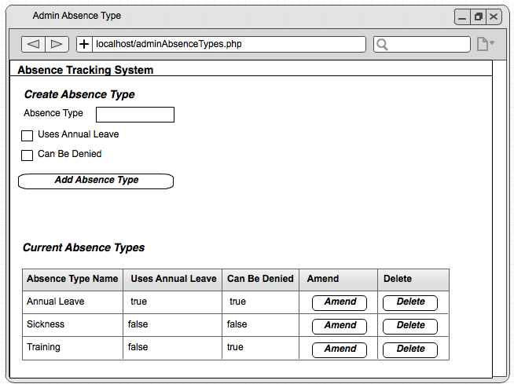

Checkboxes, since these are either true or false in the database.

Clicking this will bring up a separate page to edit this record.

A Status Bar will pop up at the top of the screen to display any success or error messages.

### Administrate Ad Hoc Requests



Drop down list, with values populated from the Employee Table.

Drop down list, with values populated from the Absence Type table.

Clicking this will bring up a separate page to edit this record.

### Administrate Approved Absence Bookings

A Status Bar will pop up at the top of the screen to display any success or error messages.



Clicking this will bring up a separate page to edit this record.

Drop down list, with values populated from the Absence Type table.

Drop down list, with values populated from the Employee Table.

### Admin Vacation

A Status Bar will pop up at the top of the screen to display any success or error messages.



Clicking Process Ad Hoc Requests will process each Ad Hoc request in turn.

Clicking Process Main Requests will sort all main requests into order based on length of service, then process each request in turn

Clicking this to approve first or second choice manually for a single Main Vacation Request.

Click this to approve a single Ad Hoc request manually.

## Office Manager Functions

A Status Bar will pop up at the top of the screen to display any success or error messages.

### Office Manager Approved Absence Bookings



Calendar control to select start date for search.

Calendar control to select end date for search

When clicked, table will be populated with all approved absence bookings between the two dates selected.

### Office Manager Ad Hoc Request

A Status Bar will pop up at the top of the screen to display any success or error messages.



Clicking this will create a new record in the AdHoc Request table.

Calendar control to select start and end dates.

Drop down list, with values populated from the Absence Type table.

Drop down list, with values populated from the Employee Table.

## Security and integrity of data

### Data Security

The Main portion of the systems data security comes from the login and password system.

In my implementation I plan to use the concept of session id to identify the user once they have logged into the system. Without a valid session id, a user will not be able to interact with the application or access any of the data.

When a user first visits the website, or if their session has timed out, then they will not have a session id and therefore will be directed to the login page.

The login page will ask for their email and password.

Email and password are fields within the employee table.

When a user sets their password I will employ logic to ensure that the password meets a minimum level of security standards. Namely:

1. The password must contain at least one upper case letter.
2. The password must contain at least one lower case letter.
3. The password must contain at least one numeric character.
4. The password must be a minimum of 6 characters in length.

In the employee table I will not store the password in plain text, since this would allow anyone with direct access to the database to obtain users passwords.

Instead, when storing passwords in the database, I will use MD5 encryption create a 128 bit hash value.

However, in the event that the database were compromised, just storing a hash of the password still exposes a risk that a criminal could reverse engineer the hack using a dictionary attack (this is where a series of common passwords are md5 encoded and compared with hash value to find the users password).

To remove this risk, I will employ ‘salting’ of the hash. This is where additional data is added to the password to create the hash.

I will use the email address for this salt. In summary, the formula will be:

EncryptedPasswordStoredInDatabase = md5hash(emailAddress+md5(password))

When a user attempts to login, I can repeat this calculation based on the email and password they have entered at login, and compare the resultant hash with the value stored in the database.

When a valid username and password is input to the login page, the PHP on the page will fetch the users role from the SQL Database. Using this data, the website will either display a generic Member of Staff Homepage, an Office Manager Homepage or an Admin Homepage.

### Data Integrity

All data will be held in a MySQL database. In the implementation of my project I will create a set of functions that encapsulate all access to the database. To protect the integrity of the data, all changes to data in the database will be subject to strict validation rules, both at the user interface level, but also within the PHP scripts to process these requests.

### System Security

I plan to create an automatic scheduled nightly backup of the database. In the user guide I will include instructions for the administrator to follow in order to restore the database from a previous backup. This procedure would only be required in the event of a database corruption.

## test strategy

### Introduction

As part of the system development, I need to define a strong test plan to ensure that the system functions as designed and contains no defects. My test plan will use a variety of test techniques to achieve this.

### Top Down Based Approach

My application is based around a series of web pages, in a tree hierarchy as shown below.

My approach to testing will be initially to create a stub for each and every page, with allowing a top down approach to page by page testing, as each page is introduced.



### Trace Tables

For some of the key and most complex functionality, described earlier in pseudocode, I will dry run my code using trace tables prior to any unit testing. By using this approach, I aim to identify any logic errors as early as possible.

### Unit Testing

I will use a white box testing approach for unit testing, using my knowledge of the implementation of each page to exercise each logic path of the code.

Within the unit testing I will include validation and bounds testing of all inputs.

### System and Integration Testing

I will use a black box testing approach for overall system testing, basing the testing on a number of use case scenarios to exercise the functionality of the overall system, ensuring that the resultant output of these use cases matches the expected results.

### Security Testing

Security testing will be conducted to ensure that the minimum password standards described earlier are enforced, to ensure that the users session timeout is enforced, and to ensure that no unencrypted password information is maintained in the database.

# technical solution

## COMMON WEB PAGE HEADER

### File: navbar.php

Each of the pages on the website will have a standard header bar, which is implemented in the file navbar.h. Every webpage includes this file



Figure 1 – Navigation Bar header.

On the left hand side the header bar contains the title of the website, a small logo, a link back to the index (home) page.

On the right hand side the header bar contains the name of the logged in user (if there is one) and a logout button which will destroy the current user session and redirect back to the login page.

1. **<?php**
2. $userDetails = "Not Logged In";
3. if (isset($_SESSION['userID']))
4. {
5. $employee = RetrieveEmployeeByID($_SESSION['userID']);
6. if ($employee)
7. {
8. $userDetails = "Logged in as ".$employee[EMP_NAME];

If the session variable userID has been set, it will be the employeeID of the logged in user. We can use this to get the employeeID record and retrieve their name.

1. }
2. }
3. **?>**

6. **<nav** role="navigation" class="navbar navbar-default"**>**
7. **<div** class="navbar-header"**>**
8. **<button** type="button" data-target=".navbarCollapse"
9. data-toggle="collapse" class="navbar-toggle"**>**
10. **<span** class="sr-only"**>**Toggle navigation**</span>**
11. **<span** class="icon-bar"**></span>**
12. **<span** class="icon-bar"**></span>**
13. **<span** class="icon-bar"**></span>**
14. **</button>**
16. **<img** src="/images/logo.png" style="max-width:45px" class="img-rounded"
17. alt="Rounded Image"**>**
18. **<a** href="#" class="navbar-brand"**>**Absence Tracking System**</a>**
19. **</div>**
21. **<div** class="nav navbar-nav"**>**
22. **<ul** class=""navbar-nav**>**
23. **<li><a** href="index.php"**>**Home**</a></li>**
24. **</ul>**
25. **</div>**
27. **<div** id="navbarCollapse" class="collapse navbar-collapse"**>**
28. **<ul** class="nav navbar-nav navbar-right"**>**
29. **<li><?php** echo $userDetails; **?></li>**
30. **<li><a** href="logout.php"**>**Logout**</a></li>**
31. **</ul>**
32. **</div>**
33. **</nav>**
34. **<?php** echo $_SESSION["StatusDiv"] **?>**

### File: status.php

Each of the pages on the website will use a standard mechanism to feedback success and failure information to the user, using a status div containing the status text. For a success condition, the background of this div will be green. For an error condition, the background will be red. The logic to format this div is contained in the file Status.php.

Figure 2 – Success status div example



Figure 3 – Error status div example

1. <?php
3. //-----------------------------------------------------------------------------
4. // Function ClearStatus
5. //
6. // This function simply clears any text from the session variable "StatusDiv"
7. //-----------------------------------------------------------------------------
8. **function** ClearStatus()
9. {
10. $_SESSION["StatusDiv"]="";
11. }
13. /* ----------------------------------------------------------------------------
14. * Function GenerateStatus
15. *
16. * This function generates a session variable called "StatusDiv" which
17. * contains the HTML necessary to display a dismissable status div on the web
18. * page.
19. *
20. * $isSuccess (bool) If true, the status div will have a green background.
21. *                   If false, the status div will have a red background.
22. * $statusMessage (string) The status message to display in the statis div.
23. * @return (none)
24. * * -------------------------------------------------------------------------*/
25. **function** GenerateStatus($isSuccess,$statusMessage)
26. {
27. $statusClass = "alert-danger";
29. **if** ($isSuccess)
30. {
31. $statusClass = "alert-success";
32. }
34. $_SESSION["StatusDiv"] =
35. "<div class='alert $statusClass alert-dismissable'>$statusMessage".
36. '<button type="button" class="close" data-dismiss="alert">x</button>'.
37. "</div>";
38. }
39. ?>

### File: Style.css

Each web page uses the same css file, which provides common styling across the site.

1. h2 {
2. **color**:#A6E5E4;
3. **margin-top**:0px;
4. **padding-top**:0px;
6. }
8. form {
9. marign:0 auto;
10. **padding**:0;
11. }
13. navbar {
14. **padding**:0;
15. **margin**:0;
16. **border-bottom**: 5px solid black;
17. }
19. body {
20. **background-color**:#C6E0E4;
21. **margin-top**:0px;
22. **padding-top**:0px;
23. }
25. div {
26. **margin-top**:0px;
27. **padding-top**:0px;
28. }
30. form {
31. **margin-top**:0px;
32. **padding-top**:0px;
33. }
35. .navbar-form {
36. **margin-top**:0px;
37. **padding-top**:0px;
38. }
40. #login {
41. **margin-top**:-10px;
42. }
44. #signin {
45. **margin-top**:-10px;
46. }
48. #Options {
49. **float**:right;
50. **margin-top**:-10px;
51. **margin-right**:20px;
52. }
54. .btn-info{
55. **background-color**:#222222;
56. **border-color**:#222222;
57. **color**:#A6E5E4;
58. }
60. .btn-info:hover {
61. **border-color**:#A6E5E4;
62. **background-color**:#A6E5E4;
63. **color**:#121B1B;
64. }
66. .btn-info:active {
67. **border-color**:#A6E5E4;
68. **background-color**:#A6E5E4;
69. **color**:#121B1B;
70. }
72. .btn-info:focus {
73. **border-color**:#A6E5E4;
74. **background-color**:#A6E5E4;
75. **color**:#121B1B;
76. }

## Login

### File: login.php



Figure 4 - Login Screen

1. <?php
2. session_start();
3. **include** 'sessionmanagement.php';


7. **if** (!isset($_SESSION['StatusDiv']))
8. {
9. $_SESSION['StatusDiv'] = "";
10. }
12. **if** (isset($_POST["submit"])) {
13. ClearStatus();
14. $email = $_POST["inputEmail"];
15. $password = $_POST["inputPassword"];
17. **if** ($email == "")
18. {
19. GenerateStatus(false,"You must enter an email address.");
20. }
21. **else** **if** ($password == "")
22. {
23. GenerateStatus(false,"You must enter a password.");
24. }
25. **else**
26. {
27. $filter[EMP_EMAIL] = $email;
28. $employees = RetrieveEmployees($filter);
29. **if** (count($employees)<>1)
30. {
31. GenerateStatus(false,"No matching email address found.");
32. }
33. **else**
34. {
35. $encryptedPassword = $employees[0][EMP_PASSWORD];
36. $temp = md5(md5($email).$password);
38. **if** ($temp == $encryptedPassword)
39. {
40. $_SESSION['userID'] = $employees[0][EMP_ID];
41. $_SESSION['administrator'] = $employees[0][EMP_ADMIN_PERM];
42. $_SESSION['manager'] = $employees[0][EMP_MANAGER_PERM];
43. header('Location: index.php');
44. }
45. **else**
46. {
47. GenerateStatus(false,"Password is incorrect.");
48. }
49. }
50. }
51. }
53. ?>
55. <!DOCTYPE html>
56. <html>
57. <head>
58. <link href="https://maxcdn.bootstrapcdn.com/bootstrap/3.2.0/css/bootstrap.min.css" rel="stylesheet">
59. <link rel="stylesheet" href="style.css">
60. <script src="http://ajax.googleapis.com/ajax/libs/jquery/1.11.1/jquery.min.js"></script>
61. <script src="https://maxcdn.bootstrapcdn.com/bootstrap/3.2.0/js/bootstrap.min.js"></script>
62. <script src="https://oss.maxcdn.com/html5shiv/3.7.2/html5shiv.min.js"></script>
63. <script src="https://oss.maxcdn.com/respond/1.4.2/respond.min.js"></script>
64. <meta charset="UTF-8">
65. <title>Absence Tracking System Login</title>
66. </head>
68. <body>
69. <?php **include** 'navbar.php'; ?>
71. <div **class**="container">
72. <div **class**="row">
73. <div **class**="col-md-4 col-md-offset-4">
74. <form method="POST">
75. <div **class**="input-group" **for**="email">
76. <span **class**="input-group-addon glyphicon glyphicon-user"></span>
77. <input type="email" **class**="form-control"
78. name="inputEmail" id="email" placeholder="Email">
79. </div>
81. <div **class**="input-group" **for**="password">
82. <span **class**="input-group-addon glyphicon glyphicon-lock"></span>
83. <input type="password" **class**="form-control"
84. name="inputPassword" id="password" placeholder="Password">
85. </div>
87. <input type="submit"
88. **class**="btn btn-lg btn-primary btn-block btn-default"
89. name="submit" value="Sign In">
90. </form>
91. </div>
92. </div>
93. </div>
94. </body>
95. </html>

### File: logout.php

1. <?php
2. //----------------------------------------------------------------------------
3. // To log a user out of the system we simply clear and destroy the session
4. // and then redirect the user back to the login page.
5. //----------------------------------------------------------------------------
6. session_start();
7. session_unset();
8. session_destroy();
9. header('Location: login.php');
10. exit();
11. ?>

## SESSIONMANAGEMENT CODE

### File: sessionmanagement.php

Each of the pages that follow include the file sessionmanagement.php. This file is executed at the beginning of each page generation at the server, and checks to ensure that the session variables created at login are defined. If these variables are not defined then the user is redirected to the login page. IE: It is impossible to access any of the pages of the system without a valid login.

Also note that if the user is logged in and a session exists, then the variables userID,isAdministrator and isManager are set based on the values of these session variables. These can then be referenced in the web page code.

1. <?php
2. IF (!isset($_SESSION))
3. {
4. session_start();
5. }
7. **include** 'databasefunctions.php';
8. **include** 'config.php';

11. $userID          = "";
12. $isAdministrator = false;
13. $isManager       = false;
15. //Create a connection to the database. This is a global variable and will
16. //be accessed via $_GLOBALS["connection"]
17. **if** (!isset($GLOBALS["connection"]))
18. {
19. $GLOBALS["connection"] = connectToSql($configDBHostName,
20. $configDBUser,
21. $configDBPassword);
22. }
23. $connection = $GLOBALS["connection"];
25. **if** (basename($_SERVER['PHP_SELF']) != "setup.php")
26. {
27. **if** (!mysqli_select_db($connection,'mydb'))
28. {
29. header('Location: setup.php');
30. exit();
31. }
32. }
34. **if** (!isset($_SESSION['StatusDiv']))
35. {
36. $_SESSION['StatusDiv'] = "";
37. }
39. $page = basename($_SERVER['PHP_SELF']);
40. **if** ( $page != "login.php" && $page!="setup.php" && $page != "test.php")
41. {
42. //----------------------------------------------------------------------------
43. // If the session variables are not set, then the user is not logged in.
44. // If this happens, redirect the user to the login page.
45. //----------------------------------------------------------------------------
46. **if** ( (!isset($_SESSION['userID'])) OR
47. (!isset($_SESSION['administrator'])) OR
48. (!isset($_SESSION['manager']) ))
49. {
50. header('Location: login.php');
51. exit();
52. }
53. **else**
54. {
55. //Set up some local variables using the values of the session variables.
56. //All of our web code can then refer to these variable names.
57. $userID          = $_SESSION['userID'];
58. $isAdministrator = $_SESSION['administrator'];
59. $isManager       = $_SESSION['manager'];
60. }
61. }
62. ?>

### File: setup.php

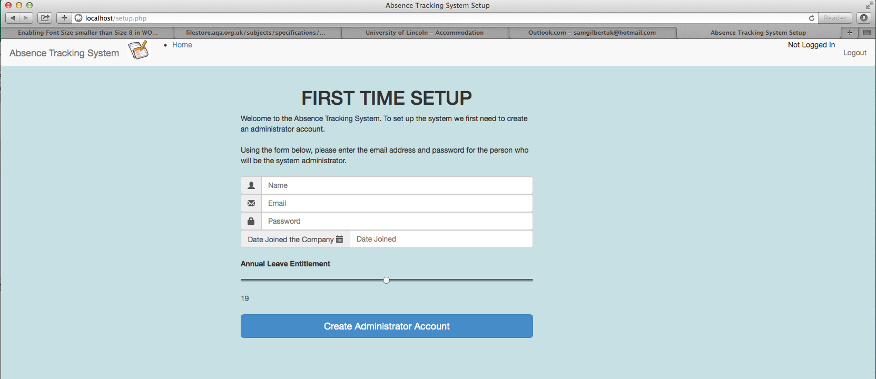

Figure 5 – First Time Setup Screen.

1. <?php
2. session_start();
3. session_unset();
4. session_destroy();
5. **include** "sessionmanagement.php";
7. $connection = $GLOBALS["connection"];
9. //Check to see if database already exists. If it does we do not allow the user
10. //to access this page, and instead re-direct them to the login page.
11. **if** (mysqli_select_db($connection,'mydb'))
12. {
13. $totalEmployees = 0;
14. $employeesWithNoMainVacation = 0;
15. GetEmployeeCount($totalEmployees,$employeesWithNoMainVacation);
17. **if** ($totalEmployees > 0)
18. {
19. header('Location: login.php');
20. exit();
21. }
22. }
24. **if** (!isset($_SESSION['StatusDiv']))
25. {
26. $_SESSION['StatusDiv'] = "";
27. }
29. **if** (isset($_POST["submit"]))
30. {
31. ClearStatus();
32. $name = $_POST["empName"];
33. $email = $_POST["eMail"];
34. $password = $_POST["password"];
35. $dateJoined= $_POST["dateJoin"];
36. $annualLeave = $_POST["annualLeave"];
38. CreateNewDatabase();
39. $success = CreateDefaultRecords($name,$email,$password,$dateJoined,$annualLeave);
41. **if** ($success)
42. {
43. header('Location: login.php');
44. exit();
45. }
46. }
48. ?>
50. <!DOCTYPE html>
51. <html>
52. <head>
53. <link href="https://maxcdn.bootstrapcdn.com/bootstrap/3.2.0/css/bootstrap.min.css" rel="stylesheet">
54. <link rel="stylesheet" href="style.css">
55. <script src="http://ajax.googleapis.com/ajax/libs/jquery/1.11.1/jquery.min.js"></script>
56. <script src="https://maxcdn.bootstrapcdn.com/bootstrap/3.2.0/js/bootstrap.min.js"></script>
57. <script src="https://oss.maxcdn.com/html5shiv/3.7.2/html5shiv.min.js"></script>
58. <script src="https://oss.maxcdn.com/respond/1.4.2/respond.min.js"></script>
59. <meta charset="UTF-8">
60. <title>Absence Tracking System Setup</title>
61. </head>
63. <body>
64. <?php **include** 'navbar.php'; ?>
65. <div **class**="container">
66. <div **class**="row">
67. <div **class**="col-md-6 col-md-offset-2">
68. <h1 align="center">FIRST TIME SETUP</h1>
69. Welcome to the Absence Tracking System. To set up the system
70. we first need to create an administrator account.<br/><br/>
72. Using the form below, please enter the email address **and**
73. password **for** the person who will be the system administrator.
74. <br/><br/>
76. <form method="POST">
77. <div **class**="input-group" **for**="empName">
78. <span **class**="input-group-addon">
79. <span **class**="glyphicon glyphicon-user"></span>
80. </span>
81. <input type="text" **class**="form-control" placeholder="Name"
82. name="empName" id="empName" >
83. </div>
85. <div **class**="input-group" **for**="eMail">
86. <span **class**="input-group-addon">
87. <span **class**="glyphicon glyphicon-envelope"></span>
88. </span>
89. <input type="text" **class**="form-control" placeholder="Email"
90. name="eMail" id="eMail">
91. </div>

94. <div **class**="input-group" **for**="password">
95. <span **class**="input-group-addon">
96. <span **class**="glyphicon glyphicon-lock"></span>
97. </span>
98. <input type="password" **class**="form-control" placeholder="Password"
99. name="password" id="password">
100. </div>
102. <div **class**="input-group" **for**=dateJoin">
103. <span **class**="input-group-addon"> Date Joined the Company
104. <span **class**="glyphicon glyphicon-calendar"></span>
105. </span>
106. <input type="date" **class**="form-control" name="dateJoin"
107. id="dateJoin" placeholder="Date Joined">
108. </div>
109. <br/>
111. <label **for**="annualLeave">Annual Leave Entitlement</label>
112. <input type="range"  **class**= "form-control" name="annualLeave"
113. min="10" max="28" value="19" step="1"
114. oninput="updateAnnualLeave(value)"  id="annualLeave" />
115. <output **for**="minStaff" id="Leave">19</output>
117. <br/>
118. <input type="submit"
119. **class**="btn btn-lg btn-primary btn-block btn-default"
120. name="submit" id="submit" value="Create Administrator Account"/>
121. </form>
122. </div>
123. </div>
124. </div>
126. <script>
127. **function** updateAnnualLeave(level)
128. {
129. document.querySelector('#Leave').value = level;
130. }
131. </script>
133. </body>
134. </html>

## Main Menu

### File: Index.php

Note that the options presented on the index page of the website will depend upon the entitlements of the user that is logged in. Specifically, the users ‘isAdministrator’ and ‘isManager’ settings, as demonstated in the screenshots below.



Figure 6 - Main Menu Screen with Administrator access



Figure 7 - Main Menu Screen with Office Manager access



Figure 8 - Main Menu Screen without Administrator or Office Manager access

1. <?php
2. **include** "sessionmanagement.php";
3. ClearStatus();
5. ?>
7. <!DOCTYPE html>
8. <html>
9. <head>
10. <link href="https://maxcdn.bootstrapcdn.com/bootstrap/3.2.0/css/bootstrap.min.css" rel="stylesheet">
11. <link rel="stylesheet" href="style.css">
12. <script src="http://ajax.googleapis.com/ajax/libs/jquery/1.11.1/jquery.min.js"></script>
13. <script src="https://maxcdn.bootstrapcdn.com/bootstrap/3.2.0/js/bootstrap.min.js"></script>
14. <script src="https://oss.maxcdn.com/html5shiv/3.7.2/html5shiv.min.js"></script>
15. <script src="https://oss.maxcdn.com/respond/1.4.2/respond.min.js"></script>
16. <meta charset="UTF-8">
17. <title>Administration</title>
18. </head>

Note the user of Session variables to determine what menu options are displayed.

2. <body>
3. <?php **include** 'navbar.php'; ?>
5. <?php **if** ($isAdministrator) { ?>
7. <div **class**="col-md-4 col-md-offset-4 text-center">
8. <h1>Administrator Functions</h1>
9. <ul **class**="list-group ">
10. <li **class**="list-group-item ">
11. <a href="adminCompanyRoles.php">Admin Company Roles</a>
12. </li>
13. <li **class**="list-group-item ">
14. <a href="adminEmployeeTable.php">Admin Employees</a>
15. </li>
16. <li **class**="list-group-item ">
17. <a href="adminMainVacationRequests.php">Admin Main Vacation Requests</a>
18. </li>
19. <li **class**="list-group-item ">
20. <a href="adminAbsenceTypes.php">Admin Absence Types</a>
21. </li>
22. <li **class**="list-group-item ">
23. <a href="adminAdHocAbsenceRequest.php">Admin Ad Hoc Requests</a>
24. </li>
25. <li **class**="list-group-item ">
26. <a href="adminApprovedAbsenceBookings.php">Admin Approved Absence Bookings</a>
27. </li>
28. <li **class**="list-group-item ">
29. <a href="adminApprovedAbsenceBookingDate.php">Admin Approved Absence Booking Dates</a>
30. </li>
31. <li **class**="list-group-item ">
32. <a href="adminDates.php">Admin Dates</a>
33. </li>
34. <li **class**="list-group-item ">
35. <a href="adminPublicHolidays.php">Admin Public Holidays</a>
36. </li>
37. <li **class**="list-group-item ">
38. <a href="administerVacation.php">Admin Vacation</a>
39. </li>
40. </ul>
41. </div>
42. <?php } ?>

45. <?php **if** ($isManager) { ?>
46. <div **class**="col-md-4 col-md-offset-4 text-center">
47. <h1>Office Manager  Functions</h1>
48. <ul **class**="list-group ">
49. <li **class**="list-group-item ">
50. <a href="managerViewApprovedRequests.php">View approved absence bookings</a>
51. </li>
52. <li **class**="list-group-item ">
53. <a href="adminAdHocAbsenceRequest.php">Create AdHoc request **for** staff member</a>
54. </li>
55. </ul>
56. </div>
57. <?php } ?>

60. <div **class**="col-md-4 col-md-offset-4 text-center">
61. <h1>Employee Functions</h1>
62. <ul **class**="list-group">
63. <li **class**="list-group-item ">
64. <a href="employeeMainVacationRequest.php">Main Vacation Request</a>
65. </li>
66. <li **class**="list-group-item ">
67. <a href="employeeDisplayDetails.php">Display Details</a>
68. </li>
69. <li **class**="list-group-item ">
70. <a href="employeeAdHocRequests.php">Ad Hoc Requests</a>
71. </li>
72. </ul>
73. </div>
74. </body>
75. </html>

## Employee Functions – Main Vacation Request

### File: employeeMainVacationRequest.php



Figure 9 – Employee Create Main Vacation Request Page

1. <?php
2. **include** 'sessionmanagement.php';  //sets $userID,$isAdministrator and $isManager
4. $employee = RetrieveEmployeeByID($userID);
5. $requestID = $employee[EMP_MAIN_VACATION_REQ_ID];
7. $today = date("Y-m-d");
8. $firstChoiceStart   = $today;
9. $firstChoiceEnd     = $today;
10. $secondChoiceStart  = $today;
11. $secondChoiceEnd    = $today;
13. **if** ( $requestID <> NULL)
14. {
15. $mainVacationRequest = RetrieveMainVacationRequestByID($requestID);
16. $firstChoiceStart    = $mainVacationRequest[MAIN_VACATION_1ST_START];
17. $firstChoiceEnd      = $mainVacationRequest[MAIN_VACATION_1ST_END];
18. $secondChoiceStart   = $mainVacationRequest[MAIN_VACATION_2ND_START];
19. $secondChoiceEnd     = $mainVacationRequest[MAIN_VACATION_2ND_END];
20. }
22. **if** (isset($_POST["submit"]))
23. {
24. ClearStatus();
25. $request = CreateMainVactionRequest($userID,
26. $_POST["firstChoiceStart"],
27. $_POST["firstChoiceEnd"],
28. $_POST["secondChoiceStart"],
29. $_POST["secondChoiceEnd"]);
31. **if** ($request <> NULL)
32. {
33. $url = "Location:index.php";
34. header($url);
35. }
36. }
37. ?>
39. <!DOCTYPE html>
40. <html>
41. <head>
42. <link href="https://maxcdn.bootstrapcdn.com/bootstrap/3.2.0/css/bootstrap.min.css" rel="stylesheet">
43. <link rel="stylesheet" href="style.css">
44. <script src="http://ajax.googleapis.com/ajax/libs/jquery/1.11.1/jquery.min.js"></script>
45. <script src="https://maxcdn.bootstrapcdn.com/bootstrap/3.2.0/js/bootstrap.min.js"></script>
46. <script src="https://oss.maxcdn.com/html5shiv/3.7.2/html5shiv.min.js"></script>
47. <script src="https://oss.maxcdn.com/respond/1.4.2/respond.min.js"></script>
48. <meta charset="UTF-8">
49. <title>Employee Main Vacation Request</title>
51. </head>
53. <body>
54. <?php **include** 'navbar.php'; ?>
56. <form method="post">
57. <div **class**="row">
58. <div **class**="col-md-4 col-md-offset-4 text-center">
60. <h1> Create Main Vacation Request </h1>
62. <div **class**="input-group" **for**="firstChoiceStart">
63. <span **class**="input-group-addon">1st Choice Start
64. <span **class**="glyphicon glyphicon-calendar"></span>
65. </span>
66. <input type="date" **class**="form-control" name="firstChoiceStart"
67. id="firstChoiceStart" placeholder="First Choice Start">
68. </div>
70. <div **class**="input-group" **for**="firstChoiceEnd">
71. <span **class**="input-group-addon">1st Choice Finish
72. <span **class**="glyphicon glyphicon-calendar"></span>
73. </span>
74. <input type="date" **class**="form-control" name="firstChoiceEnd"
75. id="firstChoiceEnd" placeholder="First Choice End">
76. </div>
78. <div **class**="input-group" **for**="secondChoiceStart">
79. <span **class**="input-group-addon">2nd Choice Start
80. <span **class**="glyphicon glyphicon-calendar"></span>
81. </span>
82. <input type="date" **class**="form-control" name="secondChoiceStart"
83. id="secondChoiceStart" placeholder="Second Choice Start">
84. </div>
86. <div **class**="input-group" **for**="secondChoiceEnd">
87. <span **class**="input-group-addon">2nd Choice Finish
88. <span **class**="glyphicon glyphicon-calendar"></span>
89. </span>
90. <input type="date" **class**="form-control" name="secondChoiceEnd"
91. id="secondChoiceEnd" placeholder="Second Choice End">
92. </div>
93. <br/>
94. <input **class**="btn btn-success btn-block" type="submit" name="submit"
95. id="submit" value="Submit Main Vacation Request"/>
96. </div>
97. </div>
98. </form>
99. </body>
100. </html>

## Employee Functions – Display Details

### File: employeeDisplayDetails.php



Note the lack of Amend for Approved Requests. Once a request has been approved it cannot be altered. Instead, the request should be deleted and a new Request generated.

Clicking on Amend will take you to the Edit Main Vactaion Request screen (see later section).

Clicking on Amend will take you to the Edit AdHoc Request screen (see later section).

Figure 10 – Employee Display Details Page

1. <?php

Note: Clicking the amend button for an adHoc request will redirect user to the editAbsenceRequest.php page (see later section).

1. **include** 'sessionmanagement.php';
3. **if** (isset($_POST["deleteApproved"])) {
4. DeleteApprovedAbsenceBooking($_POST["deleteApproved"]);
5. }
7. **if** (isset($_POST["amendAdHoc"])) {
8. ClearStatus();
9. $url = "Location:editAdHocAbsenceRequest.php?ID=".$_POST["amendAdHoc"].
10. "&back=employeeDisplayDetails.php";
11. header($url);
12. }
14. **if** (isset($_POST["deleteAdHoc"]))
15. {
16. DeleteAdHocAbsenceRequest($_POST["deleteAdHoc"]);
17. }

20. **if** (isset($_POST["amendMain"])) {
21. ClearStatus();
22. $url = "Location:editMainRequest.php?ID=".$_POST["amendMain"].
23. "&back=employeeDisplayDetails.php";
24. header($url);
25. }
27. **if** (isset($_POST["deleteMain"]))
28. {
29. DeleteMainVacationRequest($_POST["deleteMain"]);
30. }

33. **function** DisplayEmployeeDetailsListItems($userID)
34. {
35. $employee = RetrieveEmployeeByID($userID);
36. $companyRole = RetrieveCompanyRoleByID($employee[EMP_COMPANY_ROLE]);
38. echo '<li class="list-group-item ">ID: '.
39. $employee[EMP_ID].'</li>';
40. echo '<li class="list-group-item ">Name: '.
41. $employee[EMP_NAME].'</li>';
42. echo '<li class="list-group-item ">Email: '.
43. $employee[EMP_EMAIL].'</li>';
44. echo '<li class="list-group-item ">Date Joined: '.
45. $employee[EMP_DATEJOINED].'</li>';
46. echo '<li class="list-group-item ">Company Role: '.
47. $companyRole[COMP_ROLE_NAME].'</li>';
48. echo '<li class="list-group-item ">Is Admin: '.
49. $employee[EMP_ADMIN_PERM].'</li>';
50. echo '<li class="list-group-item ">Is Manager: '.
51. $employee[EMP_MANAGER_PERM].'</li>';
52. echo '<li class="list-group-item ">Leave Entitlement: '.
53. $employee[EMP_LEAVE_ENTITLEMENT].'</li>';
54. echo '<li class="list-group-item ">Annual leave remaining:'.
55. CalculateRemainingAnnualLeave($employee[EMP_ID]).'</li>';
56. }

59. **function** DisplayApproveAbsenceRequestsTableBody($userID)
60. {
61. $filter[APPR_ABS_EMPLOYEE_ID] = $userID;
62. $bookings = RetrieveApprovedAbsenceBookings($filter);
64. **if** ($bookings <> NULL) {
65. **foreach** ($bookings **as** $booking) {
66. $absenceTypeID = $booking[APPR_ABS_ABS_TYPE_ID];
67. $absenceType = RetrieveAbsenceTypeByID($absenceTypeID);
68. echo '<tr>';
69. echo '<td>'.$booking[APPR_ABS_START_DATE].'</td>';
70. echo '<td>'.$booking[APPR_ABS_END_DATE].'</td>';
71. echo '<td>'.$absenceType[ABS_TYPE_NAME].'</td>';
72. echo '<td> <button class="btn btn-danger" type="submit" '.
73. 'name="deleteApproved"  value="'.
74. $booking[APPR_ABS_BOOKING_ID].'">Delete</button></td>';
75. echo '</tr>';
76. }
77. }
78. }
80. **function** DisplayPendingAdHocRequestsTableBody($userID)
81. {
82. $filter[AD_HOC_EMP_ID] = $userID;
83. $adHocRequests = RetrieveAdHocAbsenceRequests($filter);
85. **if** ($adHocRequests <> NULL) {
86. **foreach** ($adHocRequests **as** $request) {
87. $absenceTypeID = $request[AD_HOC_ABSENCE_TYPE_ID];
88. $absenceType = RetrieveAbsenceTypeByID($absenceTypeID);
89. echo '<tr>';
90. echo '<td>'.$request[AD_HOC_START].'</td>';
91. echo '<td>'.$request[AD_HOC_END].'</td>';
92. echo '<td>'.$absenceType[ABS_TYPE_NAME].'</td>';
93. echo '<td> <button class="btn btn-success" type="submit" '.
94. 'name="amendAdHoc"  value="'.$request[AD_HOC_REQ_ID].'">Amend'.
95. '</button></td>';
96. echo '<td> <button class="btn btn-danger" type="submit" '.
97. 'name="deleteAdHoc"  value="'.$request[AD_HOC_REQ_ID].'">Delete'.
98. '</button></td>';
99. echo '</tr>';
100. }
101. }
102. }


106. **function** DisplayMainVacationRequestTableBody($userID)
107. {
108. $employee = RetrieveEmployeeByID($userID);
109. $mainVacationRequest = RetrieveMainVacationRequestByID($employee[EMP_MAIN_VACATION_REQ_ID]);
110. **if** ($mainVacationRequest <> NULL)
111. {
112. echo '<tr>';
113. echo '<td>'.$mainVacationRequest[MAIN_VACATION_1ST_START].'</td>';
114. echo '<td>'.$mainVacationRequest[MAIN_VACATION_1ST_END].'</td>';
115. echo '<td>'.$mainVacationRequest[MAIN_VACATION_2ND_START].'</td>';
116. echo '<td>'.$mainVacationRequest[MAIN_VACATION_2ND_END].'</td>';
117. echo '<td> <button class="btn btn-success" type="submit" name="amendMain"'.
118. 'value="'.$mainVacationRequest[MAIN_VACATION_REQ_ID].'">Amend</button></td>';
119. echo '<td> <button class="btn btn-danger" type="submit" name="deleteMain"'.
120. 'value="'.$mainVacationRequest[MAIN_VACATION_REQ_ID].'">Delete</button></td>';
121. echo '</tr>';
122. }
123. }

126. ?>
128. <!DOCTYPE html>
129. <html>
130. <head>
131. <link href="https://maxcdn.bootstrapcdn.com/bootstrap/3.2.0/css/bootstrap.min.css" rel="stylesheet">
132. <link rel="stylesheet" href="style.css">
133. <script src="http://ajax.googleapis.com/ajax/libs/jquery/1.11.1/jquery.min.js"></script>
134. <script src="https://maxcdn.bootstrapcdn.com/bootstrap/3.2.0/js/bootstrap.min.js"></script>
135. <script src="https://oss.maxcdn.com/html5shiv/3.7.2/html5shiv.min.js"></script>
136. <script src="https://oss.maxcdn.com/respond/1.4.2/respond.min.js"></script>
137. <meta charset="UTF-8">
138. <title>Display Employee Details</title>
140. </head>
142. <body>
143. <?php **include** 'navbar.php'; ?>
145. <div **class**="col-md-4 col-md-offset-4 text-center">
146. <h1>Employee Details</h1>
147. <ul **class**="list-group ">
148. <?php DisplayEmployeeDetailsListItems($userID); ?>
149. </ul>
150. </div>
152. <form method="POST">
153. <div **class**="row">
154. <div **class**="col-md-8 col-md-offset-2 text-center">
155. <table **class**="table table-bordered table-hover ">
156. <h1> Approved Absence Requests </h1>
157. <thead>
158. <tr>
159. <th>Start Date</th>
160. <th>End Date</th>
161. <th>Absence Type</th>
162. </tr>
163. </thead>
164. <tbody>
165. <?php DisplayApproveAbsenceRequestsTableBody($userID); ?>
166. </tbody>
167. </div>
168. </div>
169. </table>
170. </form>
172. <form method="POST">
173. <div **class**="row">
174. <div **class**="col-md-8 col-md-offset-2 text-center">
175. <table **class**="table table-bordered table-hover">
176. <h1>Pending AdHoc Requests</h1>
177. <thead>
178. <tr>
179. <th>Start Date</th>
180. <th>End Date</th>
181. <th>Absence Type</th>
182. </tr>
183. </thead>
184. <tbody>
185. <?php DisplayPendingAdHocRequestsTableBody($userID); ?>
186. </tbody>
187. </table>
188. </div>
189. </div>
190. </form>
191. <form method="POST">
192. <div **class**="row">
193. <div **class**="col-md-8 col-md-offset-2 tect-center">
194. <h1>Pending Main Vacation Requests</h1>
195. <table **class**="table table-bordered table-hover">
196. <thead>
197. <tr>
198. <th>First Choice Start</th>
199. <th>First Choice End</th>
200. <th>Second Choice Start</th>
201. <th>Second Choice End</th>
202. </tr>
203. </thead>
204. <tbody>
205. <?php DisplayMainVacationRequestTableBody($userID); ?>
206. </tbody>
207. </table>
208. </div>
209. </div>
210. </form>
212. </body>
213. </html>

### File: editMainVacationRequest.php



Note: This field can not be edited by the employee. Otherwise they would be able to edit records for other members of staff.

Figure 11 – Edit Main Vacation Request Page

1. <?php
2. **include** 'sessionmanagement.php';
4. $returnURL = "index.php";
5. **if** (isset($_GET["back"]))
6. {
7. $returnURL = $_GET["back"];
8. }
10. **if** ($_GET["ID"] <> NULL)
11. {
12. $record = RetrieveMainVacationRequestByID($_GET["ID"]);
14. **if** (!$isAdministrator)
15. {
16. **if** ($record[MAIN_VACATION_EMP_ID] <> $userID)
17. {
18. header('Location: index.php');
19. exit();
20. }
21. }
22. $employee = RetrieveEmployeeByID($record[MAIN_VACATION_EMP_ID]);
24. }
26. **if** (isset($_POST["cancel"])) {
27. ClearStatus();
28. header("Location:".$returnURL);
29. exit();
30. }
32. **if** (isset($_POST["update"])) {
33. ClearStatus();
34. $record[MAIN_VACATION_REQ_ID]       =   $_GET["ID"];
35. $record[MAIN_VACATION_EMP_ID]       =   $employee[EMP_ID];
36. $record[MAIN_VACATION_1ST_START]    =   $_POST["firstChoiceStart"];
37. $record[MAIN_VACATION_1ST_END]      =   $_POST["firstChoiceEnd"];
38. $record[MAIN_VACATION_2ND_START]    =   $_POST["secondChoiceStart"];
39. $record[MAIN_VACATION_2ND_END]      =   $_POST["secondChoiceEnd"];
40. $success = UpdateMainVacactionRequest($record);
42. **if** ($success)
43. {
44. header("Location:".$returnURL);
45. exit();
46. }
47. }
49. **if** (isset($_POST["delete"])) {
50. ClearStatus();
51. DeleteMainVacationRequest($_POST["delete"]);
52. }
54. ?>
56. <!DOCTYPE html>
57. <html>
58. <head>
59. <link href="https://maxcdn.bootstrapcdn.com/bootstrap/3.2.0/css/bootstrap.min.css" rel="stylesheet">
60. <link rel="stylesheet" href="style.css">
61. <script src="http://ajax.googleapis.com/ajax/libs/jquery/1.11.1/jquery.min.js"></script>
62. <script src="https://maxcdn.bootstrapcdn.com/bootstrap/3.2.0/js/bootstrap.min.js"></script>
63. <script src="https://oss.maxcdn.com/html5shiv/3.7.2/html5shiv.min.js"></script>
64. <script src="https://oss.maxcdn.com/respond/1.4.2/respond.min.js"></script>
65. <meta charset="UTF-8">
66. <title>Admin Employees</title>
67. </head>
69. <body>
70. <?php **include** 'navbar.php'; ?>
71. <div **class**="row">
72. <div **class**="col-md-4 col-md-offset-4 text-center">
73. <form method="post" **class**="signUp">
74. <h1> Edit Main Request </h1>
75. <div **class**="input-group"  **for**="empName">
76. <span **class**="input-group-addon">
77. <span **class**="glyphicon glyphicon-user"></span>
78. </span>
79. <?php
80. $employee = RetrieveEmployeeByID($record[MAIN_VACATION_EMP_ID]);
81. **if** ($employee <> NULL)
82. {
83. echo '<input type="text" class="form-control" name="empID" '
84. . 'id="empID" readonly value="'.$employee[EMP_NAME].'"/>';
85. }
86. ?>
87. </div>
89. <div **class**="input-group" **for**="firstChoiceStart">
90. <span **class**="input-group-addon">1st Choice Start
91. <span **class**="glyphicon glyphicon-calendar"></span>
92. </span>
93. <input type="date" **class**="form-control"
94. name="firstChoiceStart" id="firstChoiceStart"
95. value="<?php echo $record[MAIN_VACATION_1ST_START]; ?>">
96. </div>

99. <div **class**="input-group" **for**="firstChoiceEnd">
100. <span **class**="input-group-addon">1st Choice Finish
101. <span **class**="glyphicon glyphicon-calendar"></span>
102. </span>
103. <input type="date" **class**="form-control"
104. name="firstChoiceEnd" id="firstChoiceEnd"
105. value="<?php echo $record[MAIN_VACATION_1ST_END]; ?>">
106. </div>
108. <div **class**="input-group" **for**="secondChoiceStart">
109. <span **class**="input-group-addon">2nd Choice Start
110. <span **class**="glyphicon glyphicon-calendar"></span>
111. </span>
112. <input type="date" **class**="form-control"
113. name="secondChoiceStart" id="secondChoiceStart"
114. value="<?php echo $record[MAIN_VACATION_2ND_START]; ?>">
115. </div>

118. <div **class**="input-group" **for**="secondChoiceEnd">
119. <span **class**="input-group-addon">2nd Choice Finish
120. <span **class**="glyphicon glyphicon-calendar"></span>
121. </span>
122. <input type="date" **class**="form-control"
123. name="secondChoiceEnd" id="secondChoicEnd"
124. value="<?php echo $record[MAIN_VACATION_2ND_END]; ?>">
125. </div>
127. <br />
129. <input **class**="btn btn-success btn-block" type="submit"
130. name="update" id="submit" value="Update"/>
131. <input **class**="btn btn-danger btn-block" type="submit"
132. name="cancel" id="cancel" value="Cancel"/>
133. </form>
134. </div>
135. </div>
136. </body>
137. </html>

### File: editAdHocAbsenceRequest.php



Note: This field can not be edited by the employee.

Figure 12 – Edit Ad Hoc Request Page

1. <?php
2. **include** 'sessionmanagement.php';
4. $returnURL = "index.php";
5. **if** (isset($_GET["back"]))
6. {
7. $returnURL = $_GET["back"];
8. }
10. **if** ($_GET["ID"] <> NULL)
11. {
12. $request = RetrieveAdHocAbsenceRequestByID($_GET["ID"]);
13. $Employee = RetrieveEmployeeByID($request[AD_HOC_EMP_ID]);
15. **if** (!$isAdministrator)
16. {
17. **if** ($request[AD_HOC_EMP_ID] <> $userID)
18. {
19. //--------------------------------------------------------------
20. // The user is not an administrator, but is attempting to
21. // edit an approved absence request for another user. This is
22. // not allowed, and should not happen. If it does, we redirect
23. // the user back to the index.
24. //--------------------------------------------------------------
25. header('Location: index.php');
26. exit();
27. }
28. }
29. }
31. **if** (isset($_POST["cancel"])) {
32. ClearStatus();
33. header("location:".$returnURL);
34. exit;
35. }
37. **if** (isset($_POST["update"])) {
38. ClearStatus();
39. $request[AD_HOC_REQ_ID]          =  $_GET["ID"];
40. $request[AD_HOC_START]           =   $_POST["startDate"];
41. $request[AD_HOC_END]             =   $_POST["endDate"];
42. $request[AD_HOC_ABSENCE_TYPE_ID] =   $_POST["absenceType"];
43. $success = UpdateAdHocAbsenceRequest($request);
45. **if** ($success)
46. {
47. header("location:".$returnURL);
48. exit;
49. }
50. }


54. **function** CreateAbsenceTypeSelect($absenceIDToSelect)
55. {
56. $absenceTypes = RetrieveAbsenceTypes();
57. **if** ($absenceTypes <> NULL)
58. {
59. echo '<select class="form-control" name="absenceType">';
61. **foreach** ($absenceTypes **as** $absenceType)
62. {
63. **if** ($absenceType[ABS_TYPE_ID]== $absenceIDToSelect)
64. {
65. echo '<option selected="selected" value="'.
66. $absenceType[ABS_TYPE_ID].'">'.
67. $absenceType[ABS_TYPE_NAME].'</option>';
68. }
69. **else**
70. {
71. echo '<option value="'.$absenceType[ABS_TYPE_ID].'">'.
72. $absenceType[ABS_TYPE_NAME].'</option>';
73. }
74. }
75. echo '</select>';
76. }
77. }
78. ?>
80. <!DOCTYPE html>
81. <html>
82. <head>
83. <meta charset="UTF-8">
84. <title>Admin Ad Hoc Absence Requests</title>
85. <link href="https://maxcdn.bootstrapcdn.com/bootstrap/3.2.0/css/bootstrap.min.css" rel="stylesheet">
86. <link rel="stylesheet" href="style.css">
87. <script src="http://ajax.googleapis.com/ajax/libs/jquery/1.11.1/jquery.min.js"></script>
88. <script src="https://maxcdn.bootstrapcdn.com/bootstrap/3.2.0/js/bootstrap.min.js"></script>
89. <script src="https://oss.maxcdn.com/html5shiv/3.7.2/html5shiv.min.js"></script>
90. <script src="https://oss.maxcdn.com/respond/1.4.2/respond.min.js"></script>
91. </head>
92. <body>
93. <?php **include** 'navbar.php'; ?>

96. <form method="post" **class**="signUp">
97. <div **class**="row">
98. <div **class**="col-md-4 col-md-offset-4 text-center">
99. <h1> Edit Ad Hoc Request </h1>
101. <div **class**="input-group"  **for**="empID">
102. <span **class**="input-group-addon">
103. <span **class**="glyphicon glyphicon-user"></span>
104. </span>
105. <?php
106. **if** ($Employee <> NULL)
107. {
108. echo '<input type="text" class="form-control" name="empID" '.
109. 'id="empID" readonly value="'.$Employee[EMP_NAME].'"/>';
110. }
111. ?>
112. </div>
114. <div **class**="input-group" **for**="startDate">
115. <span **class**="input-group-addon">Start
116. <span **class**="glyphicon glyphicon-calendar"></span>
117. </span>
118. <input type="date" **class**="form-control" name="startDate"
119. id="startDate" value="<?php echo $request[AD_HOC_START]?>">
120. </div>

123. <div **class**="input-group" **for**="endDate">
124. <span **class**="input-group-addon">Finish
125. <span **class**="glyphicon glyphicon-calendar"></span>
126. </span>
127. <input type="date" **class**="form-control" name="endDate"
128. id="endDate" value="<?php echo $request[AD_HOC_END]?>">
129. </div>
131. <br/>
132. <p **class**="text-center">
133. <label **for**="absenceType">Absence Type</label>
134. <?php CreateAbsenceTypeSelect($request[AD_HOC_ABSENCE_TYPE_ID]); ?>
135. </p>
136. <br />
138. <input **class**="btn btn-success btn-block" type="submit" name="update"
139. id="submit" value="Edit Request"/>
140. <input **class**="btn btn-danger btn-block" type="submit" name="cancel"
141. id="cancel" value="Cancel"/>
142. </form>
143. </body>
144. </html>

## Employee Functions – AdHoc Absence Request

### File: employeeAdHocRequests.php



Figure 13 – Employee Create AdHoc Request Page

1. <?php
2. **include** 'sessionmanagement.php';
4. **if** (isset($_POST["submit"]))
5. {
6. ClearStatus();
7. $request = CreateAdHocAbsenceRequest($userID,
8. $_POST["startDate"],
9. $_POST["endDate"],
10. $_POST["absenceType"]);
11. }
13. **function** CreateAbsenceTypeSelect()
14. {
15. $absenceTypes = RetrieveAbsenceTypes();
16. **if** ($absenceTypes <> NULL)
17. {
18. echo '<select class="form-control" name="absenceType">';
19. **foreach** ($absenceTypes **as** $absenceType)
20. {
21. echo '<option value="' . $absenceType[ABS_TYPE_ID] . '">' .
22. $absenceType[ABS_TYPE_NAME] . '</option>';
23. }
24. }
25. echo '</select>';
26. }
27. ?>
29. <!DOCTYPE html>
30. <html>
31. <head>
32. <link href="https://maxcdn.bootstrapcdn.com/bootstrap/3.2.0/css/bootstrap.min.css" rel="stylesheet">
33. <link rel="stylesheet" href="style.css">
34. <script src="http://ajax.googleapis.com/ajax/libs/jquery/1.11.1/jquery.min.js"></script>
35. <script src="https://maxcdn.bootstrapcdn.com/bootstrap/3.2.0/js/bootstrap.min.js"></script>
36. <script src="https://oss.maxcdn.com/html5shiv/3.7.2/html5shiv.min.js"></script>
37. <script src="https://oss.maxcdn.com/respond/1.4.2/respond.min.js"></script>
38. <meta charset="UTF-8">
39. <title>Employee Create Ad Hoc Request</title>
40. </head>
42. <body>
43. <?php **include** 'navbar.php'; ?>
45. <form method="post">
47. <div **class**="row">
48. <div **class**="col-md-4 col-md-offset-4 text-center">
49. <h1> Create Ad Hoc Request </h1>
50. <div **class**="input-group" **for**="startDate">
51. <span **class**="input-group-addon">Start Date
52. <span **class**="glyphicon glyphicon-calendar"></span>
53. </span>
54. <input type="date" **class**="form-control" name="startDate"
55. id="startDate" placeholder="Start Date">
56. </div>

59. <div **class**="input-group" **for**="endDate">
60. <span **class**="input-group-addon">Finish Date
61. <span **class**="glyphicon glyphicon-calendar"></span>
62. </span>
63. <input type="date" **class**="form-control" name="endDate"
64. id="endDate" placeholder="End Date">
65. </div>
66. <p **class**="text-center">
67. <label **for**="absenceType">Absence Type</label>
68. </p>
69. <?php CreateAbsenceTypeSelect(); ?>
70. <br />
72. <input **class**="btn btn-success btn-block" type="submit" name="submit"
73. id="submit" value="Add AdHoc Request"/>
74. </div>
75. </div>
76. </form>
77. </div>
78. </body>
79. </html>

## Office Manager – View Approved Absence Bookings

### File: managerViewApprovedRequests.php



Figure 14 – Office Manager View Approved Absence Bookings



Figure 15 – Office Manager View Approved Absence Bookings with search results

1. <?php
2. include 'sessionmanagement.php';
3. if (!$isManager) {
4. header('Location: index.php');
5. exit();
6. }
7. if (isset($_POST["submit"]))
8. {
9. ClearStatus();
10. $statusMessage = "";
11. $inputIsValid = true;
13. $startDate = $_POST["startDate"];
14. $endDate = $_POST["endDate"];
16. if (!isValidDate($startDate)) {
17. $statusMessage.="Start Date is not a valid Date.</br>";
18. $inputIsValid = false;
19. }
20. if (!isValidDate($endDate)) {
21. $statusMessage.="Finish Date is not a valid Date.</br>";
22. $inputIsValid = false;
23. }
25. if (strtotime($endDate) < strtotime($startDate))
26. {
27. $statusMessage.="End Date is before Start Date.</br>";
28. $inputIsValid = false;
29. }
30. if ($inputIsValid == false)
31. {
32. GenerateStatus(false, $statusMessage);
33. }
34. }
35. function DisplaySearchTableBody($startDate,$endDate)
36. {
37. date_default_timezone_set('UTC');
38. $startDate = $_POST["startDate"];
39. $startDateTime = strtotime($startDate);
41. $endDate =
42. $endDateTime = strtotime($endDate);
43. $bookings = RetrieveApprovedAbsenceBookings();
44. if ($bookings <> NULL)
45. {
46. foreach ($bookings as $booking)
47. {
48. $bookingStartTime = strtotime($booking[APPR_ABS_START_DATE]);
49. $bookingEndTime = strtotime($booking[APPR_ABS_START_DATE]);
51. if ( ($bookingStartTime >= $startDateTime) AND
52. ($bookingEndTime <= $endDateTime))
53. {
54. $employee = RetrieveEmployeeByID($booking[APPR_ABS_EMPLOYEE_ID]);
55. $absenceType = RetrieveAbsenceTypeByID($booking[APPR_ABS_ABS_TYPE_ID]);
57. echo '<tr>';
58. echo '<td>'.$employee[EMP_NAME].'</td>';
59. echo '<td>'.$booking[APPR_ABS_START_DATE].'</td>';
60. echo '<td>'.$booking[APPR_ABS_END_DATE].'</td>';
61. echo '<td>'.$absenceType[ABS_TYPE_NAME].'</td>';
62. echo '</tr>';
63. }
64. }
65. }
66. }
67. ?>
68. <!DOCTYPE html>
69. <html>
70. <head>
71. <meta charset="UTF-8">
72. <title>View Approved Absence Bookings</title>
73. <link href="https://maxcdn.bootstrapcdn.com/bootstrap/3.2.0/css/bootstrap.min.css" rel="stylesheet">
74. <link rel="stylesheet" href="style.css">
75. <script src="http://ajax.googleapis.com/ajax/libs/jquery/1.11.1/jquery.min.js"></script>
76. <script src="https://maxcdn.bootstrapcdn.com/bootstrap/3.2.0/js/bootstrap.min.js"></script>
77. <script src="https://oss.maxcdn.com/html5shiv/3.7.2/html5shiv.min.js"></script>
78. <script src="https://oss.maxcdn.com/respond/1.4.2/respond.min.js"></script>
79. </head>
80. <body>
81. <?php include 'navbar.php'; ?>
82. <form method="post" class="signUp">
83. <div class="row">
84. <div class="col-md-4 col-md-offset-4 text-center">
85. <h1>View Approved Absence Bookings</h1>
86. <div class="input-group" for="startDate">
87. <span class="input-group-addon">Search Period Start Date&nbsp;
88. <span class="glyphicon glyphicon-calendar"></span>
89. </span>
90. <input type="date" class="form-control" name="startDate"
91. id="startDate" placeholder="Start Date">
92. </div>
93. <div class="input-group" for="endDate">
94. <span class="input-group-addon">Search Period Finish Date
95. <span class="glyphicon glyphicon-calendar"></span>
96. </span>
97. <input type="date" class="form-control" name="endDate"
98. id="endDate" placeholder="End Date">
99. </div>
100. <br/>
101. <input class="btn btn-success btn-block" type="submit"
102. name="submit" id="submit" value="Display Bookings"/>
103. </div>
104. </div>
105. </form>
106. <?php if (isset($_POST["submit"])){?>
107. <div id="table">
108. <div class="row">
109. <div class="col-md-8 col-md-offset-2 text-center">
110. <br/><br/><br/>
111. <h1>Search Results</h1>
112. <form method="post">
113. <table class="table table-bordered table-hover ">
114. <thead>
115. <tr>
116. <th>Name</th>
117. <th>Start Date</th>
118. <th>End Date</th>
119. <th>Absence Type</th>
120. </tr>
121. </thead>
122. <tbody>
123. <?php DisplaySearchTableBody($_POST["startDate"],
124. $_POST["endDate"]); ?>
125. </tbody>
126. </table>
127. </form>
128. </div> <?php }?>
129. </body>
130. </html>

## Administrator – Admin Company Roles

### File: adminCompanyRoles.php



Figure 16 – Admin Company Role page

1. **<?php**
2. include 'sessionmanagement.php';
3. include 'databaseFunctions.php';

6. if (!$isAdministrator)
7. {
8. header('Location: index.php');
9. exit();
10. }
12. if (isset($_POST["submit"])) {
13. ClearStatus();
14. $role = CreateCompanyRole($_POST["roleName"], $_POST["minStaff"]);
15. }
17. if (isset($_POST["amend"])) {
18. ClearStatus();
19. $url = "Location:editcompanyrole.php?roleID=".$_POST["amend"];
20. header($url);
21. }
23. if (isset($_POST["delete"])) {
24. ClearStatus();
25. DeleteCompanyRole($_POST["delete"]);
26. }
28. function DisplayCompanyRolesTableBody()
29. {
30. $roles = RetrieveCompanyRoles();
31. if ($roles **<>** NULL)
32. {
33. foreach ($roles as $role)
34. {
35. echo "**<tr>**";
36. echo "**<td>**".$role[COMP_ROLE_NAME]."**</td>**";
37. echo "**<td>**".$role[COMP_ROLE_MIN_STAFF]."**</td>**";
38. echo "**<td>**";
39. echo '**<button** class="btn btn-success" type="submit"'.
40. 'name="amend"'.
41. 'value="'.$role[COMP_ROLE_ID].'"**>**'.
42. 'Amend**</button></td>**';
43. echo '**<td>** **<button** class="btn btn-danger" type="submit"'.
44. 'name="delete"'.
45. 'value="'.$role[COMP_ROLE_ID].'"**>**'.
46. 'Delete**</button></td>**';
47. echo '**</tr>**';
48. }
49. }
50. }
51. **?>**
53. <!DOCTYPE html**>**
54. **<html>**
55. **<head>**
56. **<link** href="https://maxcdn.bootstrapcdn.com/bootstrap/3.2.0/css/bootstrap.min.css" rel="stylesheet"**>**
57. **<link** rel="stylesheet" href="style.css"**>**
58. **<script** src="http://ajax.googleapis.com/ajax/libs/jquery/1.11.1/jquery.min.js"**></script>**
59. **<script** src="https://maxcdn.bootstrapcdn.com/bootstrap/3.2.0/js/bootstrap.min.js"**></script>**
60. **<script** src="https://oss.maxcdn.com/html5shiv/3.7.2/html5shiv.min.js"**></script>**
61. **<script** src="https://oss.maxcdn.com/respond/1.4.2/respond.min.js"**></script>**
62. **<meta** charset="UTF-8"**>**
63. **<title>**Admin Company Roles**</title>**
64. **</head>**
66. **<body>**
67. **<?php** include 'navbar.php'; **?>**
68. **<div** class="row col-md-4 col-md-offset-4 text-center"**>**
69. **<form** method="post"**>**
70. **<h1>**Create New Company Role**</h1>**
71. **<div** class="input-group" for="roleName"**>**
72. **<span** class="input-group-addon"**>**Company Role Name **</span>**
73. **<input** type="text" class="form-control"
74. placeholder="Enter name" name="roleName"
75. id="roleName"**>**
76. **</div>**
78. **<br/>**
80. **<label** for="minStaff"**>**Minimum Staff Level**</label>**
81. **<input** type="range" class="form-control" name="minStaff" min="0"
82. max="30" value="1" step="1"
83. oninput="updateMinStaff(value)"  id="minStaff" **/>**
84. **<output** for="minStaff" id="staffNumber"**>**1**</output>**
85. **<input** class="btn btn-success btn-block" type="submit"
86. name="submit" id="submit" value="Add Role"**/>**
88. **</form>**
89. **</div>**

92. **<div** class="row col-md-8 col-md-offset-2 text-center"**>**
93. **<br/><br/>**
94. **<h1>**Current Company Roles**</h1>**
95. **<form** method="post"**>**
96. **<table** class="table table-hover table-bordered table-condensed"**>**
97. **<thead>**
98. **<tr>**
99. **<th>**Role Name**</th>**
100. **<th>**Minimum Staffing Level**</th>**
101. **<th>**Amend**</th>**
102. **<th>**Delete**</th>**
103. **</tr>**
104. **</thead>**
105. **<tbody>**
106. **<?php** DisplayCompanyRolesTableBody(); **?>**
107. **</tbody>**
108. **</table>**
109. **</form>**
110. **</div>**
112. **<script>**
113. function updateMinStaff(level)
114. {
115. document.querySelector('#staffNumber').value = level;
116. }
117. **</script>**
118. **</body>**
119. **</html>**

### File: editCompanyRole.php



Figure 17 – Edit Company Role page

1. <?php
2. **include** 'sessionmanagement.php';
4. **if** (!$isAdministrator)
5. {
6. header('Location: index.php');
7. exit();
8. }
10. **if** ($_GET["roleID"] <> NULL)
11. {
12. $role = RetrieveCompanyRoleByID($_GET["roleID"]);
13. }
15. **if** (isset($_POST["cancel"])) {
16. $url = "Location:adminCompanyRoles.php";
17. header($url);
18. }
20. **if** (isset($_POST["update"])) {
21. $role[COMP_ROLE_ID]       =   $_GET["roleID"];
22. $role[COMP_ROLE_NAME]     =   $_POST["roleName"];
23. $role[COMP_ROLE_MIN_STAFF]=   $_POST["minStaff"];
24. $result = UpdateCompanyRole($role);
26. **if** ($result)
27. {
28. $url = "Location:adminCompanyRoles.php";
29. header($url);
30. }
31. }
32. ?>
34. <!DOCTYPE html>
35. <html>
36. <head>
37. <meta charset="UTF-8">
38. <title>Amend Company Role</title>
39. <link href="https://maxcdn.bootstrapcdn.com/bootstrap/3.2.0/css/bootstrap.min.css" rel="stylesheet">
40. <link rel="stylesheet" href="style.css">
41. <script src="http://ajax.googleapis.com/ajax/libs/jquery/1.11.1/jquery.min.js"></script>
42. <script src="https://maxcdn.bootstrapcdn.com/bootstrap/3.2.0/js/bootstrap.min.js"></script>
43. <script src="https://oss.maxcdn.com/html5shiv/3.7.2/html5shiv.min.js"></script>
44. <script src="https://oss.maxcdn.com/respond/1.4.2/respond.min.js"></script>
45. </head>
47. <body>
48. <?php **include** 'navbar.php'; ?>
50. <form method="post" **class**="signUp">
51. <div **class**="row">
52. <div **class**="col-md-4 col-md-offset-4 text-center">
53. <h1> Edit Company Role </h1>
54. <div **class**="input-group" **for**="roleName">
55. <span **class**="input-group-addon">Company Role Name
56. <span **class**="glyphicon glyphicon-briefcase"></span>
57. </span>
58. <input type="text" **class**="form-control" name="roleName"
59. id="roleName" value="<?php echo $role[COMP_ROLE_NAME];?>" >
60. </div>
62. <br/>
64. <label **for**="minStaff">Minimum Staff Level</label>
65. <input type="range" name="minStaff" min="0" max="30"
66. value="<?php echo $role[COMP_ROLE_MIN_STAFF];?>" step="1"
67. oninput="updateMinStaff(value)"  id="minStaff" />
68. <output **for**="minStaff" id="staffNumber">
69. <?php echo $role[COMP_ROLE_MIN_STAFF];?></output>
70. <br/>
71. <input **class**="btn btn-success btn-block" type="submit" name="update"
72. id="submit" value="Update"/>
73. <input **class**="btn btn-danger btn-block" type="submit" name="cancel"
74. id="cancel" value="Cancel"/>
76. <script>
77. **function** updateMinStaff(level)
78. {
79. document.querySelector('#staffNumber').value = level;
80. }
81. </script>
82. </div>
83. </div>
84. </form>
85. </body>
86. </html>

## Administrator – Admin Employees

### File: adminEmployeeTable.php



1. <?php
2. **include** 'sessionmanagement.php';
3. **include** 'databaseFunctions.php';
5. **if** (!$isAdministrator)
6. {
7. header('Location: index.php');
8. exit();
9. }
11. **if** (isset($_POST["submit"]))
12. {
13. ClearStatus();
15. $isAdministrator = 0;
16. $isManager = 0;
18. **if** (isset($_POST["isAdministrator"]))
19. {
20. $isAdministrator = 1;
21. }
22. **if** (isset($_POST["isManager"] ))
23. {
24. $isManager = 1;
25. }

28. $employee = CreateEmployee($_POST["empName"],
29. $_POST["eMail"],
30. $_POST["password"],
31. $_POST["dateJoin"],
32. $_POST["annualLeave"],
33. NULL,
34. $_POST["companyRole"],
35. $isAdministrator,
36. $isManager);
37. }
39. **if** (isset($_POST["amend"])) {
40. ClearStatus();
42. $url = "Location:editEmployee.php?ID=".$_POST["amend"];
43. header($url);
44. }
46. **if** (isset($_POST["delete"]))
47. {
48. ClearStatus();
49. DeleteEmployee($_POST["delete"]);
50. }
52. **function** DisplayEmployeeTableBody()
53. {
54. $employees = RetrieveEmployees();
55. **if** ($employees <> NULL)
56. {
57. **foreach** ($employees **as** $employee)
58. {
59. $role = RetrieveCompanyRoleByID($employee[EMP_COMPANY_ROLE]);
60. echo "<tr>";
61. echo "<td>".$employee[EMP_ID]."</td>";
62. echo "<td>".$employee[EMP_NAME]."</td>";
63. echo "<td>".$employee[EMP_EMAIL]."</td>";
64. echo "<td>".$employee[EMP_DATEJOINED]."</td>";
65. echo "<td>".$employee[EMP_LEAVE_ENTITLEMENT]."</td>";
66. echo "<td>".$role[COMP_ROLE_NAME]."</td>";
67. echo "<td>".$employee[EMP_MAIN_VACATION_REQ_ID]."</td>";
68. echo "<td>".$employee[EMP_ADMIN_PERM]."</td>";
69. echo "<td>".$employee[EMP_MANAGER_PERM]."</td>";
70. echo '<td> <button type="submit" class="btn btn-success" '.
71. 'name="amend" id="amend"  value="'.$employee[EMP_ID].
72. '">Amend</button></td>';
73. echo '<td> <button type="submit" class="btn btn-danger" '.
74. 'name="delete" id="delete" value="'.$employee[EMP_ID].
75. '">Delete</button></td>';
76. echo "</tr>";
77. }
78. }
79. }
81. ?>
83. <!DOCTYPE html>
84. <html>
85. <head>
86. <link href="https://maxcdn.bootstrapcdn.com/bootstrap/3.2.0/css/bootstrap.min.css" rel="stylesheet">
87. <link rel="stylesheet" href="style.css">
88. <script src="http://ajax.googleapis.com/ajax/libs/jquery/1.11.1/jquery.min.js"></script>
89. <script src="https://maxcdn.bootstrapcdn.com/bootstrap/3.2.0/js/bootstrap.min.js"></script>
90. <script src="https://oss.maxcdn.com/html5shiv/3.7.2/html5shiv.min.js"></script>
91. <script src="https://oss.maxcdn.com/respond/1.4.2/respond.min.js"></script>
92. <meta charset="UTF-8">
93. <title>Admin Employees</title>
94. </head>
96. <body>
97. <?php **include** 'navbar.php'; ?>

100. <form **class**="signUp" method="post">
101. <div **class**="row">
103. <div **class**="col-md-4 col-md-offset-4 text-center">
104. <h1> Create a **new** Employee </h1>
106. <div **class**="input-group" **for**="empName">
107. <span **class**="input-group-addon">
108. <span **class**="glyphicon glyphicon-user"></span>
109. </span>
110. <input type="text" **class**="form-control" placeholder="Name"
111. name="empName" id="empName" >
112. </div>
114. <div **class**="input-group" **for**="eMail">
115. <span **class**="input-group-addon">
116. <span **class**="glyphicon glyphicon-envelope"></span>
117. </span>
118. <input type="text" **class**="form-control" placeholder="Email"
119. name="eMail" id="eMail">
120. </div>

123. <div **class**="input-group" **for**="password">
124. <span **class**="input-group-addon">
125. <span **class**="glyphicon glyphicon-lock"></span>
126. </span>
127. <input type="password" **class**="form-control" placeholder="Password"
128. name="password" id="password">
129. </div>
131. <div **class**="input-group" **for**=dateJoin">
132. <span **class**="input-group-addon">
133. <span **class**="glyphicon glyphicon-calendar"></span>
134. </span>
135. <input type="date" **class**="form-control" name="dateJoin"
136. id="dateJoin" placeholder="Date Joined">
137. </div>
138. <br/>
140. <label **for**="companyRole">Company Role</label>
141. <?php
142. $roles = RetrieveCompanyRoles();
143. **if** ($roles <> NULL) {
144. echo '<select  class= "form-control" name="companyRole">';
145. **foreach** ($roles **as** $role) {
146. echo '<option value="' . $role[COMP_ROLE_ID] . '">' .
147. $role[COMP_ROLE_NAME] . '</option>';
148. }
149. }
151. echo '</select>';
152. ?>
153. <br/>
155. <label **for**="annualLeave">Annual Leave Entitlement</label>
156. <input type="range"  **class**= "form-control" name="annualLeave"
157. min="10" max="28" value="19" step="1"
158. oninput="updateAnnualLeave(value)"  id="annualLeave" />
159. <output **for**="minStaff" id="Leave">19</output>
161. <br/>
163. <label **for**="isAdministrator" >Is Administrator</label>
164. <input type="checkbox" name="isAdministrator"
165. id="isAdministrator" />
166. <label **for**="isManager" >  Is Manager</label>
167. <input type="checkbox"  name="isManager" id="isManager" />
168. </div>
169. <input type="submit" **class**="btn btn-success col-md-4 col-md-offset-4"
170. name="submit" id="submit" value="Add Employee"/>
171. </div>
172. </form>
174. <div id="table" **class**="table-responsive">
175. <form method="post">
176. <div **class**="row col-md-10 col-md-offset-1 text-center">
177. <br/><br/><br/>
178. <h1>Current Employees </h1>
180. <table **class**="table table-hover table-bordered">
181. <thead>
182. <tr>
183. <th>ID</th>
184. <th>Name</th>
185. <th>Email</th>
186. <th>Date Joined</th>
187. <th>Annual Leave Entitlement</th>
188. <th>Company Role</th>
189. <th>Main Vacation Request ID</th>
190. <th>Is Administrator</th>
191. <th>Is Manager</th>
192. <th>Amend</th>
193. <th>Delete</th>
194. </tr>
195. </thead>
196. <tbody>
197. <?php DisplayEmployeeTableBody(); ?>
198. </tbody>
199. </table>
200. </form>
201. </div>
203. <script>
204. **function** updateAnnualLeave(level)
205. {
206. document.querySelector('#Leave').value = level;
207. }
208. </script>
210. </body>
212. </html>

### File: editEmployee.php



1. <?php
2. **include** 'sessionmanagement.php';
4. **if** ($_GET["ID"] <> NULL)
5. {
6. $Employee = RetrieveEmployeeByID($_GET["ID"]);
7. }
9. **if** (isset($_POST["cancel"])) {
10. ClearStatus();
12. $url = "Location:adminEmployeeTable.php";
13. header($url);
14. }
16. **if** (isset($_POST["update"])) {
17. ClearStatus();
19. unset($Employee);
20. $Employee[EMP_ID]               =   $_GET["ID"];
21. $Employee[EMP_NAME]             =   $_POST["empName"];
22. $Employee[EMP_EMAIL]            =   $_POST["eMail"];
23. $Employee[EMP_DATEJOINED]       =   $_POST["dateJoin"];
24. $Employee[EMP_LEAVE_ENTITLEMENT]=   $_POST["annualLeave"];
25. $Employee[EMP_COMPANY_ROLE]     =   $_POST["companyRole"];
27. $Employee[EMP_ADMIN_PERM] = '0';
28. **if** (isset($_POST['isAdmin']))
29. {
30. **if** ($_POST["isAdmin"] == 'on')
31. {
32. $Employee[EMP_ADMIN_PERM] = '1';
33. }
34. }
36. $Employee[EMP_MANAGER_PERM] = '0';
37. **if** (isset($_POST['isManager']))
38. {
39. **if** ($_POST["isManager"] == 'on')
40. {
41. $Employee[EMP_MANAGER_PERM] = '1';
42. }
43. }
45. $result = UpdateEmployee($Employee);
47. **if** ($result)
48. {
49. $url = "Location:adminEmployeeTable.php";
50. header($url);
51. }
52. }
54. **function** GenerateCompanyRoleSelect()
55. {
56. $roles = RetrieveCompanyRoles();
57. **if** ($roles <> NULL)
58. {
59. echo '<select class="form-control" name="companyRole">';
60. **foreach** ($roles **as** $role)
61. {
62. **if** ($role[COMP_ROLE_ID]== $Employee[EMP_COMPANY_ROLE])
63. {
64. echo '<option  selected="selected" value="'.$role[COMP_ROLE_ID].
65. '">'.$role[COMP_ROLE_NAME].'</option>';
66. }
67. **else**
68. {
69. echo '<option value="'.$role[COMP_ROLE_ID].'">'.
70. $role[COMP_ROLE_NAME].'</option>';
71. }
72. }
73. }
75. echo '</select>';
76. }
78. ?>
80. <!DOCTYPE html>
81. <html>
82. <head>
83. <meta charset="UTF-8">
84. <title>Admin Employees</title>
85. <link href="https://maxcdn.bootstrapcdn.com/bootstrap/3.2.0/css/bootstrap.min.css" rel="stylesheet">
86. <link rel="stylesheet" href="style.css">
87. <script src="http://ajax.googleapis.com/ajax/libs/jquery/1.11.1/jquery.min.js"></script>
88. <script src="https://maxcdn.bootstrapcdn.com/bootstrap/3.2.0/js/bootstrap.min.js"></script>
89. <script src="https://oss.maxcdn.com/html5shiv/3.7.2/html5shiv.min.js"></script>
90. <script src="https://oss.maxcdn.com/respond/1.4.2/respond.min.js"></script>
91. </head>
93. <body>
94. <?php **include** 'navbar.php'; ?>
96. <form **class**="signUp"method="post">
97. <div **class**="row">
98. <div **class**="col-md-4 col-md-offset-4 text-center">
99. <h1> Edit Employee </h1>
101. <div **class**="input-group" **for**="empName">
102. <span **class**="input-group-addon">
103. <span **class**="glyphicon glyphicon-user"></span>
104. </span>
105. <input type="text" **class**="form-control" placeholder="Name"
106. name="empName" id="empName"
107. value="<?php echo $Employee[EMP_NAME]; ?>">
108. </div>
110. <div **class**="input-group" **for**="eMail">
111. <span **class**="input-group-addon">
112. <span **class**="glyphicon glyphicon-envelope"></span>
113. </span>
114. <input type="text" **class**="form-control" placeholder="Email"
115. name="eMail" id="eMail"
116. value="<?php echo $Employee[EMP_EMAIL]; ?>">
117. </div>
119. <div **class**="input-group" **for**=dateJoin">
120. <span **class**="input-group-addon">
121. <span **class**="glyphicon glyphicon-calendar"></span>
122. </span>
123. <input type="date" **class**="form-control" name="dateJoin"
124. id="dateJoin" placeholder="Date Joined"
125. value="<?php echo $Employee[EMP_DATEJOINED]; ?>">
126. </div>
128. <br />
130. <label **for**="annualLeave">Annual Leave Entitlement</label>
131. <input type="range" name="annualLeave" min="10" max="28"
132. value="<?php echo $Employee[EMP_LEAVE_ENTITLEMENT]; ?>"
133. step="1" oninput="updateAnnualLeave(value)"  id="annualLeave" />
134. <output **for**="minStaff" id="Leave">
135. <?php echo $Employee[EMP_LEAVE_ENTITLEMENT]; ?></output>
137. <br />
139. <label **for**="companyRole">Company Role</label>
140. <?php  GenerateCompanyRoleSelect(); ?>
141. <br/>
143. <label **for**="isAdmin"> Is Administrator</label>
144. <input type="checkbox" name="isAdmin" id="isAdmin"
145. <?php **if** ($Employee[EMP_ADMIN_PERM] == 1) echo "checked"; ?>/>
147. <label **for**="isManager"> Is Manager</label>
148. <input type="checkbox" name="isManager" id="isManager"
149. <?php **if** ($Employee[EMP_MANAGER_PERM] == 1) echo "checked"; ?>/>
151. <br /><br/>
153. <input **class**="btn btn-success btn-block" type="submit" name="update"
154. id="submit" value="Edit Employee"/>
155. <input **class**="btn btn-danger btn-block" type="submit" name="cancel"
156. id="cancel" value="Cancel Changes"/>
158. <script>
159. **function** updateAnnualLeave(level)
160. {
161. document.querySelector('#Leave').value = level;
162. }
163. </script>
164. </div>
165. </div>
166. </form>
167. </body>
168. </html>

## Administrator – Admin Main Vacation Requests

### File: adminMainVacationRequests.php



1. **<?php**
2. include 'sessionmanagement.php';
3. include 'databaseFunctions.php';
5. if (!$isAdministrator)
6. {
7. header('Location: index.php');
8. exit();
9. }
11. if (isset($_POST["submit"]))
12. {
13. ClearStatus();
14. $request = CreateMainVactionRequest($_POST["employeeID"],
15. $_POST["firstChoiceStart"],
16. $_POST["firstChoiceEnd"],
17. $_POST["secondChoiceStart"],
18. $_POST["secondChoiceEnd"]);
19. }

22. if (isset($_POST["amend"])) {
23. ClearStatus();
24. $url = "Location:editMainRequest.php?ID=".$_POST["amend"].
25. "&back=adminMainVacationRequests.php";
26. header($url);
27. }
29. if (isset($_POST["delete"]))
30. {
31. ClearStatus();
32. DeleteMainVacationRequest($_POST["delete"]);
33. }
35. function PopulateTableBody()
36. {
37. $requests = RetrieveMainVacationRequests();
38. if ($requests **<>** NULL)
39. {
40. foreach ($requests as $request) {
41. $employee = RetrieveEmployeeByID($request[MAIN_VACATION_EMP_ID]);
42. echo "**<tr>**";
43. echo "**<td>**".$employee[EMP_NAME]."**</td>**";
44. echo "**<td>**".$request[MAIN_VACATION_1ST_START]."**</td>**";
45. echo "**<td>**".$request[MAIN_VACATION_1ST_END]."**</td>**";
46. echo "**<td>**".$request[MAIN_VACATION_2ND_START]."**</td>**";
47. echo "**<td>**".$request[MAIN_VACATION_2ND_END]."**</td>**";
48. echo '**<td>** **<button** class="btn btn-success" type="submit" '.
49. 'name="amend"  value="'.$request[MAIN_VACATION_REQ_ID].
50. '"**>**Amend**</button></td>**';
51. echo '**<td>** **<button** class="btn btn-danger" type="submit" name="delete"'.
52. ' value="'.$request[MAIN_VACATION_REQ_ID].'"**>**Delete**</button></td>**';
53. echo "**</tr>**";
54. }
55. }
56. }
58. function CreateEmployeeSelect()
59. {
60. echo '**<select** class="form-control" name="employeeID" id="employeeID" **>**';
62. $employees = RetrieveEmployees();
63. if ($employees **<>** NULL)
64. {
65. foreach ($employees as $employee)
66. {
67. echo '**<option** value="' . $employee[EMP_ID] . '"**>**' . $employee[EMP_NAME] . '**</option>**';
68. }
69. }
70. echo '**</select>**';
71. }
73. **?>**
75. <!DOCTYPE html**>**
76. **<html>**
77. **<head>**
78. **<link** href="https://maxcdn.bootstrapcdn.com/bootstrap/3.2.0/css/bootstrap.min.css" rel="stylesheet"**>**
79. **<link** rel="stylesheet" href="style.css"**>**
80. **<script** src="http://ajax.googleapis.com/ajax/libs/jquery/1.11.1/jquery.min.js"**></script>**
81. **<script** src="https://maxcdn.bootstrapcdn.com/bootstrap/3.2.0/js/bootstrap.min.js"**></script>**
82. **<script** src="https://oss.maxcdn.com/html5shiv/3.7.2/html5shiv.min.js"**></script>**
83. **<script** src="https://oss.maxcdn.com/respond/1.4.2/respond.min.js"**></script>**
84. **<meta** charset="UTF-8"**>**
85. **<title>**Admin Main Vacation Requests**</title>**
86. **</head>**
88. **<body>**
89. **<?php** include 'navbar.php'; **?>**
91. **<form** method="post"**>**
92. **<div** class="row"**>**
93. **<div** class="col-md-4 col-md-offset-4 text-center"**>**
94. **<h1>**Create Main Vacation Request**</h1>**
95. **<div** class="input-group" for="empName"**>**
96. **<span** class="input-group-addon"**>**
97. **<span** class="glyphicon glyphicon-user"**></span>**
98. **</span>**
99. **<?php** CreateEmployeeSelect(); **?>**
100. **</div>**
101. **<br/>**
103. **<div** class="input-group" for="firstChoiceStart"**>**
104. **<span** class="input-group-addon"**>**1st Choice Start Date
105. **<span** class="glyphicon glyphicon-calendar"**></span>**
106. **</span>**
107. **<input** type="date" class="form-control" name="firstChoiceStart"
108. id="firstChoiceStart" placeholder="First Choice Start Date"**>**
109. **</div>**
111. **<div** class="input-group" for="firstChoiceEnd"**>**
112. **<span** class="input-group-addon"**>**1st Choice Finish Date
113. **<span** class="glyphicon glyphicon-calendar"**></span>**
114. **</span>**
115. **<input** type="date" class="form-control" name="firstChoiceEnd"
116. id="firstChoiceEnd" placeholder="First Choice End Date"**>**
117. **</div>**
119. **<div** class="input-group" for="secondChoiceStart"**>**
120. **<span** class="input-group-addon"**>**2nd Choice Start Date
121. **<span** class="glyphicon glyphicon-calendar"**></span>**
122. **</span>**
123. **<input** type="date" class="form-control" name="secondChoiceStart"
124. id="secondChoiceStart" placeholder="Second Choice Start Date"**>**
125. **</div>**
127. **<div** class="input-group" for="secondChoiceEnd"**>**
128. **<span** class="input-group-addon"**>**1st Choice Finish Date
129. **<span** class="glyphicon glyphicon-calendar"**></span>**
130. **</span>**
131. **<input** type="date" class="form-control" name="secondChoiceEnd"
132. id="secondChoiceEnd" placeholder="Second Choice End Date"**>**
133. **</div>**
135. **<br/>**
137. **<input** class="btn btn-success btn-block" type="submit" name="submit"
138. id="submit" value="Add Main Vacation Request"**/>**
139. **</div>**
140. **</div>**
141. **</form>**
143. **<div** id="table" class="table-responsive text-center"**>**
144. **<br/><br/><br/>**
145. **<h1>**Current Main Vacation Request**</h1>**
147. **<form** method="post"**>**
148. **<div** class="row"**>**
149. **<div** class="col-md-10 col-md-offset-1"**>**
150. **<table** class="table table-hover table-bordered"**>**
151. **<thead>**
152. **<tr>**
153. **<th>**Name**</th>**
154. **<th>**First Choice Start Date**</th>**
155. **<th>**First Choice End Date**</th>**
156. **<th>**Second Choice Start Date**</th>**
157. **<th>**Second Choice End Date**</th>**
158. **</tr>**
159. **</thead>**
160. **<tbody>**
161. **<?php** PopulateTableBody(); **?>**
162. **</tbody>**
163. **</table>**
164. **</form>**
165. **</div>**
166. **</body>**
167. **</html>**

## Administrator – Admin Absence Types

### File: adminAbsenceTypes.php



1. **<?php**
2. include 'sessionmanagement.php';
3. include 'databaseFunctions.php';
5. // If user is not an adminstrator, redirect them back to the home page.
6. if (!$isAdministrator)
7. {
8. header('Location: index.php');
9. exit();
10. }
12. // If user has clicked the submit button, try and create the absence type.
13. if (isset($_POST["submit"])) {
14. ClearStatus();
16. $usesAnnualLeave = "0";
17. if (isset($_POST["usesAnnualLeave"]))
18. {
19. $usesAnnualLeave = "1";
20. }
21. $canBeDenied = "0";
22. if (isset($_POST["canBeDenied"]))
23. {
24. $canBeDenied = "1";
25. }
26. $record = CreateAbsenceType($_POST["absenceTypeName"],
27. $usesAnnualLeave,
28. $canBeDenied);
29. }
31. // If user has clicked the amend button, redirect them to the edit absence
32. // type page, using a GET parameter with the ID of the record to edit.
33. if (isset($_POST["amend"])) {
34. ClearStatus();
35. $url = "Location:editabsencetype.php?ID=".$_POST["amend"];
36. header($url);
37. }
39. // If user has clicked the delete button, delete the record from the table.
40. if (isset($_POST["delete"])) {
41. ClearStatus();
42. DeleteAbsenceType($_POST["delete"]);
43. }
45. //-----------------------------------------------------------------------------
46. // This function will generate the HTML necessary for the body of the
47. // AbsenceType table.
48. //-----------------------------------------------------------------------------
49. function DisplayAbsenceTypeBody()
50. {
51. $absenceTypes = RetrieveAbsenceTypes();
52. if ($absenceTypes **<>** NULL)
53. {
54. foreach ($absenceTypes as $absenceType)
55. {
56. echo "**<tr>**";
57. echo "**<td>**".$absenceType[ABS_TYPE_NAME]."**</td>**";
58. echo "**<td>**".$absenceType[ABS_TYPE_USES_LEAVE]."**</td>**";
59. echo "**<td>**".$absenceType[ABS_TYPE_CAN_BE_DENIED]."**</td>**";
60. echo '**<td>** **<button** class="btn btn-success" type="submit" '.
61. 'name="amend"  value="'.$absenceType[ABS_TYPE_ID].
62. '"**>**Amend**</button></td>**';
63. echo '**<td>** **<button** class="btn btn-danger" type="submit" '.
64. 'name="delete"  value="'.
65. $absenceType[ABS_TYPE_ID].'"**>**Delete**</button></td>**';
66. echo '**</tr>**';
67. }
68. }
69. }
71. **?>**
73. <!DOCTYPE html**>**
74. **<html>**
75. **<head>**
76. **<meta** charset="UTF-8"**>**
77. **<title>**Admin Absence Types**</title>**
78. **<link** href="https://maxcdn.bootstrapcdn.com/bootstrap/3.2.0/css/bootstrap.min.css" rel="stylesheet"**>**
79. **<link** rel="stylesheet" href="style.css"**>**
80. **<script** src="http://ajax.googleapis.com/ajax/libs/jquery/1.11.1/jquery.min.js"**></script>**
81. **<script** src="https://maxcdn.bootstrapcdn.com/bootstrap/3.2.0/js/bootstrap.min.js"**></script>**
82. **<script** src="https://oss.maxcdn.com/html5shiv/3.7.2/html5shiv.min.js"**></script>**
83. **<script** src="https://oss.maxcdn.com/respond/1.4.2/respond.min.js"**></script>**
84. **</head>**
86. **<body>**
87. **<?php** include 'navbar.php'; **?>**
89. **<form** name="createAbsenceType" method="post"**>**
90. **<div** class="row"**>**
91. **<div** class="col-md-4 col-md-offset-4 text-center"**>**
92. **<h1>**Create Absence Type**</h1>**
93. **<div** class="input-group" for="absenceTypeName"**>**
94. **<span** class="input-group-addon"**>**
95. **<span** class="glyphicon glyphicon-user"**></span>**
96. **</span>**
97. **<input** type="text" class="form-control"
98. placeholder="Absence Name" name="absenceTypeName"
99. id="absenceTypeName"**>**
100. **</div>**
102. **<label** for="usesAnnualLeave"**>**Uses Annual Leave**</label>**
103. **<input** type="checkbox" name="usesAnnualLeave"
104. id="usesAnnualLeave" **/>**
106. **<label** for="canBeDenied"**>**  Can Be Denied**</label>**
107. **<input** type="checkbox" name="canBeDenied" id="canBeDenied" **/>**
109. **<br** **/>** **<br** **/>**
111. **<input** class="btn btn-success btn-block" type="submit"
112. name="submit" id="submit" value="Add Absence Type"**/>**
113. **</div>**
114. **</div>**
115. **</form>**
117. **<div** class="col-md-8 col-md-offset-2 text-center"**>**
118. **<form** method="post" **>**
119. **<br/><br/><br/>**
120. **<h1>**Current Absence Types**</h1>**
121. **<table** class="table table-bordered table-hover"**>**
122. **<thead>**
123. **<tr>**
124. **<th>**Absence Type Name**</th>**
125. **<th>**Uses Annual Leave**</th>**
126. **<th>**Can Be Denied**</th>**
127. **<th>**Amend**</th>**
128. **<th>**Delete**</th>**
129. **</tr>**
130. **</thead>**
131. **<tbody>**
132. **<?php** DisplayAbsenceTypeBody(); **?>**
133. **</tbody>**
134. **</table>**
135. **</form>**
136. **</div>**
137. **</body>**
138. **</html>**

### File: editAbsenceType.php



1. <?php
2. **include** 'sessionmanagement.php';
4. **if** (!$isAdministrator)
5. {
6. header('Location: index.php');
7. exit();
8. }
10. **if** ($_GET["ID"] <> NULL)
11. {
12. $absenceType = RetrieveAbsenceTypeByID($_GET["ID"]);
13. $usesLeave = false;
14. **if** ($absenceType[ABS_TYPE_USES_LEAVE] == 1)
15. {
16. $usesLeave = true;
17. }
19. $canBeDenied = false;
20. **if** ($absenceType[ABS_TYPE_CAN_BE_DENIED] == 1)
21. {
22. $canBeDenied = true;
23. }
24. }
26. **if** (isset($_POST["cancel"])) {
27. $url = "Location:adminAbsenceTypes.php";
28. header($url);
29. }
31. **if** (isset($_POST["update"])) {
32. $absenceType[ABS_TYPE_ID]       =   $_GET["ID"];
33. $absenceType[ABS_TYPE_NAME]     =   $_POST["name"];
35. $usesLeave = "0";
36. **if** (isset($_POST["usesLeave"]))
37. {
38. $usesLeave = "1";
39. }
40. $canBeDenied = "0";
41. **if** (isset($_POST["canBeDenied"]))
42. {
43. $canBeDenied = "1";
44. }


48. $absenceType[ABS_TYPE_USES_LEAVE]= $usesLeave;
49. $absenceType[ABS_TYPE_CAN_BE_DENIED]= $canBeDenied;
51. $success = UpdateAbsenceType($absenceType);
53. **if** ($success)
54. {
55. $url = "Location:adminAbsenceTypes.php";
56. header($url);
57. }
58. }
59. ?>
61. <!DOCTYPE html>
62. <html>
63. <head>
64. <meta charset="UTF-8">
65. <title>Amend Absence Type</title>
66. <link href="https://maxcdn.bootstrapcdn.com/bootstrap/3.2.0/css/bootstrap.min.css" rel="stylesheet">
67. <link rel="stylesheet" href="style.css">
68. <script src="http://ajax.googleapis.com/ajax/libs/jquery/1.11.1/jquery.min.js"></script>
69. <script src="https://maxcdn.bootstrapcdn.com/bootstrap/3.2.0/js/bootstrap.min.js"></script>
70. <script src="https://oss.maxcdn.com/html5shiv/3.7.2/html5shiv.min.js"></script>
71. <script src="https://oss.maxcdn.com/respond/1.4.2/respond.min.js"></script>
72. </head>
74. <body>
75. <?php **include** 'navbar.php'; ?>
77. <form method="post">
78. <div **class**="row">
79. <div **class**="col-md-4 col-md-offset-4 text-center">
80. <h1> Edit Absence Type </h1>
81. <div **class**="input-group" **for**="name">
82. <span **class**="input-group-addon">
83. <span **class**="glyphicon glyphicon-user"></span>
84. </span>
85. <input type="text" **class**="form-control" name="name" id="name"
86. value="<?php echo $absenceType[ABS_TYPE_NAME];?>">
87. </div>
89. <label **for**="usesLeave">Uses Annual Leave</label>
90. <input  type="checkbox" name="usesLeave" id="usesLeave"
91. <?php **if** ($usesLeave) {echo 'checked="true"';} ?>/>
93. <label **for**="canBeDenied">Can Be Denied</label>
94. <input type="checkbox" name="canBeDenied" id="canBeDenied"
95. <?php **if** ($canBeDenied) {echo 'checked="true"';} ?>/>
97. <br/> <br/>
99. <input **class**="btn btn-success btn-block" type="submit" name="update"
100. id="submit" value="Update"/>
101. <input **class**="btn btn-success btn-block" type="submit" name="cancel"
102. id="cancel" value="Cancel"/>
103. </div>
104. </div>
105. </form>
107. </body>
108. </html>

## Administrator – Admin AdHoc Requests

### File: adminAdHocAbsenceRequests.php



1. **<?php**
2. include 'sessionmanagement.php';
3. include 'databasefunctions.php';
5. // If user is not an adminstrator or a manager redirect them back to the home
6. // page.
7. if (!$isManager AND !$isAdministrator) {
8. header('Location: index.php');
9. exit();
10. }
12. // If user has clicked the submit button, try and create the ad hoc request in
13. // the database.
14. if (isset($_POST["submit"])) {
15. ClearStatus();
16. $employeeID = NULL;
17. if (isset($_POST["employeeID"]))
18. {
19. $employeeID = $_POST["employeeID"];
20. }
22. $request = CreateAdHocAbsenceRequest($employeeID,
23. $_POST["startDate"],
24. $_POST["endDate"],
25. $_POST["absenceType"]);
26. }
28. // If user has clicked the amend button, redirect them to the edit adhoc absence
29. // page, using a GET parameter with the ID of the record to edit.
30. if (isset($_POST["amend"])) {
31. ClearStatus();
32. $url = "Location:editAdHocAbsenceRequest.php?ID=".
33. $_POST["amend"] . "&back=adminAdHocAbsenceRequest.php";
34. header($url);
35. }
37. // If user has clicked the delete button, delete the record from the table.
38. if (isset($_POST["delete"])) {
39. ClearStatus();
40. DeleteAdHocAbsenceRequest($_POST["delete"]);
41. }
43. //-----------------------------------------------------------------------------
44. // This function will generate the HTML necessary for the Employee select
45. // dropdown.
46. //-----------------------------------------------------------------------------
47. function CreateEmployeeSelect()
48. {
49. echo '**<select** class="form-control" name="employeeID" id="employeeID" **>**';
50. echo '**<option** value="" disabled selected**>**Select Employee**</option>**';
52. $employees = RetrieveEmployees();
53. if ($employees **<>** NULL)
54. {
55. foreach ($employees as $employee)
56. {
57. echo '**<option** value="' . $employee[EMP_ID] . '"**>**'.
58. $employee[EMP_NAME] . '**</option>**';
59. }
60. }
61. echo '**</select>**';
62. }
64. //-----------------------------------------------------------------------------
65. // This function will generate the HTML necessary for the body of the
66. // AbsenceType select dropdown.
67. //-----------------------------------------------------------------------------
68. function CreateAbsenceTypeSelect()
69. {
70. $absenceTypes = RetrieveAbsenceTypes();
71. if ($absenceTypes **<>** NULL)
72. {
73. echo '**<select** class="form-control" name="absenceType"**>**';
74. foreach ($absenceTypes as $absenceType)
75. {
76. echo '**<option** value="' . $absenceType[ABS_TYPE_ID] . '"**>**'.
77. $absenceType[ABS_TYPE_NAME] . '**</option>**';
78. }
79. }
80. echo '**</select>**';
81. }
83. //-----------------------------------------------------------------------------
84. // This function will generate the HTML necessary for the body of the
85. // AdHoc table.
86. //-----------------------------------------------------------------------------
87. function PopulateAdHocTable()
88. {
89. $requests = RetrieveAdHocAbsenceRequests();
90. if ($requests **<>** NULL) {
91. foreach ($requests as $request) {
92. $employeeID = $request[AD_HOC_EMP_ID];
93. $employee = RetrieveEmployeeByID($employeeID);
95. $absenceTypeID = $request[AD_HOC_ABSENCE_TYPE_ID];
96. $absenceType = RetrieveAbsenceTypeByID($absenceTypeID);
97. echo '**<tr>**';
98. echo '**<td>**'.$employee[EMP_NAME].'**</td>**';
99. echo '**<td>**'.$request[AD_HOC_START].'**</td>**';
100. echo '**<td>**'.$request[AD_HOC_END].'**</td>**';
101. echo '**<td>**'.$absenceType[ABS_TYPE_NAME].'**</td>**';
102. echo '**<td>** **<button** class="btn btn-success" type="submit" name="amend"'.
103. 'value="'.$request[AD_HOC_REQ_ID].'"**>**Amend**</button></td>**';
104. echo '**<td>** **<button** class="btn btn-danger" type="submit" name="delete"'.
105. 'value="'.$request[AD_HOC_REQ_ID].'"**>**Delete**</button></td>**';
106. echo '**</tr>**';
107. }
108. }
109. }**?>**
111. <!DOCTYPE html**>**
112. **<html>**
113. **<head>**
114. **<meta** charset="UTF-8"**>**
115. **<title>**Admin AdHoc Requests**</title>**
116. **<link** href="https://maxcdn.bootstrapcdn.com/bootstrap/3.2.0/css/bootstrap.min.css" rel="stylesheet"**>**
117. **<link** rel="stylesheet" href="style.css"**>**
118. **<script** src="http://ajax.googleapis.com/ajax/libs/jquery/1.11.1/jquery.min.js"**></script>**
119. **<script** src="https://maxcdn.bootstrapcdn.com/bootstrap/3.2.0/js/bootstrap.min.js"**></script>**
120. **<script** src="https://oss.maxcdn.com/html5shiv/3.7.2/html5shiv.min.js"**></script>**
121. **<script** src="https://oss.maxcdn.com/respond/1.4.2/respond.min.js"**></script>**
122. **</head>**
124. **<body>**
125. **<?php** include 'navbar.php'; **?>**
126. **<form** method="post" class="signUp"**>**
127. **<div** class="row"**>**
128. **<div** class="col-md-4 col-md-offset-4 text-center"**>**
129. **<h1>**Create Ad Hoc Absence Request**</h1>**
130. **<div** class="input-group" for="employeeName"**>**
131. **<span** class="input-group-addon"**>**
132. **<span** class="glyphicon glyphicon-user"**></span>**
133. **</span>**
134. **<?php** CreateEmployeeSelect(); **?>**
135. **</div>**
136. **<div** class="input-group" for=startDate"**>**
137. **<span** class="input-group-addon"**>**Start Date
138. **<span** class="glyphicon glyphicon-calendar"**></span>**
139. **</span>**
140. **<input** type="date" class="form-control" name="startDate"
141. id="startDate" placeholder="Start Date"**>**
142. **</div>**
143. **<div** class="input-group" for=endDate"**>**
144. **<span** class="input-group-addon"**>**Finish Date
145. **<span** class="glyphicon glyphicon-calendar"**></span>**
146. **</span>**
147. **<input** type="date" class="form-control" name="endDate"
148. id="endDate" placeholder="End Date"**>**
149. **</div>**
150. **<br** **/>**
151. **<label** for="absenceType"**>**Absence Type**</label>**
152. **<?php** CreateAbsenceTypeSelect(); **?>**
153. **<br/>**
154. **<input** class="btn btn-success btn-block" type="submit"
155. name="submit" id="submit" value="Add AdHoc Request"**/>**
156. **</div>**
157. **</div>**
158. **</form>**
160. **<?php** if ($isAdministrator) { **?>**
161. **<div** class="col-md-8 col-md-offset-2 text-center"**>**
162. **<form** method="post"**>**
163. **<br/><br/><br/>**
164. **<h1>**Current Ad Hoc Absence Requests**</h1>**
166. **<table** class="table table-bordered table-hover"**>**
167. **<thead>**
168. **<tr>**
169. **<th>**Name**</th>**
170. **<th>**Start Date**</th>**
171. **<th>**End Date**</th>**
172. **<th>**Absence Type**</th>**
173. **</tr>**
174. **</thead>**
175. **<tbody>**
176. **<?php** PopulateAdHocTable(); **?>**
177. **</tbody>**
178. **</table>**
179. **</form>**
180. **</div>**
181. **<?php** } **?>**
182. **</body>**
183. **</html>**

## Administrator – Admin Approved Absence Bookings

### File: adminApprovedAbsenceBookings.php



1. **<?php**
2. include 'sessionmanagement.php';
3. include 'databaseFunctions.php';
5. // If user is not an adminstrator, redirect them back to the home page.
6. if (!$isAdministrator)
7. {
8. header('Location: index.php');
9. exit();
10. }
12. //-----------------------------------------------------------------------------
13. // This function will generate the HTML necessary for the body of the
14. // Approved Absence booking date table.
15. //-----------------------------------------------------------------------------
16. function DisplayApproveAbsenceBookingDatesTable()
17. {
18. $bookingDates = RetrieveApprovedAbsenceBookingDates();
19. if ($bookingDates **<>** NULL)
20. {
21. foreach ($bookingDates as $bookingDate)
22. {
23. echo "**<tr>**";
24. echo  "**<td>**".$bookingDate[APPR_ABS_BOOK_DATE_ID]."**</td>**";
25. echo "**<td>**".$bookingDate[APPR_ABS_BOOK_DATE_DATE_ID]."**</td>**";
26. echo "**<td>**".$bookingDate[APPR_ABS_BOOK_DATE_ABS_BOOK_ID]."**</td>**";
27. echo "**</tr>**";
28. }
29. }
30. }

33. **?>**
35. <!DOCTYPE html**>**
36. **<html>**
37. **<head>**
38. **<meta** charset="UTF-8"**>**
39. **<title>**Admin Approved Absence Booking Dates**</title>**
40. **<link** href="https://maxcdn.bootstrapcdn.com/bootstrap/3.2.0/css/bootstrap.min.css" rel="stylesheet"**>**
41. **<link** rel="stylesheet" href="style.css"**>**
42. **<script** src="http://ajax.googleapis.com/ajax/libs/jquery/1.11.1/jquery.min.js"**></script>**
43. **<script** src="https://maxcdn.bootstrapcdn.com/bootstrap/3.2.0/js/bootstrap.min.js"**></script>**
44. **<script** src="https://oss.maxcdn.com/html5shiv/3.7.2/html5shiv.min.js"**></script>**
45. **<script** src="https://oss.maxcdn.com/respond/1.4.2/respond.min.js"**></script>**
46. **</head>**
48. **<body>**
49. **<?php** include 'navbar.php'; **?>**
51. **<div** id="table"**>**
52. **<form** method="post"**>**
53. **<div** class="row"**>**
54. **<div** class="col-md-8 col-md-offset-2 text-center"**>**
55. **<h1>** Approved Absence Booking Dates **</h1>**
56. **<table** class="table table-hover table-bordered"**>**
57. **<thead>**
58. **<tr>**
59. **<th>**Record ID**</th>**
60. **<th>**Date ID**</th>**
61. **<th>**Approved Absence Booking ID**</th>**
62. **</tr>**
63. **</thead>**
64. **<tbody>**
65. **<?php** DisplayApproveAbsenceBookingDatesTable(); **?>**
66. **</tbody>**
67. **</table>**
68. **</div>**
69. **</div>**
70. **</form>**
71. **</div>**
72. **</body>**
73. **</html>**

### File: editApprovedAbsenceBooking.php



1. <?php
2. **include** 'sessionmanagement.php';
3. $request = **array**();
5. **if** ($_GET["ID"] <> NULL)
6. {
7. $request = RetrieveApprovedAbsenceBookingByID($_GET["ID"]);
8. }
10. **if** (isset($_POST["cancel"])) {
11. $url = "Location:adminApprovedAbsenceBookings.php";
12. header($url);
13. }
15. **if** (isset($_POST["update"])) {
16. DeleteApprovedAbsenceBooking($_GET["ID"]);
17. $success = CreateApprovedAbsenceBooking($_POST["employeeID"],
18. $_POST["startDate"],
19. $_POST["endDate"],
20. $_POST["absenceType"]);
22. **if** ($success)
23. {
24. $url = "Location:adminApprovedAbsenceBookings.php";
25. header($url);
26. }
27. }
29. **function** GenerateEmployeeSelect($request)
30. {
31. $employees = RetrieveEmployees();
32. **if** ($employees <> NULL)
33. {
34. echo '<select class="form-control" name="employeeID">';
35. **foreach** ($employees **as** $Employee)
36. {
37. **if** ($Employee[EMP_ID]== $request[APPR_ABS_EMPLOYEE_ID])
38. {
39. echo '<option selected="selected" '.
40. 'value="'.$Employee[EMP_ID].'">'.$Employee[EMP_NAME].'</option>';
41. }
42. **else**
43. {
44. echo '<option value="'.$Employee[EMP_ID].'">'.
45. $Employee[EMP_NAME].'</option>';
46. }
47. }
49. echo '</select>';
50. }
51. }
53. **function** GenerateAbsenceTypeSelect()
54. {
55. $absenceTypes = RetrieveAbsenceTypes();
56. **if** ($absenceTypes <> NULL)
57. {
58. echo '<select class="form-control" name="absenceType">';
59. **foreach** ($absenceTypes **as** $absenceType)
60. **if** ($absenceType[ABS_TYPE_ID]== $request[APPR_ABS_ABS_TYPE_ID])
61. {
62. echo '<option selected="selected" value="'.
63. $absenceType[ABS_TYPE_ID].'">'.
64. $absenceType[ABS_TYPE_NAME].'</option>';
65. }
66. **else**
67. {
68. echo '<option value="'.$absenceType[ABS_TYPE_ID].'">'.
69. $absenceType[ABS_TYPE_NAME].'</option>';
70. }
71. }
72. echo '</select>';
73. }

76. ?>
78. <!DOCTYPE html>
79. <html>
80. <head>
81. <meta charset="UTF-8">
82. <title>Admin Approved Absence Bookings</title>
83. <link href="https://maxcdn.bootstrapcdn.com/bootstrap/3.2.0/css/bootstrap.min.css" rel="stylesheet">
84. <link href="https://maxcdn.bootstrapcdn.com/bootstrap/3.2.0/css/bootstrap.min.css" rel="stylesheet">
85. <link rel="stylesheet" href="style.css">
86. <script src="http://ajax.googleapis.com/ajax/libs/jquery/1.11.1/jquery.min.js"></script>
87. <script src="https://maxcdn.bootstrapcdn.com/bootstrap/3.2.0/js/bootstrap.min.js"></script>
88. <script src="https://oss.maxcdn.com/html5shiv/3.7.2/html5shiv.min.js"></script>
89. <script src="https://oss.maxcdn.com/respond/1.4.2/respond.min.js"></script>
90. </head>
92. <body>
93. <?php **include** 'navbar.php'; ?>
94. <div **class**="row">
95. <div **class**="col-md-4 col-md-offset-4 text-center">
96. <h1> Edit Approved Absence Booking </h1>
97. <form method="post" **class**="signUp">
98. <label **for**="employeeName">Employee Name</label>
99. <?php  GenerateEmployeeSelect($request); ?>
100. <br />
102. <div **class**="input-group" **for**="startDate">
103. <span **class**="input-group-addon">Start Date
104. <span **class**="glyphicon glyphicon-calendar"></span>
105. </span>
106. <input type="date" **class**="form-control" name="startDate"
107. id="startDate" value="<?php echo $request[APPR_ABS_START_DATE]?>">
108. </div>
110. <div **class**="input-group" **for**="endDate">
111. <span **class**="input-group-addon">Finish Date
112. <span **class**="glyphicon glyphicon-calendar"></span>
113. </span>
114. <input type="date" **class**="form-control" name="endDate" id="endDate"
115. value="<?php echo $request[APPR_ABS_END_DATE]?>">
116. </div>
118. <br />
120. <label **for**="absenceType">Absence Type</label>
121. <?php  GenerateAbsenceTypeSelect(); ?>
122. <br />
124. <input **class**="btn btn-success btn-block" type="submit" name="update"
125. id="submit" value="Edit Request"/>
126. <input **class**="btn btn-danger btn-block" type="submit" name="cancel"
127. id="cancel" value="Cancel"/>
128. </form>
129. </body>
130. </html>

## Administrator – Admin Approved Absence Booking Dates

### File: adminApprovedAbsenceBookingDate.php



1. **<?php**
2. include 'sessionmanagement.php';
3. include 'databaseFunctions.php';
5. // If user is not an adminstrator, redirect them back to the home page.
6. if (!$isAdministrator)
7. {
8. header('Location: index.php');
9. exit();
10. }
12. //-----------------------------------------------------------------------------
13. // This function will generate the HTML necessary for the body of the
14. // Approved Absence booking date table.
15. //-----------------------------------------------------------------------------
16. function DisplayApproveAbsenceBookingDatesTable()
17. {
18. $bookingDates = RetrieveApprovedAbsenceBookingDates();
19. if ($bookingDates **<>** NULL)
20. {
21. foreach ($bookingDates as $bookingDate)
22. {
23. echo "**<tr>**";
24. echo  "**<td>**".$bookingDate[APPR_ABS_BOOK_DATE_ID]."**</td>**";
25. echo "**<td>**".$bookingDate[APPR_ABS_BOOK_DATE_DATE_ID]."**</td>**";
26. echo "**<td>**".$bookingDate[APPR_ABS_BOOK_DATE_ABS_BOOK_ID]."**</td>**";
27. echo "**</tr>**";
28. }
29. }
30. }

33. **?>**
35. <!DOCTYPE html**>**
36. **<html>**
37. **<head>**
38. **<meta** charset="UTF-8"**>**
39. **<title>**Admin Approved Absence Booking Dates**</title>**
40. **<link** href="https://maxcdn.bootstrapcdn.com/bootstrap/3.2.0/css/bootstrap.min.css" rel="stylesheet"**>**
41. **<link** rel="stylesheet" href="style.css"**>**
42. **<script** src="http://ajax.googleapis.com/ajax/libs/jquery/1.11.1/jquery.min.js"**></script>**
43. **<script** src="https://maxcdn.bootstrapcdn.com/bootstrap/3.2.0/js/bootstrap.min.js"**></script>**
44. **<script** src="https://oss.maxcdn.com/html5shiv/3.7.2/html5shiv.min.js"**></script>**
45. **<script** src="https://oss.maxcdn.com/respond/1.4.2/respond.min.js"**></script>**
46. **</head>**
48. **<body>**
49. **<?php** include 'navbar.php'; **?>**
51. **<div** id="table"**>**
52. **<form** method="post"**>**
53. **<div** class="row"**>**
54. **<div** class="col-md-8 col-md-offset-2 text-center"**>**
55. **<h1>** Approved Absence Booking Dates **</h1>**
56. **<table** class="table table-hover table-bordered"**>**
57. **<thead>**
58. **<tr>**
59. **<th>**Record ID**</th>**
60. **<th>**Date ID**</th>**
61. **<th>**Approved Absence Booking ID**</th>**
62. **</tr>**
63. **</thead>**
64. **<tbody>**
65. **<?php** DisplayApproveAbsenceBookingDatesTable(); **?>**
66. **</tbody>**
67. **</table>**
68. **</div>**
69. **</div>**
70. **</form>**
71. **</div>**
72. **</body>**
73. **</html>**

## Administrator – Admin Dates

### File: adminDates.php



1. **<?php**
2. include 'sessionmanagement.php';
3. include 'databaseFunctions.php';
5. if (!$isAdministrator)
6. {
7. header('Location: index.php');
8. exit();
9. }
11. function DisplayDatesTableBody()
12. {
13. $dates = RetrieveDates();
14. if ($dates **<>** NULL)
15. {
16. foreach ($dates as $date)
17. {
18. echo "**<tr>**";
19. echo "**<td>**".$date[DATE_TABLE_DATE_ID]."**</td>**";
20. echo "**<td>**".$date[DATE_TABLE_DATE]."**</td>**";
21. echo "**<td>**".$date[DATE_TABLE_PUBLIC_HOL_ID]."**</td>**";
23. $pubHolID = $date[DATE_TABLE_PUBLIC_HOL_ID];
24. $publicHolidayName = "";
26. if ( $pubHolID **<>** NULL)
27. {
28. $publicHoliday = RetrievePublicHolidayByID($pubHolID);
29. $publicHolidayName = $publicHoliday[PUB_HOL_NAME];
30. }
32. echo "**<td>**".$publicHolidayName."**</td>**";
33. echo "**</tr>**";
34. }
35. }
36. }
37. **?>**
39. <!DOCTYPE html**>**
40. **<html>**
41. **<head>**
42. **<meta** charset="UTF-8"**>**
43. **<title>**Admin Dates**</title>**
44. **<link** href="https://maxcdn.bootstrapcdn.com/bootstrap/3.2.0/css/bootstrap.min.css" rel="stylesheet"**>**
45. **<link** rel="stylesheet" href="style.css"**>**
46. **<script** src="http://ajax.googleapis.com/ajax/libs/jquery/1.11.1/jquery.min.js"**></script>**
47. **<script** src="https://maxcdn.bootstrapcdn.com/bootstrap/3.2.0/js/bootstrap.min.js"**></script>**
48. **<script** src="https://oss.maxcdn.com/html5shiv/3.7.2/html5shiv.min.js"**></script>**
49. **<script** src="https://oss.maxcdn.com/respond/1.4.2/respond.min.js"**></script>**
50. **</head>**
52. **<body>**
53. **<?php** include 'navbar.php'; **?>**
55. **<div** id="table"**>**
56. **<div** class="row"**>**
57. **<div** class="col-md-8 col-md-offset-2 text-center"**>**
58. **<form** method="post"**>**
59. **<table** class="table table-hover table-bordered"**>**
60. **<br/>** **<br/>** **<br/>**
61. **<thead>**
62. **<tr>**
63. **<h1>** Current Dates **</h1>**
64. **<th>**Date ID**</th>**
65. **<th>**Date**</th>**
66. **<th>**Public Holiday ID**</th>**
67. **<th>**Public Holiday Name**</th>**
68. **</tr>**
69. **</thead>**
70. **<tbody>**
71. **<?php** DisplayDatesTableBody(); **?>**
72. **</tbody>**
73. **</table>**
74. **</form>**
75. **</div>**
76. **</div>**
77. **</div>**
78. **</body>**
79. **</html>**

## Administrator – Admin Public Holidays

### File: adminPublicHolidays.php



1. **<?php**
2. include 'sessionmanagement.php';
3. include 'databaseFunctions.php';
5. if (!$isAdministrator)
6. {
7. header('Location: index.php');
8. exit();
9. }
11. if (isset($_POST["submit"])) {
12. ClearStatus();
13. $dateID = RetrieveDateIDByDate($_POST["date"]);
14. $holiday = CreatePublicHoliday($_POST["name"], $dateID);
15. }
17. if (isset($_POST["amend"])) {
18. ClearStatus();
19. $url = "Location:editpublicholiday.php?ID=".$_POST["amend"];
20. header($url);
21. }
23. if (isset($_POST["delete"])) {
24. ClearStatus();
25. DeletePublicHoliday($_POST["delete"]);
26. }
28. function DisplayPublicHolidayTableBody()
29. {
30. $holidays = RetrievePublicHolidays();
31. if ($holidays **<>** NULL)
32. {
33. foreach ($holidays as $holiday)
34. {
35. $date = RetrieveDateByID($holiday[PUB_HOL_DATE_ID]);
36. echo "**<tr>**";
37. echo "**<td>**".$holiday[PUB_HOL_ID]."**</td>**";
38. echo "**<td>**".$holiday[PUB_HOL_NAME]."**</td>**";
39. echo "**<td>**".$holiday[PUB_HOL_DATE_ID]."**</td>**";
40. echo "**<td>**".$date[DATE_TABLE_DATE]."**</td>**";
41. echo '**<td>** **<button** class="btn btn-success" type="submit" '.
42. 'name="amend" value="'.$holiday[PUB_HOL_ID].'"**>**'.
43. 'Amend**</button></td>**';
44. echo '**<td>** **<button** class="btn btn-danger" type="submit"'.
45. 'name="delete" value="'.$holiday[PUB_HOL_ID].'"**>**'.
46. 'Delete**</button></td>**';
47. echo '**</tr>**';
48. }
49. }
50. }
52. **?>**
54. <!DOCTYPE html**>**
55. **<html>**
56. **<head>**
57. **<meta** charset="UTF-8"**>**
58. **<title>**Admin Public Holidays**</title>**
59. **<link** href="https://maxcdn.bootstrapcdn.com/bootstrap/3.2.0/css/bootstrap.min.css" rel="stylesheet"**>**
60. **<link** rel="stylesheet" href="style.css"**>**
61. **<script** src="http://ajax.googleapis.com/ajax/libs/jquery/1.11.1/jquery.min.js"**></script>**
62. **<script** src="https://maxcdn.bootstrapcdn.com/bootstrap/3.2.0/js/bootstrap.min.js"**></script>**
63. **<script** src="https://oss.maxcdn.com/html5shiv/3.7.2/html5shiv.min.js"**></script>**
64. **<script** src="https://oss.maxcdn.com/respond/1.4.2/respond.min.js"**></script>**
65. **</head>**
67. **<body>**
68. **<?php** include 'navbar.php'; **?>**
70. **<form** method="post" class="signUp"**>**
71. **<div** class="row"**>**
72. **<div** class="col-md-4 col-md-offset-4 text-center"**>**
73. **<h1>** Add Public Holiday **</h1>**
74. **<div** class="input-group" for="name"**>**
75. **<span** class="input-group-addon"**>**
76. **<span** class="glyphicon glyphicon-calendar"**></span>**
77. **</span>**
78. **<input** type="text" class="form-control" name="name" id="name"
79. placeholder="Public Holiday Name"**>**
80. **</div>**
82. **<div** class="input-group" for="date"**>**
83. **<span** class="input-group-addon"**>**
84. **<span** class="glyphicon glyphicon-calendar"**></span>**
85. **</span>**
86. **<input** type="date" class="form-control" name="date" id="date"
87. placeholder="Date"**>**
88. **</div>**
90. **<br/>**
91. **<input** class="btn btn-success btn-block col-md-4" type="submit"
92. name="submit" id="submit" value="Add"**/>**
93. **</div>**
94. **</div>**
95. **</form>**
97. **<div** id="table"**>**
98. **<form** method="post"**>**
99. **<div** class="row"**>**
100. **<div** class="col-md-8 col-md-offset-2 text-center"**>**
101. **<table** class="table table-bordered table-hover"**>**
102. **<br/>** **<br/>** **<br/>**
103. **<thead>**
104. **<h1>** Current Public Holidays **</h1>**
105. **<tr>**
106. **<th>**ID**</th>**
107. **<th>**Public Holday Name**</th>**
108. **<th>**Date ID**</th>**
109. **<th>**Date**</th>**
110. **<th>**Amend**</th>**
111. **<th>**Delete**</th>**
112. **</tr>**
113. **</thead>**
114. **<tbody>**
115. **<?php** DisplayPublicHolidayTableBody(); **?>**
116. **</tbody>**
117. **</table>**
118. **</div>**
119. **</div>**
120. **</form>**
121. **</div>**
122. **</body>**
123. **</html>**

### File: editPublicHolidays.php



1. <?php
2. **include** 'sessionmanagement.php';
4. **if** (!$isAdministrator)
5. {
6. header('Location: index.php');
7. exit();
8. }
10. **if** ($_GET["ID"] <> NULL)
11. {
12. $record = RetrievePublicHolidayByID($_GET["ID"]);
13. $date = RetrieveDateByID($record[PUB_HOL_DATE_ID]);
14. }
16. **if** (isset($_POST["cancel"])) {
17. $url = "Location:adminPublicHolidays.php";
18. header($url);
19. }
21. **if** (isset($_POST["update"])) {
22. $record[PUB_HOL_ID]       =   $_GET["ID"];
23. $record[PUB_HOL_NAME]     =   $_POST["name"];
25. $filter[DATE_TABLE_DATE]= $_POST["date"];
26. $dates = RetrieveDates($filter);
28. $date = $dates[0];
30. $currentRecord = RetrievePublicHolidayByID($_GET["ID"]);
32. **if** ($currentRecord <> NULL)
33. {
34. **if** ($currentRecord[PUB_HOL_DATE_ID]<> $date[DATE_TABLE_DATE_ID])
35. {
36. //Date has changed, so remove the public holiday ID from the old
37. //date record and add to the new date record.
38. $oldDate = RetrieveDateByID($currentRecord[PUB_HOL_DATE_ID]);
39. $oldDate[DATE_TABLE_PUBLIC_HOL_ID] = NULL;
40. UpdateDate($oldDate);
41. }
42. }
44. $record[PUB_HOL_DATE_ID]=   $date[DATE_TABLE_DATE_ID];
45. $success = UpdatePublicHoliday($record);
47. **if** ($success)
48. {
49. $url = "Location:adminPublicHolidays.php";
50. header($url);
51. }
52. }
54. ?>
56. <!DOCTYPE html>
57. <html>
58. <head>
59. <link href="https://maxcdn.bootstrapcdn.com/bootstrap/3.2.0/css/bootstrap.min.css" rel="stylesheet">
60. <link rel="stylesheet" href="style.css">
61. <script src="http://ajax.googleapis.com/ajax/libs/jquery/1.11.1/jquery.min.js"></script>
62. <script src="https://maxcdn.bootstrapcdn.com/bootstrap/3.2.0/js/bootstrap.min.js"></script>
63. <script src="https://oss.maxcdn.com/html5shiv/3.7.2/html5shiv.min.js"></script>
64. <script src="https://oss.maxcdn.com/respond/1.4.2/respond.min.js"></script>
66. <meta charset="UTF-8">
67. <title>Amend Company Role</title>
68. </head>
70. <body>
71. <?php **include** 'navbar.php'; ?>

74. <form method="post">
75. <div **class**="row">
76. <div **class**="col-md-4 col-md-offset-4 text-center">
78. <h1> Edit Public Holiday </h1>
80. <div **class**="input-group" **for**="roleName">
81. <span **class**="input-group-addon">
82. <span **class**="glyphicon glyphicon-calendar"></span>
83. </span>
84. <input type="text" **class**="form-control"  name="name" id="name"
85. placeholder="Public Holiday Name"
86. value="<?php echo $record[PUB_HOL_NAME];?>">
87. </div>
89. <div **class**="input-group" **for**="date">
90. <span **class**="input-group-addon">
91. <span **class**="glyphicon glyphicon-calendar"></span>
92. </span>
93. <input type="text" **class**="form-control"  name="date" id="date"
94. placeholder="Date Joined"
95. value="<?php echo $date[DATE_TABLE_DATE]; ?>">
96. </div>
98. <input **class**="btn btn-success btn-block" type="submit" name="update"
99. id="submit" value="Update"/>
100. <input **class**="btn btn-danger btn-block" type="submit" name="cancel"
101. id="cancel" value="Cancel"/>
102. </div>
103. </div>
104. </form>
105. </body>
106. </html>

## Administrator – Admin Absence Requests

### File: administerVacation.php



1. <?php
2. **include** 'sessionmanagement.php';
3. **include** 'databasefunctions.php';
5. **if** (!$isAdministrator)
6. {
7. header('Location: index.php');
8. exit();
9. }
11. $totalEmployees = 0;
12. $employeesWithNoMainVacation = 0;
13. $result = GetEmployeeCount($totalEmployees,$employeesWithNoMainVacation);
15. **if** (isset($_POST["processmainrequests"]))
16. {
17. ClearStatus();
18. $succeeded = false;
19. $statusMessage = "";
21. $result = processMainVacationRequests($statusMessage);
22. **if** ($result ==NULL)
23. {
24. $succeeded = true;
25. }
26. GenerateStatus($succeeded, $statusMessage);
27. }
29. **if** (isset($_POST["processadhocrequests"]))
30. {
31. ClearStatus();
32. $succeeded = processAdHocRequests($statusMessage);
33. GenerateStatus($succeeded, $statusMessage);
34. }
36. **if** (isset($_POST["approve1st"])) {
37. ClearStatus();
38. $requestID = $_POST["approve1st"];
39. ApproveMainVacationRequest($requestID,true);
40. }
42. **if** (isset($_POST["approve2nd"])) {
43. ClearStatus();
44. $requestID = $_POST["approve2nd"];
45. ApproveMainVacationRequest($requestID,false);
46. }
48. **if** (isset($_POST["reject"]))
49. {
50. ClearStatus();
51. $ID = $_POST["reject"];
52. DeleteMainVacationRequest($ID);
53. }
55. **if** (isset($_POST["approveadhoc"])) {
56. $ID = $_POST["approveadhoc"];
58. ClearStatus();
59. $request  = RetrieveAdHocAbsenceRequestByID($ID);
60. $startDate = $request[AD_HOC_START];
61. $endDate   = $request[AD_HOC_END];
62. $absenceTypeID = $request[AD_HOC_ABSENCE_TYPE_ID];
64. $success = CreateApprovedAbsenceBooking($request[AD_HOC_EMP_ID],
65. $startDate,
66. $endDate,
67. $absenceTypeID);
69. **if** ($success)
70. {
71. DeleteAdHocAbsenceRequest($ID);
72. }
74. }
76. **if** (isset($_POST["rejectadhoc"]))
77. {
78. ClearStatus();
79. $ID = $_POST["reject"];
80. DeleteAdHocAbsenceRequest($ID);
81. }
83. **function** ApproveMainVacationRequest($requestID,$useFirst)
84. {
85. $statusMessage = "";
86. $succeeded = true;
87. $absenceType = GetAnnualLeaveAbsenceTypeID();
89. $request = RetrieveMainVacationRequestByID($requestID);
90. **if** ($request <> NULL)
91. {
92. $start = $request[MAIN_VACATION_1ST_START];
93. $end = $request[MAIN_VACATION_1ST_END];
95. **if** (!$useFirst)
96. {
97. $start = $request[MAIN_VACATION_2ND_START];
98. $end = $request[MAIN_VACATION_2ND_END];
99. }
100. $succeeded = ProcessAbsenceRequest($request[MAIN_VACATION_EMP_ID],
101. $start,$end,$absenceType,$statusMessage);
102. **if** ($succeeded)
103. {
104. DeleteMainVacationRequest($requestID);
105. }
106. }
107. **else**
108. {
109. $statusMessage .= "Error: Unable to process your request.".
110. "The MainVacationRequest ID of $requestID ".
111. "could not be found in the database. Please ".
112. "contact your system administrator.</br>";
113. $succeeded = false;;
114. }
116. GenerateStatus($succeeded, $statusMessage);
117. }
119. **function** ApproveAdHocRequest($requestID)
120. {
121. $statusMessage = "";
122. $succeeded = true;
124. $request = RetrieveAdHocAbsenceRequestByID($requestID);
125. **if** ($request <> NULL)
126. {
127. $absenceType = $request[AD_HOC_ABSENCE_TYPE_ID];
128. $start = $request[AD_HOC_START];
129. $end = $request[AD_HOC_END];
131. $succeeded = ProcessAbsenceRequest($request[AD_HOC_EMP_ID],
132. $start,$end,$absenceType,$statusMessage);
133. **if** ($succeeded)
134. {
135. DeleteAdHocAbsenceRequest($requestID);
136. }
137. }
138. **else**
139. {
140. $statusMessage .= "Error: Unable to process your request.".
141. "The AdHoc Request ID of $requestID ".
142. "could not be found in the database. Please ".
143. "contact your system administrator.</br>";
144. $succeeded = false;;
145. }
147. GenerateStatus($succeeded, $statusMessage);
148. }
150. **function** DisplayMainVacationTableBody()
151. {
152. $requests = RetrieveMainVacationRequests();
153. **if** ($requests <> NULL)
154. {
155. **foreach** ($requests **as** $request)
156. {
157. $employee = RetrieveEmployeeByID($request[MAIN_VACATION_EMP_ID]);
158. echo "<tr>";
159. echo "<td>".$employee[EMP_NAME]."</td>";
160. echo "<td>".$request[MAIN_VACATION_1ST_START]."</td>";
161. echo "<td>".$request[MAIN_VACATION_1ST_END]."</td>";
162. echo "<td>".$request[MAIN_VACATION_2ND_START]."</td>";
163. echo "<td>".$request[MAIN_VACATION_2ND_END]."</td>";
164. echo '<td> <button class="btn btn-success" type="submit" '.
165. 'name="approve1st"  value="'.$request[MAIN_VACATION_REQ_ID].
166. '">Approve 1st Choice</button></td>';
167. echo '<td> <button class="btn btn-success" type="submit" '.
168. 'name="approve2nd"  value="'.$request[MAIN_VACATION_REQ_ID].
169. '">Approve 2nd Choice</button></td>';
170. echo '<td> <button class="btn btn-danger" type="submit" name="reject"'.
171. ' value="'.$request[MAIN_VACATION_REQ_ID].'">Reject</button></td>';
172. echo '</tr>';
173. }
174. }
175. }
177. **function** DisplayAdHocRequestTableBody()
178. {
179. $requests = RetrieveAdHocAbsenceRequests();
180. **if** ($requests <> NULL)
181. {
182. **foreach** ($requests **as** $request)
183. {
184. $employee = RetrieveEmployeeByID($request[AD_HOC_EMP_ID]);
185. echo "<tr>";
186. echo "<td>".$employee[EMP_NAME]."</td>";
187. echo "<td>".$request[AD_HOC_START]."</td>";
188. echo "<td>".$request[AD_HOC_END]."</td>";
189. echo '<td> <button class="btn btn-success" type="submit" '.
190. 'name="approveadhoc"  value="'.$request[AD_HOC_REQ_ID].
191. '">Approve</button></td>';
192. echo '<td> <button class="btn btn-danger" type="submit" '.
193. 'name="rejectadhoc"  value="'.$request[AD_HOC_REQ_ID].
194. '">Reject</button></td>';
195. echo "</tr>";
196. }
197. }
198. }
199. ?>
201. <!DOCTYPE html>
202. <html>
203. <head>
204. <meta charset="UTF-8">
205. <title>Administer Vacations</title>
206. <link href="https://maxcdn.bootstrapcdn.com/bootstrap/3.2.0/css/bootstrap.min.css" rel="stylesheet">
207. <link rel="stylesheet" href="style.css">
208. <script src="http://ajax.googleapis.com/ajax/libs/jquery/1.11.1/jquery.min.js"></script>
209. <script src="https://maxcdn.bootstrapcdn.com/bootstrap/3.2.0/js/bootstrap.min.js"></script>
210. <script src="https://oss.maxcdn.com/html5shiv/3.7.2/html5shiv.min.js"></script>
211. <script src="https://oss.maxcdn.com/respond/1.4.2/respond.min.js"></script>
212. </head>
214. <body>
215. <?php **include** "navbar.php"; ?>
217. <form method="post">
218. <div **class**="row">
219. <div **class**="col-md-4 col-md-offset-4 text-center">
220. <h1> Current Processed Requests </h1>
221. <div **class**="input-group" **for**="StaffWithRequest">
222. <span **class**="input-group-addon">
223. Employees   With  Main   Vacation  Requests
224. </span>
225. <input type="text" **class**="form-control" name="withCount"
226. id="withCount" readonly
227. value="<?php echo $totalEmployees-$employeesWithNoMainVacation;?>">
228. </div>
230. <div **class**="input-group" **for**="StaffWithoutRequest">
231. <span **class**="input-group-addon">
232. Employees Without Main Vacation Requests
233. </span>
234. <input type="text" **class**="form-control" name="withoutCount"
235. id="withCount" readonly
236. value="<?php echo $employeesWithNoMainVacation;?>">
237. </div>

240. <input **class**="btn btn-success btn-block" type="submit"
241. name="processmainrequests" id="submit"
242. value="Process Main Requests"/>
243. <input **class**="btn btn-success btn-block" type="submit"
244. name="processadhocrequests" id="submit"
245. value="Process Ad Hoc Requests"/>
246. </div>
247. </div>
248. </form>
250. <div id="table">
252. <form method="post">
254. <div **class**="row">
255. <div **class**="col-md-8 col-md-offset-2 text-center">
256. <table **class**="table table-bordered table-hover">
257. <br/> <br/> <br/>
258. <thead>
259. <h1>Current Main Vacation Requests</h1>
260. <tr>
261. <th>Name</th>
262. <th>First Choice Start</th>
263. <th>First Choice End</th>
264. <th>Second Choice Start</th>
265. <th>Second Choice End</th>
266. </tr>
267. </thead>
268. <tbody>
269. <?php DisplayMainVacationTableBody(); ?>
270. </tbody>
271. </table>
272. </div>
273. </div>
274. </form>
275. </div>
277. <div id="table">
278. <form method="post">
279. <div **class**="row">
280. <div **class**="col-md-8 col-md-offset-2 text-center">
281. <table **class**="table table-bordered table-hover">
282. <br/> <br/> <br/>
283. <thead>
284. <h1> Current Ad Hoc Requests </h1>
285. <tr>
286. <th>Name</th>
287. <th>Start</th>
288. <th>End</th>
289. </tr>
290. </thead>
291. <tbody>
292. <?php DisplayAdHocRequestTableBody(); ?>
293. </tbody>
294. </table>
295. </div>
296. </div>
297. </form>
298. </div>
299. </body>
300. </html>

## Server Database Processing

### File: config.php

1. <?php
3. //-----------------------------------------------------------------------------
4. // configDBHostName
5. // Set this value to the hostname or ip address of the server where mysql
6. // resides. If this is the machine you are using as your webserver, then
7. // set this to localhost.
8. //-----------------------------------------------------------------------------
9. $configDBHostName   = "localhost";

12. //-----------------------------------------------------------------------------
13. // configDBUser
14. // Set this value to the mysql user name you will use to access the database.
15. //-----------------------------------------------------------------------------
16. $configDBUser       = "root";
18. //-----------------------------------------------------------------------------
19. // configDBPassword
20. // Set this value to the password for the mysql user defined by configDBUser
21. //-----------------------------------------------------------------------------
22. $configDBPassword   = "root";
24. ?>

### File: databaseFunctions.php

1. <?php
3. /* -----------------------------------------------------------------------------
4. * Includes
5. * -------------------------------------------------------------------------- */
7. **include** 'status.php';
8. **include** 'AdHocRequestTable.php';
9. **include** 'CompanyRoleTable.php';
10. **include** 'EmployeeTable.php';
11. **include** 'MainVacationRequestTable.php';
12. **include** 'AbsenceTypeTable.php';
13. **include** 'ApprovedAbsenceBookingTable.php';
14. **include** 'ApprovedAbsenceBookingDateTable.php';
15. **include** 'DateTable.php';
16. **include** 'PublicHolidayTable.php';
17. **include** 'MailFunctions.php';
18. **include** 'KeyAlgorithms.php';

21. /* -----------------------------------------------------------------------------
22. * Function IsValidDate
23. *
24. * This function checks the supplied date to determine whether or not
25. * the date is a valid date in the format YYYY-MM-DD
26. *
27. * $date (string) string date to check.
28. * @return (bool)  TRUE if date supplied is a valid date, otherwise FALSE.
29. * -------------------------------------------------------------------------- */
30. **function** isValidDate($date) {
31. $d = DateTime::createFromFormat('Y-m-d', $date);
32. **return** $d && $d->format('Y-m-d') == $date;
33. }
34. /* -----------------------------------------------------------------------------
35. * Function IsNULLOrEmptyString
36. *
37. * This function performs a basic check to test whether the string supplied
38. * is NULL or empty.
39. *
40. * $inputString (string) string to check.
41. * @return (bool)  TRUE if string is NULL or empty, otherwise FALSE.
42. * -------------------------------------------------------------------------- */
43. **function** IsNullOrEmptyString($inputString) {
44. **return** (!isset($inputString) || trim($inputString) == '');
45. }
47. /* -----------------------------------------------------------------------------
48. * Function printCalstackAndDie
49. *
50. * This function is used in the event of a fatal error in processing, where
51. * the program is no longer able to function. The code will print out the call
52. * stack to the screen which may be helpful in debugging.
53. * @return(none)
54. * -------------------------------------------------------------------------- */
56. **function** printCallstackAndDie() {
57. echo "Fatal Error. Please contact your system administrator.<br/>";
59. $callers = debug_backtrace();
61. echo "Dump Trace<br/>";
62. **foreach** ($callers **as** $caller) {
63. echo "Function:   " . $caller['function'] . "    Line:   "
64. . $caller['line'] . "<br/>";
65. }
66. **die**();
67. }
69. /* -----------------------------------------------------------------------------
70. * Function connectToSQL
71. *
72. * This function performs the processing necessary to establish a connection
73. * with the SQL database.
74. *
75. * $server (string) server that the database is on
76. * $username (string) account username for the database.
77. * $password (string) account password for the database.
78. * @return (connection) id representing the database connection, or NULL if failed
79. *                      to establish a connection.
80. * -------------------------------------------------------------------------- */
81. **function** connectToSql($server, $username, $password) {
82. $connection = mysqli_connect($server, $username, $password);
83. **if** (!$connection) {
84. printCallstackAndDie();
85. }
86. **return** $connection;
87. }
89. /* -----------------------------------------------------------------------------
90. * Function performSQL
91. *
92. * This function takes an SQL string and executes this query agains the database.
93. *
94. * $sql (string) SQL statement to execute
95. * @return (array)  array of rows containing the result, or NULL if the query failed.
96. * -------------------------------------------------------------------------- */
97. **function** performSQL($sql) {
98. $result = FALSE;
99. $conn = $GLOBALS["connection"];
100. $result = mysqli_query($conn, $sql);
101. **if** (!$result) {
102. error_log("PerformSQL failed. Sql = $sql");
103. }
104. **return** $result;
105. }
107. /* -----------------------------------------------------------------------------
108. * Function performSQLDelete
109. *
110. * This function takes an SQL string representing a delete from the database and
111. * executes this query agains the database.
112. *
113. * $sql (string) SQL statement to execute
114. * @return (int) count of rows deleted or 0 if no rows were deleted.
115. * -------------------------------------------------------------------------- */
116. **function** performSQLDelete($sql) {
117. $deletedRows = 0;
119. $conn = $GLOBALS["connection"];
120. $result = mysqli_query($conn, $sql);
121. **if** ($result) {
122. $deletedRows = mysqli_affected_rows($conn);
123. }
125. **return** $deletedRows;
126. }
128. /* -----------------------------------------------------------------------------
129. * Function performSQLInsert
130. *
131. * This function takes an SQL string representing an insert into the database and
132. * executes this query agains the database.
133. *
134. * $sql (string) SQL statement to execute
135. * @return (int)id of the record creased in the database or 0 if insert failed.
136. * -------------------------------------------------------------------------- */
137. **function** performSQLInsert($sql) {
138. $conn = $GLOBALS["connection"];
139. $result = mysqli_query($conn, $sql);
140. **if** (!$result) {
141. printCallstackAndDie();
142. }
143. **return** mysqli_insert_id($conn);
144. }
146. /* -----------------------------------------------------------------------------
147. * Function performSQLSelect
148. *
149. * This function forms an select query on the database
150. *  and executes this query agains the database.
151. *
152. * $tableName (string) name of the database table that this query should be
153. *                     performed on
154. * $filter (array) set of key value pairs to use in the WHERE clause of the sql
155. *                 query. Note, this value can be NULL if you want to access
156. *                 all records in the table.
157. * @return (array) set of records matching the filter.
158. * -------------------------------------------------------------------------- */
159. **function** performSQLSelect($tableName, $filter) {
160. $conn = $GLOBALS["connection"];
162. $sql = "SELECT * FROM " . $tableName;
163. **if** ($filter <> NULL) {
164. $sql = $sql . " WHERE ";
166. **foreach** ($filter **as** $key => $value) {
167. $whereClause[] = $key . "='" . $value . "'";
168. }
170. $sql = $sql . implode(" AND ", $whereClause);
171. }
172. $result = mysqli_query($conn, $sql);
173. **if** (!$result) {
174. printCallstackAndDie();
175. }
176. $results = NULL;
177. **while** ($row = mysqli_fetch_array($result, MYSQLI_ASSOC)) {
178. $results[] = $row;
179. }

182. **return** $results;
183. }
185. /* -----------------------------------------------------------------------------
186. * Function performSQLUpdate
187. *
188. * This function forms an update statement on the database
189. *  and executes this query agains the database.
190. *
191. * $tableName (string) name of the database table that this update should be
192. *                     performed on
193. * $filter (array) set of key value pairs which contains the field names and
194. *                 values to be applied i this update.
195. * @return (bool) TRUE if the update was performed successfully, FALSE otherwise.
196. * -------------------------------------------------------------------------- */
197. **function** performSQLUpdate($tableName, $idFieldName, $fields) {
198. $conn = $GLOBALS["connection"];
199. $sql = "UPDATE " . $tableName . " SET ";
201. **if** ($fields <> NULL) {
202. **foreach** ($fields **as** $key => $value) {
203. **if** (!is_numeric($key) AND $key <> $idFieldName) {
204. **if** ($value <> NULL) {
205. $updateClause[] = $key . "='" . $value . "'";
206. } **else** {
207. $updateClause[] = $key . "=NULL";
208. }
209. }
210. }
212. $sql = $sql . implode(",", $updateClause);
213. }
214. $sql = $sql . " WHERE " . $idFieldName . "='" . $fields[$idFieldName] . "';";
215. $result = mysqli_query($conn, $sql);
216. **if** (!$result) {
217. echo mysqli_error($conn);
218. printCallstackAndDie();
219. }
221. **return** TRUE;
222. }
224. /* -----------------------------------------------------------------------------
225. * Function UseDB
226. *
227. * Very simple function that performs the SQL necessary to use the database.
228. * @return (none)
229. * -------------------------------------------------------------------------- */
230. **function** UseDB() {
231. $sql = "USE mydb;";
232. performSQL($sql);
233. }
235. /* -----------------------------------------------------------------------------
236. * Function DropDB
237. *
238. * Very simple function that performs the SQL necessary to drop the database.
239. * @return (none)
240. * -------------------------------------------------------------------------- */
241. **function** DropDB() {
242. $sql = "DROP DATABASE IF EXISTS `mydb`;";
243. performSQL($sql);
244. }
246. /* -----------------------------------------------------------------------------
247. * Function CreateDB
248. *
249. * Very simple function that performs the SQL necessary to create the database.
250. * @return (none)
251. * -------------------------------------------------------------------------- */
252. **function** CreateDB() {
253. $sql = "CREATE SCHEMA IF NOT EXISTS `mydb`" .
254. "DEFAULT CHARACTER SET utf8 COLLATE utf8_general_ci ;";
255. performSQL($sql);
256. }
258. /* -----------------------------------------------------------------------------
259. * Function CreateDefaultRecords
260. *
261. * This function is used to populate some of the tables in the database with
262. * basic date required for operation. This includes creating the admin account
263. * based on parametes supplied and creating the date entries in the
264. * date table.
265. *
266. * @return (none)
267. * -------------------------------------------------------------------------- */
268. **function** CreateDefaultRecords($adminName,$adminEmail,$adminPassword,
269. $adminDateJoined,$adminLeaveEntitlement) {
271. $filter[COMP_ROLE_NAME] = "Admin";
272. $records = RetrieveCompanyRoles($filter);
273. **if** (count($records) == 0)
274. {
275. $role = CreateCompanyRole("Admin", 0);
276. }
277. **else**
278. {
279. $role = $records[0];
280. }
282. $success = CreateEmployee($adminName, $adminEmail,
283. $adminPassword, $adminDateJoined,
284. $adminLeaveEntitlement, NULL,
285. $role[COMP_ROLE_ID], 1, 1);
286. **if** ($success)
287. {
288. date_default_timezone_set('UTC');
289. $date = '2015-01-01';
290. $end_date = '2055-12-31';
292. **while** (strtotime($date) <= strtotime($end_date)) {
293. CreateDate($date, NULL);
294. $date = date("Y-m-d", strtotime("+1 day", strtotime($date)));
295. }
296. }
297. **return** $success;
298. }

301. /* -----------------------------------------------------------------------------
302. * Function CreateNewDatabase
303. *
304. * This function creates the database and all tables within it.
305. *
306. * $destroyExistingDB(bool) ic TRUE, will destroy existing database
307. * $createWithTestData(bool) if TRUE, will populate new database with test data.
308. * @return (none)
309. * -------------------------------------------------------------------------- */
310. **function** CreateNewDatabase($destroyExistingDB = false, $createWithTestData = false) {
311. **if** ($destroyExistingDB) {
312. DropDB();
313. }
314. CreateDB();
315. UseDB();
316. CreateDateTable();
317. CreatePublicHolidayTable();
318. CreateAbsenceTypeTable();
319. CreateCompanyRoleTable();
320. CreateEmployeeTable();
321. CreateApprovedAbsenceBookingTable();
322. CreateApprovedAbsenceDateTable();
323. CreateAdHocAbsenceRequestTable();
324. CreateMainVacationRequestTable();
326. **if** ($createWithTestData) {
328. $annualLeave = CreateAbsenceType("Annual Leave", 1, 1);
329. $training = CreateAbsenceType("Training", 0, 1);
330. $sickness = CreateAbsenceType("Sickness", 0, 0);
331. $compasionate = CreateAbsenceType("Compasionate Leave", 0, 1);
333. $cashier = CreateCompanyRole("Cashier", 3);
334. $customerAdvisor = CreateCompanyRole("Customer Advisor", 2);
335. $manager = CreateCompanyRole("Manager", 1);
337. $steveBrookstein = CreateEmployee("Steve Brookstein",
338. "stevebrookstein@test.com",
339. "Zaq12wsx", "2005-01-01", 20, NULL,
340. $cashier[COMP_ROLE_ID], 0, 0);
342. $shayneWard = CreateEmployee("Shane Ward",
343. "shaneWard@test.com",
344. "Zaq12wsx", "2006-01-01", 20, NULL,
345. $cashier[COMP_ROLE_ID], 0, 0);

348. $leonJackson = CreateEmployee("Leon Jackson", "leonjackson@test.com",
349. "Zaq12wsx", "2008-01-01", 20, NULL,
350. $manager[COMP_ROLE_ID], 0, 0);
352. $alexandraBurke = CreateEmployee("Alexandra Burke", "alexburke@test.com",
353. "Zaq12wsx", "2009-01-01", 20, NULL,
354. $cashier[COMP_ROLE_ID], 0, 0);
356. $joeMcElderry = CreateEmployee("Joe McElderry", "JoeMcElderry@test.com",
357. "Zaq12wsx", "2010-01-01", 20, NULL,
358. $customerAdvisor[COMP_ROLE_ID], 0, 0);
360. $mattCardle = CreateEmployee("Matt Cardle", "mattCardle@test.com",
361. "Zaq12wsx", "2011-01-01", 20, NULL,
362. $customerAdvisor[COMP_ROLE_ID], 0, 0);
364. $jamesArthur = CreateEmployee("James Arthur", "jamesarthur@test.com",
365. "Zaq12wsx", "2012-01-01", 20, NULL,
366. $customerAdvisor[COMP_ROLE_ID], 0, 0);
368. $samBailey = CreateEmployee("Sam Bailey", "sambailey@test.com",
369. "Zaq12wsx", "2013-01-01", 20, NULL,
370. $customerAdvisor[COMP_ROLE_ID], 0, 0);
372. $benHaenow = CreateEmployee("Ben Haenow", "benHaenow@test.com",
373. "Zaq12wsx", "2014-01-01", 20, NULL,
374. $manager[COMP_ROLE_ID], 0, 1);

377. $dates = RetrieveDates();
379. **if** (count($dates) == 0) {
380. date_default_timezone_set('UTC');
382. // Start date
383. $date = '2015-01-01';
385. // End date
386. $end_date = '2055-12-31';
388. **while** (strtotime($date) <= strtotime($end_date)) {
389. CreateDate($date, NULL);
390. $date = date("Y-m-d", strtotime("+1 day", strtotime($date)));
391. }
392. }
394. $dateID = RetrieveDateIDByDate("2015-04-03");
395. $goodFriday = CreatePublicHoliday("Good Friday", $dateID);
397. $dateID = RetrieveDateIDByDate("2015-04-06");
398. $easterMonday = CreatePublicHoliday("Easter Monday", $dateID);
400. $dateID = RetrieveDateIDByDate("2015-05-04");
401. $earlyMay = CreatePublicHoliday("Early May Bank Holiday", $dateID);
403. $dateID = RetrieveDateIDByDate("2015-05-25");
404. $springHoliday = CreatePublicHoliday("Spring Bank Holiday", $dateID);
406. $dateID = RetrieveDateIDByDate("2015-08-31");
407. $summerHoliday = CreatePublicHoliday("Summer Bank Holiday", $dateID);
409. $dateID = RetrieveDateIDByDate("2015-12-25");
410. $christmasDay = CreatePublicHoliday("Christmas Day", $dateID);
412. $dateID = RetrieveDateIDByDate("2015-12-28");
413. $boxingDay = CreatePublicHoliday("Boxing Day (substitute day)", $dateID);
415. $request = CreateMainVactionRequest($steveBrookstein[EMP_ID],
416. "2015-01-10", "2015-01-15", "2015-02-10", "2015-02-15");
418. $request = CreateMainVactionRequest($shayneWard[EMP_ID],
419. "2015-01-10", "2015-01-15", "2015-02-10", "2015-02-15");


423. $request = CreateMainVactionRequest($leonJackson[EMP_ID],
424. "2015-01-10", "2015-01-15", "2015-02-10", "2015-02-15");
426. $request = CreateMainVactionRequest($alexandraBurke[EMP_ID],
427. "2015-01-10", "2015-01-15", "2015-02-10", "2015-02-15");
429. $request = CreateMainVactionRequest($joeMcElderry [EMP_ID],
430. "2015-01-10", "2015-01-15", "2015-02-10", "2015-02-15");
432. $request = CreateMainVactionRequest($jamesArthur [EMP_ID],
433. "2015-01-10", "2015-01-15", "2015-02-10", "2015-02-15");
435. $request = CreateMainVactionRequest($mattCardle[EMP_ID],
436. "2015-01-10", "2015-01-15", "2015-02-10", "2015-02-15");
438. $request = CreateMainVactionRequest($samBailey[EMP_ID],
439. "2015-01-10", "2015-01-15", "2015-02-10", "2015-02-15");
441. $request = CreateMainVactionRequest($benHaenow [EMP_ID],
442. "2015-01-10", "2015-01-15", "2015-02-10", "2015-02-15");

445. $request = CreateAdHocAbsenceRequest($steveBrookstein[EMP_ID],
446. "2015-03-10", "2015-03-15", $annualLeave[ABS_TYPE_ID]);
448. $request = CreateAdHocAbsenceRequest($shayneWard[EMP_ID],
449. "2015-03-10", "2015-03-15", $annualLeave[ABS_TYPE_ID]);


453. $request = CreateAdHocAbsenceRequest($leonJackson[EMP_ID],
454. "2015-03-10", "2015-03-15", $sickness[ABS_TYPE_ID]);
456. $request = CreateAdHocAbsenceRequest($alexandraBurke[EMP_ID],
457. "2015-03-10", "2015-03-15", $training[ABS_TYPE_ID]);
459. $request = CreateAdHocAbsenceRequest($joeMcElderry[EMP_ID],
460. "2015-03-10", "2015-03-15", $training[ABS_TYPE_ID]);
462. $request = CreateAdHocAbsenceRequest($mattCardle[EMP_ID],
463. "2015-03-10", "2015-03-15", $training[ABS_TYPE_ID]);
465. $request = CreateAdHocAbsenceRequest($jamesArthur[EMP_ID],
466. "2015-03-10", "2015-03-15", $training[ABS_TYPE_ID]);
468. $request = CreateAdHocAbsenceRequest($samBailey[EMP_ID],
469. "2015-03-10", "2015-03-15", $compasionate[ABS_TYPE_ID]);
471. $request = CreateAdHocAbsenceRequest($benHaenow[EMP_ID],
472. "2015-03-10", "2015-03-15", $compasionate[ABS_TYPE_ID]);

475. $leonaLewis = CreateEmployee("Leona Lewis", "leonalewis@test.com",
476. "Zaq12wsx", "2007-01-01", 20, NULL,
477. $cashier[COMP_ROLE_ID], 1, 1);
479. $request = CreateAdHocAbsenceRequest($leonaLewis[EMP_ID],
480. "2015-03-10", "2015-03-15", $sickness[ABS_TYPE_ID]);
482. $request = CreateMainVactionRequest($leonaLewis[EMP_ID],
483. "2015-01-10", "2015-01-15", "2015-02-10", "2015-02-15");
485. $request = CreateApprovedAbsenceBooking($leonaLewis[EMP_ID],
486. "2015-04-01","2015-04-10",
487. $training[ABS_TYPE_ID]);
488. }
489. }
491. ?>

## Key Algorithms

### File: keyAlgorithms.php

1. <?php
3. /* -----------------------------------------------------------------------------
4. * Function IsPublicHoliday
5. *
6. * This function creates checks the supplied date to determine whether or not
7. * the date is a public holiday.
8. *
9. * $date (string) string date in the form YYYY-MM-DD.
10. * @return (bool)  TRUE if date supplied is a public holiday, otherwise FALSE.
11. * -------------------------------------------------------------------------- */
12. **function** isPublicHoliday($date)
13. {
14. //Assume false. Will set to true if it is a public holiday
15. $result = FALSE;
17. // Obtain the date record that matches this date from the Date table
18. $dateRecord = RetrieveDateRecordByDate($date);
20. //Q.Was the date found?
21. **if** ($dateRecord <> NULL)
22. {
23. //Yes. Q.Does the date record have a public holiday ID set?
24. **if** ($dateRecord[DATE_TABLE_PUBLIC_HOL_ID]<> NULL)
25. {
26. //Yes. Date is therefore a public holiday.
27. $result = TRUE;
28. }
29. }
30. **return** $result;
31. }
33. /* -----------------------------------------------------------------------------
34. * Function IsWeekend
35. *
36. * This function checks the supplied date to determine whether or not
37. * the date is on a Saturday or Sunday.
38. *
39. * $date (string) string date in the form YYYY-MM-DD.
40. * @return (bool)  TRUE if date supplied lies on a weekend. FALSE otherwise.
41. * -------------------------------------------------------------------------- */
42. **function** isWeekend($date)
43. {
44. //Assume false. Will set to true if it is a weekend
45. $result = FALSE;
47. //Convert the date supplied to a lower case textual day of the week.
48. $date = strtotime($date);
49. $date = date("l", $date);
50. $date = strtolower($date);
52. //check to see if this is is a weekend.
53. **if** (($date == "saturday" )|| ($date == "sunday"))
54. {
55. $result = TRUE;
56. }
57. **return** $result;
58. }
60. /* -----------------------------------------------------------------------------
61. * Function CalculateAnnualLeaveRequired
62. *
63. * This function calculates how many days of annual leave will be needed to
64. * book a period of time between two dates.
65. *
66. * $startDate (string) string date in the form YYYY-MM-DD.
67. * $endDate   (string) string date in the form YYYY-MM-DD.
68. * $absenceTypeID (int)  key of the absence type record.
69. * @return (int)  Number of days annual leave required for this period. Will be
70. *                zero if no leave is required.
71. * -------------------------------------------------------------------------- */
72. **function** CalculateAnnualLeaveRequired($startDate,$endDate,$absenceTypeID)
73. {
74. //Assume no leave is required. Will increment this in the function.
75. $annualLeaveRequired = 0;
77. $absenceType = RetrieveAbsenceTypeByID($absenceTypeID);
79. // Check to ensure that an absence type of this ID actually exists.
80. **if** ($absenceType <> NULL)
81. {
82. //Q.Does the absence type supplied use annual leave?
83. **if** ($absenceType[ABS_TYPE_USES_LEAVE] == TRUE)
84. {
85. //Y.We need to calulate the leave required. First convert dates supplied
86. //  into times.
87. $startTime = strtotime($startDate);
88. $endTime = strtotime($endDate);
90. // Loop between timestamps, 24 hours at a time.
91. // Note that 86400 = 24 hours in second.
92. **for** ($i = $startTime; $i <= $endTime; $i = $i + 86400)
93. {
94. //Format the time into a date string
95. $thisDate = date('Y-m-d', $i); // 2010-05-01, 2010-05-02, etc
97. **if** (!isWeekend($thisDate))
98. {
99. **if** (!isPublicHoliday($thisDate) )
100. {
101. //Date is not a weekend or public holiday, so increment
102. $annualLeaveRequired = $annualLeaveRequired + 1;
103. }
104. }
105. }
106. }
107. }
108. **else**
109. {
110. error_log("Unknown absence type identifier of $absenceTypeID");
111. }
112. **return** $annualLeaveRequired;
113. }
115. /* ----------------------------------------------------------------------------
116. * Function CalculateRemainingAnnualLeave
117. *
118. * This function calculates the number of days annual leave that an employee
119. * has remaining.
120. *
121. * $employeeID(int) ID of the employee to calculate this for.
122. *
123. * @return (int) Number of days annual leave available to the employee.
124. * -------------------------------------------------------------------------- */
125. **function** CalculateRemainingAnnualLeave($employeeID)
126. {
127. //Assume no leave is remaining. Will increment this in the function.
128. $annualLeaveRemaining = 0;
130. $employee = RetrieveEmployeeByID($employeeID);
131. **if** ($employee <> NULL)
132. {
133. //Start with the annual leave entitlement for the employee.
134. $annualLeaveRemaining = $employee[EMP_LEAVE_ENTITLEMENT];
136. //Get all of the absence bookings for this employee.
137. $filter[APPR_ABS_EMPLOYEE_ID] = $employeeID;
138. $bookings = RetrieveApprovedAbsenceBookings($filter);
140. //Q. Does employee have any absence bookings?
141. **if** ($bookings)
142. {
143. //Yes. For each booking.....
144. **foreach** ($bookings **as** $booking)
145. {
146. //Calculate how much leave is needed for the booking.
147. $startDate   = $booking[APPR_ABS_START_DATE];
148. $endDate     = $booking[APPR_ABS_END_DATE];
149. $absenceType = $booking[APPR_ABS_ABS_TYPE_ID];
151. $leaveRequired = CalculateAnnualLeaveRequired($startDate,
152. $endDate,
153. $absenceType);
155. //subtract this from the annual leave entitlement.
156. $annualLeaveRemaining = $annualLeaveRemaining - $leaveRequired;
157. }
158. }
159. }
160. **else**
161. {
162. error_log("Unknown employee identifier of $employeeID");
163. }
165. **return** $annualLeaveRemaining;
166. }
168. /* ----------------------------------------------------------------------------
169. * Function HasSufficientAnnualLeave
170. *
171. * This function will determine whether an employee has sufficent annual leave
172. * available to cover the period of absence between start date and end date,
173. * taking into account the absence type of the request.
174. *
175. * $employeeID(int) ID of the employee to calculate this for.
176. * $startDate(string) start date of the request in the form YYYY-MM-DD.
177. * $endDate(string) end date of the request in the form YYYY-MM-DD.
178. * $absenceTypeID(int) ID of the absence type of this request.
179. *
180. * @return (bool) TRUE means sufficent days to cover the requested period.
181. *                FALSE means insufficent days to cover the requested period.
182. * -------------------------------------------------------------------------- */
183. **function** HasSufficentAnnualLeave($employeeID,$startDate,$endDate,$absenceTypeID)
184. {
185. $hasSufficentLeave = FALSE;
187. // Firstly, calculate how much leave the employee has remaining.
188. $employeesAvailableLeave = CalculateRemainingAnnualLeave($employeeID);
190. // then calculate how much leave is needed for the period requested.
191. $amountOfLeaveNeeded = CalculateAnnualLeaveRequired($startDate,$endDate,$absenceTypeID);
193. // If amount of leave required is less than or equal to available leave then
194. // then the employee has sufficent leave available.
195. **if** ($amountOfLeaveNeeded <= $employeesAvailableLeave)
196. {
197. $hasSufficentLeave = TRUE;
198. }
200. **return** $hasSufficentLeave;
201. }

204. /* ----------------------------------------------------------------------------
205. * Function CountStaffOnLeave
206. *
207. * This function will calculate the number of staff in a given role who are
208. * on leave on a given date.
209. *
210. * $roleID(int) ID of the role we are checking
211. * $date(string) date we are checking. In the format YYYY-MM-DD.
212. *
213. * @return (bool) TRUE means there are sufficent staff to grant the request.
214. *                FALSE means there are insufficent staff to grant the request.
215. * -------------------------------------------------------------------------- */
216. **function** CountStaffOnLeave($roleID,$date)
217. {
218. //Assume no staff on leave to begin with.
219. $countOfStaffOnLeave = 0;
221. //Retrieve the date record from the database.
222. $dateRecord = RetrieveDateRecordByDate($date);
223. **if** ($dateRecord <> NULL)
224. {
225. //Retrieve all approved absence bookings for this date.
226. $dateID = $dateRecord[DATE_TABLE_DATE_ID];
227. $filter[APPR_ABS_BOOK_DATE_DATE_ID] = $dateID;
228. $bookingsForDate = RetrieveApprovedAbsenceBookingDates($filter);
229. **if** ($bookingsForDate <> NULL)
230. {
231. //One or more bookings exist. itterate through them.
232. **foreach** ($bookingsForDate **as** $bookingDate)
233. {
234. //Using the absence booking record, obtain the employee
235. //record from the database
236. $absenceBooking = RetrieveApprovedAbsenceBookingByID(
237. $bookingDate[APPR_ABS_BOOK_DATE_ABS_BOOK_ID]);
238. **if** ($absenceBooking <> NULL)
239. {
240. $staffMember = RetrieveEmployeeByID(
241. $absenceBooking[APPR_ABS_EMPLOYEE_ID]);
242. //-----------------------------------------------------
243. // Check to see if this member of staff performs the
244. // same role as the role of the employee requesting this
245. // leave. If so, add one to the count of staff on leave.
246. //-----------------------------------------------------
247. **if** ($staffMember[EMP_COMPANY_ROLE] == $roleID)
248. {
249. $countOfStaffOnLeave = $countOfStaffOnLeave + 1;
250. }
251. }
252. **else**
253. {
254. error_log("Unknown absence booking id of ".
255. $bookingDate[APPR_ABS_BOOK_DATE_ABS_BOOK_ID]);
256. }
257. }
258. }
259. }
260. **else**
261. {
262. error_log("Unknown date of $date");
263. }
265. **return** $countOfStaffOnLeave;
266. }
268. /* ----------------------------------------------------------------------------
269. * Function SufficentStaffInRoleToGrantRequest
270. *
271. * This function will determine whether there are sufficent staff within a role
272. * to allow the employee to book the period of startDate to endDate as absence.
273. *
274. * $employeeID(int) ID of the employee to calculate this for.
275. * $startDate(string) start date of the request in the form YYYY-MM-DD.
276. * $endDate(string) end date of the request in the form YYYY-MM-DD.
277. *
278. * @return (bool) TRUE means there are sufficent staff to grant the request.
279. *                FALSE means there are insufficent staff to grant the request.
280. * -------------------------------------------------------------------------- */
281. **function** SufficentStaffInRoleToGrantRequest($employeeID,$startDate,$endDate)
282. {
283. $sufficentStaffInRole = TRUE;
285. // Get the employee record from the database.
286. $Employee = RetrieveEmployeeByID($employeeID);
287. **if** ($Employee <> NULL)
288. {
289. // Get the associated Company Role record from the database.
290. $employeeRole = RetrieveCompanyRoleByID($Employee[EMP_COMPANY_ROLE]);
291. **if** ($employeeRole <> NULL)
292. {
293. $minimumStaffingLevel = $employeeRole[COMP_ROLE_MIN_STAFF];
295. //Calculate the total number of employees in this role.
296. $filter[EMP_COMPANY_ROLE] = $Employee[EMP_COMPANY_ROLE];
297. $employeesInRole = RetrieveEmployees($filter);
298. $numEmployeesInRole = count($employeesInRole);
300. //Check staffing levels for each day in the period requested.
301. $tempDate = strtotime($startDate);
302. $endTime = strtotime($endDate);
304. $underMinimumStaffing = FALSE;
306. **while** ($tempDate <= $endTime AND $underMinimumStaffing == FALSE)
307. {
308. // 2010-05-01, 2010-05-02, etc
309. $strDate = date('Y-m-d', $tempDate);
310. //Calculate the number of staff in this role that are on leave
311. //on this date.
312. $staffOnLeave = CountStaffOnLeave($Employee[EMP_COMPANY_ROLE],
313. $strDate);
315. //Q.Would granting this leave would take us below the minimum
316. //staffing level for the role.
317. $availableStaff = $numEmployeesInRole - $staffOnLeave;
318. **if** ( $availableStaff <= $minimumStaffingLevel)
319. {
320. //Y.Granting the request would take us below the minimum
321. //staffing level for the role.
322. $underMinimumStaffing = TRUE;
323. $sufficentStaffInRole = FALSE;
324. }
326. //move temp date onto the next day. Note tempdate is in seconds.
327. //86400 = 60 seconds * 60 minutes * 24 hours.
328. $tempDate = $tempDate + 86400;
329. }
330. }
331. **else**
332. {
333. error_log("Unknown company role identifier of ".
334. $employee[EMP_COMPANY_ROLE]);
335. }
336. }
337. **else**
338. {
339. error_log("Unknown employee identifier of $employeeID");
340. }
341. **return** $sufficentStaffInRole;
342. }
344. /* ----------------------------------------------------------------------------
345. * Function ProcessAbsenceRequest
346. *
347. * This function will process an absence request, checking to ensure that:
348. * a) The employee has sufficent leave available to cover the request.
349. * b) That sufficent staff in the same role are working on that day to allow the
350. *    request.
351. *
352. * $employeeID(int) ID of the employee that this absence request is for.
353. * $startDate(string) start date of the request in the form YYYY-MM-DD.
354. * $endDate(string) end date of the request in the form YYYY-MM-DD.
355. * $absenceTypeID(int) ID of the absence type of this request.
356. *
357. * @return (bool) TRUE means the booking was approved.
358. *                FALSE means the booking was denied.
359. * -------------------------------------------------------------------------- */
360. **function** ProcessAbsenceRequest($employeeID,$startDate,$endDate,$absenceTypeID,
361. &$statusMessage)
362. {
363. //Assume that booking will be approved. Will be set to FALSE in function
364. //if necessary.
365. $bookingApproved = TRUE;
367. //--------------------------------------------------------------------------
368. //Check to ensure if the employee has sufficent leave available to cover the
369. //requested period.
370. //--------------------------------------------------------------------------
371. **if** (HasSufficentAnnualLeave($employeeID, $startDate, $endDate,
372. $absenceTypeID) == FALSE)
373. {
374. //Employee has insufficent leave available. Deny the request.
375. $statusMessage .= "Insufficent Annual Leave to cover the period ".
376. "requested.</br>";
377. $message = "Insufficent Annual Leave to cover the period requested.";
378. SendDeniedEmail($employeeID,$startDate,$endDate,$message);
379. $bookingApproved = FALSE;
380. }
381. **else**
382. {
383. //----------------------------------------------------------------------
384. //Check to ensure there are sufficent staff in the same role as employee
385. //working to cover the request.
386. //----------------------------------------------------------------------
387. **if** (SufficentStaffInRoleToGrantRequest($employeeID, $startDate, $endDate))
388. {
389. //Sufficent staff are available, grant the request.
390. CreateApprovedAbsenceBooking($employeeID, $startDate, $endDate,
391. $absenceTypeID);
392. SendApprovedEmail($employeeID,$startDate,$endDate);
393. $statusMessage .= "Absence Approved from $startDate to $endDate. ".
394. "Staff notifed via email.</br>";
395. $bookingApproved = TRUE;
396. }
397. **else**
398. {
399. //------------------------------------------------------------------
400. // Granting the request would mean going below the minimum staffing
401. // level for the role. However, if the type of absence requested is
402. // not deniable, then we have to grant the leave.
403. //-----------------------------------------------------------------
404. $absenceType = RetrieveAbsenceTypeByID($absenceTypeID);
405. **if** ($absenceType[ABS_TYPE_CAN_BE_DENIED])
406. {
407. //Type of leave requested can be denied. Deny the request.
408. $bookingApproved = FALSE;
409. $statusMessage .= "Absence Rejected from $startDate to $endDate.".
410. "Request would leave role below minimum ".
411. "staffing level. Staff notified via email.</br>";
413. $message = "Absence Rejected from $startDate to $endDate. ".
414. "Request would leave role below minimum staffing ".
415. "level. Staff notified via email.";
416. SendDeniedEmail($employeeID,$startDate,$endDate,$message);
417. }
418. **else**
419. {
420. //--------------------------------------------------------------
421. //Type of leave requested can not be denied. Approve the request.
422. //But also inform the office manager that we will be going below
423. //the minimum staffing level.
424. //--------------------------------------------------------------
425. $absenceType = RetrieveAbsenceTypeByID($absenceTypeID);
426. $statusMessage .= "Absence Approved from $startDate to $endDate.".
427. "Staff notifed via email.</br>";
428. $statusMessage .= "<em>Note that the ".$absenceType[ABS_TYPE_NAME].
429. " role will be under the minimum staffing level".
430. " during this time. </br>";
431. CreateApprovedAbsenceBooking($employeeID, $startDate, $endDate,
432. $absenceTypeID);
433. SendApprovedEmail($employeeID,$startDate,$endDate);
434. SendShortfallAlertToOfficeManager($employeeID,$startDate,$endDate,
435. $absenceTypeID);
437. $bookingApproved = TRUE;
438. }
439. }
440. }
442. **return** $bookingApproved;
443. }
445. /* -----------------------------------------------------------------------------
446. * Function ProcessMainVacationRequests
447. *
448. * This function handles the processing of the Main Vacation Requests
449. *
450. * @return (int)  NULL if all requests were successfully processed.
451. *               If not NULL, the return value indicates the employee ID
452. *      whose main vacation request could not be granted.
453. * -------------------------------------------------------------------------- */
454. **function** ProcessMainVacationRequests(&$statusMessage)
455. {
456. $stoppedAtEmployeeID = NULL;
458. //--------------------------------------------------------------------------
459. // Need to get all main vacation requests in an order based on the employees
460. // length of service, so use the bespoke SQL query below.
461. //--------------------------------------------------------------------------
462. $conn = $GLOBALS["connection"];
464. $sql = "SELECT * FROM mainVacationRequestTable JOIN EmployeeTable ".
465. "WHERE mainVacationRequestTable.EmployeeID = EmployeeTable.EmployeeID ".
466. "ORDER BY EmployeeTable.dateJoinedTheCompany;";
468. $result = mysqli_query($conn, $sql);
469. **if** (!$result) {
470. $statusMessage.="SQL Error when accessing database.</br>";
471. error_log("PerformSQL failed. Sql = $sql");
472. }
473. **else**
474. {
475. $row = mysqli_fetch_array($result, MYSQLI_ASSOC);
476. $lastRequestGranted = TRUE;
478. //---------------------------------------------------------------------
479. // Process each request in turn until either all have been processed,
480. // or we reach a request that can't be granted.
481. //---------------------------------------------------------------------
482. **while** ($row **and** $lastRequestGranted)
483. {
484. $id                         = $row[MAIN_VACATION_REQ_ID];
485. $employeeID                 = $row[MAIN_VACATION_EMP_ID];
486. $firstChoiceStartDate       = $row[MAIN_VACATION_1ST_START];
487. $firstChoiceEndDate         = $row[MAIN_VACATION_1ST_END];
488. $secondChoiceStartDate      = $row[MAIN_VACATION_2ND_START];
489. $secondChoiceEndDate        = $row[MAIN_VACATION_2ND_END];
490. $absenceTypeID              = GetAnnualLeaveAbsenceTypeID();
491. $Employee                   = RetrieveEmployeeByID($employeeID);

494. $statusMessage.="<b>[Processing main vacation request for ".
495. $Employee[EMP_NAME]."]</b><br/>";
496. $statusMessage.="Attempting first choice from $firstChoiceStartDate ".
497. "to $firstChoiceEndDate.</br>";
499. //Try and approve first choice request.
500. **if** ( ProcessAbsenceRequest($employeeID,$firstChoiceStartDate,
501. $firstChoiceEndDate,$absenceTypeID,
502. $statusMessage) == FALSE)
503. {
504. //First choice denied. Try and approve second choice request.
505. $statusMessage.="Attempting second choice from ".
506. "$secondChoiceStartDate to $secondChoiceEndDate.</br>";
507. **if** ( ProcessAbsenceRequest($employeeID,$secondChoiceStartDate,
508. $secondChoiceEndDate,$absenceTypeID,
509. $statusMessage) == FALSE)
510. {
511. //second choice denied. Mail employee to instruct them to
512. //submit a new booking.
513. $statusMessage .="Neither first nor second choice could be ".
514. "granted. Employee has been emailed to ask ".
515. "for new dates.</br>";
516. SendResubmitMainVacationRequest($employeeID);
518. //set the ID of the employee who needs to resubmit, to
519. //pass back to the calling function.
520. $lastRequestGranted = FALSE;
521. $stoppedAtEmployeeID = $employeeID;
522. }
523. }
525. //Delete the main vacation request.
526. DeleteMainVacationRequest($id);
527. $row = mysqli_fetch_array($result, MYSQLI_ASSOC);
528. }
529. }
530. **return** $stoppedAtEmployeeID;
531. }

534. /* -----------------------------------------------------------------------------
535. * Function ProcessAdHocRequests.
536. *
537. * This function itterates through the AdHoc absence requests, processing each
538. * one.
539. *
540. * @return (none)
541. * -------------------------------------------------------------------------- */
542. **function** ProcessAdHocRequests(&$statusMessage)
543. {
544. $requests = RetrieveAdHocAbsenceRequests();
545. $return = true;
547. **foreach** ($requests **as** $request)
548. {
549. $id             = $request[AD_HOC_REQ_ID];
550. $employeeID     = $request[AD_HOC_EMP_ID];
551. $startDate      = $request[AD_HOC_START];
552. $endDate        = $request[AD_HOC_END];
553. $absenceTypeID  = $request[AD_HOC_ABSENCE_TYPE_ID];
555. $employee = RetrieveEmployeeByID($employeeID);
556. $statusMessage.="<b>[Processing AdHoc request for ".
557. $employee[EMP_NAME]."]</b><br/>";
559. $result = ProcessAbsenceRequest($employeeID,$startDate,$endDate,
560. $absenceTypeID,$statusMessage);
561. **if** ($result == false)
562. {
563. $return = false;
564. }
566. DeleteAdHocAbsenceRequest($id);
567. }
568. **return** $return;
569. }
571. ?>

## Company Role Table

### File: CompanyRoleTable.php

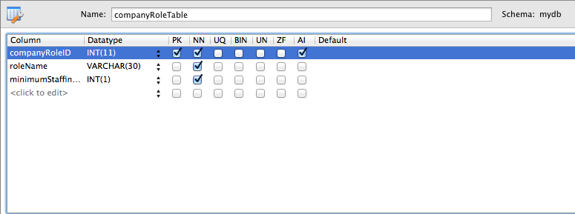

1. <?php
3. /* -----------------------------------------------------------------------------
4. * CONSTANTS
5. *
6. * These constants should be used when refering to the table and the fields
7. * within its records.
8. * ---------------------------------------------------------------------------*/
9. define("COMPANY_ROLE_TABLE", "companyRoleTable");
10. define("COMP_ROLE_ID", "companyRoleID");
11. define("COMP_ROLE_NAME", "roleName");
12. define("COMP_ROLE_MIN_STAFF", "minimumStaffingLevel");
14. /* ----------------------------------------------------------------------------
15. * Function CreateCompanyRoleTable
16. *
17. * This function creates the SQL statement needed to construct the table
18. * in the database.
19. *
20. * @return (bool)  True if table is created successfully, false otherwise.
21. * ---------------------------------------------------------------------------*/
23. **function** CreateCompanyRoleTable() {
24. $sql = "CREATE TABLE IF NOT EXISTS `mydb`.`companyRoleTable` (
25. `companyRoleID` INT NOT NULL AUTO_INCREMENT,
26. `roleName` VARCHAR(30) NOT NULL,
27. `minimumStaffingLevel` INT(1) NOT NULL,
28. PRIMARY KEY (`companyRoleID`));";
29. performSQL($sql);
30. }
32. /* ---------------------------------------------------------------------------
33. * Function CreateCompanyRole
34. *
35. * This function creates a new CompanyRole record in the
36. * table.
37. *
38. * $roleName (string) name of the role.
39. * $minStaffLevel (int) minimum number of staff that needs to be maintained.
40. *
41. * @return (array) If successful, an array is returned where each key represents
42. *                 a field in the record. If unsuccessful, the return will be
43. *                 NULL.
44. * ------------------------------------------------------------------------- */
46. **function** CreateCompanyRole($roleName, $minStaffLevel) {
47. $role = NULL;
48. //-------------------------------------------------------------------------
49. // Validate Input parameters
50. //-------------------------------------------------------------------------
51. $inputIsValid = TRUE;
52. $statusMessage = "";
53. **if** ($roleName == NULL) {
54. $statusMessage .= "Invalid Company Role Name.";
55. error_log("Invalid NULL name passed to CreateCompanyRole.");
56. $inputIsValid = FALSE;
57. }
59. **if** (isNullOrEmptyString($roleName)) {
60. $statusMessage .= "Company Role Name must be specified.";
61. error_log("Invalid roleName passed to CreateCompanyRole.");
62. $inputIsValid = FALSE;
63. }
65. **if** (!is_numeric($minStaffLevel)) {
66. $statusMessage .= "Minimum Staff Level must be numeric.";
67. error_log("Invalid minStaffLevel parameter passed to CreateCompanyRole.");
68. $inputIsValid = FALSE;
69. }

72. //-------------------------------------------------------------------------
73. // Only attempt to insert a record in the database if the input parameters
74. // are ok.
75. //-------------------------------------------------------------------------
76. **if** ($inputIsValid) {
77. // Create an array with each field required in the record.
78. $role[COMP_ROLE_ID] = NULL;
79. $role[COMP_ROLE_NAME] = $roleName;
80. $role[COMP_ROLE_MIN_STAFF] = $minStaffLevel;
82. $success = sqlInsertCompanyRole($role);
83. **if** (!$success) {
84. $statusMessage .= "Failed to add company role to the database.".
85. "Please contact your system administrator.";
86. error_log("Failed to create company Role. " . print_r($role));
87. $role = NULL;
88. }
89. **else**
90. {
91. $statusMessage .= "Company Role created successfully.";
92. }
94. }
95. GenerateStatus($inputIsValid, $statusMessage);
96. **return** $role;
97. }
99. /* -----------------------------------------------------------------------------
100. * Function sqlInsertCompanyRole
101. *
102. * This function constructs the SQL statement required to insert a new record
103. * into the companyRole table.
104. *
105. * &$role (array) Array containing all of the fields required for the record.
106. *
107. * @return (bool) TRUE if insert into database was successful, false otherwise.
108. *
109. * Note: If successful then the COMP_ROLE_ID entry in the
110. * array passed by the caller will be set to the ID of the record in the database.
111. * ---------------------------------------------------------------------------*/
113. **function** sqlInsertCompanyRole(&$role) {
114. $sql = "INSERT INTO companyroletable (roleName,minimumStaffingLevel) " .
115. "VALUES ('" . $role[COMP_ROLE_NAME] . "'," . $role[COMP_ROLE_MIN_STAFF] . ");";
117. $role[COMP_ROLE_ID] = performSQLInsert($sql);
118. **return** ($role[COMP_ROLE_ID] <> 0);
119. }
121. /* ----------------------------------------------------------------------------
122. * Function RetrieveCompanyRoleByID
123. *
124. * This function uses the ID supplied as a parameter to construct an SQL select
125. * statement and then performs this query, returning an array containing the key
126. * value pairs of the record (or NULL if no record is found matching the id).
127. *
128. * $id (int) id of the record to retrieve from the database..
129. *
130. * @return (array) array of key value pairs representing the fields in the
131. *                 record, or NULL if no record exists with the id supplied.
132. * ---------------------------------------------------------------------------*/
134. **function** RetrieveCompanyRoleByID($id) {
135. $filter[COMP_ROLE_ID] = $id;
136. $resultArray = performSQLSelect(COMPANY_ROLE_TABLE, $filter);
138. $result = NULL;
140. **if** (count($resultArray) == 1) {      //Check to see if record was found.
141. $result = $resultArray[0];
142. }
144. **return** $result;
145. }
147. /* -----------------------------------------------------------------------------
148. * Function RetrieveCompanyRoles
149. *
150. * This function constructs the SQL statement required to query the CompanyRole
151. * table.
152. *
153. * $filter (array) Optional parameter. If supplied, then the array should
154. *                 contain a set of key value pairs, where the keys correspond
155. *                 to one (or more) fields in the record (see constants at top
156. *                 of file) and the values correspond to the values to filter
157. *                 against (IE: The WHERE clause).
158. *
159. * @return (array) If successful, an array of arrays, where each element
160. *                 corresponds to a row from the query. If a failure occurs,
161. *                 return will be NULL.
162. * ---------------------------------------------------------------------------*/
164. **function** RetrieveCompanyRoles($filter = NULL) {
165. $inputIsValid = TRUE;
167. //--------------------------------------------------------------------------------
168. // Validate Input parameters
169. //--------------------------------------------------------------------------------
170. **if** ($filter <> NULL) {
171. **foreach** ($filter **as** $key => $value) {
172. **if** (strcmp($key, COMP_ROLE_ID) == 0) {
173. **if** (!is_numeric($value)) {
174. error_log("Invalid COMP_ROLE_ID of " . $value .
175. " passed to RetrieveCompanyRoles.");
176. $inputIsValid = FALSE;
177. }
178. } **else** **if** (strcmp($key, COMP_ROLE_NAME) == 0) {
179. **if** (isNullOrEmptyString($value)) {
180. error_log("Invalid COMP_ROLE_NAME of " . $value .
181. " passed to RetrieveCompanyRoles.");
182. $inputIsValid = FALSE;
183. }
184. } **else** **if** (strcmp($key, COMP_ROLE_MIN_STAFF) == 0) {
185. **if** (!is_numeric($value)) {
186. error_log("Invalid COMP_ROLE_MIN_STAFF of " . $value .
187. " passed to RetrieveCompanyRoles.");
188. $inputIsValid = FALSE;
189. }
190. } **else** {
191. error_log("Unknown Filter " . $key . " passed to RetrieveCompanyRoles.");
192. $inputIsValid = FALSE;
193. }
194. }
195. }
197. //--------------------------------------------------------------------------
198. // Only attempt to perform query in the database if the input parameters are
199. // ok.
200. //--------------------------------------------------------------------------
201. $result = NULL;
202. **if** ($inputIsValid) {
203. $result = performSQLSelect(COMPANY_ROLE_TABLE, $filter);
204. }
205. **return** $result;
206. }
208. /* -----------------------------------------------------------------------------
209. * Function UpdateCompanyRole
210. *
211. * This function constructs the SQL statement required to update a row in
212. * the CompanyRole table.
213. *
214. * $fields (array) array of key value pairs, where keys correspond to fields
215. *                 in the record (see constants at start of this file). Note,
216. *                 this array MUST provide the id of the record (COMP_ROLE_ID)
217. *                 and one or more other fields to be updated.
218. *
219. * @return (bool) TRUE if update succeeds. FALSE otherwise.
220. * ---------------------------------------------------------------------------*/
222. **function** UpdateCompanyRole($fields) {
223. //-------------------------------------------------------------------------
224. // Validate Input parameters
225. //-------------------------------------------------------------------------
226. $statusMessage="";
227. $inputIsValid = TRUE;
228. $validID = false;
229. $countOfFields = 0;
231. **foreach** ($fields **as** $key => $value) {
232. **if** ($key == COMP_ROLE_ID) {
233. $record = RetrieveCompanyRoleByID($value);
234. **if** ($record <> NULL) {
235. $validID = true;
236. $countOfFields++;
237. }
238. **else**
239. {
240. $statusMessage.= "Unable to locate Company Role in the database.";
241. error_log("No valid ID supplied in call to UpdateCompanyRole.");
242. $inputIsValid = FALSE;
243. }
244. } **else** **if** ($key == COMP_ROLE_NAME) {
245. $countOfFields++;
247. **if** (isNullOrEmptyString($value)) {
248. $statusMessage  .= "You must enter a company role name.";
249. error_log("Invalid COMP_ROLE_NAME passed to UpdateCompanyRole.");
250. $inputIsValid = FALSE;
251. }
252. } **else** **if** ($key == COMP_ROLE_MIN_STAFF) {
253. $countOfFields++;
255. **if** (!is_numeric($value)) {
256. $statusMessage  .= "You must enter a numeric value for minimum staff";
257. error_log("Invalid COMP_ROLE_MIN_STAFF passed to UpdateCompanyRole.");
258. $inputIsValid = FALSE;
259. }
260. } **else** {
261. $statusMessage  .= "Invalid field.";
262. error_log("Invalid field passed to UpdateCompanyRole. $key=" . $key);
263. $inputIsValid = FALSE;
264. }
265. }
267. **if** ($countOfFields < 2) {
268. $statusMessage  .= "You must alter at least one field before updating.";
269. error_log("Insufficent fields supplied in call to UpdateCompanyRole.");
270. $inputIsValid = FALSE;
271. }
273. //-------------------------------------------------------------------------
274. // Only attempt to update a record in the database if the input parameters
275. // are ok.
276. //-------------------------------------------------------------------------
277. $success = false;
279. **if** ($inputIsValid) {
280. $success = performSQLUpdate(COMPANY_ROLE_TABLE, COMP_ROLE_ID, $fields);
281. $statusMessage .= "Record has been updated successfully.";
282. }
284. GenerateStatus($inputIsValid, $statusMessage);
285. **return** $success;
286. }
288. /* ----------------------------------------------------------------------------
289. * Function DeleteCompanyRole
290. *
291. * This function constructs the SQL statement required to delete a row in
292. * the CompanyRole table.
293. *
294. * $ID(integer) ID of the record to be removed from the table. This should be set
295. *              to the COMP_ROLE_ID value of the record you wish to delete.
296. *
297. * @return (int) count of rows deleted. 0 means delete was unsuccessful.
298. * -------------------------------------------------------------------------- */
300. **function** DeleteCompanyRole($ID) {
301. $statusMessage = "";
302. $result = 0;
303. $record = RetrieveCompanyRoleByID($ID);
304. **if** ($record <> NULL) {
305. $filter[EMP_COMPANY_ROLE] = $ID;
306. $employees = RetrieveEmployees($filter);
308. **if** ($employees <> NULL) {
309. **foreach** ($employees **as** $employee) {
310. DeleteEmployee($employee[EMP_ID]);
311. }
312. }
314. $sql = "DELETE FROM companyroletable WHERE companyRoleID=" . $ID . ";";
315. $result = performSQL($sql);
316. $statusMessage = "Role Deleted.</br>";
317. GenerateStatus(true, $statusMessage);
318. }
319. **return** $result;
320. }
322. ?>

## Main Vacation Request Table

### File: MainVacationRequestTable.php

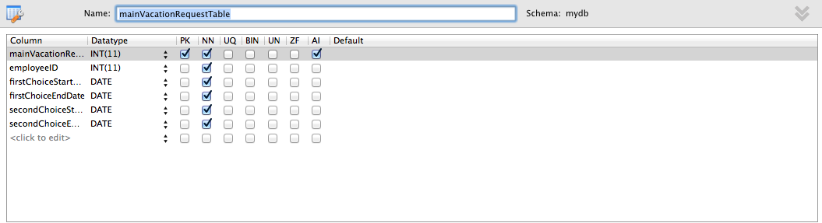

1. <?php
3. /* -----------------------------------------------------------------------------
4. * CONSTANTS
5. *
6. * These constants should be used when refering to the table and the fields
7. * within its records.
8. * ---------------------------------------------------------------------------*/
9. define("MAIN_VACATION_REQUEST_TABLE", "mainVacationRequestTable");
10. define("MAIN_VACATION_REQ_ID", "mainVacationRequestID");
11. define("MAIN_VACATION_EMP_ID", "employeeID");
12. define("MAIN_VACATION_1ST_START", "firstChoiceStartDate");
13. define("MAIN_VACATION_1ST_END", "firstChoiceEndDate");
14. define("MAIN_VACATION_2ND_START", "secondChoiceStartDate");
15. define("MAIN_VACATION_2ND_END", "secondChoiceEndDate");
17. /* -----------------------------------------------------------------------------
18. * Function CreateMainVacationRequestTable
19. *
20. * This function creates the SQL statement needed to construct the table
21. * in the database.
22. *
23. * @return (bool)  True if table is created successfully, false otherwise.
24. * ---------------------------------------------------------------------------*/
26. **function** CreateMainVacationRequestTable() {
27. $sql = "CREATE TABLE IF NOT EXISTS `mydb`.`mainVacationRequestTable` (
28. `mainVacationRequestID` INT NOT NULL AUTO_INCREMENT,
29. `employeeID` INT NOT NULL,
30. `firstChoiceStartDate` DATE NOT NULL,
31. `firstChoiceEndDate` DATE NOT NULL,
32. `secondChoiceStartDate` DATE NOT NULL,
33. `secondChoiceEndDate` DATE NOT NULL,
34. PRIMARY KEY (`mainVacationRequestID`),
35. INDEX `fk_mainVacationRequest_Employee1_idx` (`employeeID` ASC),
36. CONSTRAINT `fk_mainVacationRequest_Employee1`
37. FOREIGN KEY (`employeeID`)
38. REFERENCES `mydb`.`EmployeeTable` (`employeeID`)
39. ON DELETE NO ACTION
40. ON UPDATE NO ACTION);";
42. performSQL($sql);
43. }
45. /* ----------------------------------------------------------------------------
46. * Function CreateMainVacationRequest
47. *
48. * This function creates a new MainVacationRequestrecord in the table.
49. *
50. * $employeeID (int)       EmployeeID that this request relates to.
51. * $firstChoiceStartDate (string)  string in the form YYYY-MM-DD.
52. *                                 start date of the first choice request.
53. * $firstChoiceEndDate (string)  string in the form YYYY-MM-DD.
54. *                               end date of the first choice request.
55. * $secondChoiceStartDate (string)  string in the form YYYY-MM-DD.
56. *                                 start date of the second choice request.
57. * $secondChoiceEndDate (string)  string in the form YYYY-MM-DD.
58. *                               end date of the second choice request.
59. *
60. * @return (array) If successful, an array is returned where each key represents
61. *                 a field in the record. If unsuccessful, the return will be
62. *                 NULL.
63. * ---------------------------------------------------------------------------*/
65. **function** CreateMainVactionRequest($employeeID, $firstChoiceStartDate,
66. $firstChoiceEndDate, $secondChoiceStartDate,
67. $secondChoiceEndDate)
68. {
69. $statusMessage = "";
70. $request = NULL;
71. //-------------------------------------------------------------------------
72. // Validate Input parameters
73. //-------------------------------------------------------------------------
74. $inputIsValid = TRUE;
76. $employee = RetrieveEmployeeByID($employeeID);
78. **if** ($employee == NULL) {
79. $statusMessage.="Unrecognised Employee ID.</br>";
80. error_log("Invalid employeeID passed to CreateMainVacationRequest." .
81. " value=" . $employeeID);
82. $inputIsValid = FALSE;
83. }
85. **if** (!isValidDate($firstChoiceStartDate)) {
86. $statusMessage.="1st Choice Start Date is not a valid Date.</br>";
87. error_log("Invalid firstChoiceStartDate passed to CreateMainVacationRequest." .
88. " value=" . $firstChoiceStartDate);
89. $inputIsValid = FALSE;
90. }
92. **if** (!isValidDate($firstChoiceEndDate)) {
93. $statusMessage.="1st Choice Finish Date is not a valid Date.</br>";
94. error_log("Invalid firstChoiceEndDate passed to CreateMainVacationRequest." .
95. " value=" . $firstChoiceEndDate);
96. $inputIsValid = FALSE;
97. }
99. **if** (!isValidDate($secondChoiceStartDate)) {
100. $statusMessage.="2nd Choice Start Date is not a valid Date.</br>";
101. error_log("Invalid secondChoiceStartDate passed to CreateMainVacationRequest." .
102. " value=" . $secondChoiceStartDate);
103. $inputIsValid = FALSE;
104. }
106. **if** (!isValidDate($secondChoiceEndDate)) {
107. $statusMessage.="2nd Choice Finish Date is not a valid Date.</br>";
108. error_log("Invalid secondChoiceEndDate passed to CreateMainVacationRequest." .
109. " value=" . $secondChoiceEndDate);
110. $inputIsValid = FALSE;
111. }
113. **if** (strtotime($firstChoiceEndDate) < strtotime($firstChoiceStartDate))
114. {
115. $statusMessage.="1st Choice End Date is before 1st Choice Start Date.</br>";
116. error_log("First Choice End Date is before First Choice Start Date.");
117. $inputIsValid = FALSE;
118. }
120. **if** (strtotime($secondChoiceEndDate) < strtotime($secondChoiceStartDate))
121. {
122. $statusMessage.="2nd Choice End Date is before 2nd Choice Start Date.</br>";
123. error_log("Second Choice End Date is before Second Choice Start Date.");
124. $inputIsValid = FALSE;
125. }

128. //-------------------------------------------------------------------------
129. // Only attempt to insert a record in the database if the input parameters
130. // are ok.
131. //-------------------------------------------------------------------------
132. **if** ($inputIsValid) {
133. $request[MAIN_VACATION_REQ_ID] = NULL;
134. $request[MAIN_VACATION_EMP_ID] = $employeeID;
135. $request[MAIN_VACATION_1ST_START] = $firstChoiceStartDate;
136. $request[MAIN_VACATION_1ST_END] = $firstChoiceEndDate;
137. $request[MAIN_VACATION_2ND_START] = $secondChoiceStartDate;
138. $request[MAIN_VACATION_2ND_END] = $secondChoiceEndDate;
140. $success = sqlInsertMainVacationRequest($request);
141. **if** (!$success) {
142. $inputIsValid = false;
144. $statusMessage.="Unexpected error encountered with database. ".
145. "Contact your system administrator.</br>";
146. error_log("Failed to create main vacation request. ");
147. $request = NULL;
148. }
149. **else**
150. {
151. //-----------------------------------------------------------------
152. // Now that Main Vacation Request has been created, we need to
153. // update the employee record to reference it. First, chcek to see
154. // if the employee already has a main vacation request (in which
155. //  case we need to deltete it.
156. //-----------------------------------------------------------------
157. **if** ($employee[EMP_MAIN_VACATION_REQ_ID] <> NULL) {
158. $count = DeleteMainVacationRequest(
159. $employee[EMP_MAIN_VACATION_REQ_ID]);
160. **if** ($count == 0) {
161. $inputIsValid = false;
162. $statusMessage.="Unexpected error encountered when removing".
163. " Main Vacation Request from Database. ".
164. "Contact your system administrator.</br>";
165. error_log("Failed to delete main vacation request. ID=" .
166. $employee[EMP_MAIN_VACATION_REQ_ID]);
167. }
168. }
170. //-----------------------------------------------------------------
171. // Now update the employee record to reference the new
172. // MainVacationRequest record.
173. //-----------------------------------------------------------------
174. $employee[EMP_MAIN_VACATION_REQ_ID] = $request[MAIN_VACATION_REQ_ID];
175. $success = UpdateEmployee($employee);
176. **if** (!$success) {
177. $statusMessage.="Failed to update employee to reference new ".
178. "main vacation request.";
179. error_log("Failed to update employee to reference new " .
180. "main vacation request.");
181. $inputIsValid = false;
182. }
183. **else**
184. {
185. $statusMessage .= "Main Vacation Request successfully created.";
186. }
187. }
188. }
190. GenerateStatus($inputIsValid, $statusMessage);
191. **return** $request;
192. }
194. /* ----------------------------------------------------------------------------
195. * Function sqlInsertMainVacationRequest
196. *
197. * This function constructs the SQL statement required to insert a new record
198. * into the mainVacationRequest table.
199. *
200. * &$request(array) Array containing all of the fields required for the record.
201. *
202. * @return (bool) TRUE if insert into database was successful, false otherwise.
203. *
204. * Note: If successful then the MAIN_VACATION_REQ_ID entry in the
205. * array passed by the caller will be set to the ID of the record in the
206. * database.
207. * ---------------------------------------------------------------------------*/
209. **function** sqlInsertMainVacationRequest(&$request) {
210. $sql = "INSERT INTO mainVacationRequestTable (employeeID,".
211. "firstChoiceStartDate,firstChoiceEndDate," .
212. "secondChoiceStartDate,secondChoiceEndDate) " .
213. "VALUES ('" . $request[MAIN_VACATION_EMP_ID] .
214. "','" . $request[MAIN_VACATION_1ST_START] .
215. "','" . $request[MAIN_VACATION_1ST_END] .
216. "','" . $request[MAIN_VACATION_2ND_START] .
217. "','" . $request[MAIN_VACATION_2ND_END] . "');";
218. $request[MAIN_VACATION_REQ_ID] = performSQLInsert($sql);
219. **return** $request[MAIN_VACATION_REQ_ID] <> 0;
220. }
222. /* -----------------------------------------------------------------------------
223. * Function RetrieveMainVacationRequestByID
224. *
225. * This function uses the ID supplied as a parameter to construct an SQL select
226. * statement and then performs this query, returning an array containing the key
227. * value pairs of the record (or NULL if no record is found matching the id).
228. *
229. * $id (int) id of the record to retrieve from the database..
230. *
231. * @return (array) array of key value pairs representing the fields in the
232. *                 record, or NULL if no record exists with the id supplied.
233. * ---------------------------------------------------------------------------*/
235. **function** RetrieveMainVacationRequestByID($id) {
236. $filter[MAIN_VACATION_REQ_ID] = $id;
237. $resultArray = performSQLSelect(MAIN_VACATION_REQUEST_TABLE, $filter);
239. $result = NULL;
241. **if** (count($resultArray) == 1) {      //Check to see if record was found.
242. $result = $resultArray[0];
243. }
245. **return** $result;
246. }
248. /* ----------------------------------------------------------------------------
249. * Function RetrieveMainVacationRequests
250. *
251. * This function constructs the SQL statement required to query the
252. * MainVacationRequest table.
253. *
254. * $filter (array) Optional parameter. If supplied, then the array should
255. *                 contain a set of key value pairs, where the keys correspond
256. *                 to one (or more) fields in the record (see constants at top
257. *                 of file) and the values correspond to the values to filter
258. *                 against (IE: The WHERE clause).
259. *
260. * @return (array) If successful, an array of arrays, where each element
261. *                 corresponds to a row from the query. If a failure occurs,
262. *                 return will be NULL.
263. * ---------------------------------------------------------------------------*/
265. **function** RetrieveMainVacationRequests($filter = NULL) {
266. $inputIsValid = TRUE;
268. //-------------------------------------------------------------------------
269. // Validate Input parameters
270. //-------------------------------------------------------------------------
271. **if** ($filter <> NULL) {
272. **foreach** ($filter **as** $key => $value) {
273. **if** (strcmp($key, MAIN_VACATION_REQ_ID) == 0) {
274. **if** (!is_numeric($value)) {
275. error_log("Invalid MAIN_VACATION_REQ_ID of " . $value .
276. " passed to RetrieveMainVacationRequests.");
277. $inputIsValid = FALSE;
278. }
279. } **else** **if** (strcmp($key, MAIN_VACATION_EMP_ID) == 0) {
280. **if** (!is_numeric($value)) {
281. error_log("Invalid MAIN_VACATION_EMP_ID of " . $value .
282. " passed to RetrieveMainVacationRequests.");
283. $inputIsValid = FALSE;
284. }
285. } **else** **if** (strcmp($key, MAIN_VACATION_1ST_START) == 0) {
286. **if** (!isValidDate($value)) {
287. error_log("Invalid MAIN_VACATION_1ST_START of " . $value .
288. " passed to RetrieveMainVacationRequests.");
289. $inputIsValid = FALSE;
290. }
291. } **else** **if** (strcmp($key, MAIN_VACATION_1ST_END) == 0) {
292. **if** (!isValidDate($value)) {
293. error_log("Invalid MAIN_VACATION_1ST_END of " . $value .
294. " passed to RetrieveMainVacationRequests.");
295. $inputIsValid = FALSE;
296. }
297. } **else** **if** (strcmp($key, MAIN_VACATION_2ND_START) == 0) {
298. **if** (!isValidDate($value)) {
299. error_log("Invalid MAIN_VACATION_2ND_START of " . $value .
300. " passed to RetrieveMainVacationRequests.");
301. $inputIsValid = FALSE;
302. }
303. } **else** **if** (strcmp($key, MAIN_VACATION_2ND_END) == 0) {
304. **if** (!isValidDate($value)) {
305. error_log("Invalid MAIN_VACATION_2ND_END of " . $value .
306. " passed to RetrieveMainVacationRequests.");
307. $inputIsValid = FALSE;
308. }
309. } **else** {
310. error_log("Unknown Filter " . $key .
311. " passed to RetrieveMainVacationRequests.");
312. $inputIsValid = FALSE;
313. }
314. }
315. }
317. //-------------------------------------------------------------------------
318. // Only attempt to perform query in the database if the input parameters
319. // are ok.
320. //-------------------------------------------------------------------------
321. $result = NULL;
322. **if** ($inputIsValid) {
323. $result = performSQLSelect(MAIN_VACATION_REQUEST_TABLE, $filter);
324. }
325. **return** $result;
326. }
328. /* ----------------------------------------------------------------------------
329. * Function UpdateMainVacationRequest
330. *
331. * This function constructs the SQL statement required to update a row in
332. * the MainVacationRequest table.
333. *
334. * $fields (array) array of key value pairs, where keys correspond to fields
335. *                 in the record (see constants at start of this file). Note,
336. *                 this array MUST provide the id of the record
337. *                 (MAIN_VACATION_REQ_ID) and one or more other fields to be
338. *                 updated.
339. *
340. * @return (bool) TRUE if update succeeds. FALSE otherwise.
341. * ------------------------------------------------------------------------- */
343. **function** UpdateMainVacactionRequest($fields) {
344. $success = false;
345. $statusMessage = "";
346. //-------------------------------------------------------------------------
347. // Validate Input parameters
348. //--------------------------------------------------------------------------
349. $inputIsValid = TRUE;
350. $validID = false;
351. $countOfFields = 0;
353. **foreach** ($fields **as** $key => $value) {
354. **if** ($key == MAIN_VACATION_REQ_ID) {
355. $record = RetrieveMainVacationRequestByID($value);
356. **if** ($record <> NULL) {
357. $validID = true;
358. $countOfFields++;
359. }
360. } **else** **if** ($key == MAIN_VACATION_EMP_ID) {
361. $countOfFields++;
363. $record = RetrieveEmployeeByID($value);
364. **if** ($record == NULL) {
365. $statusMessage .="Invalid Main Vacation Employee ID</br>";
366. error_log("Invalid MAIN_VACATION_EMP_ID passed to " .
367. "UpdateMainVacationRequest.");
368. $inputIsValid = FALSE;
369. }
370. } **else** **if** ($key == MAIN_VACATION_1ST_START) {
371. $countOfFields++;
373. **if** (!isValidDate($value)) {
374. $statusMessage .="Invalid 1st Choice Start Date</br>";
375. error_log("Invalid MAIN_VACATION_1ST_START passed to ".
376. "UpdateMainVacationRequest.");
377. $inputIsValid = FALSE;
378. }
379. } **else** **if** ($key == MAIN_VACATION_1ST_END) {
380. $countOfFields++;
382. **if** (!isValidDate($value)) {
383. $statusMessage .="Invalid 1st Choice Finish Date/br>";
384. error_log("Invalid MAIN_VACATION_1ST_END passed to ".
385. "UpdateMainVacationRequest.");
386. $inputIsValid = FALSE;
387. }
388. } **else** **if** ($key == MAIN_VACATION_2ND_START) {
389. $countOfFields++;
391. **if** (!isValidDate($value)) {
392. $statusMessage .="Invalid 2nd Choice Start Date/br>";
393. error_log("Invalid MAIN_VACATION_2ND_START passed to ".
394. "UpdateMainVacationRequest.");
395. $inputIsValid = FALSE;
396. }
397. } **else** **if** ($key == MAIN_VACATION_2ND_END) {
398. $countOfFields++;
400. **if** (!isValidDate($value)) {
401. $statusMessage .="Invalid 2nd Choice Finish Date/br>";
402. error_log("Invalid MAIN_VACATION_2ND_END passed to ".
403. "UpdateMainVacationRequest.");
404. $inputIsValid = FALSE;
405. }
406. } **else** {
407. $statusMessage .="Invalid Field encountered./br>";
408. error_log("Invalid field passed to ".
409. "UpdateMainVacationRequest. $key=" . $key);
410. $inputIsValid = FALSE;
411. }
412. }
414. $firstChoiceStartDate = $fields[MAIN_VACATION_1ST_START];
415. $firstChoiceEndDate = $fields[MAIN_VACATION_1ST_END];
416. $secondChoiceStartDate = $fields[MAIN_VACATION_2ND_START];
417. $secondChoiceEndDate = $fields[MAIN_VACATION_2ND_END];

420. **if** (strtotime($firstChoiceEndDate) < strtotime($firstChoiceStartDate))
421. {
422. $statusMessage.="1st Choice End Date is before 1st Choice Start Date.</br>";
423. error_log("First Choice End Date is before First Choice Start Date.");
424. $inputIsValid = FALSE;
425. }
427. **if** (strtotime($secondChoiceEndDate) < strtotime($secondChoiceStartDate))
428. {
429. $statusMessage.="2nd Choice End Date is before 2nd Choice Start Date.</br>";
430. error_log("Second Choice End Date is before Second Choice Start Date.");
431. $inputIsValid = FALSE;
432. }
434. **if** (!$validID) {
435. $statusMessage .="No valid record ID found/br>";
436. error_log("No valid ID supplied in call to UpdateMainVacationRequest.");
437. $inputIsValid = FALSE;
438. }
440. **if** ($countOfFields < 2) {
441. $statusMessage .="You must modify at least one of the fields of the record./br>";
442. error_log("Insufficent fields supplied in call to UpdateMainVacationRequest.");
443. $inputIsValid = FALSE;
444. }
446. //--------------------------------------------------------------------------
447. // Only attempt to update a record in the database if the input parameters
448. // are ok.
449. //--------------------------------------------------------------------------
450. **if** ($inputIsValid) {
451. $success = performSQLUpdate(MAIN_VACATION_REQUEST_TABLE,
452. MAIN_VACATION_REQ_ID, $fields);
453. **if** ($success)
454. {
455. $statusMessage.="Record successfully modified.";
456. }
457. **else**
458. {
459. $inputIsValid = false;
460. $statusMessage.="Error encountered when updating the database. ".
461. "Contact system administrator.</br>";
462. }
463. }
464. GenerateStatus($inputIsValid, $statusMessage);
465. **return** $success;
466. }
468. /* ----------------------------------------------------------------------------
469. * Function DeleteMainVacationRequest
470. *
471. * This function constructs the SQL statement required to delete a row in
472. * the MainVacationRequest table.
473. *
474. * $ID(integer) ID of the record to be removed from the table. This should be
475. *              set to the  MAIN_VACATION_REQ_ID value of the record you wish to
476. *              delete.
477. *
478. * @return (int) count of rows deleted. 0 means delete was unsuccessful.
479. * --------------------------------------------------------------------------*/
481. **function** DeleteMainVacationRequest($ID) {
482. $result = 0;
483. $record = RetrieveMainVacationRequestByID($ID);
485. **if** ($record <> NULL) {
486. $employee = RetrieveEmployeeByID($record[MAIN_VACATION_EMP_ID]);
487. **if** ($employee) {
488. $employee[EMP_MAIN_VACATION_REQ_ID] = NULL;
489. UpdateEmployee($employee);
490. }
492. $sql = "DELETE FROM mainVacationRequestTable WHERE mainVacationRequestID=".
493. $ID . ";";
494. $result = performSQL($sql);
495. }
496. **return** $result;
497. }
498. ?>

## Employee Table

### File: EmployeeTable.php

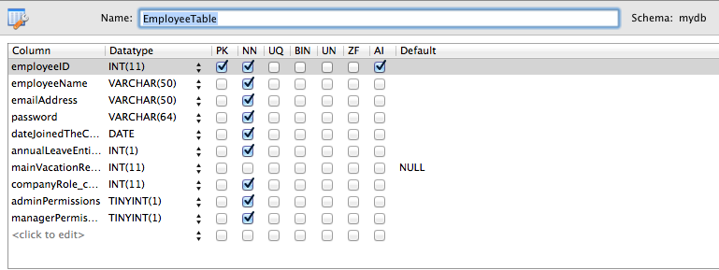

1. <?php
3. /* ----------------------------------------------------------------------------
4. * CONSTANTS
5. *
6. * These constants should be used when refering to the table and the fields
7. * within its records.
8. * ---------------------------------------------------------------------------*/
9. define("EMPLOYEE_TABLE", "employeeTable");
10. define("EMP_ID", "employeeID");
11. define("EMP_NAME", "employeeName");
12. define("EMP_EMAIL", "emailAddress");
13. define("EMP_PASSWORD", "password");
14. define("EMP_DATEJOINED", "dateJoinedTheCompany");
15. define("EMP_LEAVE_ENTITLEMENT", "annualLeaveEntitlement");
16. define("EMP_MAIN_VACATION_REQ_ID", "mainVacationRequestID");
17. define("EMP_COMPANY_ROLE", "companyRole_companyRoleID");
18. define("EMP_ADMIN_PERM","adminPermissions");
19. define("EMP_MANAGER_PERM","managerPermissions");

22. /* -----------------------------------------------------------------------------
23. * Function IsValidPassword
24. *
25. * This function checks the supplied password string to determine whether it
26. * conforms to the following password rules.
27. *
28. * 1. Must be a minimum of 6 characters in length.
29. * 2. Must contain one numeric character.
30. * 3. Must contain at least one lower case character.
31. * 4. Must contain at least one upper case character.
32. *
33. * $password (string) the password to check.
34. * @return (array)  Array of errors. If array is empty (count(array)==0) then no
35. *                  errors occured. Otherwise, each element of the array contains
36. *                  a description of the error(s).
37. * -------------------------------------------------------------------------- */
38. **function** isValidPassword($password)
39. {
40. //Empty error array for the errors if any
41. $error = **array**();
43. //1. Must be a minimum of 6 characters in length.
44. **if**( strlen($password) < 6 )
45. {
46. $error[] = 'Password need to have at least 6 characters!';
47. }
49. //2. Must contain one numeric character.
50. **if**( !preg_match("#[0-9]+#", $password) )
51. {
52. $error[] = 'Password must include at least one number!';
53. }
55. //3. Must contain at least one lower case character.
56. **if**( !preg_match("#[a-z]+#", $password) )
57. {
58. $error[] = 'Password must include at least one lowercase letter!';
59. }
61. //4. Must contain at least one upper case character.
62. **if**( !preg_match("#[A-Z]+#", $password) )
63. {
64. $error[] = 'Password must include at least one uppercase letter!';
65. }
67. **return** $error;
68. }

71. /* ----------------------------------------------------------------------------
72. * Function CreateEmployeeTable
73. *
74. * This function creates the SQL statement needed to construct the table
75. * in the database.
76. *
77. * @return (bool)  True if table is created successfully, false otherwise.
78. * -------------------------------------------------------------------------- */
80. **function** CreateEmployeeTable() {
81. $sql = "CREATE TABLE IF NOT EXISTS `mydb`.`EmployeeTable` (
82. `employeeID` INT NOT NULL AUTO_INCREMENT,
83. `employeeName` VARCHAR(50) NOT NULL,
84. `emailAddress` VARCHAR(50) NOT NULL,
85. `password` VARCHAR(64) NOT NULL,
86. `dateJoinedTheCompany` DATE NOT NULL,
87. `annualLeaveEntitlement` INT(1) NOT NULL,
88. `mainVacationRequestID` INT NULL,
89. `companyRole_companyRoleID` INT NOT NULL,
90. `adminPermissions` TINYINT(1) NOT NULL,
91. `managerPermissions` TINYINT(1) NOT NULL,
92. PRIMARY KEY (`employeeID`),
93. INDEX `fk_Employee_companyRole1_idx` (`companyRole_companyRoleID` ASC),
94. CONSTRAINT `fk_Employee_companyRole1`
95. FOREIGN KEY (`companyRole_companyRoleID`)
96. REFERENCES `mydb`.`companyRoleTable` (`companyRoleID`)
97. ON DELETE NO ACTION
98. ON UPDATE NO ACTION);";
100. performSQL($sql);
101. }
103. /* ----------------------------------------------------------------------------
104. * Function CreateEmployee
105. *
106. * This function creates a new Employee record in the table.
107. *
108. * $employeeName (string)  Name of the employee
109. * $emailAddress (string)  Email address of the employee
110. * $password (string)      Password for the employee
111. * $dateJoinedTheCompany (string) Date joined the company. Must be in the form
112. *                                YYYY-MM-DD
113. * $annualLeaveEntitlement (int) Number of days annual leave that the employee
114. *                               is entitled to.
115. * $mainVacationRequestID (int) ID of the main Vacation Request record
116. *                         associated with this employee. Note this parameter
117. *                         may be set to NULL if the employee has no
118. *                         mainVacationRequest at time of creation.
119. * $companyRoleID (int) ID of the company role record associated with this
120. *                      employee.
121. *
122. * @return (array) If successful, an array is returned where each key represents
123. *                 a field in the record. If unsuccessful, the return will be NULL.
124. * -------------------------------------------------------------------------- */
126. **function** CreateEmployee($employeeName, $emailAddress, $password,
127. $dateJoinedTheCompany, $annualLeaveEntitlement,
128. $mainVacationRequestID, $companyRoleID,
129. $isAdministrator = 0, $isManager =0) {
131. $statusMessage = "";
132. $employee = NULL;
133. //--------------------------------------------------------------------------
134. // Validate Input parameters
135. //--------------------------------------------------------------------------
136. $inputIsValid = TRUE;
138. **if** (isNullOrEmptyString($employeeName)) {
139. $statusMessage .= "Employee Name can not be blank.<br/>";
140. error_log("Invalid employeeName passed to CreateEmployee.");
141. $inputIsValid = FALSE;
142. }
144. **if** (!filter_var($emailAddress, FILTER_VALIDATE_EMAIL)) {
145. $statusMessage .= "Email address given is not a valid email format.<br/>";
146. error_log("Invalid email address passed to CreateEmployee.");
147. $inputIsValid = FALSE;
148. }
150. $errorArray = isValidPassword($password);
152. **if** (count($errorArray) <> 0)
153. {
154. **foreach** ($errorArray **as** $key=>$value)
155. {
156. $statusMessage .= $value."<br/>";
157. error_log($value);
158. }
159. $inputIsValid = FALSE;
160. }
162. **if** (!isValidDate($dateJoinedTheCompany)) {
163. $statusMessage .= "Value given for Date joined the company is not a ".
164. "valid date.<br/>";
165. error_log("Invalid dateJoinedTheCompany passed to CreateEmployee.");
166. $inputIsValid = FALSE;
167. }
169. **if** (!is_numeric($annualLeaveEntitlement)) {
170. $statusMessage .= "Please enter a valid value for annual leave ".
171. "entitlement.<br/>";
172. error_log("Invalid annualLeaveEntitlement passed to CreateEmployee.");
173. $inputIsValid = FALSE;
174. }
176. **if** ($mainVacationRequestID <> NULL) {
177. $record = RetrieveMainVacationRequestByID($mainVacationRequestID);
179. **if** ($record == NULL) {
180. $statusMessage .= "Main Vacation Request ID does not exist in the ".
181. "database.<br/>";
182. error_log("Invalid mainVacationRequestID passed to CreateEmployee.");
183. $inputIsValid = FALSE;
184. }
185. }
187. $record = RetrieveCompanyRoleByID($companyRoleID);
189. **if** ($record == NULL) {
190. $statusMessage .= "Company Role ID does not exist in the database.<br/>";
191. error_log("Invalid companyRoleID passed to CreateEmployee.");
192. $inputIsValid = FALSE;
193. }
195. //Ensure email address doesn't already exist in the database.
196. $filter[EMP_EMAIL] = $emailAddress;
197. $result = RetrieveEmployees($filter);
199. **if** ($result <> NULL)
200. {
201. $statusMessage .= "Unable to create record as a user with email address "
202. ."$emailAddress already exists.<br/>";
203. error_log("Unable to create record as a user with email address "
204. ."$emailAddress already exists");
205. $inputIsValid = FALSE;
206. }
208. //--------------------------------------------------------------------------
209. // Only attempt to insert a record in the database if the input parameters
210. // are ok.
211. //--------------------------------------------------------------------------
212. **if** ($inputIsValid) {
213. // Create an array with each field required in the record.
214. $employee[EMP_ID] = NULL;
215. $employee[EMP_NAME] = $employeeName;
216. $employee[EMP_EMAIL] = $emailAddress;
218. $encryptedPassword = md5(md5($emailAddress).$password);
220. $employee[EMP_PASSWORD] = $encryptedPassword;
221. $employee[EMP_DATEJOINED] = $dateJoinedTheCompany;
222. $employee[EMP_LEAVE_ENTITLEMENT] = $annualLeaveEntitlement;
223. $employee[EMP_MAIN_VACATION_REQ_ID] = $mainVacationRequestID;
224. $employee[EMP_COMPANY_ROLE] = $companyRoleID;
225. $employee[EMP_ADMIN_PERM] = $isAdministrator;
226. $employee[EMP_MANAGER_PERM] = $isManager;
228. $success = sqlInsertEmployee($employee);
229. **if** (!$success) {
230. $statusMessage .= "Unexpected error when inserting the record to ".
231. "the database.<br/>";
232. error_log("Failed to create Employee. " . print_r($employee));
233. $employee = NULL;
234. $inputIsValid = false;
235. }
236. **else**
237. {
238. $statusMessage = "Record Created Successfully.";
239. }
240. }
242. GenerateStatus($inputIsValid, $statusMessage);
243. **return** $employee;
244. }
246. /* ----------------------------------------------------------------------------
247. * Function sqlInsertEmployee
248. *
249. * This function constructs the SQL statement required to insert a new record
250. * into the employee table.
251. *
252. * &$employee(array) Array containing all of the fields required for the record.
253. *
254. * @return (bool) TRUE if insert into database was successful, false otherwise.
255. *
256. * Note: If successful then the EMP_ID entry in the
257. * array passed by the caller will be set to the ID of the record in the
258. * database.
259. * ---------------------------------------------------------------------------*/
261. **function** sqlInsertEmployee(&$employee) {
262. $sql = "INSERT INTO EmployeeTable (employeeName,emailAddress,password," .
263. "annualLeaveEntitlement,dateJoinedTheCompany,".
264. "companyRole_companyRoleID,adminPermissions,managerPermissions) " .
265. "VALUES ('".$employee[EMP_NAME]."','". $employee[EMP_EMAIL]. "','"
266. . $employee[EMP_PASSWORD] . "','".$employee[EMP_LEAVE_ENTITLEMENT] .
267. "','".$employee[EMP_DATEJOINED]."','".$employee[EMP_COMPANY_ROLE] .
268. "','".$employee[EMP_ADMIN_PERM]."','".$employee[EMP_MANAGER_PERM]."');";
270. $employee[EMP_ID] = performSQLInsert($sql);
271. **return** $employee[EMP_ID] <> 0;
272. }
274. /* ----------------------------------------------------------------------------
275. * Function RetrieveEmployeeByID
276. *
277. * This function uses the ID supplied as a parameter to construct an SQL select
278. * statement and then performs this query, returning an array containing the key
279. * value pairs of the record (or NULL if no record is found matching the id).
280. *
281. * $id (int) id of the record to retrieve from the database..
282. *
283. * @return (array) array of key value pairs representing the fields in the
284. *                  record, or NULL if no record exists with the id supplied.
285. * ---------------------------------------------------------------------------*/
287. **function** RetrieveEmployeeByID($id) {
288. $filter[EMP_ID] = $id;
289. $resultArray = performSQLSelect(EMPLOYEE_TABLE, $filter);
291. $result = NULL;
293. **if** (count($resultArray) == 1) {      //Check to see if record was found.
294. $result = $resultArray[0];
295. }
297. **return** $result;
298. }
300. /* ----------------------------------------------------------------------------
301. * Function RetrieveEmployees
302. *
303. * This function constructs the SQL statement required to query the employees
304. * table.
305. *
306. * $filter (array) Optional parameter. If supplied, then the array should
307. *                 contain a set of key value pairs, where the keys correspond â‰ˆ
308. *                 contain a set in the record (see constants at top of file)
309. *                 and the values correspond to the values to filter against
310. *                 (IE: The WHERE clause).
311. *
312. * @return (array) If successful, an array of arrays, where each element
313. *                 corresponds to a row from the query. If a failure occurs,
314. *                 return will be NULL.
315. * ---------------------------------------------------------------------------*/
317. **function** RetrieveEmployees($filter = NULL) {
318. $inputIsValid = TRUE;
320. //-------------------------------------------------------------------------
321. // Validate Input parameters
322. //-------------------------------------------------------------------------
323. **if** ($filter <> NULL) {
324. **foreach** ($filter **as** $key => $value) {
325. **if** (strcmp($key, EMP_ID) == 0) {
326. **if** (!is_numeric($value)) {
327. error_log("Invalid EMP_ID of " . $value .
328. " passed to RetrieveEmployees.");
329. $inputIsValid = FALSE;
330. }
331. } **else** **if** (strcmp($key, EMP_NAME) == 0) {
332. **if** (isNullOrEmptyString($value)) {
333. error_log("Invalid EMP_NAME passed to RetrieveEmployees.");
334. $inputIsValid = FALSE;
335. }
336. } **else** **if** (strcmp($key, EMP_EMAIL) == 0) {
337. **if** (!filter_var($value, FILTER_VALIDATE_EMAIL)) {
338. error_log("Invalid EMP_EMAIL of " . $value .
339. " passed to RetrieveEmployees.");
340. $inputIsValid = FALSE;
341. }
342. } **else** **if** (strcmp($key, EMP_PASSWORD) == 0) {
343. **if** (isNullOrEmptyString($value)) {
344. error_log("Invalid EMP_PASSWORD passed to RetrieveEmployees.");
345. $inputIsValid = FALSE;
346. }
347. } **else** **if** (strcmp($key, EMP_DATEJOINED) == 0) {
348. **if** (!isValidDate($value)) {
349. error_log("Invalid EMP_DATEJOINED of " . $value .
350. " passed to RetrieveEmployees.");
351. $inputIsValid = FALSE;
352. }
353. } **else** **if** (strcmp($key, EMP_LEAVE_ENTITLEMENT) == 0) {
354. **if** (!is_numeric($value)) {
355. error_log("Invalid EMP_LEAVE_ENTITLEMENT of " . $value .
356. " passed to RetrieveEmployees.");
357. $inputIsValid = FALSE;
358. }
359. } **else** **if** (strcmp($key, EMP_MAIN_VACATION_REQ_ID) == 0) {
360. **if** (!is_numeric($value)) {
361. error_log("Invalid EMP_MAIN_VACATION_REQ_ID of " . $value .
362. " passed to RetrieveEmployees.");
363. $inputIsValid = FALSE;
364. }
365. } **else** **if** (strcmp($key, EMP_COMPANY_ROLE) == 0) {
366. **if** (!is_numeric($value)) {
367. error_log("Invalid EMP_COMPANY_ROLE of " . $value .
368. " passed to RetrieveEmployees.");
369. $inputIsValid = FALSE;
370. }
371. } **else** {
372. error_log("Unknown Filter " . $key . " passed to RetrieveEmployees.");
373. $inputIsValid = FALSE;
374. }
375. }
376. }
378. //--------------------------------------------------------------------------
379. // Only attempt to perform query in the database if the input parameters
380. // are ok.
381. //--------------------------------------------------------------------------
382. $result = NULL;
383. **if** ($inputIsValid) {
384. $result = performSQLSelect(EMPLOYEE_TABLE, $filter);
385. }
386. **return** $result;
387. }
389. /* -----------------------------------------------------------------------------
390. * Function UpdateEmployee
391. *
392. * This function constructs the SQL statement required to update a row in
393. * the Employee table.
394. *
395. * $fields (array) array of key value pairs, where keys correspond to fields in
396. *                 the record (see constants at start of this file). Note, this
397. *                 array MUST provide the id of the record (EMP_ID) and one or
398. *                 more other fields to be updated.
399. *
400. * @return (bool) TRUE if update succeeds. FALSE otherwise.
401. * -------------------------------------------------------------------------- */
403. **function** UpdateEmployee($fields) {
404. $statusMessage = "";
406. //-------------------------------------------------------------------------
407. // Validate Input parameters
408. //-------------------------------------------------------------------------
409. $inputIsValid = TRUE;
410. $validID = false;
411. $countOfFields = 0;

414. **foreach** ($fields **as** $key => $value) {
415. **if** ($key == EMP_ID) {
416. $record = RetrieveEmployeeByID($value);
417. **if** ($record <> NULL) {
418. $validID = true;
419. $countOfFields++;
420. }
421. } **else** **if** ($key == EMP_NAME) {
422. $countOfFields++;
424. **if** (isNullOrEmptyString($value)) {
426. $statusMessage .= "Employee name can not be blank.</br>";
427. error_log("Invalid EMP_NAME passed to UpdateEmployee.");
428. $inputIsValid = FALSE;
429. }
430. } **else** **if** ($key == EMP_EMAIL) {
432. $countOfFields++;
434. **if** (!filter_var($value, FILTER_VALIDATE_EMAIL)) {
436. $statusMessage .= "Email address is not in a valid format.</br>";
437. error_log("Invalid email address passed to UpdateEmployee.");
438. $inputIsValid = FALSE;
439. }
440. } **else** **if** ($key == EMP_PASSWORD) {
441. //No validation on password, since this is an MD5 encoded string.
442. $countOfFields++;
444. } **else** **if** ($key == EMP_DATEJOINED) {
446. $countOfFields++;
448. **if** (!isValidDate($value)) {
450. $statusMessage.="Date Joined value is not a valid date</br>";
451. error_log("Invalid EMP_DATEJOINED passed to UpdateEmployee.");
452. $inputIsValid = FALSE;
453. }
454. } **else** **if** ($key == EMP_LEAVE_ENTITLEMENT) {
455. $countOfFields++;
457. **if** (!is_numeric($value)) {
458. $statusMessage.="Employee Leave Entitlement must be a numeric value.</br>";
459. error_log("Invalid EMP_LEAVE_ENTITLEMENT passed to UpdateEmployee.");
460. $inputIsValid = FALSE;
461. }
462. } **else** **if** ($key == EMP_MAIN_VACATION_REQ_ID) {
463. **if** ($value <> NULL)
464. {
465. $record = RetrieveMainVacationRequestByID($value);
467. **if** ($record == NULL) {
469. $statusMessage.="Main Vacation Request ID not found in database.</br>";
470. error_log("Invalid EMP_MAIN_VACATION_REQ_ID passed to UpdateEmployee.");
471. $inputIsValid = FALSE;
473. }
474. }
475. } **else** **if** ($key == EMP_COMPANY_ROLE) {
477. $countOfFields++;
479. $record = RetrieveCompanyRoleByID($value);
481. **if** ($record == NULL) {
483. $statusMessage.="Company Role ID not found in database.</br>";
484. error_log("Invalid EMP_COMPANY_ROLE passed to UpdateEmployee.");
485. $inputIsValid = FALSE;
486. }
487. } **else** **if**($key == EMP_ADMIN_PERM)
488. {
489. $countOfFields++;
490. } **else** **if**($key == EMP_MANAGER_PERM)
491. {
492. $countOfFields++;
493. }
494. **else** {
496. $statusMessage.="Unrecognised field of $key encountered.</br>";
497. error_log("Invalid field passed to UpdateEmployee. $key=" . $key);
498. $inputIsValid = FALSE;
499. }
500. }
501. **if** (!$validID) {
502. $statusMessage .= "No valid ID supplied.</br>";
503. error_log("No valid ID supplied in call to UpdateEmployee.");
504. $inputIsValid = FALSE;
505. }
507. **if** ($countOfFields < 2) {
508. $statusMessage .= "Insufficent fields supplied.</br>";
509. error_log("Insufficent fields supplied in call to UpdateEmployee.");
510. $inputIsValid = FALSE;
511. }
513. //-------------------------------------------------------------------------
514. // Only attempt to update a record in the database if the input parameters
515. // are ok.
516. //-------------------------------------------------------------------------
517. $success = false;
519. **if** ($inputIsValid) {
521. $success = performSQLUpdate(EMPLOYEE_TABLE, EMP_ID, $fields);
522. **if** ($success)
523. {
525. $statusMessage .= "Record has been successfully updated.";
526. }
527. **else**
528. {
530. $inputIsValid = false;
531. $statusMessage .= "Unexpected Database error encountered. Please ".
532. "contact your system administrator.";
533. }
534. }
536. GenerateStatus($inputIsValid, $statusMessage);
537. **return** $success;
538. }
540. /* -----------------------------------------------------------------------------
541. * Function DeleteEmployee
542. *
543. * This function constructs the SQL statement required to delete a row in
544. * the employee table.
545. *
546. * $ID(integer) ID of the record to be removed from the table. This should be
547. *              set to the EMP_ID value of the record you wish to delete.
548. *
549. * @return (int) count of rows deleted. 0 means delete was unsuccessful.
550. * -------------------------------------------------------------------------- */
552. **function** DeleteEmployee($ID) {
553. $result = 0;
554. $statusMessage = "";
556. $employee = RetrieveEmployeeByID($ID);
558. **if** ($employee != NULL) {
559. **if** ($employee[EMP_MAIN_VACATION_REQ_ID] <> NULL) {
560. DeleteMainVacatioNRequest($employee[EMP_MAIN_VACATION_REQ_ID]);
561. }
563. $filter[AD_HOC_EMP_ID] = $ID;
564. $adHocAbsenceRequests = RetrieveAdHocAbsenceRequests($filter);
566. **foreach** ((**array**) $adHocAbsenceRequests **as** $value) {
567. DeleteAdHocAbsenceRequest($value[AD_HOC_REQ_ID]);
568. }
570. unset($filter);
571. $filter[APPR_ABS_EMPLOYEE_ID] = $ID;
572. $approvedAbsenceBookings = RetrieveApprovedAbsenceBookings($filter);
574. **if** ($approvedAbsenceBookings <> NULL) {
575. **foreach** ($approvedAbsenceBookings **as** $value) {
576. DeleteApprovedAbsenceBooking($value[APPR_ABS_BOOKING_ID]);
577. }
578. }
580. $sql = "DELETE FROM employeeTable WHERE employeeID=" . $ID . ";";
581. $result = performSQL($sql);
583. $statusMessage .= "Record deleted.</br>";
584. GenerateStatus(true,$statusMessage);
585. }
587. **return** $result;
588. }

591. /* -----------------------------------------------------------------------------
592. * Function GetEmployeeCount
593. *
594. * This function gets a count of employee records which match a given filter.
595. *
596. * $filter(array) array of key value pairs representing the fields of the record
597. *                that should be filtered into the count.
598. *
599. * @return (int) count of rows that match this filter.
600. * -------------------------------------------------------------------------- */
602. **function** GetEmployeeCount(&$totalEmployees,&$employeesWithNoMainVacation)
603. {
604. $conn = $GLOBALS["connection"];
606. $sql = "SELECT COUNT(*) FROM ".EMPLOYEE_TABLE;
608. $result = mysqli_query($conn, $sql);
609. **if** (!$result) {
610. printCallstackAndDie();
611. }
612. $data = mysqli_fetch_array($result);
613. $totalEmployees = $data[0];

616. $sql = "SELECT COUNT(*) FROM ".EMPLOYEE_TABLE." WHERE mainVacationRequestID ".
617. "IS NULL";
619. $result = mysqli_query($conn, $sql);
620. **if** (!$result) {
621. printCallstackAndDie();
622. }
623. $data = mysqli_fetch_array($result);
624. $employeesWithNoMainVacation = $data[0];
625. }
627. ?>

## AdHoc Absence Table

### File: AdHocRequestTable.php

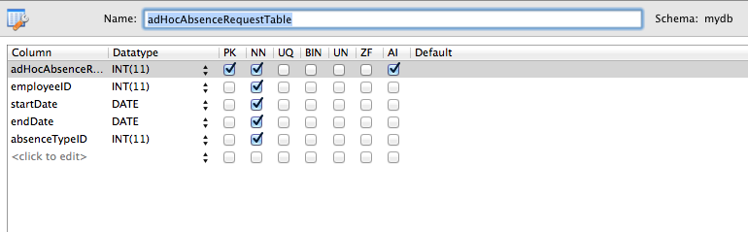

1. <?php
3. /* ----------------------------------------------------------------------------
4. * CONSTANTS
5. *
6. * These constants should be used when refering to the table and the fields
7. * within its records.
8. * -------------------------------------------------------------------------- */
9. define("ADHOC_ABSENCE_REQUEST_TABLE", "adHocAbsenceRequestTable");
10. define("AD_HOC_REQ_ID", "adHocAbsenceRequestID");
11. define("AD_HOC_EMP_ID", "employeeID");
12. define("AD_HOC_START", "startDate");
13. define("AD_HOC_END", "endDate");
14. define("AD_HOC_ABSENCE_TYPE_ID", "absenceTypeID");
16. /* ---------------------------------------------------------------------------
17. * Function CreateAdHocAbsenceRequestTable
18. *
19. * This function creates the SQL statement needed to construct the table
20. * in the database.
21. *
22. * @return (bool)  True if table is created successfully, false otherwise.
23. * ---------------------------------------------------------------------------*/
25. **function** CreateAdHocAbsenceRequestTable() {
26. $sql = "CREATE TABLE IF NOT EXISTS `mydb`.`adHocAbsenceRequestTable` (
27. `adHocAbsenceRequestID` INT NOT NULL AUTO_INCREMENT,
28. `employeeID` INT NOT NULL,
29. `startDate` DATE NOT NULL,
30. `endDate` DATE NOT NULL,
31. `absenceTypeID` INT NOT NULL,
32. PRIMARY KEY (`adHocAbsenceRequestID`),
33. INDEX `fk_adHocAbsenceRequest_absenceType1_idx` (`absenceTypeID` ASC),
34. INDEX `fk_adHocAbsenceRequest_Employee1_idx` (`employeeID` ASC),
35. CONSTRAINT `fk_adHocAbsenceRequest_absenceType1`
36. FOREIGN KEY (`absenceTypeID`)
37. REFERENCES `mydb`.`absenceTypeTable` (`absenceTypeID`)
38. ON DELETE NO ACTION
39. ON UPDATE NO ACTION,
40. CONSTRAINT `fk_adHocAbsenceRequest_Employee1`
41. FOREIGN KEY (`employeeID`)
42. REFERENCES `mydb`.`EmployeeTable` (`employeeID`)
43. ON DELETE NO ACTION
44. ON UPDATE NO ACTION);";
46. performSQL($sql);
47. }
49. /* -----------------------------------------------------------------------------
50. * Function CreateAdHocAbsenceRequest
51. *
52. * This function creates a new AdHocAbsenceRequest record in the
53. * AdHocAbsenceRequestTable.
54. *
55. * $employeeID (int) ID of the employee record associated with this request.
56. * $startDate (string) Start date of the request. Should be in the form YYYY-MM-DD
57. * $endDate (string)  End date of the request. Should be in the form YYYY-MM-DD
58. * $absenceTypeID (int) ID of the absenceType record assocaited with this request.
59. *
60. * @return (array) If successful, an array is returned where each key represents
61. *                  a field in the record. If unsuccessful, the return will be NULL.
62. * -------------------------------------------------------------------------- */
64. **function** CreateAdHocAbsenceRequest($employeeID, $startDate, $endDate, $absenceTypeID) {
65. $statusMessage = "";
66. $request = NULL;
67. //--------------------------------------------------------------------------------
68. // Validate Input parameters
69. //--------------------------------------------------------------------------------
70. $inputIsValid = TRUE;
72. $record = RetrieveEmployeeByID($employeeID);
74. **if** ($record == NULL) {
75. $statusMessage .= "Unable to locate the employees ID in the database.</br>";
76. error_log("employeeID passed to CreateAdHocAbsenceRequest does not " .
77. "exist in the database. ID=" . $employeeID);
78. $inputIsValid = FALSE;
79. }
81. **if** (!isValidDate($startDate)) {
82. $statusMessage .= "Start date given is not a valid date.</br>";
83. error_log("Invalid start date passed to CreateAdHocAbsenceRequest.".
84. "date=".$startDate);
85. $inputIsValid = FALSE;
86. }
88. **if** (!isValidDate($endDate)) {
89. $statusMessage .= "End date given is not a valid date.</br>";
90. error_log("Invalid end date passed to CreateAdHocAbsenceRequest. date=".
91. $endDate);
92. $inputIsValid = FALSE;
93. }
95. **if** (strtotime($endDate) < strtotime($startDate))
96. {
97. $statusMessage.="end Date is before start Date.</br>";
98. error_log("End Date is before Start Date.");
99. $inputIsValid = FALSE;
100. }
102. //ensure absenceType exists in the database.
103. $record = RetrieveAbsenceTypeByID($absenceTypeID);
105. **if** ($record == NULL) {
106. $statusMessage .= "Unable to locate the absence type in the database.</br>";
107. error_log("absenceType passed to CreateAdHocAbsenceRequest does not " .
108. "exist in the database. ID=" . $absenceTypeID);
109. $inputIsValid = FALSE;
110. }

113. //------------------------------------------------------------------------
114. // Only attempt to insert a record in the database if the input parameters
115. // are ok.
116. //------------------------------------------------------------------------
117. **if** ($inputIsValid) {
118. $request[AD_HOC_REQ_ID] = NULL;
119. $request[AD_HOC_EMP_ID] = $employeeID;
120. $request[AD_HOC_START] = $startDate;
121. $request[AD_HOC_END] = $endDate;
122. $request[AD_HOC_ABSENCE_TYPE_ID] = $absenceTypeID;
124. $success = sqlInsertAdHocAbsenceRequest($request);
126. **if** (!$success) {
127. $isValidInput = false;
128. $statusMessage .= "Unexpected issue when writing to the database.".
129. "Contact your system administrator.</br>";
130. error_log("Failed to create Ad Hoc Absence Request.");
131. $request = NULL;
132. }
133. **else**
134. {
135. $statusMessage.="Record successfully created.";
136. }
137. }
139. GenerateStatus($inputIsValid, $statusMessage);
140. **return** $request;
141. }
143. /* ----------------------------------------------------------------------------
144. * Function sqlInsertAdHocAbsenceRequest
145. *
146. * This function constructs the SQL statement required to insert a new record
147. * into the adHocAbsenceRequest table.
148. *
149. * &$adHocAbsenceRequest (array) Array containing all of the fields required for
150. *                               the record.
151. *
152. * @return (bool) TRUE if insert into database was successful, false otherwise.
153. *
154. * Note: If successful then the AD_HOC_REQ_ID entry in the array
155. *       passed by the caller will be set to the ID of the record in the
156. *           database.
157. * ---------------------------------------------------------------------------*/
159. **function** sqlInsertAdHocAbsenceRequest(&$adHocAbsenceRequest) {
160. $sql = "INSERT INTO adHocAbsenceRequestTable (employeeID,startDate,"
161. . "endDate,absenceTypeID) "
162. . "VALUES ('" . $adHocAbsenceRequest[AD_HOC_EMP_ID] .
163. "','" . $adHocAbsenceRequest[AD_HOC_START] . "','" .
164. $adHocAbsenceRequest[AD_HOC_END] .
165. "','" . $adHocAbsenceRequest[AD_HOC_ABSENCE_TYPE_ID] . "');";
166. $adHocAbsenceRequest[AD_HOC_REQ_ID] = performSQLInsert($sql);
167. **return** $adHocAbsenceRequest[AD_HOC_REQ_ID] <> 0;
168. }
170. /* -----------------------------------------------------------------------------
171. * Function RetrieveAdHocAbsenceRequestByID
172. *
173. * This function uses the ID supplied as a parameter to construct an SQL select
174. * statement and then performs this query, returning an array containing the key
175. * value pairs of the record (or NULL if no record is found matching the id).
176. *
177. * $id (int) id of the record to retrieve from the database..
178. *
179. * @return (array) array of key value pairs representing the fields in the
180. *                 record, or NULL if no record exists with the id supplied.
181. * ---------------------------------------------------------------------------*/
183. **function** RetrieveAdHocAbsenceRequestByID($id) {
184. $filter[AD_HOC_REQ_ID] = $id;
185. $resultArray = performSQLSelect(ADHOC_ABSENCE_REQUEST_TABLE, $filter);
187. $result = NULL;
189. **if** (count($resultArray) == 1) {      //Check to see if record was found.
190. $result = $resultArray[0];
191. }
193. **return** $result;
194. }
196. /* -----------------------------------------------------------------------------
197. * Function RetrieveAdHocAbsenceRequests
198. *
199. * This function constructs the SQL statement required to query the
200. * AdHocAbsenceRequest table.
201. *
202. * $filter (array) Optional parameter. If supplied, then the array should
203. *                 contain a set of key value pairs, where the keys correspond
204. *                 to one (or more) fields in the record (see constants at top
205. *                 of file) and the values correspond to the values to filter
206. *                 against (IE: The WHERE clause).
207. *
208. * @return (array) If successful, an array of arrays, where each element
209. *                 corresponds to a row from the query. If a failure occurs,
210. *                 return will be NULL.
211. * -------------------------------------------------------------------------- */
213. **function** RetrieveAdHocAbsenceRequests($filter = NULL) {
214. $inputIsValid = TRUE;
215. //--------------------------------------------------------------------------
216. // Validate Input parameters
217. //--------------------------------------------------------------------------
218. **if** ($filter <> NULL) {
219. **foreach** ($filter **as** $key => $value) {
220. **if** (strcmp($key, AD_HOC_REQ_ID) == 0) {
221. **if** (!is_numeric($value)) {
222. error_log("Invalid AdHocRequestID of " . $value .
223. " passed to RetrieveAdHocAbsenceRequests.");
224. $inputIsValid = FALSE;
225. }
226. } **else** **if** (strcmp($key, AD_HOC_EMP_ID) == 0) {
227. **if** (!is_numeric($value)) {
228. error_log("InvalidAD_HOC_EMP_ID of " . $value .
229. " passed to RetrieveAdHocAbsenceRequests.");
230. $inputIsValid = FALSE;
231. }
232. } **else** **if** (strcmp($key, AD_HOC_START) == 0) {
233. **if** (!isValidDate($value)) {
234. error_log("Invalid AD_HOC_START of " . $value .
235. " passed to RetrieveAdHocAbsenceRequests.");
236. $inputIsValid = FALSE;
237. }
238. } **else** **if** (strcmp($key, AD_HOC_END) == 0) {
239. **if** (!isValidDate($value)) {
240. error_log("Invalid AD_HOC_END of " . $value .
241. " passed to RetrieveAdHocAbsenceRequests.");
242. $inputIsValid = FALSE;
243. }
244. } **else** **if** (strcmp($key, AD_HOC_ABSENCE_TYPE_ID) == 0) {
245. **if** (!is_numeric($value)) {
246. error_log("Invalid AD_HOC_ABSENCE_TYPE_ID of " . $value .
247. " passed to RetrieveAdHocAbsenceRequests.");
248. $inputIsValid = FALSE;
249. }
250. } **else** {
251. error_log("Unknown Filter " . $key . " passed to "
252. . "RetrieveAdHocAbsenceRequests.");
253. $inputIsValid = FALSE;
254. }
255. }
256. }
258. //-------------------------------------------------------------------------
259. // Only attempt to perform query in the database if the input parameters
260. // are ok.
261. //------------------------------------------------------------------------
262. $result = NULL;
263. **if** ($inputIsValid) {
264. $result = performSQLSelect(ADHOC_ABSENCE_REQUEST_TABLE, $filter);
265. }
267. **return** $result;
268. }
270. /* ----------------------------------------------------------------------------
271. * Function UpdateAdHocAbsenceRequest
272. *
273. * This function constructs the SQL statement required to update a row in
274. * the AdHocAbsenceRequest table.
275. *
276. * $fields (array) array of key value pairs, where keys correspond to fields
277. *                 in the record (see constants at start of this file). Note,
278. *                 this array MUST provide the id of the record (AD_HOC_REQ_ID)
279. *                 and one or more other fields to be updated.
280. *
281. * @return (bool) TRUE if update succeeds. FALSE otherwise.
282. * ---------------------------------------------------------------------------*/
284. **function** UpdateAdHocAbsenceRequest($fields) {
285. $statusMessage = "";
287. //-------------------------------------------------------------------------
288. // Validate Input parameters
289. //-------------------------------------------------------------------------
290. $inputIsValid = TRUE;
291. $validID = false;
292. $countOfFields = 0;
293. **foreach** ($fields **as** $key => $value) {
294. **if** ($key == AD_HOC_REQ_ID) {
295. $record = RetrieveAdHocAbsenceRequestByID($value);
296. **if** ($record <> NULL) {
297. $validID = true;
298. $countOfFields++;
299. }
300. } **else** **if** ($key == AD_HOC_EMP_ID) {
301. $countOfFields++;
303. $record = RetrieveEmployeeByID($value);
304. **if** ($record == NULL) {
305. $statusMessage .= "Employee specified can not be found in the "
306. . "database.</br>";
307. error_log("Invalid AD_HOC_EMP_ID passed to "
308. . "UpdateAdHocAbsenceRequest." .
309. " Value=" . $value);
310. $inputIsValid = FALSE;
311. }
312. } **else** **if** ($key == AD_HOC_START) {
313. $countOfFields++;
315. **if** (!isValidDate($value)) {
316. $statusMessage .= "Start date entered is not a valid date.</br>";
317. error_log("Invalid AD_HOC_START passed to UpdateAdHocAbsenceRequest." .
318. " Value=" . $value);
319. $inputIsValid = FALSE;
320. }
321. } **else** **if** ($key == AD_HOC_END) {
322. $countOfFields++;
324. **if** (!isValidDate($value)) {
325. $statusMessage .= "End date entered is not a valid date.</br>";
326. error_log("Invalid AD_HOC_END passed to UpdateAdHocAbsenceRequest." .
327. " Value=" . $value);
328. $inputIsValid = FALSE;
329. }
330. } **else** **if** ($key == AD_HOC_ABSENCE_TYPE_ID) {
331. $countOfFields++;
333. $record = RetrieveAbsenceTypeByID($value);
334. **if** ($record == NULL) {
335. $statusMessage .= "Absence Type selected can not be found in the "
336. . "database.</br>";
337. error_log("Invalid  AD_HOC_ABSENCE_TYPE_ID passed to " .
338. "UpdateAdHocAbsenceRequest. Value=" . $value);
339. $inputIsValid = FALSE;
340. }
341. } **else** {
342. $statusMessage .= "Unknown field encountered.</br>";
343. error_log("Invalid field passed to UpdateAdHocAbsenceRequest."
344. ." $key=" . $key);
345. $inputIsValid = FALSE;
346. }
347. }
348. $startDate = $fields[AD_HOC_START];
349. $endDate = $fields[AD_HOC_END];
351. **if** (strtotime($endDate) < strtotime($startDate))
352. {
353. $statusMessage.="end Date is before start Date.</br>";
354. error_log("End Date is before Start Date.");
355. $inputIsValid = FALSE;
356. }
358. **if** (!$validID) {
359. $statusMessage .= "No valid record ID found.</br>";
360. error_log("No valid ID supplied in call to UpdateAbsenceType.");
361. $inputIsValid = FALSE;
362. }
364. **if** ($countOfFields < 2) {
365. $statusMessage .= "Insufficent fields supplied in call to UpdateAbsenceType.</br>";
366. error_log("Insufficent fields supplied in call to UpdateAbsenceType.");
367. $inputIsValid = FALSE;
368. }
370. //-------------------------------------------------------------------------
371. // Only attempt to update a record in the database if the input parameters
372. // are ok.
373. //-------------------------------------------------------------------------
374. $success = false;
376. **if** ($inputIsValid) {
377. $success = performSQLUpdate(ADHOC_ABSENCE_REQUEST_TABLE,
378. AD_HOC_REQ_ID, $fields);
379. **if** ($success)
380. {
381. $statusMessage .= "Record successfully updated.</br>";
382. }
383. **else**
384. {
385. $statusMessage .= "Unexpected error encountered when updating database.".
386. "Contact your system administrator.</br>";
387. $inputIsValid = false;
388. }
389. }
391. GenerateStatus($inputIsValid, $statusMessage);
392. **return** $success;
393. }
395. /* ----------------------------------------------------------------------------
396. * Function DeleteAdHocAbsenceRequest
397. *
398. * This function constructs the SQL statement required to delete a row in
399. * the AdHocAbsenceRequest table.
400. *
401. * $ID(integer) ID of the record to be removed from the table. This should be set to
402. *              the AD_HOC_REQ_ID value of the record you wish to delete.
403. *
404. * @return (int) count of rows deleted. 0 means delete was unsuccessful.
405. * -------------------------------------------------------------------------- */
407. **function** DeleteAdHocAbsenceRequest($ID) {
408. $sql = "DELETE FROM adHocAbsenceRequestTable WHERE adHocAbsenceRequestID=" . $ID . ";";
409. GenerateStatus(true,"Record successfully deleted");
410. **return** performSQL($sql);
411. }
412. ?>

## AbsenceType Table

### File: AbsenceTypeTable.php

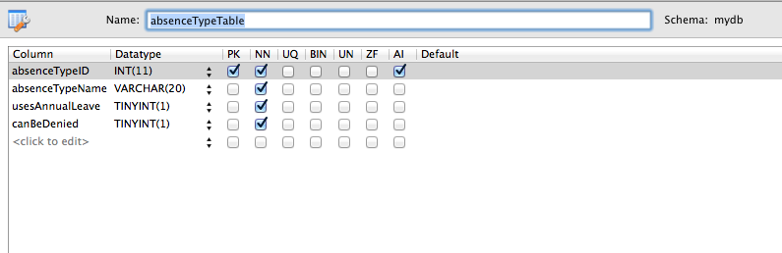

1. <?php
3. /* ----------------------------------------------------------------------------
4. * CONSTANTS
5. *
6. * These constants should be used when refering to the table and the fields
7. * within its records.
8. * -------------------------------------------------------------------------- */
9. define("ABSENCE_TYPE_TABLE", "absenceTypeTable");
10. define("ABS_TYPE_ID", "absenceTypeID");
11. define("ABS_TYPE_NAME", "absenceTypeName");
12. define("ABS_TYPE_USES_LEAVE", "usesAnnualLeave");
13. define("ABS_TYPE_CAN_BE_DENIED", "canBeDenied");
15. //This constant is used to refer to the default annual leave record, which is
16. //used as the type of leave for main vacation requests.
17. define("ANNUAL_LEAVE", "Annual leave");
19. /* ----------------------------------------------------------------------------
20. * Function CreateAbsenceTypeTable
21. *
22. * This function creates the SQL statement needed to construct the AbsenceType
23. * table in the database.
24. *
25. * @return (bool)  True if table is created successfully, false otherwise.
26. * ---------------------------------------------------------------------------*/
27. **function** CreateAbsenceTypeTable() {
28. $sql = "CREATE TABLE IF NOT EXISTS `mydb`.`absenceTypeTable` (
29. `absenceTypeID` INT NOT NULL AUTO_INCREMENT,
30. `absenceTypeName` VARCHAR(20) NOT NULL,
31. `usesAnnualLeave` TINYINT(1) NOT NULL,
32. `canBeDenied` TINYINT(1) NOT NULL,
33. PRIMARY KEY (`absenceTypeID`));";
35. $success = performSQL($sql);
37. **if** ($success)
38. {
39. //Check to see if the table is empty
40. **if** (GetAbsenceTypeCount() == 0)
41. {
42. //Table is empty. Create some default absence types.
43. CreateAbsenceType(ANNUAL_LEAVE,TRUE,TRUE);
44. }
45. }
46. }
48. /* ----------------------------------------------------------------------------
49. * Function CreateAbsenceType
50. *
51. * This function creates a new Absence Type row in the AbsenceTypeTable.
52. *
53. * $absenceTypeName (string) Textual name of the type of absence.
54. * $usesAnnual Leave (boolean) Whether or not this type of absence uses annual
55. *             leave.
56. * $canBeDenied (boolean) Whether or not this type of absence can be denied.
57. *
58. * @return (array) If successful, an array is returned where each key represents
59. *                 a field in the record. If unsuccessful, the return will
60. *                 be NULL.
61. * ---------------------------------------------------------------------------*/
62. **function** CreateAbsenceType($absenceTypeName, $usesAnnualLeave, $canBeDenied) {
63. $statusMessage = "";
64. $absenceType = NULL;
65. //-------------------------------------------------------------------------
66. // Validate Input parameters
67. //-------------------------------------------------------------------------
68. $inputIsValid = TRUE;
70. **if** (isNullOrEmptyString($absenceTypeName)) {
71. $statusMessage.="Invalid absence type name. Can not be blank.</br>";
72. error_log("Invalid absenceTypeName passed to CreateAbsenceType.");
73. $inputIsValid = FALSE;
74. }
76. **if** ($usesAnnualLeave<>0 AND $usesAnnualLeave<>1) {
77. $statusMessage.="Invalid value for the uses annual leave flag.</br>";
78. error_log("Invalid usesAnnualLeave parameter passed to CreateAbsenceType.");
79. $inputIsValid = FALSE;
80. }
82. **if** ($canBeDenied<>0 AND $canBeDenied<>1) {
83. $statusMessage.="Invalid value for the can be denied flag.</br>";
84. error_log("Invalid canBeDenied parameter passed to CreateAbsenceType.");
85. $inputIsValid = FALSE;
86. }
88. //Check to ensure that a record with the same name doesn't already exist.
89. $filter[ABS_TYPE_NAME] = $absenceTypeName;
90. $result = RetrieveAbsenceTypes($filter);
92. **if** ($result <> NULL)
93. {
94. $statusMessage.="Unable to create as an absence type with that name ".
95. "already exists</br>";
96. error_log("Unable to create as an absence type with that name ".
97. "already exists");
98. $inputIsValid = FALSE;
99. }
101. //--------------------------------------------------------------------------
102. // Only attempt to insert a record in the database if the input parameters
103. // are ok.
104. //--------------------------------------------------------------------------
105. **if** ($inputIsValid) {
106. // Create an array with each field required in the record.
107. $absenceType[ABS_TYPE_ID] = NULL;
108. $absenceType[ABS_TYPE_NAME] = $absenceTypeName;
109. $absenceType[ABS_TYPE_USES_LEAVE] = $usesAnnualLeave;
110. $absenceType[ABS_TYPE_CAN_BE_DENIED] = $canBeDenied;
112. $success = sqlInsertAbsenceType($absenceType);
113. **if** (!$success) {
114. $statusMessage.="Database error encountered. Unable to create absence type.</br>";
115. $inputIsValid = false;
116. error_log("Failed to create absence type.");
117. $absenceType = NULL;
118. }
119. **else**
120. {
121. $statusMessage.="Record created in database successfully.</br>";
122. }
123. }
125. GenerateStatus($inputIsValid, $statusMessage);
126. **return** $absenceType;
127. }
129. /* ----------------------------------------------------------------------------
130. * Function sqlInsertAbsenceType
131. *
132. * This function constructs the SQL statement required to insert a new record
133. * into the absenceTypeTable
134. *
135. * &$absenceType (array) Array containing all of the fields required for the
136. *                       record.
137. *
138. * @return (bool) TRUE if insert into database was successful, false otherwise.
139. *
140. * Note: If successful then the ABS_TYPE_ID entry in the array
141. *   passed by the caller will be set to the ID of the record in the
142. *       database.
143. * ---------------------------------------------------------------------------*/
145. **function** sqlInsertAbsenceType(&$absenceType) {
146. $absenceType[ABS_TYPE_ID] = NULL;
148. $sql = "INSERT INTO absenceTypeTable (absenceTypeName,usesAnnualLeave,canBeDenied) "
149. . "VALUES ('"
150. . $absenceType[ABS_TYPE_NAME] . "','"
151. . $absenceType[ABS_TYPE_USES_LEAVE] . "','"
152. . $absenceType[ABS_TYPE_CAN_BE_DENIED] . "');";
154. $absenceType[ABS_TYPE_ID] = performSQLInsert($sql);
156. **return** $absenceType[ABS_TYPE_ID] <> 0;
157. }
159. /* ----------------------------------------------------------------------------
160. * Function RetrieveAbsenceTypeByID
161. *
162. * This function uses the ID supplied as a parameter to construct an SQL select
163. * statement and then performs this query, returning an array containing the key
164. * value pairs of the record (or NULL if no record is found matching the id).
165. *
166. * $id (int) id of the record to retrieve from the database..
167. *
168. * @return (array) array of key value pairs representing the fields in the
169. *                 record, or NULL if no record exists with the id supplied.
170. * ---------------------------------------------------------------------------*/
172. **function** RetrieveAbsenceTypeByID($id) {
173. $filter[ABS_TYPE_ID] = $id;
174. $resultArray = performSQLSelect(ABSENCE_TYPE_TABLE, $filter);
176. $absenceType = NULL;
178. //There should only be one record in the database with this ID.
179. **if** (count($resultArray) == 1) {
180. $absenceType = $resultArray[0];
181. }
183. **return** $absenceType;
184. }
186. /* ----------------------------------------------------------------------------
187. * Function RetrieveAbsenceTypes
188. *
189. * This function constructs the SQL statement required to query the
190. * AbsenceTypeTable.
191. *
192. * $filter (array) Optional parameter. If supplied, then the array should
193. *                 contain a set of key value pairs, where the keys correspond
194. *                 to one (or more) fields in the record (see constants at top
195. *                 of file) and the values correspondto the values to filter
196. *                 against (IE: The WHERE clause).
197. *
198. * @return (array) If successful, an array of arrays, where each element
199. *                 corresponds to a row from the query. If a failure occurs,
200. *                 return will be NULL.
201. * ---------------------------------------------------------------------------*/
203. **function** RetrieveAbsenceTypes($filter = NULL) {
204. $inputIsValid = TRUE;
206. //-------------------------------------------------------------------------
207. // Validate Input parameters
208. //-------------------------------------------------------------------------
209. **if** ($filter <> NULL) {
210. **foreach** ($filter **as** $key => $value) {
211. **if** (strcmp($key, ABS_TYPE_ID) == 0) {
212. **if** (!is_numeric($value)) {
213. error_log("Invalid AbsenceTypeID of " . $value .
214. " passed to RetrieveAbsenceTypes.");
215. $inputIsValid = FALSE;
216. }
217. } **else** **if** (strcmp($key, ABS_TYPE_NAME) == 0) {
218. **if** (isNullOrEmptyString($value)) {
219. error_log("Invalid ABS_TYPE_NAME passed to RetrieveAbsenceTypes.");
220. $inputIsValid = FALSE;
221. }
222. } **else** **if** (strcmp($key, ABS_TYPE_USES_LEAVE) == 0) {
223. **if** ($value<>0 AND $value<>1) {
224. error_log("Invalid ABS_TYPE_USES_LEAVE of " . $value .
225. " passed to RetrieveAbsenceTypes.");
226. $inputIsValid = FALSE;
227. }
228. } **else** **if** (strcmp($key, ABS_TYPE_CAN_BE_DENIED) == 0) {
229. **if** ($value<>0 AND $value<>1) {
230. error_log("Invalid ABS_TYPE_CAN BE DENIED of " . $value .
231. " passed to RetrieveAbsenceTypes.");
232. $inputIsValid = FALSE;
233. }
234. } **else** {
235. error_log("Unknown Filter " . $key . " passed to RetrieveAbsenceTypes.");
236. $inputIsValid = FALSE;
237. }
238. }
239. }
241. //-------------------------------------------------------------------------
242. // Only attempt to perform query in the database if the input parameters
243. // are ok.
244. //-------------------------------------------------------------------------
245. $result = NULL;
246. **if** ($inputIsValid) {
247. $result = performSQLSelect(ABSENCE_TYPE_TABLE, $filter);
248. }

251. **return** $result;
252. }
254. /* ----------------------------------------------------------------------------
255. * Function UpdateAbsenceType
256. *
257. * This function constructs the SQL statement required to update a row in
258. * the AbsenceTypeTable.
259. *
260. * $fields (array) array of key value pairs, where keys correspond to fields
261. *                 in the record (see constants at start of this file).
262. *                 Note, this array MUST provide the id of the
263. *                 record (ABS_TYPE_ID) and one or more other fields to be updated.
264. *
265. * @return (bool) TRUE if update succeeds. FALSE otherwise.
266. * ---------------------------------------------------------------------------*/
268. **function** UpdateAbsenceType($fields) {
269. $statusMessage = "";
270. //-------------------------------------------------------------------------
271. // Validate Input parameters
272. //-------------------------------------------------------------------------
273. $inputIsValid = TRUE;
274. $validID = false;
275. $countOfFields = 0;
277. **foreach** ($fields **as** $key => $value) {
278. **if** ($key == ABS_TYPE_ID) {
279. $record = RetrieveAbsenceTypeByID($value);
280. **if** ($record <> NULL) {
281. $validID = true;
282. $countOfFields++;
283. }
284. } **else** **if** ($key == ABS_TYPE_NAME) {
285. $countOfFields++;
287. **if** (isNullOrEmptyString($value)) {
288. $statusMessage.="Invalid absence type name. Can not be empty.</br>";
289. error_log("Invalid ABS_TYPE_NAME passed to UpdateAbsenceType.");
290. $inputIsValid = FALSE;
291. }
292. } **else** **if** ($key == ABS_TYPE_USES_LEAVE) {
293. $countOfFields++;
294. **if** ($value<>0 AND $value<>1) {
295. $statusMessage.="Invalid uses annual leave flag value.</br>";
296. error_log("Invalid ABS_TYPE_USES_LEAVE passed to UpdateAbsenceType.");
297. $inputIsValid = FALSE;
298. }
299. } **else** **if** ($key == ABS_TYPE_CAN_BE_DENIED) {
300. $countOfFields++;
302. **if** ($value<>0 AND $value<>1) {
303. $statusMessage.="Invalid can be denied flag value.</br>";
304. error_log("Invalid ABS_TYPE_CAN_BE_DENIED passed to UpdateAbsenceType.");
305. $inputIsValid = FALSE;
306. }
307. } **else** {
308. $statusMessage.="Invalid field encountered.</br>";
309. error_log("Invalid field passed to UpdateAbsenceType. $key=" . $key);
310. $inputIsValid = FALSE;
311. }
312. }
314. **if** (!$validID) {
315. $statusMessage.="No valid ID supplied.</br>";
316. error_log("No valid ID supplied in call to UpdateAbsenceType.");
317. $inputIsValid = FALSE;
318. }
320. **if** ($countOfFields < 2) {
321. $statusMessage.="Insufficent fields supplied in call.</br>";
322. error_log("Insufficent fields supplied in call to UpdateAbsenceType.");
323. $inputIsValid = FALSE;
324. }
326. //--------------------------------------------------------------------------------
327. // Only attempt to update a record in the database if the input parameters are ok.
328. //--------------------------------------------------------------------------------
329. $success = false;
331. **if** ($inputIsValid) {
333. $success = performSQLUpdate(ABSENCE_TYPE_TABLE, ABS_TYPE_ID, $fields);
334. **if** ($success)
335. {
336. $statusMessage .= "Record successfully created in Database.</br>";
337. }
338. **else** {
339. $statusMessage .= "Unexpected database error encountered when ".
340. "trying to perform update.</br>";
341. $inputIsValid = false;
342. }
343. }
345. GenerateStatus($inputIsValid, $statusMessage);
346. **return** $success;
347. }
349. /* ----------------------------------------------------------------------------
350. * Function DeleteAbsenceType
351. *
352. * This function constructs the SQL statement required to delete a row in
353. * the AbsenceTypeTable.
354. *
355. * $ID(integer) ID of the record to be removed from the table. This should be
356. *              set to the ABS_TYPE_ID value of the record you wish
357. *              to delete.
358. *
359. * @return (int) count of rows deleted. 0 means delete was unsuccessful, usually
360. *               because one or more records in the database refers to this
361. *               absenceType.
362. * --------------------------------------------------------------------------*/
364. **function** DeleteAbsenceType($ID) {
365. $isValidRequest = TRUE;
367. // Ensure there are no AdHocAbsenceRequest records which reference this record.
368. $filter[AD_HOC_ABSENCE_TYPE_ID] = $ID;
369. $adHocAbsenceRequests = RetrieveAdHocAbsenceRequests($filter);
370. **if** ($adHocAbsenceRequests <> NULL) {
371. error_log("Attempt to DeleteAbsenceType failed. " .
372. "One or more adHocAbsenceRequest records exist with an " .
373. "absence type ID of " . $ID);
374. $isValidRequest = FALSE;
375. }
376. // Ensure there are no ApprovedAbsenceBooking records which reference this record.
377. unset($filter);
378. $filter[APPR_ABS_ABS_TYPE_ID] = $ID;
379. $approvedBookings = RetrieveApprovedAbsenceBookings($filter);
380. **if** ($approvedBookings <> NULL) {
381. error_log("Attempt to DeleteAbsenceType failed. " .
382. "One or more approvedAbsenceBooking records exist with an " .
383. "absence type ID of " . $ID);
384. $isValidRequest = FALSE;
385. }
387. $result = 0;
388. **if** ($isValidRequest) {
389. $sql = "DELETE FROM absenceTypeTable WHERE absenceTypeID=" . $ID . ";";
390. $result = performSQLDelete($sql);
391. GenerateStatus(true, "Record has been deleted.");
392. }
393. **return** $result;
394. }
396. /* ---------------------------------------------------------------------------
397. * Function GetAbsenceTypeCount
398. *
399. * This function gets a count of absence type records in the table.
400. *
401. * @return (int) count of rows in the table
402. * --------------------------------------------------------------------------*/
404. **function** GetAbsenceTypeCount()
405. {
406. $conn = $GLOBALS["connection"];
408. $sql = "SELECT COUNT(*) FROM ".ABSENCE_TYPE_TABLE;
410. $result = mysqli_query($conn, $sql);
411. **if** (!$result) {
412. printCallstackAndDie();
413. }
414. $count = mysqli_num_rows($result);
416. **return** $count;
417. }

420. /* ----------------------------------------------------------------------------
421. * Function GetAnnualLeaveAbsenceTypeID
422. *
423. * This function gets the absence type ID of the absence type record which is
424. * used for annual leave..
425. *
426. * @return (int) absence type ID or NULL if the absence type is not in the
427. *               database.
428. * -------------------------------------------------------------------------- */
429. **function** GetAnnualLeaveAbsenceTypeID()
430. {
431. $filter[ABS_TYPE_NAME] = ANNUAL_LEAVE;
432. $absenceTypes = RetrieveAbsenceTypes($filter);
434. $absenceTypeID = NULL;
435. **if** (count($absenceTypes)== 1)
436. {
437. $absenceTypeID = $absenceTypes[0][ABS_TYPE_ID];
438. }
440. **return** $absenceTypeID;
441. }
443. ?>

## Approved Absence Booking Table

### File: ApprovedAbsenceBookingTable.php

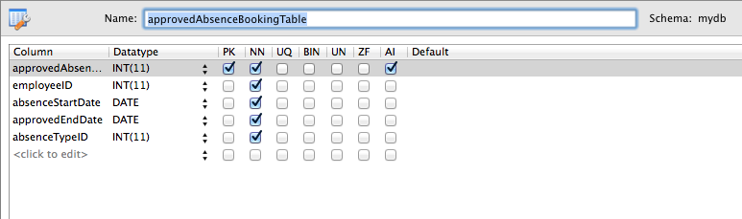

1. <?php
3. /* --------------------------------------------------------------------------------------
4. * CONSTANTS
5. *
6. * These constants should be used when refering to the table and the fields within its
7. * records.
8. * ------------------------------------------------------------------------------------- */
9. define("APPROVED_ABSENCE_BOOKING_TABLE", "approvedAbsenceBookingTable");
10. define("APPR_ABS_BOOKING_ID", "approvedAbsenceBookingID");
11. define("APPR_ABS_EMPLOYEE_ID", "employeeID");
12. define("APPR_ABS_START_DATE", "absenceStartDate");
13. define("APPR_ABS_END_DATE", "approvedEndDate");
14. define("APPR_ABS_ABS_TYPE_ID", "absenceTypeID");

17. /* --------------------------------------------------------------------------------------
18. * Function CreateApprovedAbsenceBookingTable
19. *
20. * This function creates the SQL statement needed to construct the table
21. * in the database.
22. *
23. * @return (bool)  True if table is created successfully, false otherwise.
24. * ------------------------------------------------------------------------------------- */
26. **function** CreateApprovedAbsenceBookingTable() {
27. $sql = "CREATE TABLE IF NOT EXISTS `mydb`.`approvedAbsenceBookingTable` (
28. `approvedAbsenceBookingID` INT NOT NULL AUTO_INCREMENT,
29. `employeeID` INT NOT NULL,
30. `absenceStartDate` DATE NOT NULL,
31. `approvedEndDate` DATE NOT NULL,
32. `absenceTypeID` INT NOT NULL,
33. PRIMARY KEY (`approvedAbsenceBookingID`),
34. INDEX `fk_approvedAbsenceBooking_absenceType1_idx` (`absenceTypeID` ASC),
35. INDEX `fk_approvedAbsenceBooking_Employee1_idx` (`employeeID` ASC),
36. CONSTRAINT `fk_approvedAbsenceBooking_absenceType1`
37. FOREIGN KEY (`absenceTypeID`)
38. REFERENCES `mydb`.`absenceTypeTable` (`absenceTypeID`)
39. ON DELETE NO ACTION
40. ON UPDATE NO ACTION,
41. CONSTRAINT `fk_approvedAbsenceBooking_Employee1`
42. FOREIGN KEY (`employeeID`)
43. REFERENCES `mydb`.`EmployeeTable` (`employeeID`)
44. ON DELETE NO ACTION
45. ON UPDATE NO ACTION);";
47. performSQL($sql);
48. }
50. /* --------------------------------------------------------------------------------------
51. * Function CreateApprovedAbsenceBooking
52. *
53. * This function creates a new ApprovedAbsenceBooking record in the
54. * table.
55. *
56. * $employeeID (int) ID of the employee record associated with this record.
57. * $absenceStartDate (string) Start date of the request. Should be in the form YYYY-MM-DD
58. * $absenceEndDate (string)  End date of the request. Should be in the form YYYY-MM-DD
59. * $absenceTypeID (int) ID of the absenceType record associated with this record.
60. *
61. * @return (array) If successful, an array is returned where each key represents a field
62. *                 in the record. If unsuccessful, the return will be NULL.
63. * ------------------------------------------------------------------------------------- */
65. **function** CreateApprovedAbsenceBooking($employeeID, $absenceStartDate, $absenceEndDate, $absenceTypeID) {
66. $statusMessage = "";
67. $absenceBooking = NULL;
68. //--------------------------------------------------------------------------------
69. // Validate Input parameters
70. //--------------------------------------------------------------------------------
71. $inputIsValid = TRUE;
73. //ensure employee exists in the database.
74. $record = RetrieveEmployeeByID($employeeID);
75. **if** ($record == NULL) {
76. $statusMessage.= "Unable to locate employee in database.</br>";
77. error_log("employeeID passed to CreateApprovedAbsenceBooking " .
78. " does not exist in the database. ID=" . $employeeID);
79. $inputIsValid = FALSE;
80. }
82. **if** (!isValidDate($absenceStartDate)) {
83. $statusMessage.= "Start date is not a valid date.</br>";
84. error_log("absenceStartDate passed to CreateApprovedAbsenceBooking " .
85. " is invalid. date=" . $absenceStartDate);
86. $inputIsValid = FALSE;
87. }
89. **if** (!isValidDate($absenceEndDate)) {
90. $statusMessage.= "End date is not a valid date.</br>";
91. error_log("absenceEndDate passed to CreateApprovedAbsenceBooking " .
92. " is invalid. date=" . $absenceEndDate);
93. $inputIsValid = FALSE;
94. }
96. **if** (strtotime($absenceEndDate) < strtotime($absenceStartDate))
97. {
98. $statusMessage.="end Date is before start Date.</br>";
99. error_log("End Date is before Start Date.");
100. $inputIsValid = FALSE;
101. }

104. //ensure absence type exists in the database.
105. $record = RetrieveAbsenceTypeByID($absenceTypeID);
107. **if** ($record == NULL) {
108. $statusMessage.= "Unable to locate absence type in database.</br>";
109. error_log("absenceTypeID passed to CreateApprovedAbsenceBooking " .
110. " does not exist in the database. ID=" . $absenceTypeID);
111. $inputIsValid = FALSE;
112. }
114. //--------------------------------------------------------------------------------
115. // Only attempt to insert a record in the database if the input parameters are ok.
116. //--------------------------------------------------------------------------------
117. $booking = NULL;
119. **if** ($inputIsValid) {
120. $booking[APPR_ABS_BOOKING_ID] = NULL;
121. $booking[APPR_ABS_EMPLOYEE_ID] = $employeeID;
122. $booking[APPR_ABS_START_DATE] = $absenceStartDate;
123. $booking[APPR_ABS_END_DATE] = $absenceEndDate;
124. $booking[APPR_ABS_ABS_TYPE_ID] = $absenceTypeID;
126. $success = sqlInsertApprovedAbsenceBooking($booking);
127. **if** (!$success) {
128. $statusMessage.= "Unexpected error when inserting to database.".
129. "Contact your system administrator.</br>";
130. $inputIsValid = false;
131. error_log("Failed to create Approved Absence Booking.");
132. $booking = NULL;
133. }
135. // Set timezone
136. date_default_timezone_set('UTC');
138. // Start date
139. $date = $absenceStartDate;
140. // End date
142. **while** (strtotime($date) <= strtotime($absenceEndDate)) {
143. $dateID = RetrieveDateIDByDate($date);
144. **if** ($dateID <> NULL)
145. {
146. $result = CreateApprovedAbsenceBookingDate($dateID,
147. $booking[APPR_ABS_BOOKING_ID]);
148. }
149. **else**
150. {
151. $statusMessage.="Unable to locate Date of $date in database.</br>";
152. $inputIsValid = false;
153. error_log("Unable to find date record. Date=".$date);
154. }
155. $date = date ("Y-m-d", strtotime("+1 day", strtotime($date)));
156. }
157. **if** ($inputIsValid)
158. {
159. $statusMessage.= "Record created successfully.</br>";
160. }
161. }
163. GenerateStatus($inputIsValid, $statusMessage);
164. **return** $booking;
165. }
167. /* --------------------------------------------------------------------------------------
168. * Function sqlInsertApprovedAbsenceBooking
169. *
170. * This function constructs the SQL statement required to insert a new record
171. * into the approvedAbsenceBooking table.
172. *
173. * &$approvedAbsenceBooking (array) Array containing all of the fields required for
174. * the record.
175. *
176. * @return (bool) TRUE if insert into database was successful, false otherwise.
177. *
178. * Note: If successful then the APPR_ABS_BOOKING_ID entry in the
179. * array passed by the caller will be set to the ID of the record in the database.
180. * ------------------------------------------------------------------------------------- */
182. **function** sqlInsertApprovedAbsenceBooking(&$absenceBooking) {
183. $sql = "INSERT INTO approvedAbsenceBookingTable " .
184. "(employeeID,absenceStartDate,approvedEndDate,absenceTypeID) " .
185. "VALUES ('" .
186. $absenceBooking[APPR_ABS_EMPLOYEE_ID] . "','" .
187. $absenceBooking[APPR_ABS_START_DATE] . "','" .
188. $absenceBooking[APPR_ABS_END_DATE] . "','" .
189. $absenceBooking[APPR_ABS_ABS_TYPE_ID] . "');";
191. $absenceBooking[APPR_ABS_BOOKING_ID] = performSQLInsert($sql);
192. **return** $absenceBooking[APPR_ABS_BOOKING_ID] <> 0;
193. }
195. /* --------------------------------------------------------------------------------------
196. * Function RetrieveApprovedAbsenceBookingByID
197. *
198. * This function uses the ID supplied as a parameter to construct an SQL select statement
199. * and then performs this query, returning an array containing the key value pairs of the
200. * record (or NULL if no record is found matching the id).
201. *
202. * $id (int) id of the record to retrieve from the database..
203. *
204. * @return (array) array of key value pairs representing the fields in the record, or
205. *                 NULL if no record exists with the id supplied.
206. * ------------------------------------------------------------------------------------- */
208. **function** RetrieveApprovedAbsenceBookingByID($id) {
209. $filter[APPR_ABS_BOOKING_ID] = $id;
210. $resultArray = performSQLSelect(APPROVED_ABSENCE_BOOKING_TABLE, $filter);
212. $result = NULL;
214. **if** (count($resultArray) == 1) {      //Check to see if record was found.
215. $result = $resultArray[0];
216. }
218. **return** $result;
219. }
221. /* --------------------------------------------------------------------------------------
222. * Function RetrieveApprovedAbsenceBookings
223. *
224. * This function constructs the SQL statement required to query the
225. * ApprovedAbsenceBookings table.
226. *
227. * $filter (array) Optional parameter. If supplied, then the array should contain a set
228. *                 of key value pairs, where the keys correspond to one (or more) fields
229. *                 in the record (see constants at top of file) and the values correspond
230. *                 to the values to filter against (IE: The WHERE clause).
231. *
232. * @return (array) If successful, an array of arrays, where each element corresponds to
233. *                 a row from the query. If a failure occurs, return will be NULL.
234. * ------------------------------------------------------------------------------------- */
236. **function** RetrieveApprovedAbsenceBookings($filter = NULL) {
237. $inputIsValid = TRUE;
239. //--------------------------------------------------------------------------------
240. // Validate Input parameters
241. //--------------------------------------------------------------------------------
242. **if** ($filter <> NULL) {
243. **foreach** ($filter **as** $key => $value) {
244. **if** (strcmp($key, APPR_ABS_BOOKING_ID) == 0) {
245. **if** (!is_numeric($value)) {
246. error_log("Invalid APPR_ABS_BOOKING_ID of " . $value .
247. " passed to RetrieveApprovedAbsenceBookings.");
248. $inputIsValid = FALSE;
249. }
250. } **else** **if** (strcmp($key, APPR_ABS_EMPLOYEE_ID) == 0) {
251. **if** (!is_numeric($value)) {
252. error_log("Invalid APPR_ABS_EMPLOYEE_ID of " . $value .
253. " passed to RetrieveApprovedAbsenceBookings.");
254. $inputIsValid = FALSE;
255. }
256. } **else** **if** (strcmp($key, APPR_ABS_START_DATE) == 0) {
257. **if** (!isValidDate($value)) {
258. error_log("Invalid APPR_ABS_START_DATE of " . $value .
259. " passed to RetrieveApprovedAbsenceBookings.");
260. $inputIsValid = FALSE;
261. }
262. } **else** **if** (strcmp($key, APPR_ABS_END_DATE) == 0) {
263. **if** (!isValidDate($value)) {
264. error_log("Invalid APPR_ABS_END_DATE of " . $value .
265. " passed to RetrieveApprovedAbsenceBookings.");
266. $inputIsValid = FALSE;
267. }
268. } **else** **if** (strcmp($key, APPR_ABS_ABS_TYPE_ID) == 0) {
269. **if** (!is_numeric($value)) {
270. error_log("Invalid APPR_ABS_ABS_TYPE_ID of " . $value .
271. " passed to RetrieveApprovedAbsenceBookings.");
272. $inputIsValid = FALSE;
273. }
274. } **else** {
275. error_log("Unknown Filter " . $key . " passed to " .
276. "RetrieveApprovedAbsenceBookings.");
277. $inputIsValid = FALSE;
278. }
279. }
280. }
282. //--------------------------------------------------------------------------------
283. // Only attempt to perform query in the database if the input parameters are ok.
284. //--------------------------------------------------------------------------------
285. $result = NULL;
286. **if** ($inputIsValid) {
287. $result = performSQLSelect(APPROVED_ABSENCE_BOOKING_TABLE, $filter);
288. }
289. **return** $result;
290. }
292. /* --------------------------------------------------------------------------------------
293. * Function UpdateApprovedAbsenceBooking
294. *
295. * This function constructs the SQL statement required to update a row in
296. * the ApprovedAbsenceBooking table.
297. *
298. * $fields (array) array of key value pairs, where keys correspond to fields in the
299. *                 record (see constants at start of this file). Note, this array
300. *                 MUST provide the id of the record (APPR_ABS_BOOKING_ID) and one or more
301. *                 other fields to be updated.
302. *
303. * @return (bool) TRUE if update succeeds. FALSE otherwise.
304. * ------------------------------------------------------------------------------------- */
306. **function** UpdateApprovedAbsenceBooking($fields) {
307. $statusMessage = "";
308. //--------------------------------------------------------------------------------
309. // Validate Input parameters
310. //--------------------------------------------------------------------------------
311. $inputIsValid = TRUE;
312. $validID = false;
313. $countOfFields = 0;
315. **foreach** ($fields **as** $key => $value) {
316. **if** ($key == APPR_ABS_BOOKING_ID) {
317. $record = RetrieveApprovedAbsenceBookingByID($value);
318. **if** ($record <> NULL) {
319. $validID = true;
320. $countOfFields++;
321. }
322. } **else** **if** ($key == APPR_ABS_EMPLOYEE_ID) {
323. $countOfFields++;
325. $record = RetrieveEmployeeByID($value);
326. **if** ($record == NULL) {
327. $statusMessage.="Unable to locate employee in database</br>";
328. error_log("Invalid EMP_ID passed to " .
329. "UpdateApprovedAbsenceBooking. Value=" . $value);
330. $inputIsValid = FALSE;
331. }
332. } **else** **if** ($key == APPR_ABS_START_DATE) {
333. $countOfFields++;
335. **if** (!isValidDate($value)) {
336. $statusMessage.="Start date is not a valid date.</br>";
337. error_log("Invalid APPR_ABS_START_DATE passed to " .
338. "UpdateApprovedAbsenceBooking. Value=" . $value);
339. $inputIsValid = FALSE;
340. }
341. } **else** **if** ($key == APPR_ABS_END_DATE) {
342. $countOfFields++;
344. **if** (!isValidDate($value)) {
345. $statusMessage.="End date is not a valid date.</br>";
346. error_log("Invalid APPR_ABS_END_DATE passed to " .
347. "UpdateApprovedAbsenceBooking. Value=" . $value);
348. $inputIsValid = FALSE;
349. }
350. } **else** **if** ($key == APPR_ABS_ABS_TYPE_ID) {
351. $countOfFields++;
353. $record = RetrieveAbsenceTypeByID($value);
354. **if** ($record == NULL) {
355. $statusMessage.="Unable to locate absence type in database</br>";
356. error_log("Invalid APPR_ABS_ABS_TYPE_ID passed to " .
357. "UpdateApprovedAbsenceBooking. Value=" . $value);
358. $inputIsValid = FALSE;
359. }
360. } **else** {
361. $statusMessage.="Unexpected field found in input</br>";
362. error_log("Invalid field passed to UpdateApprovedAbsenceBooking." .
363. " $key=" . $key);
364. $inputIsValid = FALSE;
365. }
366. }
368. $absenceStartDate = $fields[APPR_ABS_START_DATE];
369. $absenceEndDate = $fields[APPR_ABS_END_DATE];
371. **if** (strtotime($absenceEndDate) < strtotime($absenceStartDate))
372. {
373. $statusMessage.="end Date is before start Date.</br>";
374. error_log("End Date is before Start Date.");
375. $inputIsValid = FALSE;
376. }

379. **if** (!$validID) {
380. $statusMessage.="No valid ID supplied</br>";
381. error_log("No valid ID supplied in call to UpdateApprovedAbsenceBooking.");
382. $inputIsValid = FALSE;
383. }
385. **if** ($countOfFields < 2) {
386. $statusMessage.="Insufficent fields supplied</br>";
387. error_log("Insufficent fields supplied in call to UpdateApprovedAbsenceBooking.");
388. $inputIsValid = FALSE;
389. }
391. //--------------------------------------------------------------------------------
392. // Only attempt to update a record in the database if the input parameters are ok.
393. //--------------------------------------------------------------------------------
394. $success = false;
396. **if** ($inputIsValid) {
397. $success = performSQLUpdate(APPROVED_ABSENCE_BOOKING_TABLE, APPR_ABS_BOOKING_ID, $fields);
398. **if** ($success)
399. {
400. $statusMessage.="Record updated successfully.</br>";
401. }
402. **else**
403. {
404. $statusMessage.="Unexpected error encountered when updating database.</br>";
405. $inputIsValid = false;
406. }
407. }
409. GenerateStatus($inputIsValid, $statusMessage);
410. **return** $success;
411. }
413. /* --------------------------------------------------------------------------------------
414. * Function DeleteApprovedAbsenceBooking
415. *
416. * This function constructs the SQL statement required to delete a row in
417. * the ApprovedAbsenceBooking table.
418. *
419. * $ID(integer) ID of the record to be removed from the table. This should be set to
420. *              the APPR_ABS_BOOKING_ID value of the record you wish to delete.
421. *
422. * @return (int) count of rows deleted. 0 means delete was unsuccessful.
423. * ------------------------------------------------------------------------------------- */
425. **function** DeleteApprovedAbsenceBooking($ID) {
426. $result = 0;
428. $approvedAbsenceBooking = RetrieveApprovedAbsenceBookingByID($ID);
429. **if** ($approvedAbsenceBooking <> NULL) {
430. $sql = "DELETE FROM approvedAbsenceBookingTable WHERE approvedAbsenceBookingID=" . $ID . ";";
431. $result = performSQL($sql);

434. $filter[APPR_ABS_BOOK_DATE_ABS_BOOK_ID] = $ID;
435. $approvedAbsenceBookingDates = RetrieveApprovedAbsenceBookingDates($filter);
437. **foreach** ((**array**) $approvedAbsenceBookingDates **as** $approvedAbsenceBookingDate) {
438. DeleteApprovedAbsenceBookingDate($approvedAbsenceBookingDate[APPR_ABS_BOOK_DATE_ID]);
439. }
440. }
441. GenerateStatus(true,"Record successfully deleted.");
442. **return** $result;
443. }
445. ?>

## Approved Absence Booking Date Table

### File: ApprovedAbsenceBookingDateTable.php

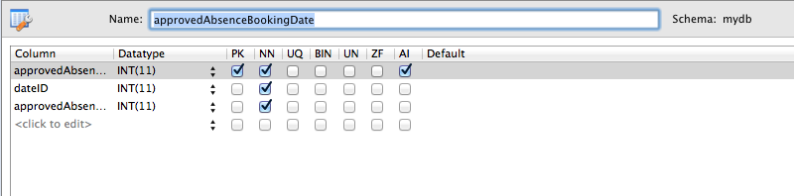

1. <?php
3. /* --------------------------------------------------------------------------------------
4. * CONSTANTS
5. *
6. * These constants should be used when refering to the table and the fields within its
7. * records.
8. * ------------------------------------------------------------------------------------- */
9. define("APPROVED_ABSENCE_BOOKING_DATE", "approvedAbsenceBookingDate");
10. define("APPR_ABS_BOOK_DATE_ID", "approvedAbsenceBookingDateID");
11. define("APPR_ABS_BOOK_DATE_DATE_ID", "dateID");
12. define("APPR_ABS_BOOK_DATE_ABS_BOOK_ID", "approvedAbsenceBookingID");
14. /* --------------------------------------------------------------------------------------
15. * Function CreateApprovedAbsenceDateTable
16. *
17. * This function creates the SQL statement needed to construct the table
18. * in the database.
19. *
20. * @return (bool)  True if table is created successfully, false otherwise.
21. * ------------------------------------------------------------------------------------- */
23. **function** CreateApprovedAbsenceDateTable() {
24. $sql = "CREATE TABLE IF NOT EXISTS `mydb`.`approvedAbsenceBookingDate` (
25. `approvedAbsenceBookingDateID` INT NOT NULL AUTO_INCREMENT,
26. `dateID` INT NOT NULL,
27. `approvedAbsenceBookingID` INT NOT NULL,
28. PRIMARY KEY (`approvedAbsenceBookingDateID`),
29. INDEX `fk_approvedAbsenceBookingDate_Date1_idx` (`dateID` ASC),
30. INDEX `fk_approvedAbsenceBookingDate_approvedAbsenceBooking1_idx`
31. (`approvedAbsenceBookingID` ASC),
32. CONSTRAINT `fk_approvedAbsenceBookingDate_Date1`
33. FOREIGN KEY (`dateID`)
34. REFERENCES `mydb`.`DateTable` (`dateID`)
35. ON DELETE NO ACTION
36. ON UPDATE NO ACTION,
37. CONSTRAINT `fk_approvedAbsenceBookingDate_approvedAbsenceBooking1`
38. FOREIGN KEY (`approvedAbsenceBookingID`)
39. REFERENCES `mydb`.`approvedAbsenceBookingTable` (`approvedAbsenceBookingID`)
40. ON DELETE NO ACTION
41. ON UPDATE NO ACTION);";
43. performSQL($sql);
44. }
46. /* --------------------------------------------------------------------------------------
47. * Function CreateApprovedAbsenceBookingDate
48. *
49. * This function creates a new ApprovedAbsenceBookingDate record in the
50. * table.
51. *
52. * $dateID (int) ID of the date record associated with this record.
53. * $approvedAbsenceBookingID (int) ID of the approvedAbsenceBooking assocaited with
54. * this record.
55. *
56. * @return (array) If successful, an array is returned where each key represents a field
57. *                 in the record. If unsuccessful, the return will be NULL.
58. * ------------------------------------------------------------------------------------- */
60. **function** CreateApprovedAbsenceBookingDate($dateID, $approvedAbsenceBookingID) {
61. $absenceRequest = NULL;
62. //--------------------------------------------------------------------------------
63. // Validate Input parameters
64. //--------------------------------------------------------------------------------
65. $inputIsValid = TRUE;
67. // Check that a record with the DateID supplied exists in the database.
68. $record = RetrieveDateByID($dateID);
70. **if** ($record == NULL) {
71. error_log("dateID passed to CreateApprovedAbsenceBookingDate " .
72. " does not exist in the database. ID=" . $dateID);
73. $inputIsValid = FALSE;
74. }
76. // Check that a record with the approvedAbsenceBookingID supplied exists in the database.
77. $record = RetrieveApprovedAbsenceBookingByID($approvedAbsenceBookingID);
78. **if** ($record == NULL) {
79. error_log("approvedAbsenceBookingID passed to CreateApprovedAbsenceBookingDate " .
80. " does not exist in the database. ID=" . $approvedAbsenceBookingID);
81. $inputIsValid = FALSE;
82. }
84. //--------------------------------------------------------------------------------
85. // Only attempt to insert a record in the database if the input parameters are ok.
86. //--------------------------------------------------------------------------------
87. $bookingDate = NULL;
89. **if** ($inputIsValid) {
90. $bookingDate[APPR_ABS_BOOK_DATE_ID] = NULL;
91. $bookingDate[APPR_ABS_BOOK_DATE_DATE_ID] = $dateID;
92. $bookingDate[APPR_ABS_BOOK_DATE_ABS_BOOK_ID] = $approvedAbsenceBookingID;
94. $success = sqlInsertApprovedAbsenceBookingDate($bookingDate);
95. **if** (!$success) {
96. error_log("Failed to create Approved Absence Booking Date.");
97. $bookingDate = NULL;
98. }
99. }
100. **return** $bookingDate;
101. }
103. /* --------------------------------------------------------------------------------------
104. * Function sqlInsertApprovedAbsenceBookingDate
105. *
106. * This function constructs the SQL statement required to insert a new record
107. * into the approvedAbsenceBookingDate table.
108. *
109. * &$approvedAbsenceBookingDate (array) Array containing all of the fields required for
110. * the record.
111. *
112. * @return (bool) TRUE if insert into database was successful, false otherwise.
113. *
114. * Note: If successful then the APPR_ABS_BOOK_DATE_ID entry in the
115. * array passed by the caller will be set to the ID of the record in the database.
116. * ------------------------------------------------------------------------------------- */
118. **function** sqlInsertApprovedAbsenceBookingDate(&$absenceBookingDate) {
119. $sql = "INSERT INTO approvedAbsenceBookingDate " .
120. "(dateID,approvedAbsenceBookingID) " .
121. "VALUES ('" .
122. $absenceBookingDate[APPR_ABS_BOOK_DATE_DATE_ID] . "','" .
123. $absenceBookingDate[APPR_ABS_BOOK_DATE_ABS_BOOK_ID] . "');";
125. $absenceBookingDate[APPR_ABS_BOOK_DATE_ID] = performSQLInsert($sql);
126. **return** $absenceBookingDate[APPR_ABS_BOOK_DATE_ID] <> 0;
127. }
129. /* --------------------------------------------------------------------------------------
130. * Function RetrieveApprovedAbsenceBookingDateByID
131. *
132. * This function uses the ID supplied as a parameter to construct an SQL select statement
133. * and then performs this query, returning an array containing the key value pairs of the
134. * record (or NULL if no record is found matching the id).
135. *
136. * $id (int) id of the record to retrieve from the database..
137. *
138. * @return (array) array of key value pairs representing the fields in the record, or
139. *                 NULL if no record exists with the id supplied.
140. * ------------------------------------------------------------------------------------- */
142. **function** RetrieveApprovedAbsenceBookingDateByID($id) {
143. $filter[APPR_ABS_BOOK_DATE_ID] = $id;
144. $resultArray = performSQLSelect(APPROVED_ABSENCE_BOOKING_DATE, $filter);
146. $result = NULL;
148. //Check to see if record was found.
149. **if** (count($resultArray) == 1) {
150. //Yes, record was found.
151. $result = $resultArray[0];
152. }
154. **return** $result;
155. }
157. /* --------------------------------------------------------------------------------------
158. * Function RetrieveApprovedAbsenceBookingDates
159. *
160. * This function constructs the SQL statement required to query the
161. * ApprovedAbsenceBookingDate table.
162. *
163. * $filter (array) Optional parameter. If supplied, then the array should contain a set
164. *                 of key value pairs, where the keys correspond to one (or more) fields
165. *                 in the record (see constants at top of file) and the values correspond
166. *                 to the values to filter against (IE: The WHERE clause).
167. *
168. * @return (array) If successful, an array of arrays, where each element corresponds to
169. *                 a row from the query. If a failure occurs, return will be NULL.
170. * ------------------------------------------------------------------------------------- */
172. **function** RetrieveApprovedAbsenceBookingDates($filter = NULL) {
173. $inputIsValid = TRUE;
175. //--------------------------------------------------------------------------------
176. // Validate Input parameters
177. //--------------------------------------------------------------------------------
178. **if** ($filter <> NULL) {
179. **foreach** ($filter **as** $key => $value) {
180. **if** (strcmp($key, APPR_ABS_BOOK_DATE_ID) == 0) {
181. **if** (!is_numeric($value)) {
182. error_log("Invalid approvedAbsenceBookingDateID of " . $value .
183. " passed to RetrieveApprovedAbsenceBookingDates.");
184. $inputIsValid = FALSE;
185. }
186. } **else** **if** (strcmp($key, APPR_ABS_BOOK_DATE_DATE_ID) == 0) {
187. **if** (!is_numeric($value)) {
188. error_log("Invalid dateID of " . $value .
189. " passed to RetrieveApprovedAbsenceBookingDates.");
190. $inputIsValid = FALSE;
191. }
192. } **else** **if** (strcmp($key, APPR_ABS_BOOK_DATE_ABS_BOOK_ID) == 0) {
193. **if** (!is_numeric($value)) {
194. error_log("Invalid approvedAbsenceBookingID of " . $value .
195. " passed to RetrieveApprovedAbsenceBookingDates.");
196. $inputIsValid = FALSE;
197. }
198. } **else** {
199. error_log("Unknown Filter " . $key . " passed to " .
200. "RetrieveApprovedAbsenceBookingDates.");
201. $inputIsValid = FALSE;
202. }
203. }
204. }
206. //--------------------------------------------------------------------------------
207. // Only attempt to perform query in the database if the input parameters are ok.
208. //--------------------------------------------------------------------------------
209. $result = NULL;
210. **if** ($inputIsValid) {
211. $result = performSQLSelect(APPROVED_ABSENCE_BOOKING_DATE, $filter);
212. }
214. **return** $result;
215. }
217. /* --------------------------------------------------------------------------------------
218. * Function UpdateApprovedAbsenceBookingDate
219. *
220. * This function constructs the SQL statement required to update a row in
221. * the ApprovedAbsenceBookingDate table.
222. *
223. * $fields (array) array of key value pairs, where keys correspond to fields in the
224. *                 record (see constants at start of this file). Note, this array
225. *                 MUST provide the id of the record (AAPPR_ABS_BOOK_DATE_ID) and one or
226. *                 more other fields to be updated.
227. *
228. * @return (bool) TRUE if update succeeds. FALSE otherwise.
229. * ------------------------------------------------------------------------------------- */
231. **function** UpdateApprovedAbsenceBookingDate($fields) {
232. //--------------------------------------------------------------------------------
233. // Validate Input parameters
234. //--------------------------------------------------------------------------------
235. $inputIsValid = TRUE;
236. $validID = false;
237. $countOfFields = 0;
239. **foreach** ($fields **as** $key => $value) {
240. **if** ($key == APPR_ABS_BOOK_DATE_ID) {
241. $record = RetrieveApprovedAbsenceBookingDateByID($value);
242. **if** ($record <> NULL) {
243. $validID = true;
244. $countOfFields++;
245. }
246. } **else** **if** ($key == APPR_ABS_BOOK_DATE_DATE_ID) {
247. $countOfFields++;
249. $record = RetrieveDateByID($value);
250. **if** ($record == NULL) {
251. error_log("Invalid APPR_ABS_BOOK_DATE_DATE_ID passed to " .
252. "UpdateApprovedAbsenceBookingDate. Value=" . $value);
253. $inputIsValid = FALSE;
254. }
255. } **else** **if** ($key == APPR_ABS_BOOK_DATE_ABS_BOOK_ID) {
256. $countOfFields++;
258. $record = RetrieveApprovedAbsenceBookingByID($value);
259. **if** ($record == NULL) {
260. error_log("Invalid APPR_ABS_BOOKING_ID passed to " .
261. "UpdateApprovedAbsenceBookingDate. Value=" . $value);
262. $inputIsValid = FALSE;
263. }
264. } **else** {
265. error_log("Invalid field passed to UpdateApprovedAbsenceBookingDate." .
266. " $key=" . $key);
267. $inputIsValid = FALSE;
268. }
269. }
271. **if** (!$validID) {
272. error_log("No valid ID supplied in call to UpdateApprovedAbsenceBookingDate.");
273. $inputIsValid = FALSE;
274. }
276. **if** ($countOfFields < 2) {
277. error_log("Insufficent fields supplied in call to UpdateApprovedAbsenceBookingDate.");
278. $inputIsValid = FALSE;
279. }
281. //--------------------------------------------------------------------------------
282. // Only attempt to update a record in the database if the input parameters are ok.
283. //--------------------------------------------------------------------------------
284. $success = false;
286. **if** ($inputIsValid) {
287. $success = performSQLUpdate(APPROVED_ABSENCE_BOOKING_DATE, APPR_ABS_BOOK_DATE_ID, $fields);
288. }
289. **return** $success;
290. }
292. /* --------------------------------------------------------------------------------------
293. * Function DeleteApprovedAbsenceBookingDate
294. *
295. * This function constructs the SQL statement required to delete a row in
296. * the ApprovedAbsenceBookingDate table.
297. *
298. * $ID(integer) ID of the record to be removed from the table. This should be set to
299. *              the   APPR_ABS_BOOK_DATE_ID value of the record you wish to delete.
300. *
301. * @return (int) count of rows deleted. 0 means delete was unsuccessful.
302. * ------------------------------------------------------------------------------------- */
304. **function** DeleteApprovedAbsenceBookingDate($ID) {
305. $result = 0;
306. $record = RetrieveApprovedAbsenceBookingDateByID($ID);
308. **if** ($record <> NULL) {
309. $sql = "DELETE FROM approvedAbsenceBookingDate WHERE approvedAbsenceBookingDateID=" . $ID . ";";
310. $result = performSQL($sql);
311. }
312. **return** $result;
313. }
315. ?>

## Date Table

### File: DateTable.php

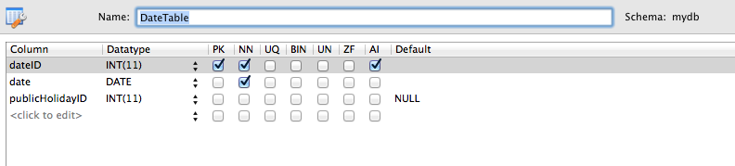

1. <?php
3. /* --------------------------------------------------------------------------------------
4. * CONSTANTS
5. *
6. * These constants should be used when refering to the table and the fields within its
7. * records.
8. * ------------------------------------------------------------------------------------- */
9. define("DATE_TABLE", "dateTable");
10. define("DATE_TABLE_DATE_ID", "dateID");
11. define("DATE_TABLE_DATE", "date");
12. define("DATE_TABLE_PUBLIC_HOL_ID", "publicHolidayID");
14. /* --------------------------------------------------------------------------------------
15. * Function CreateDateTable
16. *
17. * This function creates the SQL statement needed to construct the table
18. * in the database.
19. *
20. * @return (bool)  True if table is created successfully, false otherwise.
21. * ------------------------------------------------------------------------------------- */
23. **function** CreateDateTable() {
24. $sql = "CREATE TABLE IF NOT EXISTS `mydb`.`DateTable` (
25. `dateID` INT NULL AUTO_INCREMENT,
26. `date` DATE NOT NULL,
27. `publicHolidayID` INT NULL,
28. PRIMARY KEY (`dateID`));";
29. performSQL($sql);
30. }
32. /* --------------------------------------------------------------------------------------
33. * Function CreateDate
34. *
35. * This function creates a new Date record in the table.
36. *
37. * $dateParam (string) Date. Should be in the form YYYY-MM-DD
38. * $publicHolidayID (int) ID of the publicHoliday record associated with this record.
39. *                        May be NULL if date is not a public holiday.
40. *
41. * @return (array) If successful, an array is returned where each key represents a field
42. *                 in the record. If unsuccessful, the return will be NULL.
43. * ------------------------------------------------------------------------------------- */
45. **function** CreateDate($dateParam, $publicHolidayID) {
46. $date = NULL;
47. //--------------------------------------------------------------------------------
48. // Validate Input parameters
49. //--------------------------------------------------------------------------------
50. $inputIsValid = TRUE;
52. **if** (!isValidDate($dateParam)) {
53. error_log("Invalid date passed to CreateDate. value=" . $dateParam);
54. $inputIsValid = FALSE;
55. }
57. **if** ($publicHolidayID <> NULL) {
58. //ensure publicHolidayID exists in the database.
59. $record = RetrievePublicHolidayByID($publicHolidayID);
60. **if** ($record == NULL) {
61. error_log("publicHolidayID passed to CreateDate does not exist in " .
62. "the database. ID=" . $publicHolidayID);
63. $inputIsValid = FALSE;
64. }
65. }
67. //--------------------------------------------------------------------------------
68. // Only attempt to insert a record in the database if the input parameters are ok.
69. //--------------------------------------------------------------------------------
70. **if** ($inputIsValid) {
71. // Create an array with each field required in the record.
72. $date[DATE_TABLE_DATE_ID] = NULL;
73. $date[DATE_TABLE_DATE] = $dateParam;
74. $date[DATE_TABLE_PUBLIC_HOL_ID] = $publicHolidayID;
76. $success = sqlInsertDate($date);
77. **if** (!$success) {
78. error_log("Failed to create Date. " . print_r($date));
79. $date = NULL;
80. }
81. }
83. **return** $date;
84. }
86. /* --------------------------------------------------------------------------------------
87. * Function sqlInsertDate
88. *
89. * This function constructs the SQL statement required to insert a new record
90. * into the Date table.
91. *
92. * &$date(array) Array containing all of the fields required for the record.
93. *
94. * @return (bool) TRUE if insert into database was successful, false otherwise.
95. *
96. * Note: If successful then the DATE_TABLE_DATE_ID entry in the
97. * array passed by the caller will be set to the ID of the record in the database.
98. * ------------------------------------------------------------------------------------- */
100. **function** sqlInsertDate(&$date) {
101. $sql = "INSERT INTO DateTable (date,publicHolidayID) " .
102. "VALUES ('" . $date[DATE_TABLE_DATE] . "',";

105. **if** ($date[DATE_TABLE_PUBLIC_HOL_ID] <> NULL) {
106. $sql = $sql . "'" . $date[DATE_TABLE_PUBLIC_HOL_ID] . "');";
107. } **else** {
108. $sql = $sql . "NULL);";
109. }
111. $date[DATE_TABLE_DATE_ID] = performSQLInsert($sql);
113. **return** $date[DATE_TABLE_DATE_ID] <> 0;
114. }
116. /* --------------------------------------------------------------------------------------
117. * Function RetrieveDateByID
118. *
119. * This function uses the ID supplied as a parameter to construct an SQL select statement
120. * and then performs this query, returning an array containing the key value pairs of the
121. * record (or NULL if no record is found matching the id).
122. *
123. * $id (int) id of the record to retrieve from the database..
124. *
125. * @return (array) array of key value pairs representing the fields in the record, or
126. *                 NULL if no record exists with the id supplied.
127. * ------------------------------------------------------------------------------------- */
129. **function** RetrieveDateByID($id) {
130. $filter[DATE_TABLE_DATE_ID] = $id;
131. $resultArray = performSQLSelect(DATE_TABLE, $filter);
132. $result = NULL;
134. **if** (count($resultArray) == 1) {      //Check to see if record was found.
135. $result = $resultArray[0];
136. }
138. **return** $result;
139. }
141. /* --------------------------------------------------------------------------------------
142. * Function RetrievDates
143. *
144. * This function constructs the SQL statement required to query the Dates table.
145. *
146. * $filter (array) Optional parameter. If supplied, then the array should contain a set
147. *                 of key value pairs, where the keys correspond to one (or more) fields
148. *                 in the record (see constants at top of file) and the values correspond
149. *                 to the values to filter against (IE: The WHERE clause).
150. *
151. * @return (array) If successful, an array of arrays, where each element corresponds to
152. *                 a row from the query. If a failure occurs, return will be NULL.
153. * ------------------------------------------------------------------------------------- */
155. **function** RetrieveDates($filter = NULL) {
156. $inputIsValid = TRUE;
157. //--------------------------------------------------------------------------------
158. // Validate Input parameters
159. //--------------------------------------------------------------------------------
160. **if** ($filter <> NULL) {
161. **foreach** ($filter **as** $key => $value) {
162. **if** (strcmp($key, DATE_TABLE_DATE_ID) == 0) {
163. **if** (!is_numeric($value)) {
164. printCallStackAndDie();
165. error_log("Invalid DATE_TABLE_DATE_ID of " . $value .
166. " passed to RetrieveDates.");
167. $inputIsValid = FALSE;
168. }
169. } **else** **if** (strcmp($key, DATE_TABLE_DATE) == 0) {
170. **if** (!isValidDate($value)) {
171. error_log("Invalid DATE_TABLE_DATE of " . $value .
172. " passed to RetrieveDates.");
173. $inputIsValid = FALSE;
174. }
175. } **else** **if** (strcmp($key, DATE_TABLE_PUBLIC_HOL_ID) == 0) {
176. **if** (!is_numeric($value)) {
177. error_log("Invalid DATE_TABLE_PUBLIC_HOL_ID of " . $value .
178. " passed to RetrieveDates.");
179. $inputIsValid = FALSE;
180. }
181. } **else** {
182. error_log("Unknown Filter " . $key . " passed to RetrieveDates.");
183. $inputIsValid = FALSE;
184. }
185. }
186. }
188. //--------------------------------------------------------------------------------
189. // Only attempt to perform query in the database if the input parameters are ok.
190. //--------------------------------------------------------------------------------
191. $result = NULL;
192. **if** ($inputIsValid) {
193. $result = performSQLSelect(DATE_TABLE, $filter);
194. }
195. **return** $result;
196. }
198. /* --------------------------------------------------------------------------------------
199. * Function UpdateDate
200. *
201. * This function constructs the SQL statement required to update a row in
202. * the Date table.
203. *
204. * $fields (array) array of key value pairs, where keys correspond to fields in the
205. *                 record (see constants at start of this file). Note, this array
206. *                 MUST provide the id of the record (DATE_TABLE_DATE_ID) and one or more
207. *                 other fields to be updated.
208. *
209. * @return (bool) TRUE if update succeeds. FALSE otherwise.
210. * ------------------------------------------------------------------------------------- */
212. **function** UpdateDate($fields) {
213. //--------------------------------------------------------------------------------
214. // Validate Input parameters
215. //--------------------------------------------------------------------------------
216. $inputIsValid = TRUE;
217. $validID = false;
218. $countOfFields = 0;
220. **foreach** ($fields **as** $key => $value) {
221. **if** ($key == DATE_TABLE_DATE_ID) {
222. $record = RetrieveDateByID($value);
223. **if** ($record <> NULL) {
224. $validID = true;
225. $countOfFields++;
226. }
227. } **else** **if** ($key == DATE_TABLE_DATE) {
228. $countOfFields++;
230. **if** (!isValidDate($value)) {
231. error_log("Invalid DATE_TABLE_DATE passed to UpdateDate.");
232. $inputIsValid = FALSE;
233. }
234. } **else** **if** ($key == DATE_TABLE_PUBLIC_HOL_ID) {
235. $countOfFields++;
237. **if** ($value <> NULL)
238. {
239. $record = RetrievePublicHolidayByID($value);
240. **if** ($record == NULL) {
241. error_log("Invalid DATE_TABLE_PUBLIC_HOL_ID passed to UpdateDate.");
242. $inputIsValid = FALSE;
243. }
244. }
245. } **else** {
246. error_log("Invalid field passed to UpdateDate. $key=" . $key);
247. $inputIsValid = FALSE;
248. }
249. }
251. **if** (!$validID) {
252. error_log("No valid ID supplied in call to UpdateDate.");
253. $inputIsValid = FALSE;
254. }
256. **if** ($countOfFields < 2) {
257. error_log("Insufficent fields supplied in call to UpdateDate.");
258. $inputIsValid = FALSE;
259. }
261. //--------------------------------------------------------------------------------
262. // Only attempt to update a record in the database if the input parameters are ok.
263. //--------------------------------------------------------------------------------
264. $success = false;
266. **if** ($inputIsValid) {
267. $success = performSQLUpdate(DATE_TABLE, DATE_TABLE_DATE_ID, $fields);
268. }
269. **return** $success;
270. }
272. /* --------------------------------------------------------------------------------------
273. * Function DeleteDate
274. *
275. * This function constructs the SQL statement required to delete a row in
276. * the Date table.
277. *
278. * $ID(integer) ID of the record to be removed from the table. This should be set to
279. *              the DATE_TABLE_DATE_ID value of the record you wish to delete.
280. *
281. * @return (int) count of rows deleted. 0 means delete was unsuccessful.
282. * ------------------------------------------------------------------------------------- */
284. **function** DeleteDate($ID) {
285. $result = 0;
287. $date = RetrieveDateByID($ID);
288. **if** ($date <> NULL) {
289. $filter[APPR_ABS_BOOK_DATE_DATE_ID] = $date[DATE_TABLE_DATE_ID];
290. $approvedAbsenceBookingDates = RetrieveApprovedAbsenceBookingDates($filter);
292. **if** ($approvedAbsenceBookingDates <> NULL) {
293. **foreach** ($approvedAbsenceBookingDates **as** $value) {
294. DeleteApprovedAbsenceBooking($value[APPR_ABS_BOOK_DATE_ABS_BOOK_ID]);
295. }
296. }
298. **if** ($date[DATE_TABLE_PUBLIC_HOL_ID] <> NULL)
299. {
300. DeletePublicHoliday($date[DATE_TABLE_PUBLIC_HOL_ID]);
301. }
303. $sql = "DELETE FROM dateTable WHERE dateID=" . $ID . ";";
304. $result = performSQL($sql);
305. }
306. **return** $result;
307. }
309. /* --------------------------------------------------------------------------------------
310. * Function RetrieveDateRecordByDate
311. *
312. * This function uses the date supplied to locate the corresponding date record from
313. * the database.
314. *
315. * $date(string) string in the form YYYY-MM-DD for which the matching date table record
316. *               is needed.
317. *
318. * @return (array) array of key value pairs, representing the fields from the date record.
319. *                 Will be NULL if no matching record is found.
320. * ------------------------------------------------------------------------------------- */
321. **function** RetrieveDateRecordByDate($date)
322. {
323. $result = NULL;
325. $filter[DATE_TABLE_DATE] = $date;
326. $records = RetrieveDates($filter);
328. **if** (count($records) == 1)
329. {
330. $result = $records[0];
331. }
333. **return** $result;
334. }


338. /* --------------------------------------------------------------------------------------
339. * Function RetrievDateIDFromDate
340. *
341. * This function takes a string representing a date and returns the id of the date
342. * record in the database which matches this date.
343. * *
344. * $date (string) Date in the form YYYY-MM-DD.
345. * @return (int) If successful, this number is the key of the record in the databse
346. *               which is for the date supplied. If a failure occurs, will be NULL.
347. * ------------------------------------------------------------------------------------- */
349. **function** RetrieveDateIDByDate($date)
350. {
351. $result = NULL;
353. $record = RetrieveDateRecordByDate($date);
355. **if** ($record)
356. {
357. $result = $record[DATE_TABLE_DATE_ID];
358. }
360. **return** $result;
361. }
362. ?>

## Public Holiday Table

### File: PublicHolidayTable.php

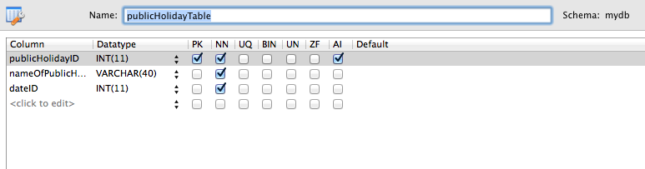

1. <?php
3. /* -----------------------------------------------------------------------------
4. * CONSTANTS
5. *
6. * These constants should be used when refering to the table and the fields
7. * within its records.
8. * -------------------------------------------------------------------------- */
9. define("PUBLIC_HOLIDAY_TABLE", "publicHolidayTable");
10. define("PUB_HOL_ID", "publicHolidayID");
11. define("PUB_HOL_NAME", "nameOfPublicHoliday");
12. define("PUB_HOL_DATE_ID", "dateID");
14. /* ----------------------------------------------------------------------------
15. * Function CreatePublicHolidayTable
16. *
17. * This function creates the SQL statement needed to construct the PublicHoliday
18. * table in the database.
19. *
20. * @return (bool)  True if table is created successfully, false otherwise.
21. * ---------------------------------------------------------------------------*/
23. **function** CreatePublicHolidayTable() {
24. $sql = "CREATE TABLE IF NOT EXISTS `mydb`.`publicHolidayTable` (
25. `publicHolidayID` INT NOT NULL AUTO_INCREMENT,
26. `nameOfPublicHoliday` VARCHAR(40) NOT NULL,
27. `dateID` INT NOT NULL,
28. PRIMARY KEY (`publicHolidayID`),
29. INDEX `fk_publicHoliday_Date_idx` (`dateID` ASC),
30. CONSTRAINT `fk_publicHoliday_Date`
31. FOREIGN KEY (`dateID`)
32. REFERENCES `mydb`.`DateTable` (`dateID`)
33. ON DELETE NO ACTION
34. ON UPDATE NO ACTION);";
35. performSQL($sql);
36. }
38. /* ----------------------------------------------------------------------------
39. * Function CreatePublicHoliday
40. *
41. * This function creates a new Absence Type row in the AbsenceTypeTable.
42. *
43. * $absenceTypeName (string) Textual name of the type of absence.
44. * $usesAnnual Leave (boolean) Whether or not this type of absence uses annual
45. *                             leave.
46. * $canBeDenied (boolean) Whether or not this type of absence can be denied.
47. *
48. * @return (array) If successful, an array is returned where each key represents
49. *                 a field in the record.
50. *                 If unsuccessful, the return will be NULL.
51. * ---------------------------------------------------------------------------*/
53. **function** CreatePublicHoliday($nameOfPublicHoliday, $dateID) {
54. $statusMessage = "";
56. $publicHoliday = NULL;
57. //-------------------------------------------------------------------------
58. // Validate Input parameters
59. //-------------------------------------------------------------------------
60. $inputIsValid = TRUE;
61. **if** (isNullOrEmptyString($nameOfPublicHoliday)) {
62. $statusMessage.="Name of public holiday can not be blank</br>";
63. error_log("Invalid name passed to CreatePublicHoliday.");
64. $inputIsValid = FALSE;
65. }
67. //-------------------------------------------------------------
68. // Check that a record with the DateID exists in the database.
69. //-------------------------------------------------------------
70. $dateRecord = RetrieveDateByID($dateID);
72. **if** ($dateRecord == NULL) {
73. $statusMessage.="Invalid Date supplied.</br>";
74. error_log("DateID passed to CreatePublicHoliday doesn't exist ".
75. "in database.");
76. $inputIsValid = FALSE;
77. }
79. **if** ($inputIsValid) {
80. //-------------------------------------------------------------
81. // Create the public holiday record in the database.
82. //-------------------------------------------------------------
83. $publicHoliday[PUB_HOL_ID] = NULL;
84. $publicHoliday[PUB_HOL_NAME] = $nameOfPublicHoliday;
85. $publicHoliday[PUB_HOL_DATE_ID] = $dateID;
87. $success = sqlInsertPublicHoliday($publicHoliday);
89. **if** (!$success) {
90. $statusMessage.="Unexpected error when inserting to database.</br>";
91. $inputIsValid = false;
92. error_log("Failed to create public holiday.");
93. $publicHoliday = NULL;
94. } **else** {
95. //-------------------------------------------------------------
96. // Update the date records public holiday ID field.
97. //-------------------------------------------------------------
98. $dateRecord[DATE_TABLE_PUBLIC_HOL_ID] = $publicHoliday[PUB_HOL_ID];
99. $success = UpdateDate($dateRecord);
101. **if** (!$success) {
102. $statusMessage.="Unexpected error when updating date table.</br>";
103. $inputIsValid = false;
104. error_log("Failed to update date reference to public holiday.");
105. $publicHoliday = NULL;
106. }
107. **else**
108. {
109. $statusMessage.="Record successfully created.</br>";
110. }
111. }
112. }
114. GenerateStatus($inputIsValid, $statusMessage);
115. **return** $publicHoliday;
116. }
118. /* ----------------------------------------------------------------------------
119. * Function sqlInsertPublicHoliday
120. *
121. * This function constructs the SQL statement required to insert a new record
122. * into the publicHolidayTable
123. *
124. * &$publicHoliday (array) Array containing all of the fields required for the
125. *                         record.
126. * @return (bool) TRUE if insert into database was successful, false otherwise.
127. *
128. * Note: If successful then the PUB_HOL_ID entry in the publicHoliday array
129. *   passed by the caller will be set to the ID of the record in the database.
130. * ---------------------------------------------------------------------------*/
132. **function** sqlInsertPublicHoliday(&$publicHoliday) {
133. $sql = "INSERT INTO publicHolidayTable (nameOfPublicHoliday,dateID) " .
134. "VALUES ('"
135. . $publicHoliday[PUB_HOL_NAME] . "','"
136. . $publicHoliday[PUB_HOL_DATE_ID] . "');";
138. $publicHoliday[PUB_HOL_ID] = performSQLInsert($sql);
139. **return** $publicHoliday[PUB_HOL_ID] <> 0;
140. }
142. /* ----------------------------------------------------------------------------
143. * Function RetrieveMainVacationRequestByID
144. *
145. * This function uses the ID supplied as a parameter to construct an SQL select
146. * statement and then performs this query, returning an array containing the key
147. * value pairs of the record (or NULL if no record is found matching the id).
148. *
149. * $id (int) id of the record to retrieve from the database..
150. *
151. * @return (array) array of key value pairs representing the fields in the
152. *                 record, or NULL if no record exists with the id supplied.
153. * --------------------------------------------------------------------------*/
155. **function** RetrievePublicHolidayByID($id) {
156. $filter[PUB_HOL_ID] = $id;
157. $resultArray = performSQLSelect(PUBLIC_HOLIDAY_TABLE, $filter);
159. $result = NULL;
161. **if** (count($resultArray) == 1) {      //Check to see if record was found.
162. $result = $resultArray[0];
163. }
165. **return** $result;
166. }
168. /* ----------------------------------------------------------------------------
169. * Function RetrievePublicHolidays
170. *
171. * This function constructs the SQL statement required to query the
172. * PublicHolidayTable.
173. *
174. * $filter (array) Optional parameter. If supplied, then the array should
175. *                 contain a set of key value pairs, where the keys correspond
176. *                 to one (or more) fields in the record (see constants at top
177. *                 of file) and the values correspond to the values to filter
178. *                 against (IE: The WHERE clause).
179. *
180. * @return (array) If successful, an array of arrays, where each element
181. *                 corresponds to a row from the query. If a failure occurs,
182. *                 return will be NULL.
183. * ---------------------------------------------------------------------------*/
185. **function** RetrievePublicHolidays($filter = NULL) {
186. $inputIsValid = TRUE;
188. //-------------------------------------------------------------------------
189. // Validate Input parameters
190. //-------------------------------------------------------------------------
191. **if** ($filter <> NULL) {
192. **foreach** ($filter **as** $key => $value) {
193. **if** (strcmp($key, PUB_HOL_ID) == 0) {
194. **if** (!is_numeric($value)) {
195. error_log("Invalid PUB_HOL_ID of " . $value .
196. " passed to RetrievePublicHolidays.");
197. $inputIsValid = FALSE;
198. }
199. } **else** **if** (strcmp($key, PUB_HOL_NAME) == 0) {
200. **if** (isNullOrEmptyString($value)) {
201. error_log("Invalid PUB_HOL_NAME passed to ".
202. "RetrievePublicHolidays.");
203. $inputIsValid = FALSE;
204. }
205. } **else** **if** (strcmp($key, PUB_HOL_DATE_ID) == 0) {
206. **if** (!is_numeric($value)) {
207. error_log("Invalid PUB_HOL_DATE_ID of " . $value .
208. " passed toRetrievePublicHolidays.");
209. $inputIsValid = FALSE;
210. }
211. } **else** {
212. error_log("Unknown Filter " . $key . " passed to ".
213. "RetrievePublicHolidays.");
214. $inputIsValid = FALSE;
215. }
216. }
217. }
219. //-------------------------------------------------------------------------
220. // Only attempt to perform query in the database if the input parameters
221. // are ok.
222. //-------------------------------------------------------------------------
223. $result = NULL;
224. **if** ($inputIsValid) {
225. $result = performSQLSelect(PUBLIC_HOLIDAY_TABLE, $filter);
226. }
227. **return** $result;
228. }
230. /* ----------------------------------------------------------------------------
231. * Function UpdatePublicHoliday
232. *
233. * This function constructs the SQL statement required to update a row in
234. * the publicHolidayTable.
235. *
236. * $fields (array) array of key value pairs, where keys correspond to fields
237. *                 in the record (see constants at start of this file). Note,
238. *                 this array MUST provide the id of the record (PUB_HOL_ID)
239. *                 and one or more other fields to be updated.
240. *
241. * @return (bool) TRUE if update succeeds. FALSE otherwise.
242. * --------------------------------------------------------------------------*/
244. **function** UpdatePublicHoliday($fields) {
245. $statusMessage = "";
246. //-------------------------------------------------------------------------
247. // Validate Input parameters
248. //-------------------------------------------------------------------------
249. $inputIsValid = TRUE;
250. $validID = false;
251. $countOfFields = 0;
252. $oldDateRecord = NULL;
254. **foreach** ($fields **as** $key => $value) {
255. **if** ($key == PUB_HOL_ID) {
256. $record = RetrievePublicHolidayByID($value);
257. **if** ($record <> NULL) {
258. $validID = true;
259. $countOfFields++;
260. $oldDateRecord = RetrieveDateByID($record[PUB_HOL_DATE_ID]);
261. }
262. } **else** **if** ($key == PUB_HOL_NAME) {
263. $countOfFields++;
265. **if** (isNullOrEmptyString($value)) {
266. $statusMessage.="Public holiday name must be entered.</br>";
267. error_log("Invalid PUB_HOL_NAME passed to UpdatePublicHoliday.");
268. $inputIsValid = FALSE;
269. }
270. } **else** **if** ($key == PUB_HOL_DATE_ID) {
271. $countOfFields++;
273. $record = RetrieveDateByID($value);
275. **if** ($record == NULL) {
276. $statusMessage.="Unable to located date in database.</br>";
277. error_log("Invalid  PUB_HOL_DATE_ID passed to UpdatePublicHoliday.");
278. $inputIsValid = FALSE;
279. }
280. } **else** {
281. $statusMessage.="Unexpected field encountered in input.</br>";
282. error_log("Invalid field passed to UpdatePublicHoliday.");
283. $inputIsValid = FALSE;
284. }
285. }
287. **if** (!$validID) {
288. $statusMessage.="No valid ID supplied in call to UpdatePublicHoliday.</br>";
289. error_log("No valid ID supplied in call to UpdatePublicHoliday.");
290. $inputIsValid = FALSE;
291. }
293. **if** ($countOfFields < 2) {
294. $statusMessage.="Insufficent fields supplied in call to UpdatePublicHoliday.</br>";
295. error_log("Insufficent fields supplied in call to UpdatePublicHoliday.");
296. $inputIsValid = FALSE;
297. }
299. //--------------------------------------------------------------------------
300. // Only attempt to update a record in the database if the input parameters
301. // are ok.
302. //--------------------------------------------------------------------------
303. $success = false;
305. **if** ($inputIsValid) {
306. $success = performSQLUpdate(PUBLIC_HOLIDAY_TABLE, PUB_HOL_ID, $fields);
307. **if** ($success)
308. {
309. $oldDateRecord[DATE_TABLE_PUBLIC_HOL_ID] = NULL;
310. $success = UpdateDate($oldDateRecord);
312. $dateRecord = RetrieveDateByID($fields[PUB_HOL_DATE_ID]);
313. //-------------------------------------------------------------
314. // Update the date records public holiday ID field.
315. //-------------------------------------------------------------
316. $dateRecord[DATE_TABLE_PUBLIC_HOL_ID] = $fields[PUB_HOL_ID];
317. $success = UpdateDate($dateRecord);
319. $statusMessage.="Record successfully updated.</br>";
320. }
321. **else**
322. {
323. $statusMessage.="Unexpected error when updating the database.</br>";
324. $inputIsValid = false;
325. }
326. }
328. GenerateStatus($inputIsValid, $statusMessage);
329. **return** $success;
330. }
332. /* -----------------------------------------------------------------------------
333. * Function DeletePublicHoliday
334. *
335. * This function constructs the SQL statement required to delete a row in
336. * the PublicHolidayTable.
337. *
338. * $ID(integer) ID of the record to be removed from the table. This should be
339. *              set to the PUB_HOL_ID value of the record you wish to delete.
340. *
341. * @return (int) count of rows deleted. 0 means delete was unsuccessful.
342. * ---------------------------------------------------------------------------*/
344. **function** DeletePublicHoliday($ID) {
345. $result = 0;
346. $record = RetrievePublicHolidayByID($ID);
348. **if** ($record <> NULL) {
349. $date = RetrieveDateByID($record[PUB_HOL_DATE_ID]);
350. $date[DATE_TABLE_PUBLIC_HOL_ID] = NULL;
351. UpdateDate($date);
353. $sql = "DELETE FROM publicHolidayTable WHERE publicHolidayID=". $ID. ";";
354. $result = performSQL($sql);
355. }
356. GenerateStatus(true,"Record successfully deleted.");
357. **return** $result;
358. }  ?>

## EMAIL Functions

### File: mailFunctions.php

1. <?php
3. /* -----------------------------------------------------------------------------
4. * Function SendApprovedEmail
5. *
6. * This function creates and sends an email to an employee, informing them that
7. * an absence booking request has been approved.
8. *
9. * $employeeID (int) id for the employee that the email should be sent to.
10. * $startDate (string) date that the booking starts in the form YYYY-MM-DD
11. * $endDate (string) date that the booking ends in the form YYYY-MM-DD
12. * @return (bool)  TRUE if email was generated successfully, FALSE otherwise.
13. * -------------------------------------------------------------------------- */
14. **function** SendApprovedEmail($employeeID,$startDate,$endDate)
15. {
16. $employee   = RetrieveEmployeeByID($employeeID);
17. $to     = $employee[EMP_EMAIL];
18. $from   = "admin@absencetrackingsystem.com";
20. $subject    = "ABSENCE REQUEST APPROVED";
21. $message    = "Your request for absence between the dates of ".
22. "$startDate and $endDate has been approved.";
24. $result = mail($to,$subject,$message);
25. **return** $result;
26. }

29. /* -----------------------------------------------------------------------------
30. * Function SendDeniedEmail
31. *
32. * This function creates and sends an email to an employee, informing them that
33. * an absence booking request has been denied.
34. *
35. * $employeeID (int) id for the employee that the email should be sent to.
36. * $startDate (string) date that the booking starts in the form YYYY-MM-DD
37. * $endDate (string) date that the booking ends in the form YYYY-MM-DD
38. * $reason (string) reason for denial.
39. * @return (bool)  TRUE if email was generated successfully, FALSE otherwise.
40. * -------------------------------------------------------------------------- */
41. **function** SendDeniedEmail($employeeID,$startDate,$endDate,$reason)
42. {
43. $employee   = RetrieveEmployeeByID($employeeID);
44. $to     = $employee[EMP_EMAIL];
45. $from   = "admin@absencetrackingsystem.com";
47. $subject    = "ABSENCE REQUEST DENIED";
48. $message    = "Unfortunatly, your request for absence between the dates of ".
49. "$startDate and $endDate has been denied. Reason: $reason";
51. $result = mail($to,$subject,$message);
52. **return** $result;
53. }

56. /* -----------------------------------------------------------------------------
57. * Function SendEmailToOfficeManager
58. *
59. * This function creates and sends an email to the office managers informing them
60. * of a staff shortfall due to a booking that can not be disallowed taking place
61. * during a time period which will take the number of people in that role below
62. * the minimum number defined for that role.
63. *
64. * $employeeID (int) id for the employee that has requested the leave.
65. * $startDate (string) date that the booking starts in the form YYYY-MM-DD
66. * $endDate (string) date that the booking ends in the form YYYY-MM-DD
67. * $absenceType (int) id for the type of absence.
68. * @return (bool)  TRUE if email was generated successfully, FALSE otherwise.
69. * -------------------------------------------------------------------------- */
70. **function** SendShortfallAlertToOfficeManager($employeeID,$startDate,$endDate,$absenceTypeID)
71. {
72. $employee   = RetrieveEmployeeByID($employeeID);
73. $employeeName   = $employee[EMP_NAME];
75. $absenceType    = RetrieveAbsenceTypeByID($absenceTypeID);
76. $absenceName    = $absenceType[ABS_TYPE_NAME];
78. $role           = RetrieveCompanyRoleByID($employee[EMP_COMPANY_ROLE]);
79. $roleName       = $role[COMP_ROLE_NAME];
80. $minimumStaff   = $role[COMP_ROLE_MIN_STAFF];
82. $from           = "admin@absencetrackingsystem.com";
84. $subject    = "URGENT: STAFF SHORTFALL";
85. $message    = "Between $startDate and $endDate the number of staff performing the ".
86. "role of $roleName will be below $minimumStaff.".
87. "This is due to $employeeName being absent with $absenceName.";

90. $filter[EMP_MANAGER_PERM] = 1;
91. $managers = RetrieveEmployees($filter);
93. $success = TRUE;
94. **foreach** ($managers **as** $manager)
95. {
96. **if** (! mail($manager[EMP_EMAIL],$subject,$message))
97. {
98. $success = FALSE;
99. }
100. }
101. **return** $success;
102. }
104. /* -----------------------------------------------------------------------------
105. * Function SendResubmitMainValcationRequest
106. *
107. * This function creates and sends an email to an employee, asking them to resubmit
108. * their main vacation request.
109. *
110. * $employeeID (int) id for the employee that the email should be sent to.
111. * @return (bool)  TRUE if email was generated successfully, FALSE otherwise.
112. * -------------------------------------------------------------------------- */
113. **function** SendResubmitMainVacationRequest($employeeID)
114. {
115. $employee   = RetrieveEmployeeByID($employeeID);
116. $to         = $employee[EMP_EMAIL];
117. $from       = "admin@absencetrackingsystem.com";
119. $subject    = "URGENT: NEW MAIN VACATION REQUEST NEEDED";
120. $message    = "Unfortunatly, both of your main vacation choices are unavailable.".
121. "Please submit a new Main Vacation Request with two new choices.";
123. $result = mail($to,$subject,$message);
124. **return** $result;
125. }
126. ?>

# system testing

## LOGIN

|  |  |  |  |  |  |
| --- | --- | --- | --- | --- | --- |
| Test ID | description | data type | expected result | pass / fail | cross reference |
| 1.1 | Users email with correct password login succeeds. | typical | User is logged in and the main index page is displayed | PASS | Figure 18 |
| 1.2 | Users email with Incorrect password login denied | erroneous | Red error status bar shows password is incorrect. User is not logged in. | PASS | Figure 19 |
| 1.3 | Unknown user email with password login denied. | erroneous | Red error status bar shows “no matching email address found”. User is not logged in. | PASS | Figure 20 |
| 1.4 | Empty email and empty password login denied. | erroneous | Red error status bar shows “You must enter an email address”. User is not logged in. | PASS | Figure 21 |
| 1.5 | Valid email address with empty password login denied. | erroneous | Red error status bar shows “You must enter a password”. User is not logged in. | PASS | Figure 22 |

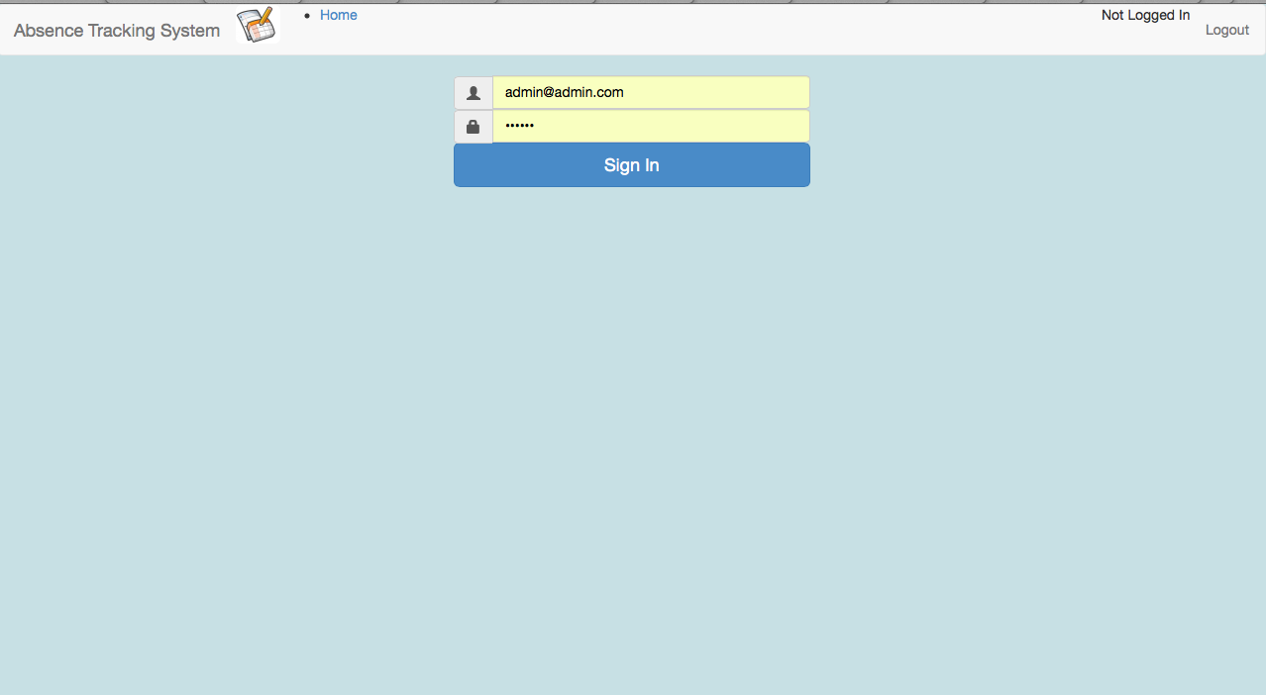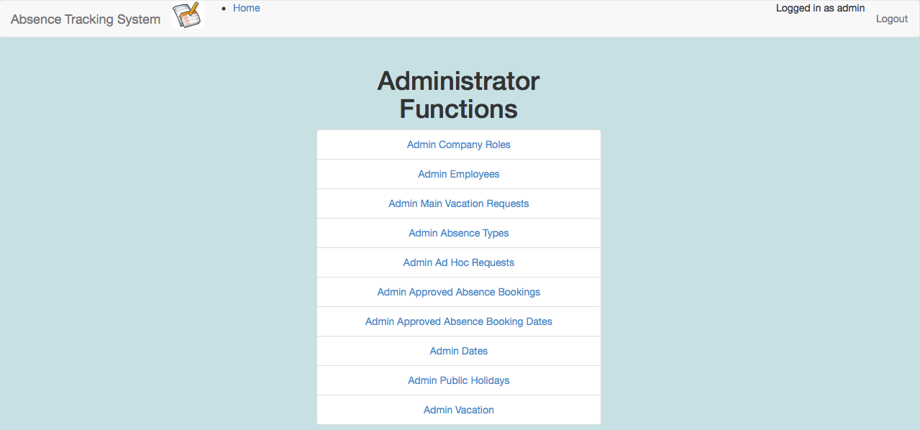

Figure 18 - Test 1.1 Output

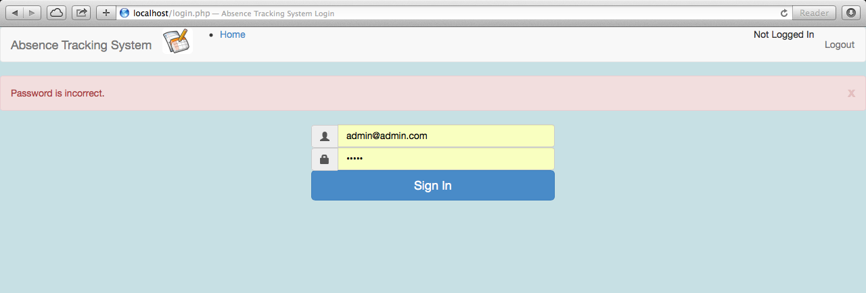

Figure 19 - Test 1.2 Output

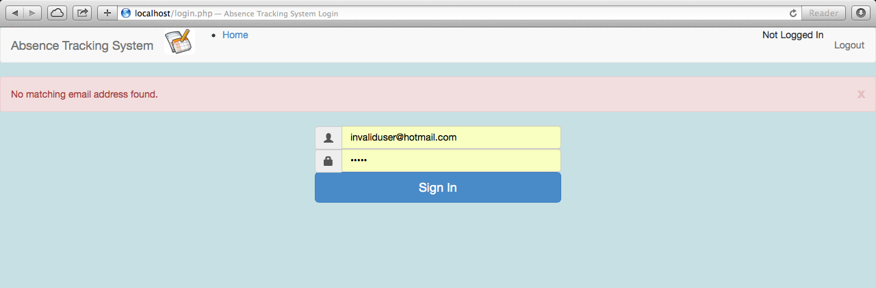

Figure 20 - Test 1.3 Output

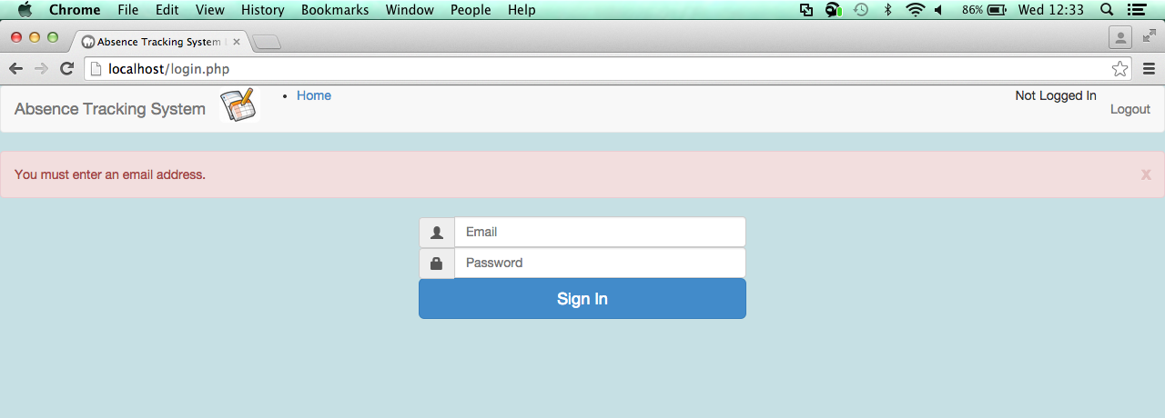

Figure 21 - Test 1.4 Output

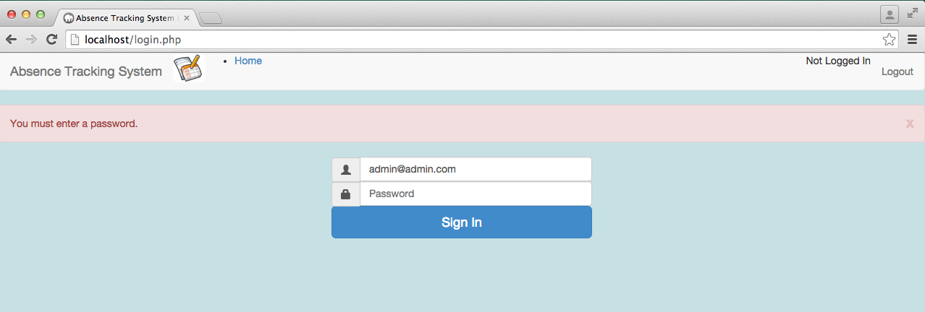

Figure 22 - Test 1.5 Output

## ADMIN COMPANY ROLES PAGE

| Test ID | description | data type | expected result | pass / fail | cross reference |
| --- | --- | --- | --- | --- | --- |
| 3.1 | Enter company role name of “Team Leader” with minimum staff level set to 1.  Click on “Add Role” | typical | Green success status bar shows “Company role created successfully”.  Current company roles table on page shows the team leader role with a minimum staffing level of 1.  Using MySQL workbench, Database query of the CompanyRole table shows a record for the new team leader role. | PASS | Figure 23  Figure 24 |
| 3.2 | Leave company role name blank.  Click on “Add Role” | erroneous | Red error status bar shows “Invalid company Role name.” No record is added to the Current company roles table. | PASS | Figure 25 |
| 3.3 | Following successful completion of test 3.1, Enter company role name of “Team Leader” with minimum staff level set to 1.  Click on “Add Role” | erroneous | Red error status bar shows “A role with this name already exists in the database.”  No record is added to the current company roles table | FAIL | Figure 26 |
|  | **NOTE TEST 3.3 FAILED BUT WAS THEN RERUN AFTER A FIX HAD BEEN MADE TO THE CODE. SEE SECTION 0 ON PAGE 282 FOR DETAILS OF FIX** |  |  |  |  |
| 3.3 | Following successful completion of test 3.1, Enter company role name of “Team Leader” with minimum staff level set to 1.  Click on “Add Role” | Erroneous | Red error status bar shows “A role with this name already exists in the database.”  No record is added to the current company roles table | PASS | **Error! Reference source not found.**  **Error! Reference source not found.** |
| 3.4 | Click on Delete button for Team Leader Role. | Typical | Green success status bar shows “Record deleted”.  Team Leader role disappears from Current Company Role table.  Using MySQL workbench, Database query of the CompanyRole table shows no record for a team leader role. | PASS | Figure 27  Figure 28 |
| 3.5 | Click on Amend Button for Cashier  Click on the Cancel Button on the editCompanyRole.php page you are redirected to. | Typical | Page will redirect to editCompanyRole.php, displaying details for the Cashier role.  Upon clicking cancel, you will return to the adminCompanyRole.php page. | PASS | Figure 29 |
| 3.6 | Click on Amend Button for Cashier.  Modify the “Cashier” role name to “Cashiers”.  Modify the minimum staff level from 3 to 1.  Click on the Update Button. | Typical | Page will redirect to editCompanyRole.php, displaying details for the Cashier role.  Upon clicking Update, you will return to the adminCompanyRole.php page.  Green success status bar shows “Record successfully updated”.  In the Current Company Roles table, the record now shows as Cashiers with a minimum staffing level of 1. | PASS | Figure 30 |
| 3.7 | Click on Amend Button for Cashiers.  Delete all text in the Cashiers role name, making the field empty.  Click on the Update Button | Erroneous | Page will redirect to editCompanyRole.php, displaying details for the Cashier role.  Upon clicking Updatea red error status bar shows “You must enter a company role name.” | PASS | Figure 31 |

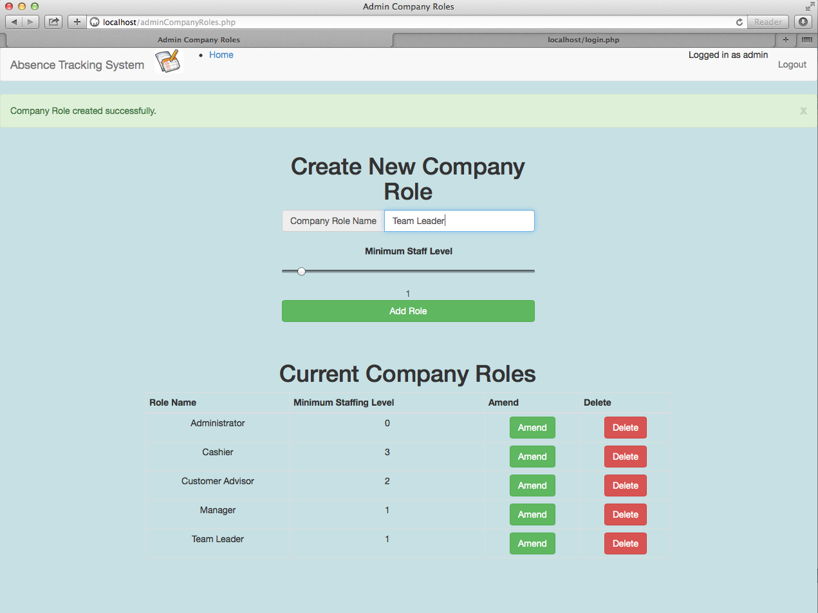

Figure 23 - Test 3.1 Output

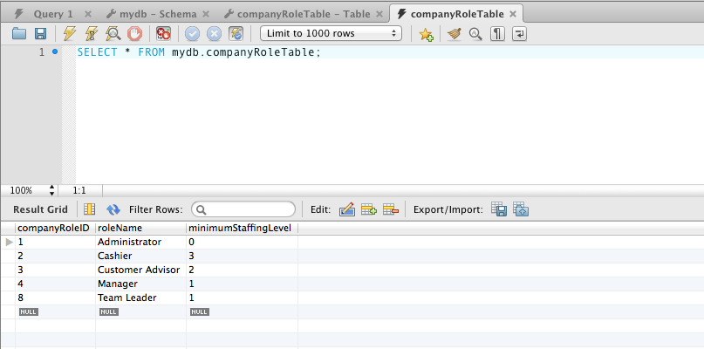

Figure 24 - Test 3.1 – Database table

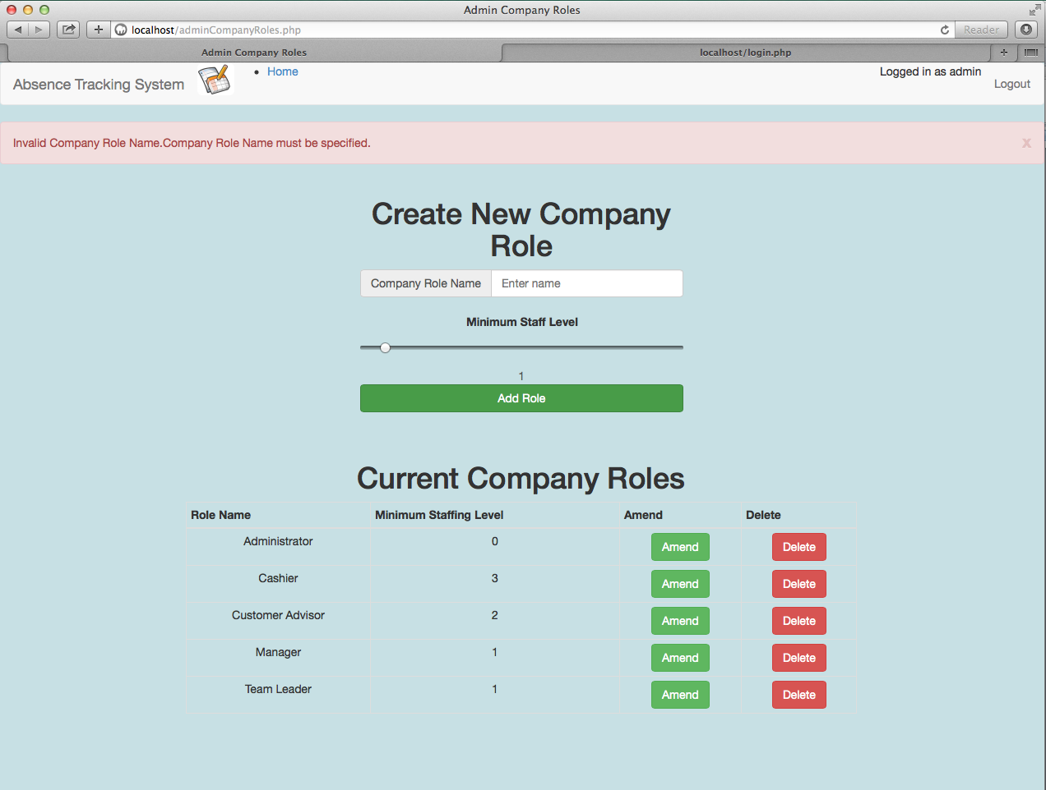

Figure 25 - Test 3.2 Output

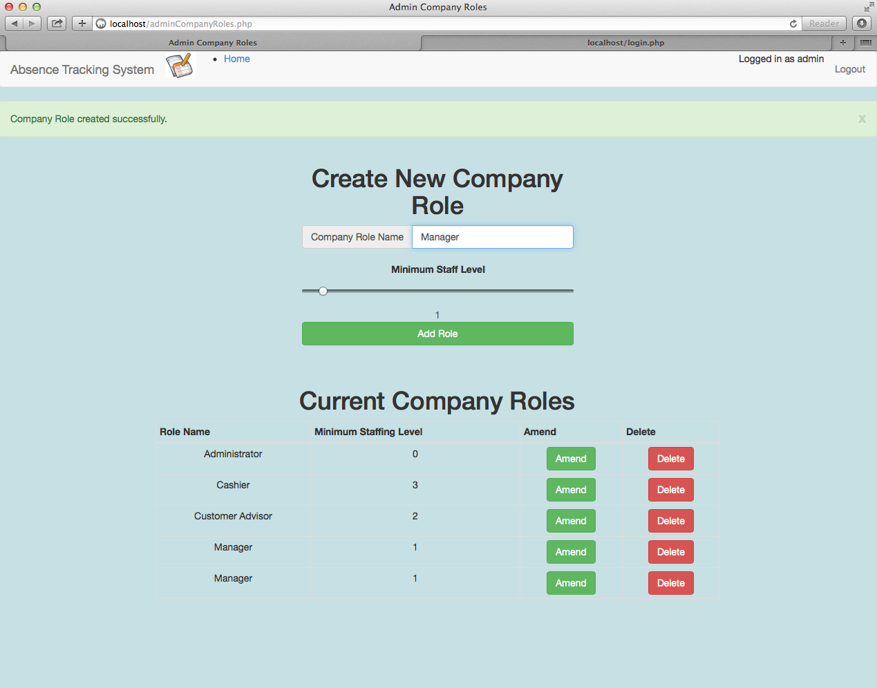

Attempting to create a Role using a name that already exists. This **SHOULD** fail.

Result = two manager roles in the table. This is an error.

Attempt did **NOT** fail.

Figure 26 - Test 3.3 FAILED Output

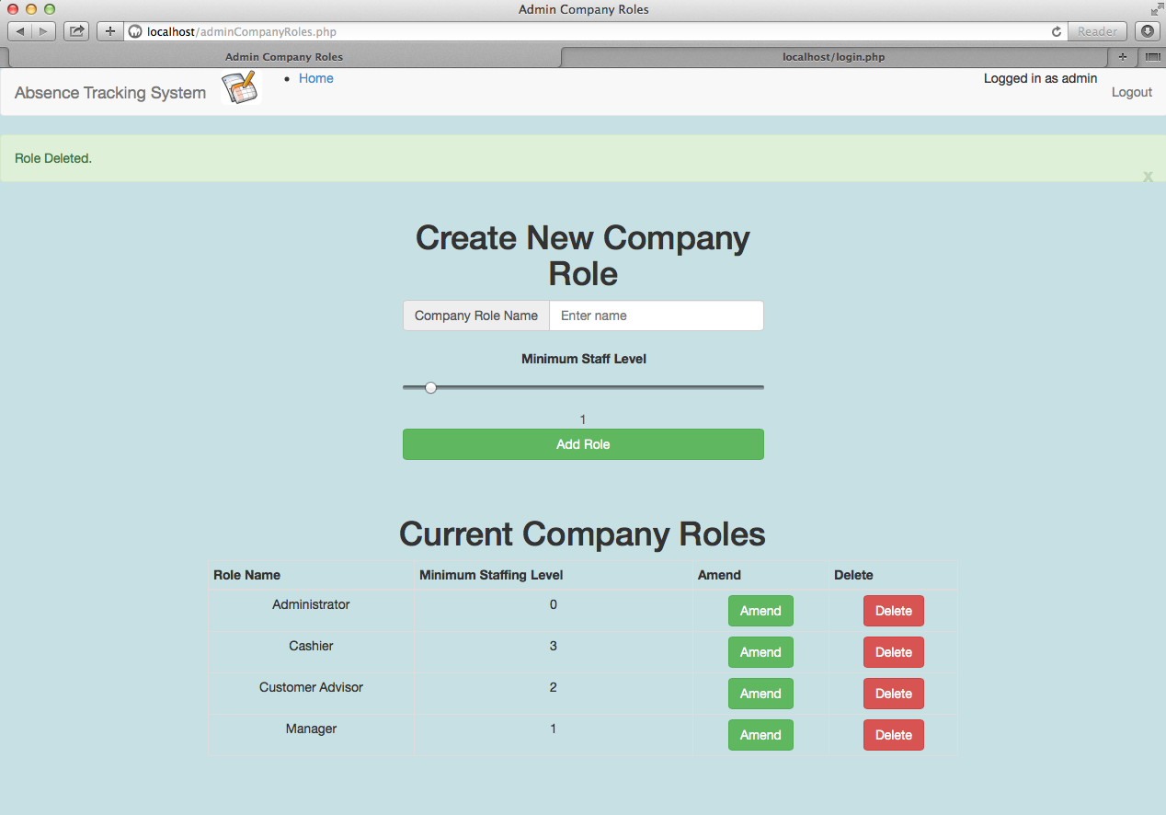

Figure 27 – Test 3.4 Output

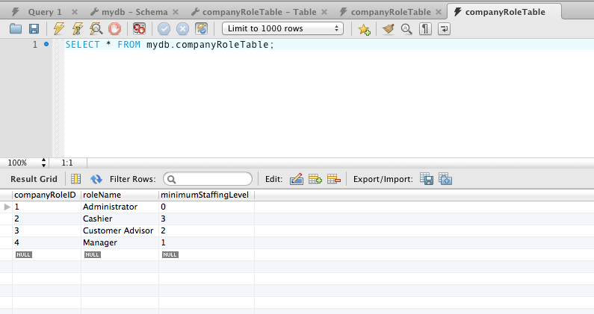

Figure 28 - Test 3.4 – Database table

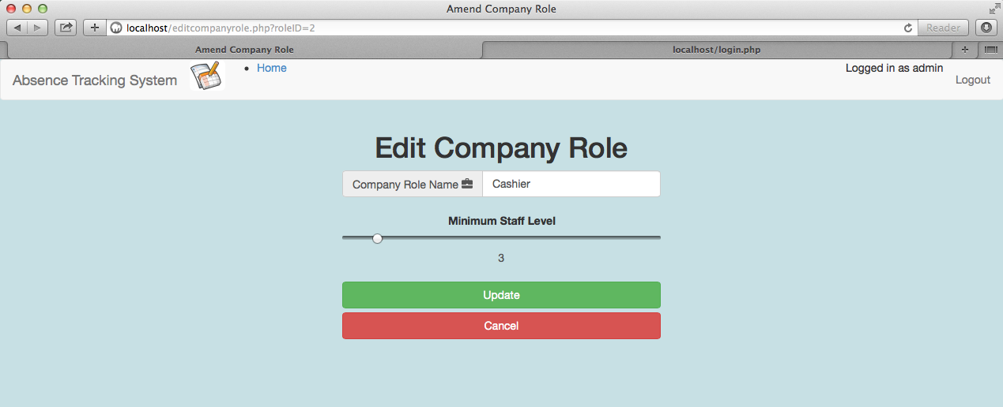

Figure 29 - Test 3.5 Output

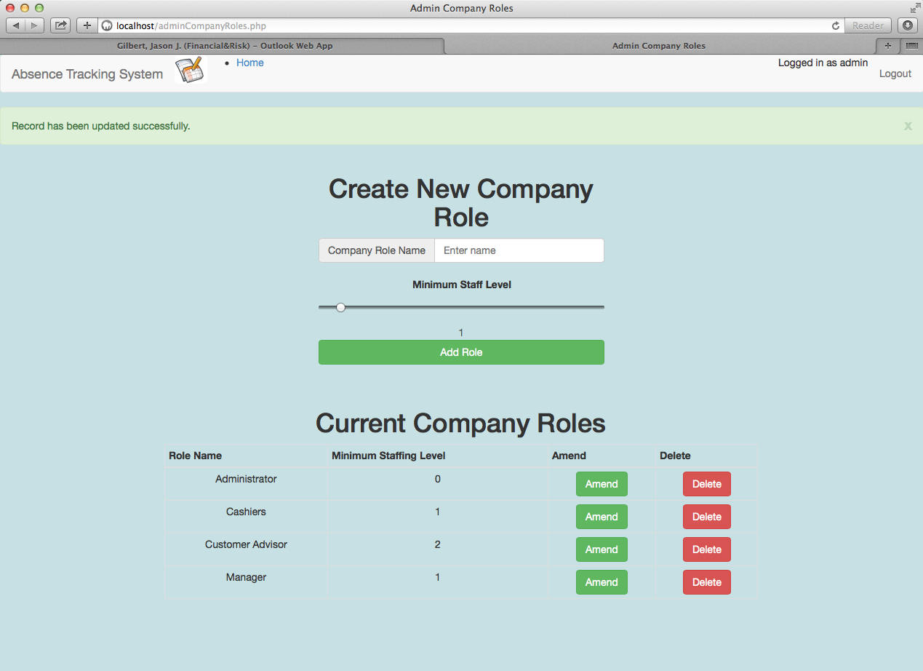

Figure 30 - Test 3.6 Output

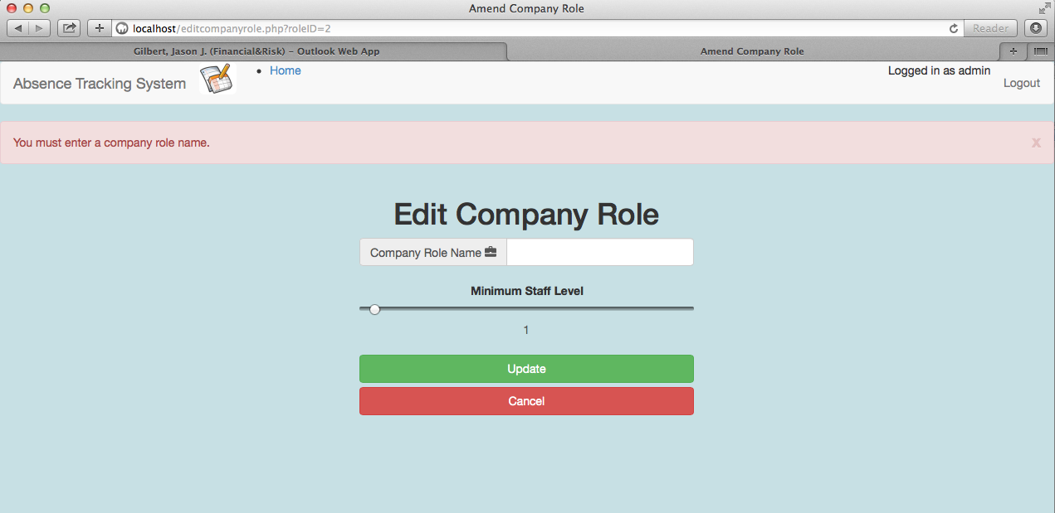

Figure 31 - Test 3.7 Output

## ADMIN EMPLOYEES PAGE

| Test ID | description | data type | expected result | pass / fail | cross reference |
| --- | --- | --- | --- | --- | --- |
| 4.1 | Enter a name of John Smith  Enter an email of [johnsmith@example.com](mailto:johnsmith@example.com)  Enter a password of Zaq12wsx  Select a date of 01/01/2015  Select a company role of Cashier  Set an annual leave entitlement of 25  Set the isManager checkbox.  Click Add Employee | Typical | Green success status bar shows “Record created successfully”.  Current employees table on page shows an entry for this new employee.  Using MySQL workbench, Database query of the Employee table shows a record for the new employee with all values except password set to the values entered. Password will show as a long encrypted value. | PASS | Figure 32  Figure 33  Figure 34 |
| 4.2 | Enter a name of Jane Doe  Enter an email of [johnsmith@example.com](mailto:johnsmith@example.com)  Enter a password of Zaq12wsx  Select a date of 01/01/2015  Select a company role of Cashier  Set an annual leave entitlement of 25  Set the isManager checkbox.  Click Add Employee | Erroneous | Red error status bar shows “Unable to create record as user with email address [johnsmith@example.com](mailto:johnsmith@example.com) already exists.”  No new entry created in Current Employee table. | PASS | Figure 35 |
| 4.3 | Leave name field blank  Enter an email of [janedoe@example.com](mailto:janedoe@example.com)  Enter a password of Zaq12wsx  Select a date of 01/01/2015  Select a company role of Cashier  Set an annual leave entitlement of 25  Set the isManager checkbox.  Click Add Employee | Erroneous | Red error status bar shows “Employee name can not be blank.”  No new entry created in Current Employee table. | PASS | Figure 36 |
| 4.4 | Enter Name of Jane Doe  Leave Email address blank  Enter a password of Zaq12wsx  Select a date of 01/01/2015  Select a company role of Cashier  Set an annual leave entitlement of 25  Set the isManager checkbox.  Click Add Employee | Erroneous | Red error status bar shows “Email Address given is not a valid email format.”  No new entry created in Current Employee table. | PASS | Figure 37 |
| 4.5 | Enter Name of Jane Doe  Enter email address of JaneDoeexample.com (Note: missing the @ symbol).  Enter a password of Zaq12wsx  Select a date of 01/01/2015  Select a company role of Cashier  Set an annual leave entitlement of 25  Set the isManager checkbox.  Click Add Employee | Erroneous | Red error status bar shows “Email Address given is not a valid email format.”  No new entry created in Current Employee table. | PASS | Figure 38 |
| 4.6 | Enter Name of Jane Doe  Enter email address of JaneDoe@example.  Enter a password of zaq12wsx (note no capital letters)  Select a date of 01/01/2015  Select a company role of Cashier  Set an annual leave entitlement of 25  Set the isManager checkbox.  Click Add Employee | Erroneous | Red error status bar shows “Password must include at least one capital letter.”  No new entry created in Current Employee table. | PASS | Figure 39 |
| 4.7 | Enter Name of Jane Doe  Enter email address of JaneDoe@example.  Enter a password of ZAQ12WSX (note no lower case letters)  Select a date of 01/01/2015  Select a company role of Cashier  Set an annual leave entitlement of 25  Set the isManager checkbox.  Click Add Employee | Erroneous | Red error status bar shows “Password must include at least one lower case letter.”  No new entry created in Current Employee table. | PASS | Figure 40 |
| 4.8 | Enter Name of Jane Doe  Enter email address of JaneDoe@example.  Enter a password of Zaqqqwsx (note no numeric values)  Select a date of 01/01/2015  Select a company role of Cashier  Set an annual leave entitlement of 25  Set the isManager checkbox.  Click Add Employee | Erroneous | Red error status bar shows “Password must include at least one number.”  No new entry created in Current Employee table. | PASS | Figure 41 |
| 4.9 | Enter Name of Jane Doe  Enter email address of JaneDoe@example.  Enter a password of Zaq1 (note less than 6 characters)  Select a date of 01/01/2015  Select a company role of Cashier  Set an annual leave entitlement of 25  Set the isManager checkbox.  Click Add Employee | Erroneous | Red error status bar shows “Password must be at least 6 characters.”  No new entry created in Current Employee table. | PASS | Figure 42 |
| 4.10 | Enter Name of Jane Doe  Enter email address of JaneDoe@example.  Leave the password field empty  Select a date of 01/01/2015  Select a company role of Cashier  Set an annual leave entitlement of 25  Set the isManager checkbox.  Click Add Employee | Erroneous | Red error status bar shows:  “Password must be at least 6 characters.”  “Password must include at least one number.”  “Password must include at least one lower case letter.”  “Password must include at least one upper case letter.”  No new entry created in Current Employee table. | PASS | Figure 43 |
| 4.11 | Enter Name of Jane Doe  Enter email address of JaneDoe@example.  Enter a password of Zaq12wsx  Leave the date field empty  Select a company role of Cashier  Set an annual leave entitlement of 25  Set the isManager checkbox.  Click Add Employee | Erroneous | Red error status bar shows:  “Value given for date joined the company is not a valid date.”  No new entry created in Current Employee table. | PASS | Figure 44 |
| 4.12 | Locate the current employee table on the page and find the entry for John Smith.  Click the delete button. | Typical | Green success status bar shows “Record Deleted.”  Using MySQL workbench, Database query of the Employee table shows the record has been deleted from the database. | PASS | Figure 45  Figure 46  Figure 47 |
| 4.13 | Locate the current employee table on the page and find the entry for Sam Bailey.  Click the amend button. | Typical | User is redirected to the editEmployee.php page. Details displayed are for the employee Sam Bailey. | PASS | Figure 48 |
| 4.14 | Locate the current employee table on the page and find the entry for Sam Bailey.  Click the amend button.  Change the name of Sam Bailey to Samuel Bailey.  Click Edit Employee | Typical | User is redirected back to the adminEmployeeTable.php page.  Green success status bar shows “Record has been successfully updated.”  Current Employees Table on page shows Samuel Bailey.  Using MySQL workbench, Database query of the Employee table shows record now has name of “Samuel Bailey” | PASS | Figure 49  Figure 50 |
| 4.15 | Locate the current employee table on the page and find the entry for Samuel Bailey.  Click the amend button.  On the edit page, click cancel. | Typical | User is redirected back to the adminEmployeeTable.php page.  Using MySQL workbench, Database query of the Employee table shows no changes when compared with Figure 50). | PASS | Figure 51 |
| 4.16 | Locate the current employee table on the page and find the entry for Samuel Bailey.  Click the amend button.  Delete the employee name field so that it is empty.  Click on the Edit Employee | Erroneous | Red error status bar shows “Employee name can not be blank.”  No change is made to the record. | PASS | Figure 52 |
| 4.17 | Locate the current employee table on the page and find the entry for Samuel Bailey.  Click the amend button.  Delete the email field so that it is empty.  Click on the Edit Employee | Erroneous | Red error status bar shows “Employee address is not valid.”  No change is made to the record. | PASS | Figure 53 |
| 4.18 | Locate the current employee table on the page and find the entry for Samuel Bailey.  Click the amend button.  Delete the Date field so that it is empty.  Click on the Edit Employee | Erroneous | Red error status bar shows “Date Joined value is not a valid date”  No change is made to the record. | PASS | Figure 54 |

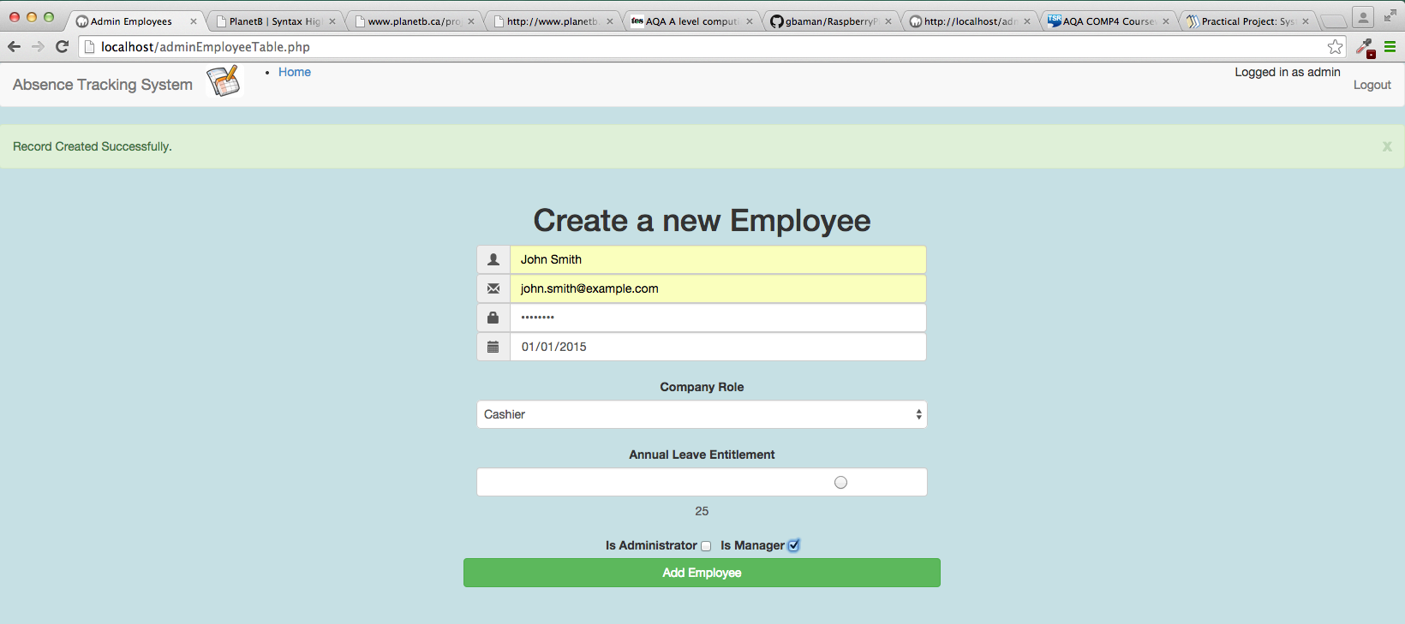

Figure 32 - Test 4.1 Record Created

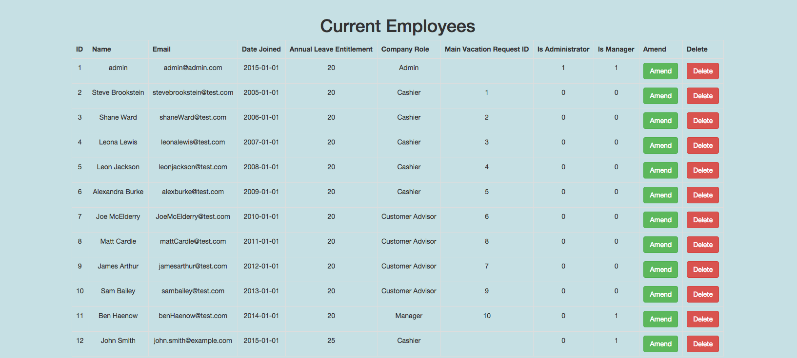

Figure 33 - Test 4.1 New Record shown in table.

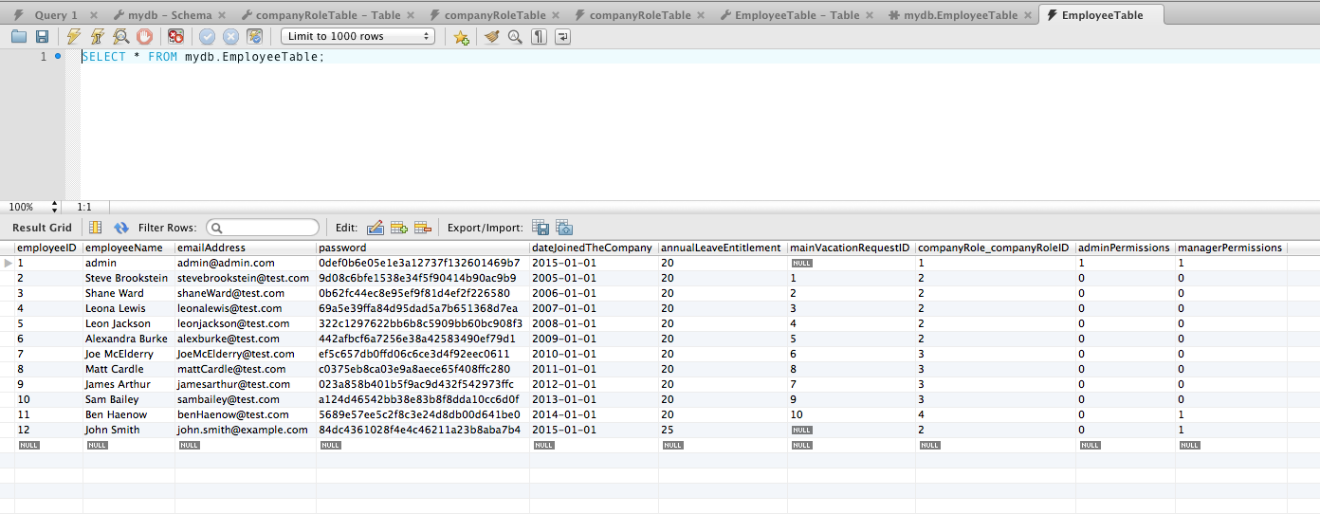

Figure 34 - Test 4.1 Record in the database.

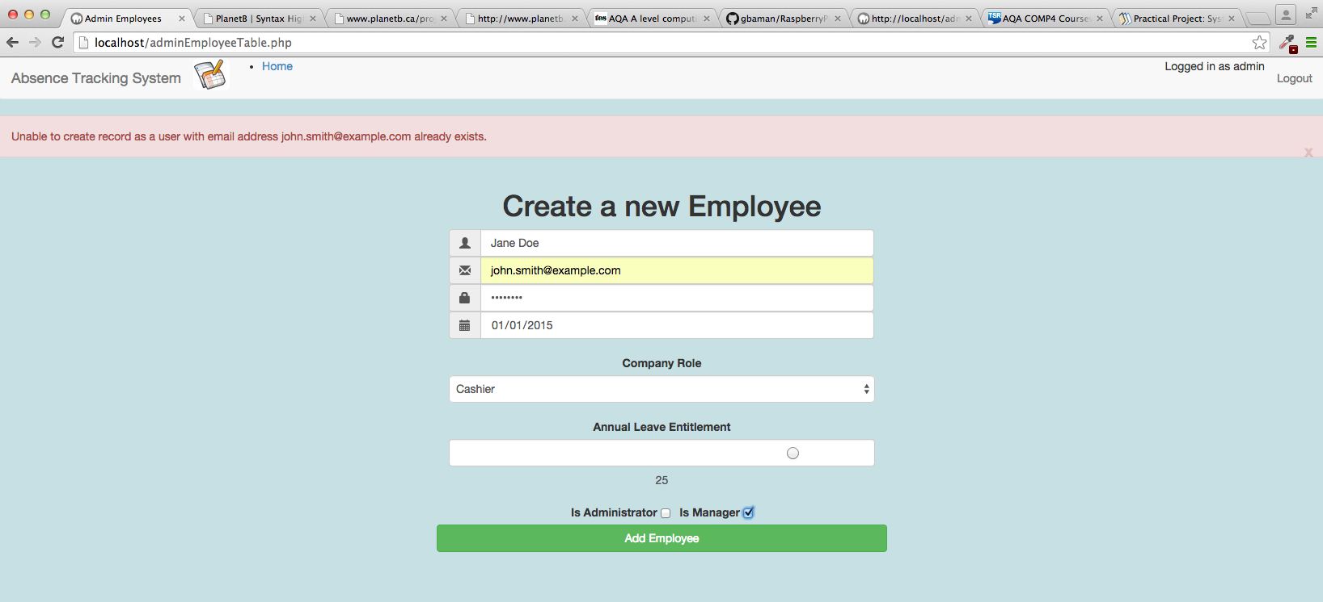

Figure 35 - Test 4.2 Output

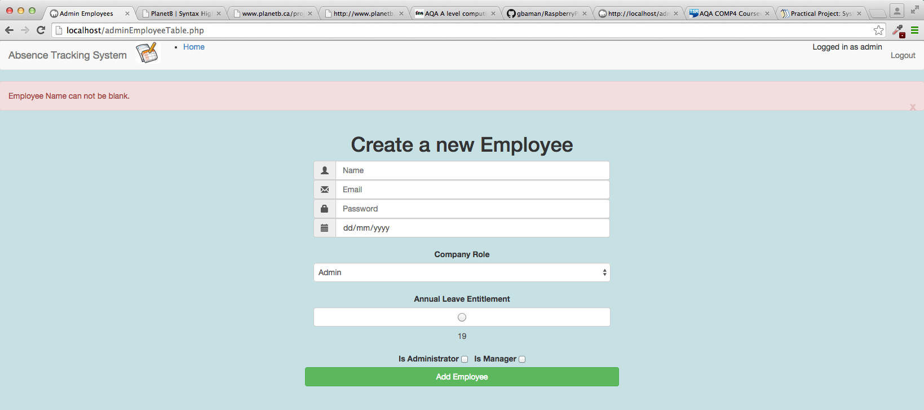

Figure 36 - Test 4.3 Output

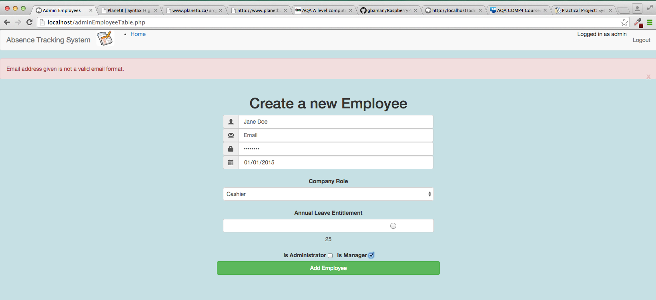

Figure 37 - Test 4.4 Output

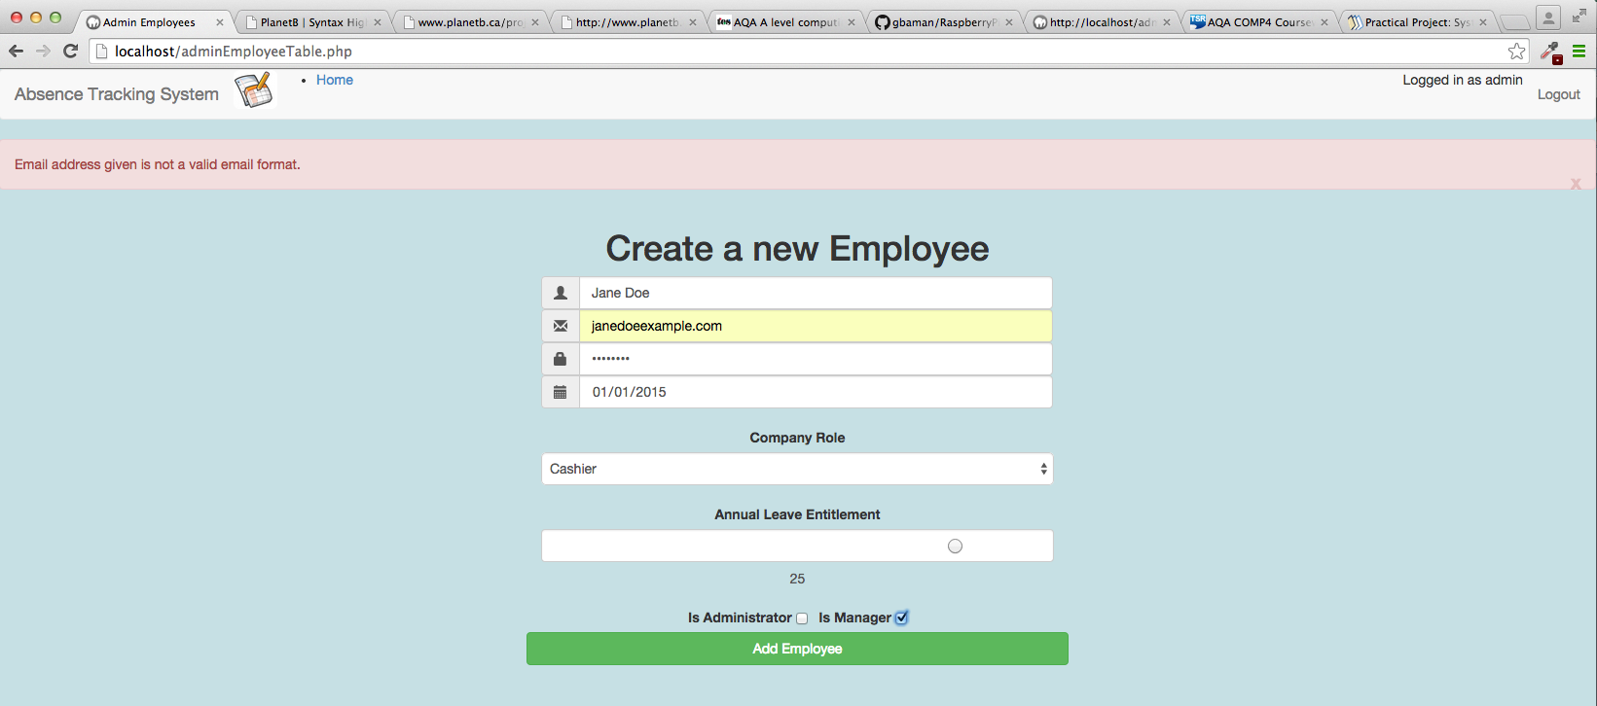

Figure 38 - Test 4.5 Output

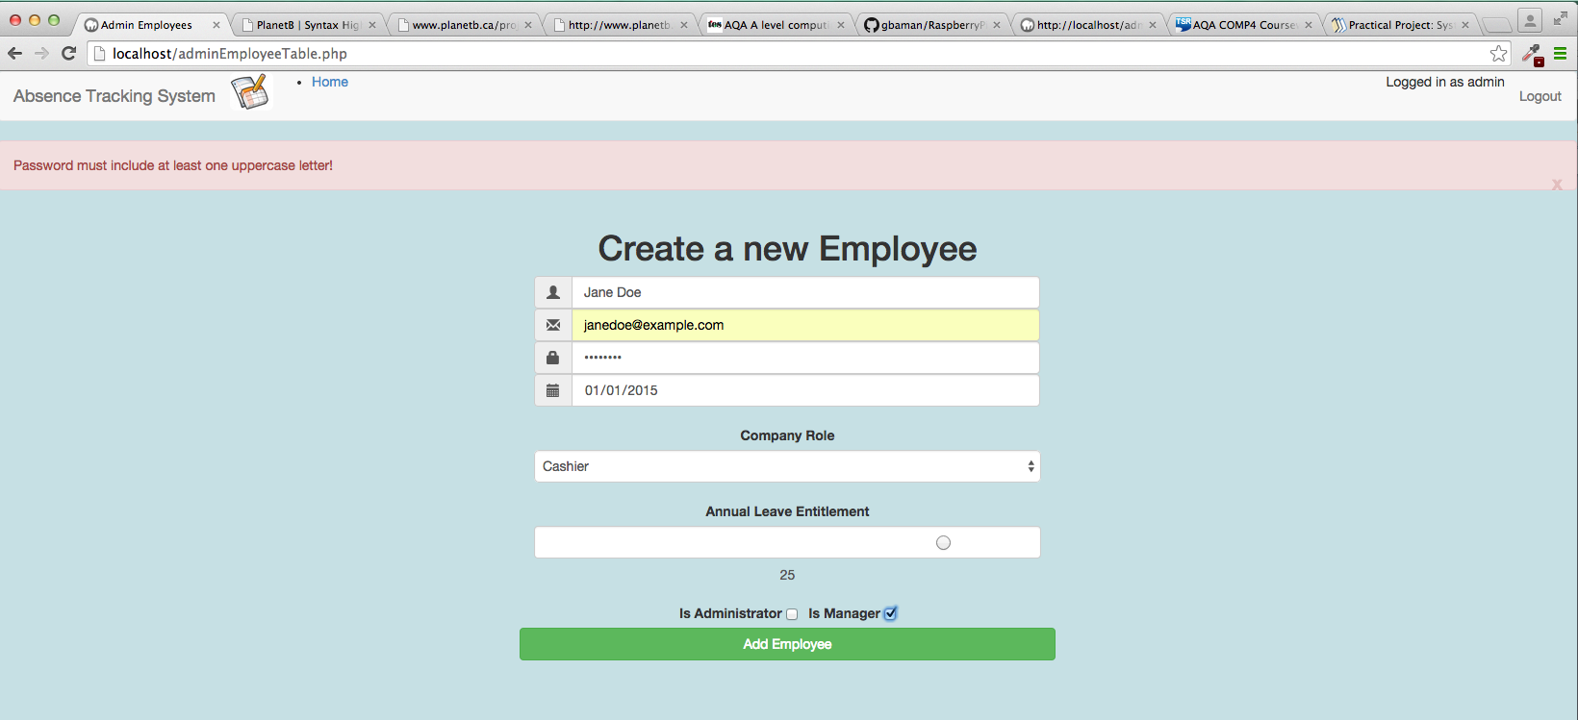

Figure 39 - Test 4.6 Output

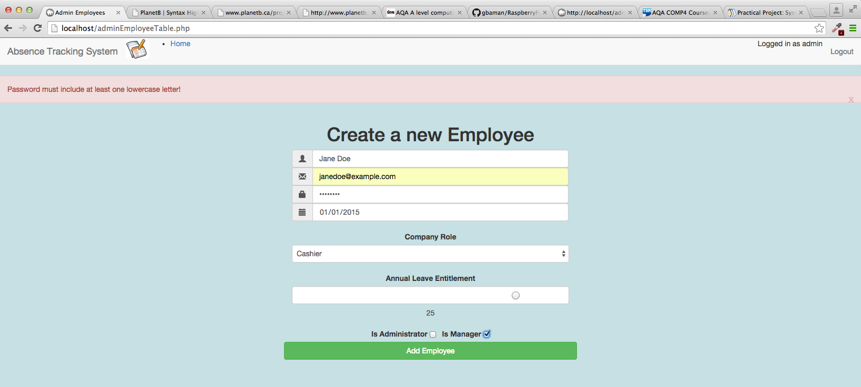

Figure 40 - Test 4.7 Output

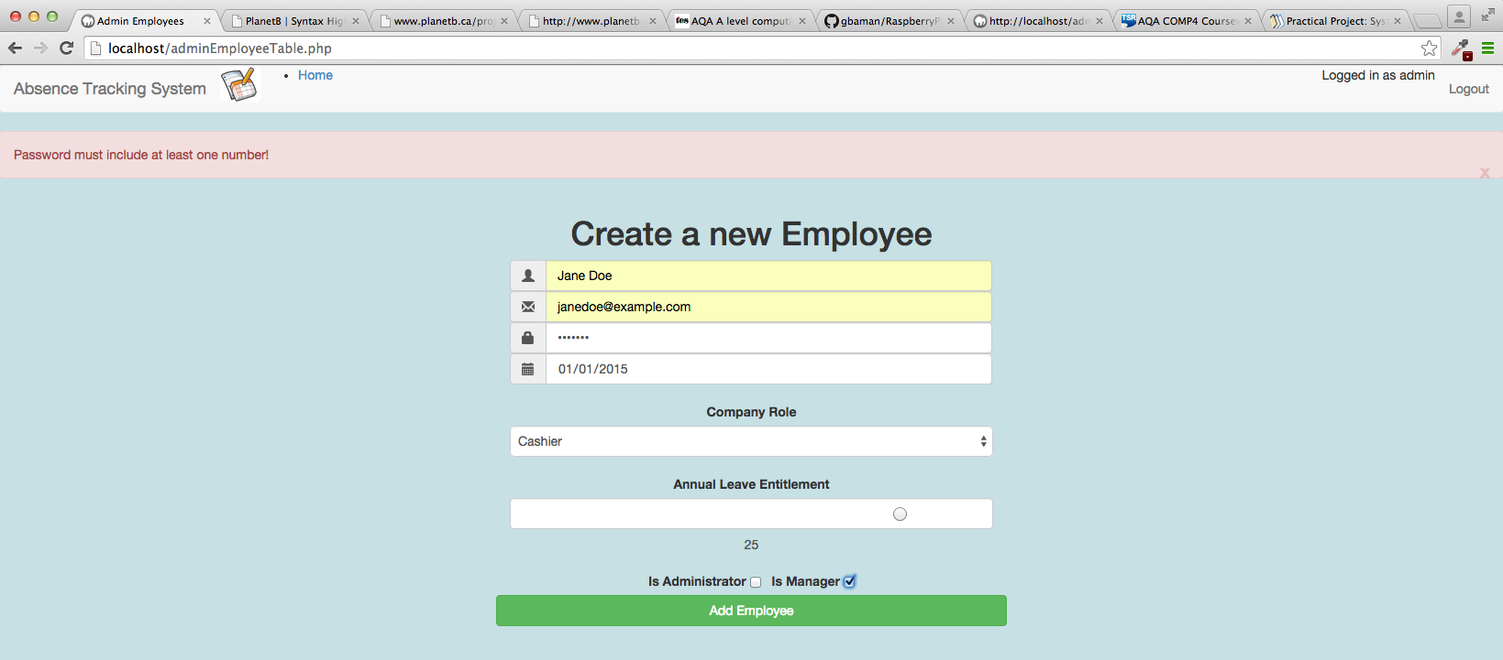

Figure 41 - Test 4.8 Output

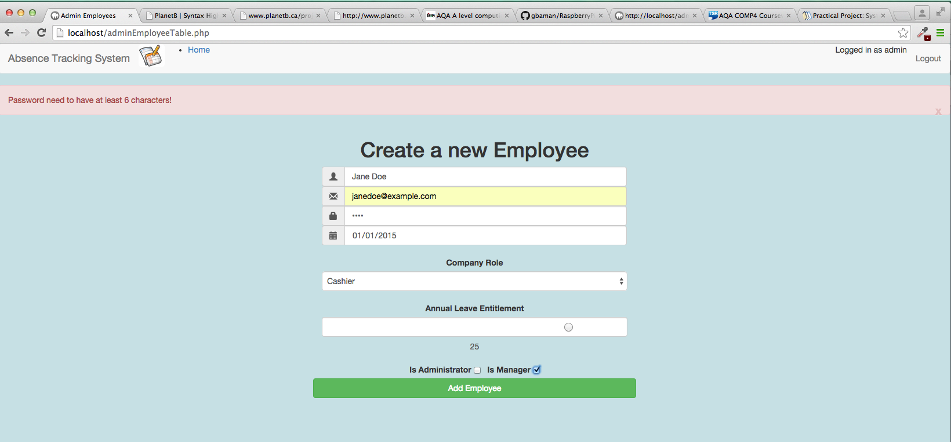

Figure 42 - Test 4.9 Output

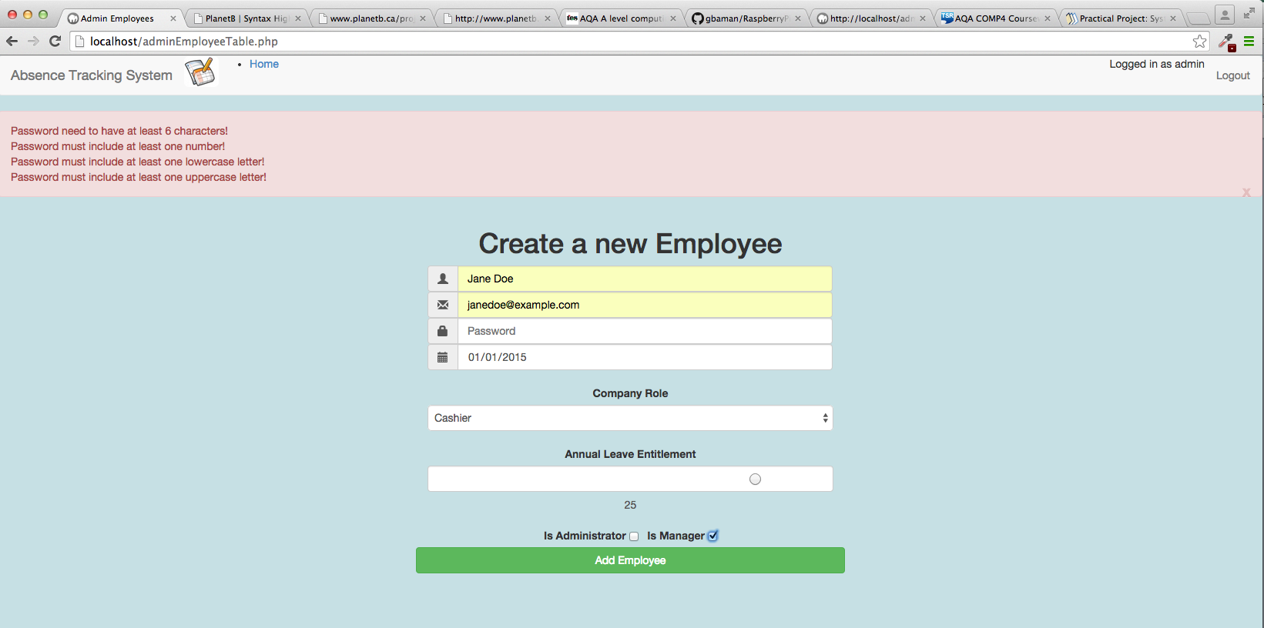

Figure 43 - Test 4.10 Output

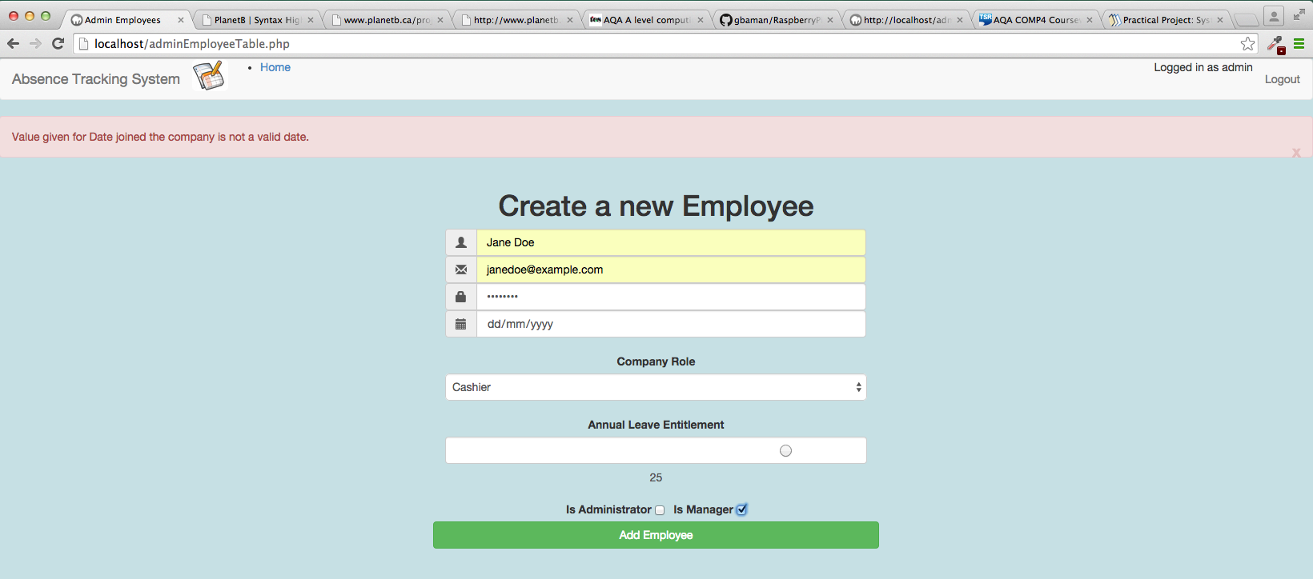

Figure 44 - Test 4.11 Output

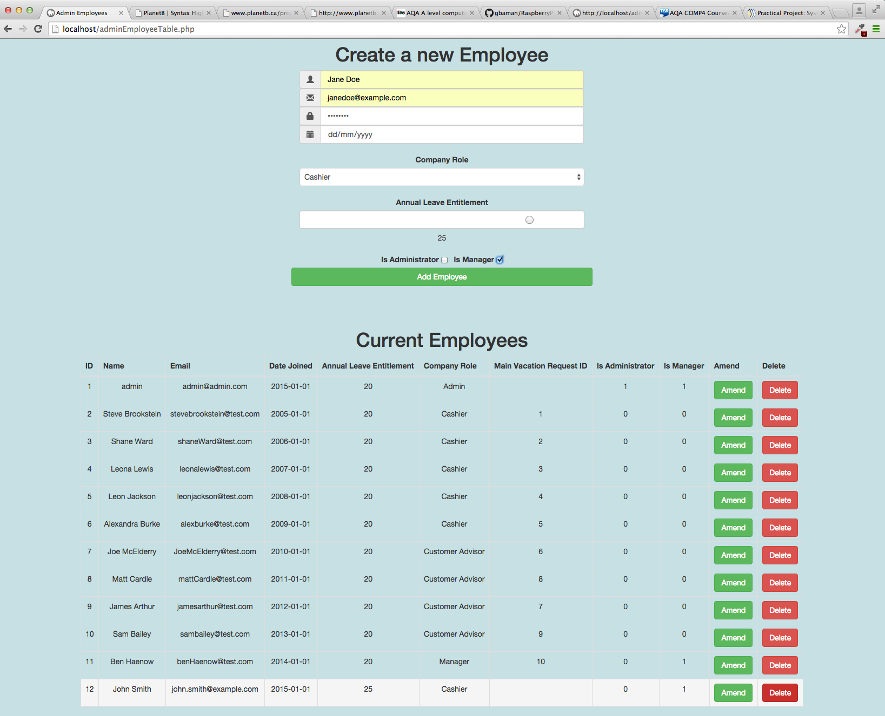

Figure 45 - Test 4.12 Before Delete Click

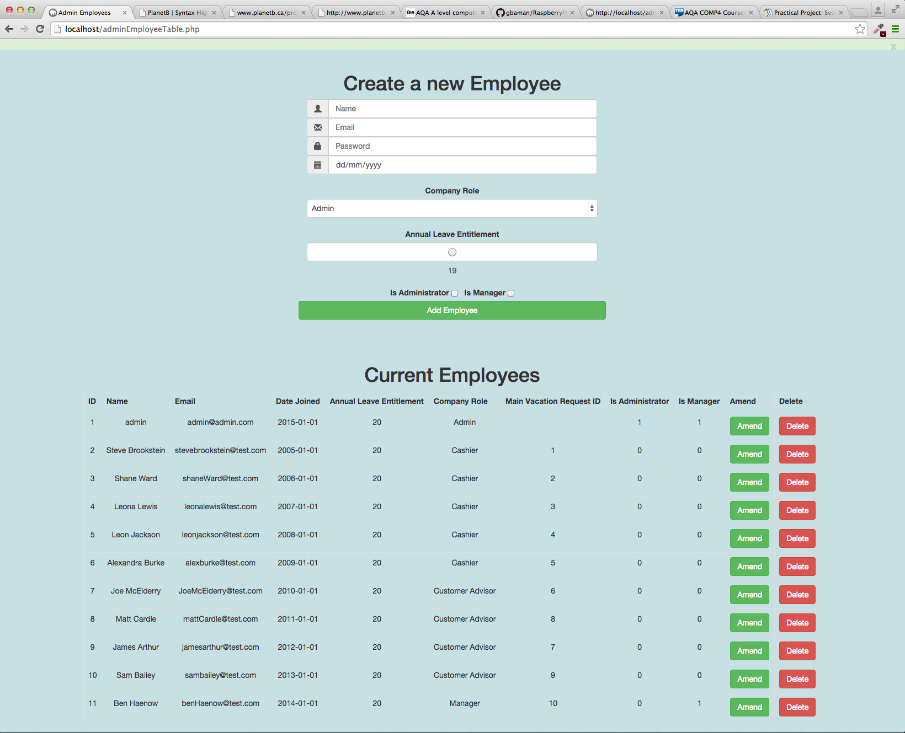

Figure 46 - Test 4.12 After Delete Click

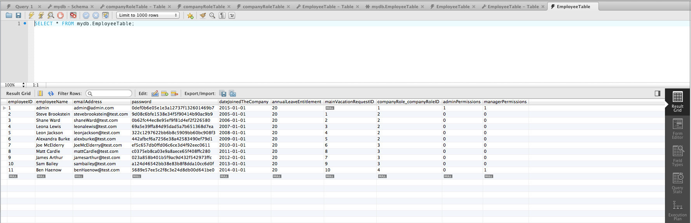

Figure 47 - Test 4.12 Employee Table in database after delete.

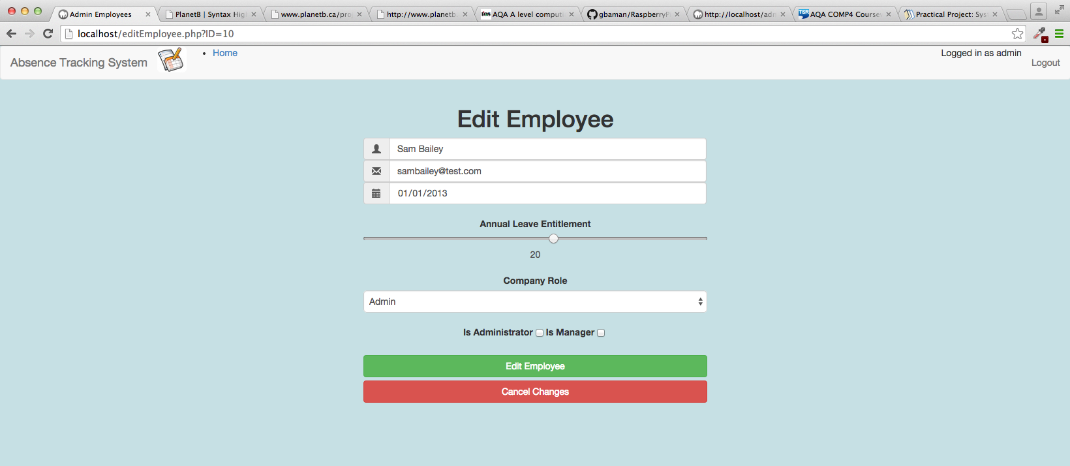

Figure 48 - Test 4.13 Test Output.

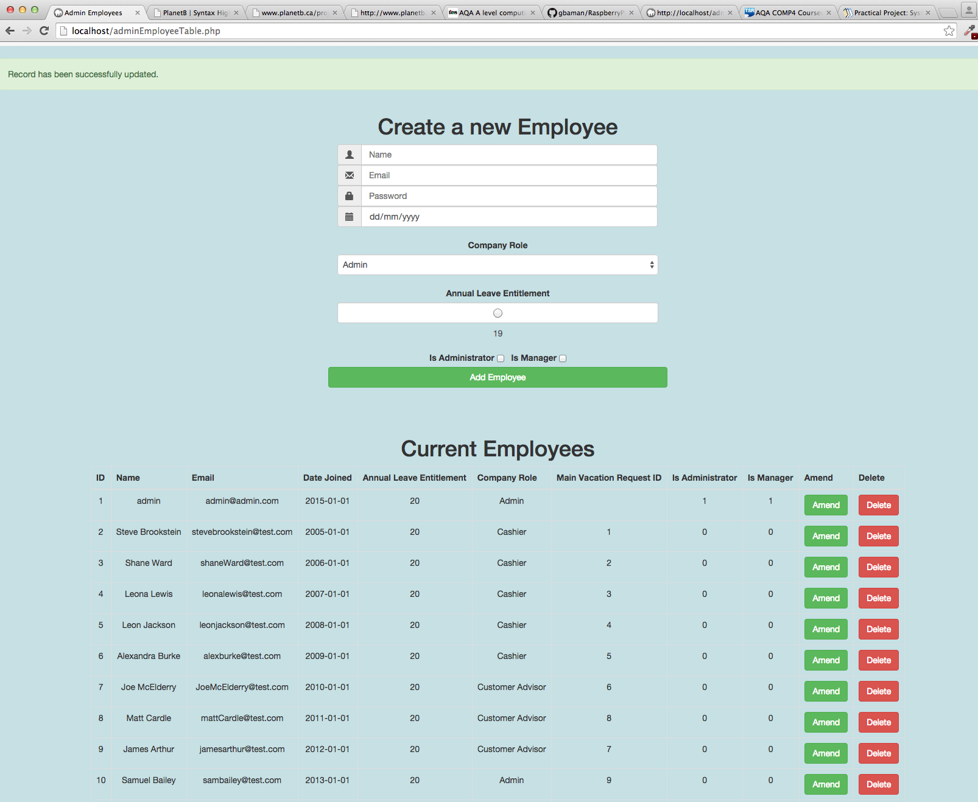

Figure 49 - Test 4.14 Test Output.

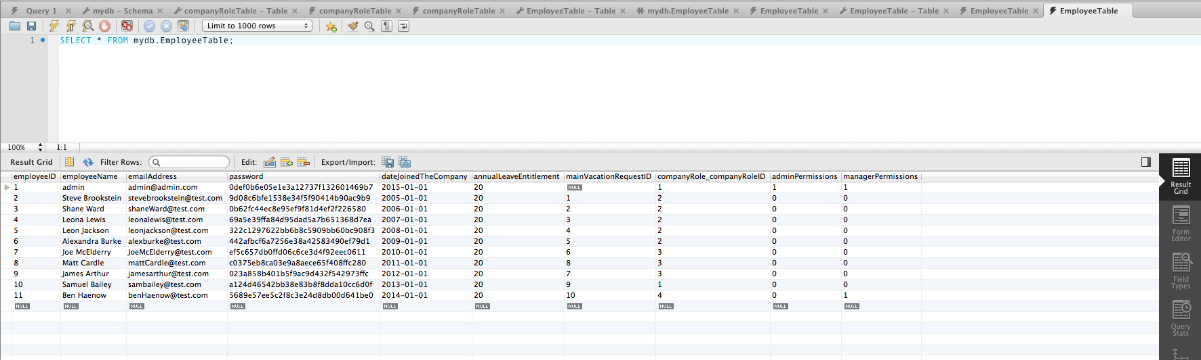

Figure 50 - Test 4.14 Employee Table in Database.

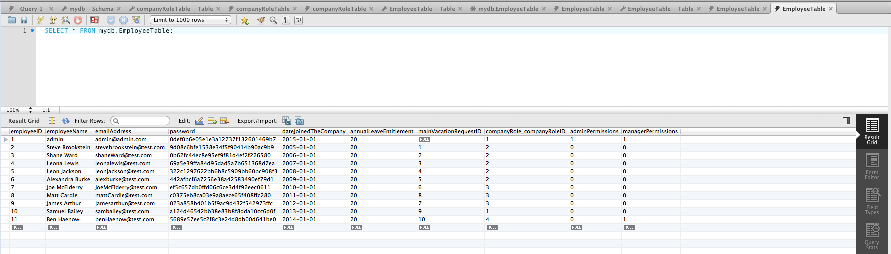

Figure 51 - Test 4.15 Employee Table in Database.

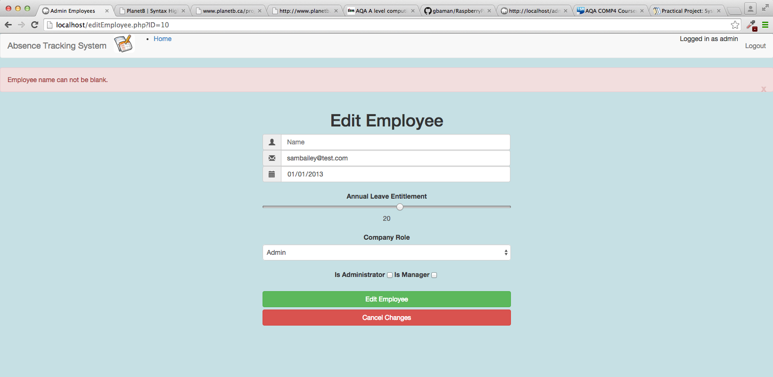

Figure 52 - Test 4.16 Output.

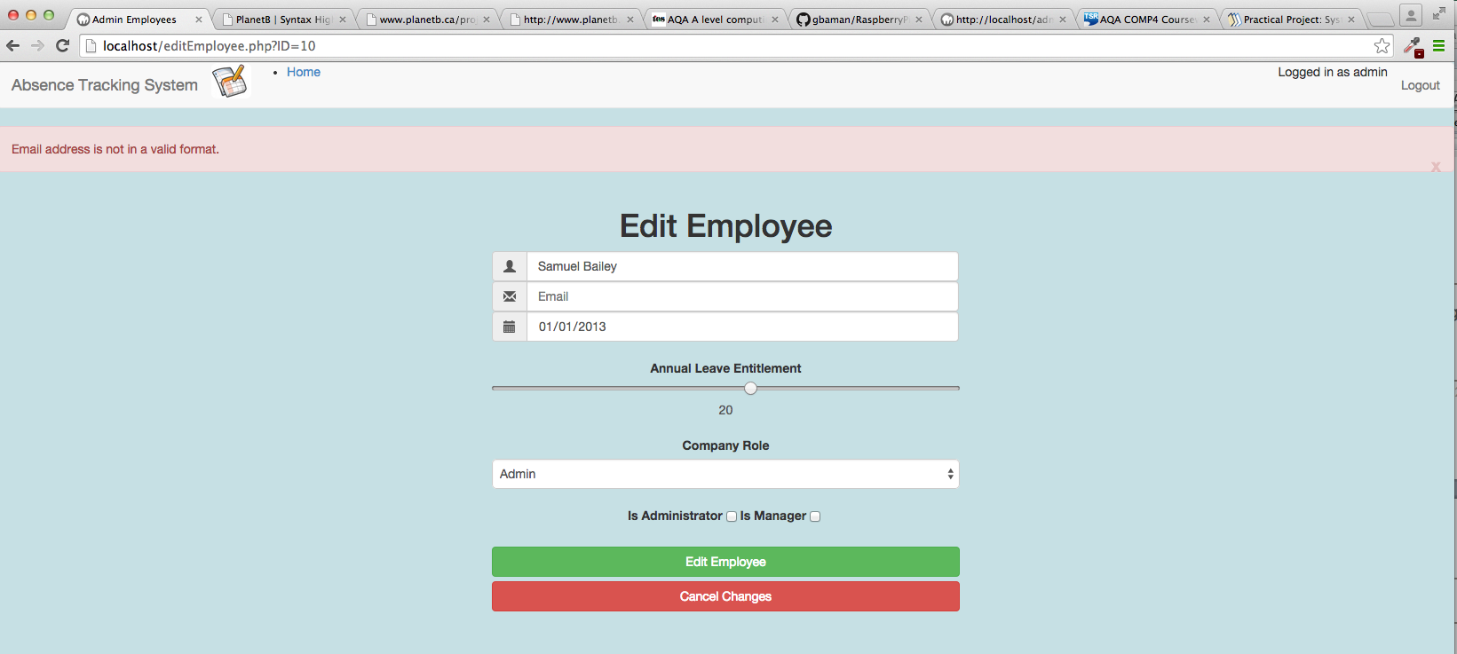

Figure 53 - Test 4.17 Output.

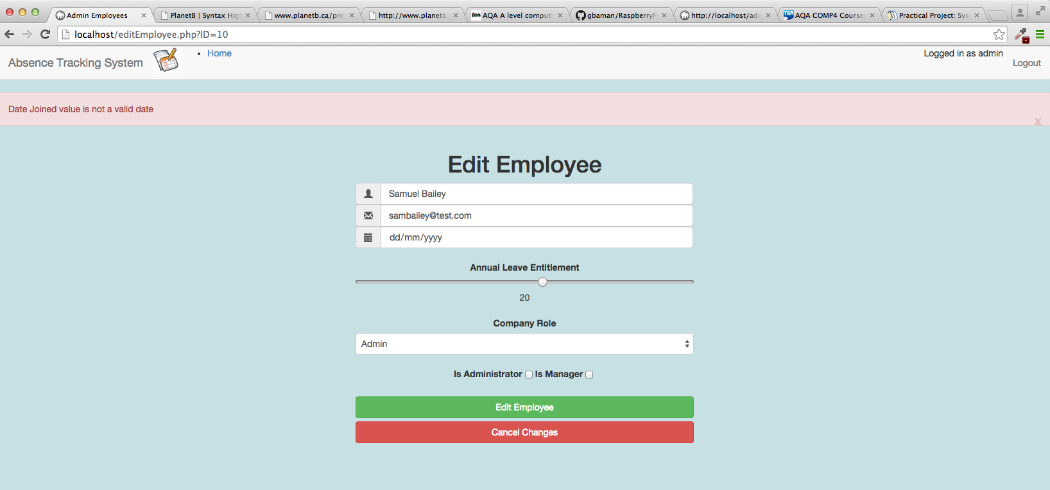

Figure 54 - Test 4.18 Output.

## ADMIN MAIN VACATION REQUESTS PAGE

Excluded to reduce size of report, since this functionality is very similar to the functionality tested in section 6.10 on page 254.

## ADMIN ABSENCE TYPES PAGE

| Test ID | description | data type | expected result | pass / fail | cross reference |
| --- | --- | --- | --- | --- | --- |
| 6.1 | From the Main Menu select Admin Absence Types  Enter “Maternity Leave” as the absence type name.  Leave the “Uses Annual Leave” and “Can be denied” checkboxes unchecked.  Click on Add Absence Type button. | Typical | Green success status bar shows “Record created in database successfully”.  Current Absence Types table on screen shows the new record.  Using MySQL workbench, database query of the Absence Types Table shows the new record. | PASS | Figure 55  Figure 56 |
| 6.2 | From the Main Menu select Admin Absence Types  In the list of Current absence types, find the entry for Maternity Leave and click on the Amend button. | Typical | User is redirected to the editabsencetype.php page and the details of the Maternity Leave absence type are displayed. | PASS | Figure 57 |
| 6.3 | From the Main Menu select Admin Absence Types  In the list of Current absence types, find the entry for Maternity Leave and click on the Amend button.  On the edit absence type screen, delete the text so that the absence type name is blank.  Click on Update. | Erroneous | Red error status bar shows “Invalid absence type name. Can not be empty”.  No change made to the data. | PASS | Figure 58 |
| 6.4 | From the Main Menu select Admin Absence Types  In the list of Current absence types, find the entry for Maternity Leave and click on the Amend button.  On the edit absence type screen, modify the name to be Parental Leave.  Click on Update. | Typical | User is redirected to the Admin Absence Types page  Green success status bar shows “Record successfully created in database”.  No change made to the data.  Current absence table on screen shows Paternity leave entry. | PASS | Figure 59 |
| 6.5 | From the Main Menu select Admin Absence Types  Enter “Parental Leave” as the absence type name.  Leave the “Uses Annual Leave” and “Can be denied” checkboxes unchecked.  Click on Add Absence Type button. | Erroneous | Red error status bar shows “Unable to create as an absence type with that name already exists”.  No change made to the data. | PASS | Figure 60 |
| 6.6 | From the Main Menu select Admin Absence Types  In the list of Current absence types, find the entry for Parental Leave and click on the Delete button. | Typical | Green success status bar shows “Record has been deleted”  Current absence types table on screen doesn’t show Parental Leave.  Using MySQL workbench, database query of the Absence Types Table shows no record for Parental Leave. | PASS | Figure 61  Figure 62 |

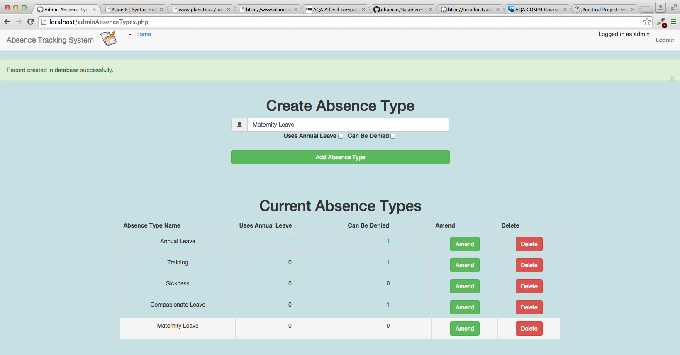

Figure 55 - Test 6.1 Output

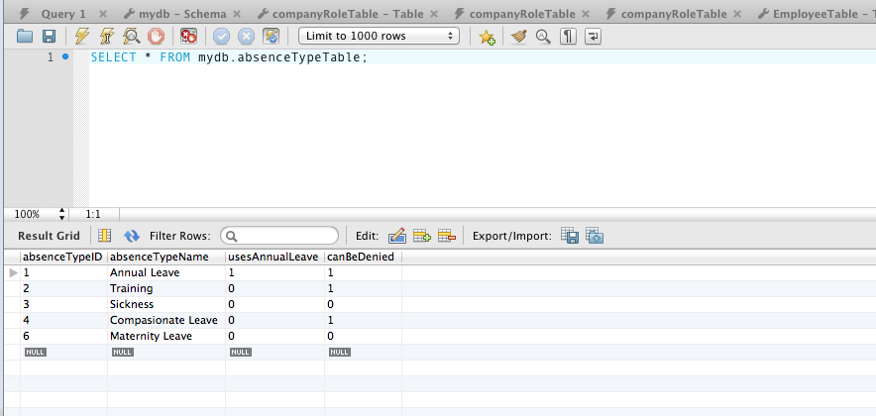

Figure 56 - Test 6.1 Absence Type Table Database query

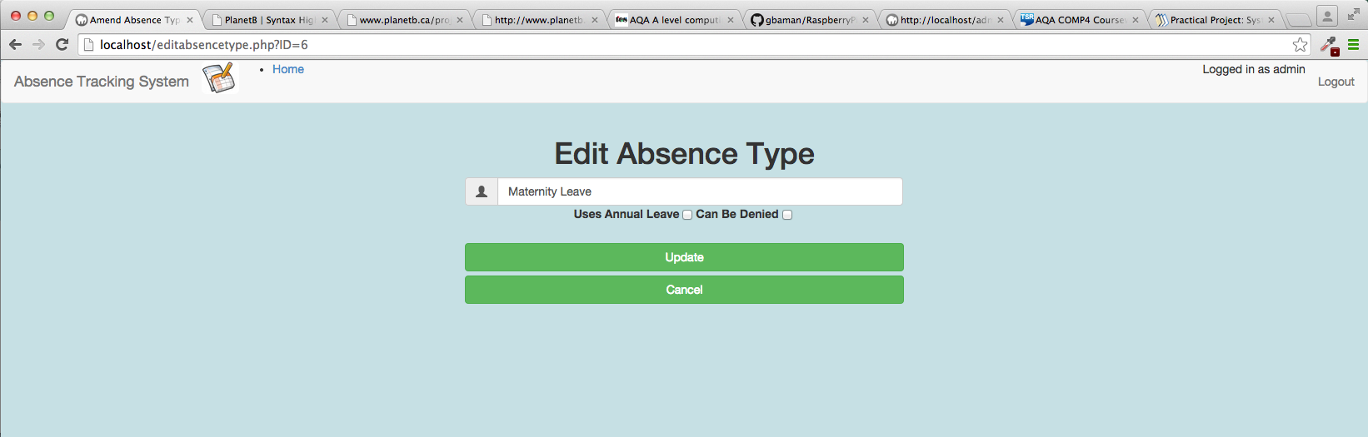

Figure 57 - Test 6.2 Output

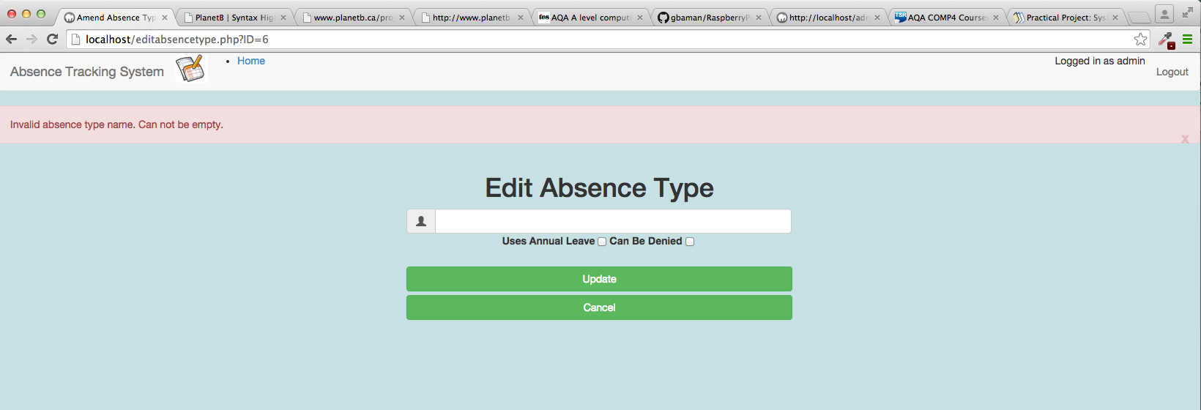

Figure 58 - Test 6.3 Output

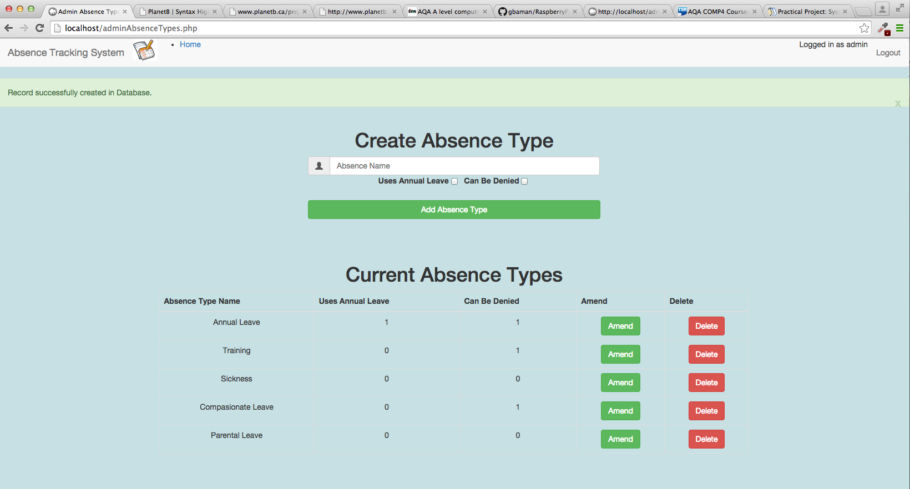

Figure 59 - Test 6.4 Output

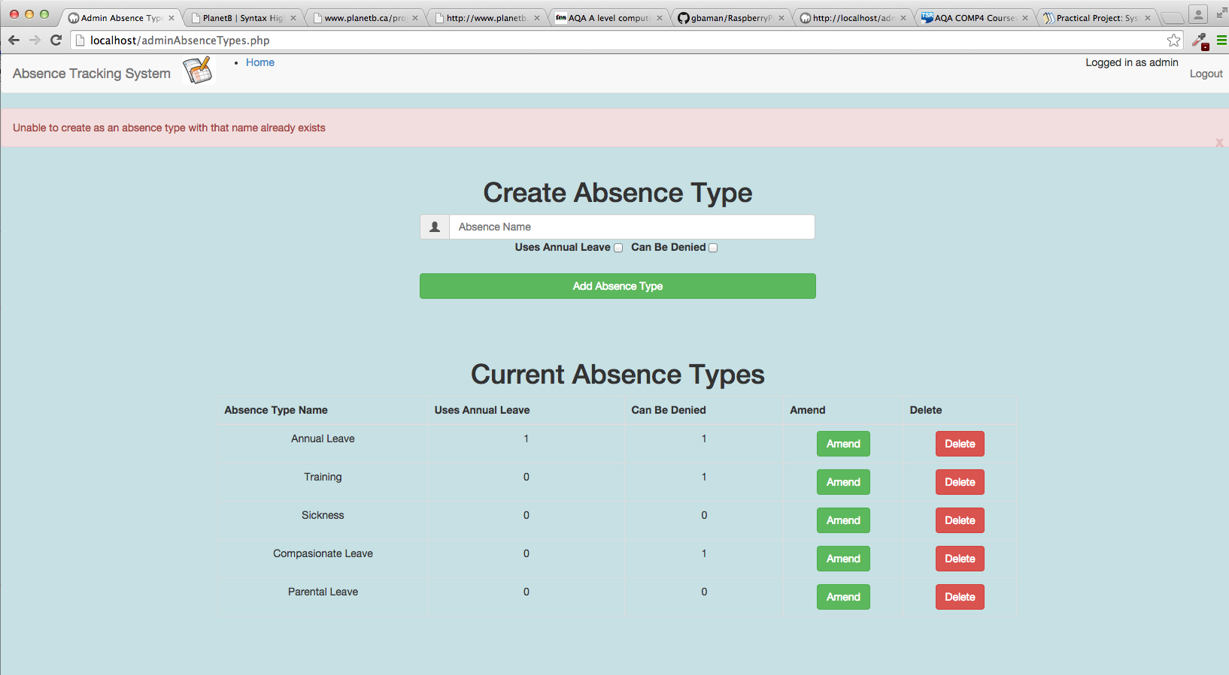

Figure 60 - Test 6.5 Output

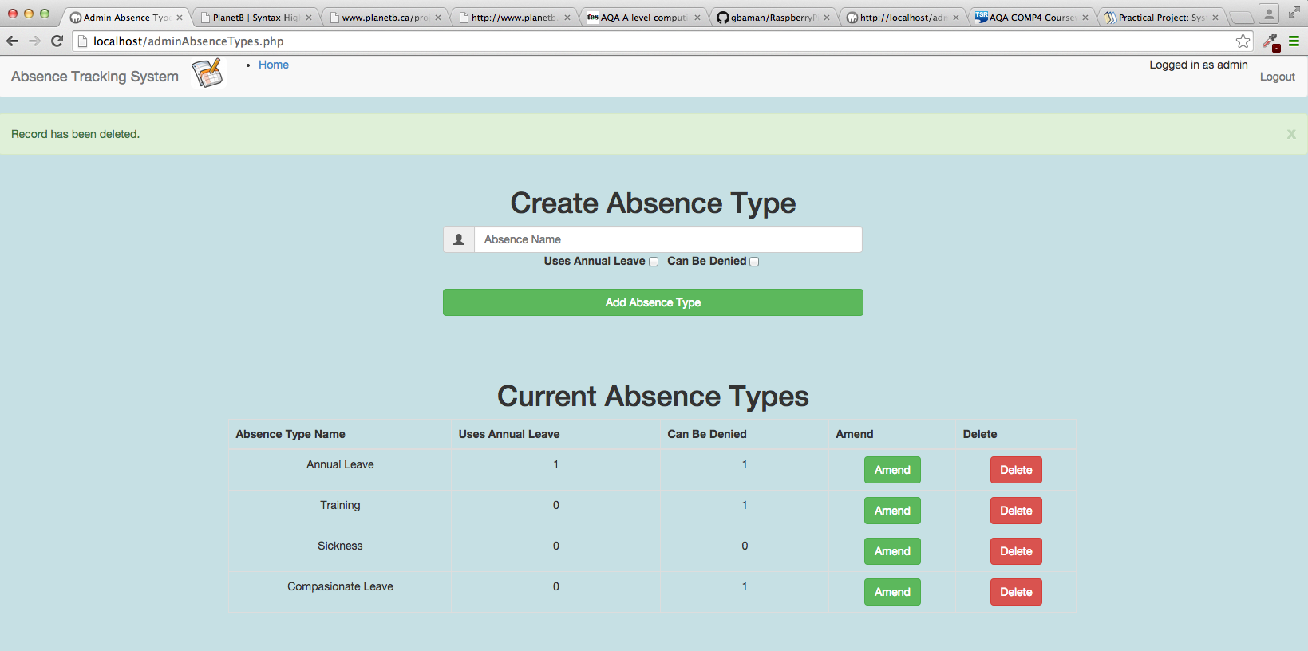

Figure 61 - Test 6.6 Output

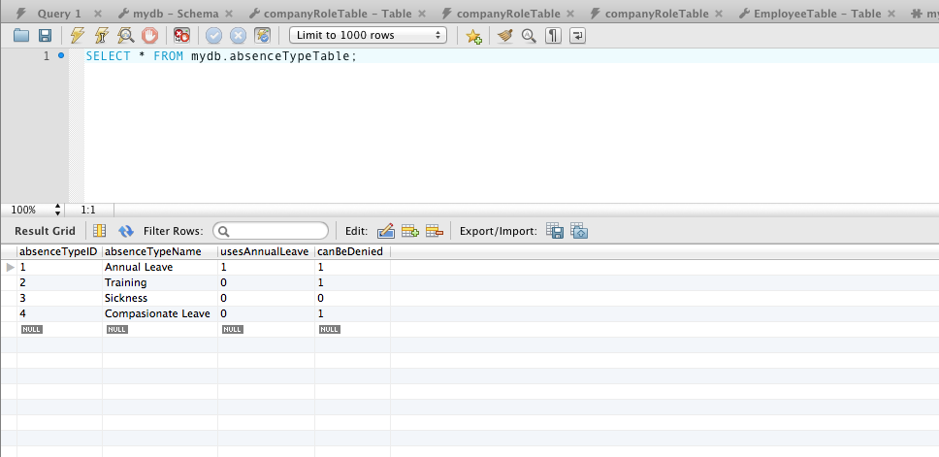

Figure 62 - Test 6.6 MySQL Database Query of AbsenceType table after delete.

## ADMIN AD HOC REQUESTS PAGE

Excluded to reduce size of report, since this functionality is very similar to the functionality tested in section 6.12 on page 272.

## ADMIN APPROVED ABSENCE BOOKINGS PAGE

| Test ID | description | data type | expected result | pass / fail | cross reference |
| --- | --- | --- | --- | --- | --- |
| 8.1 | From the Main Menu select Admin Approved Absence Bookings  Leave all fields on the screen unchanged  Click on Create Approved Booking button. | Erroneous | Red error status bar shows  “Unable to locate employee ID in the database”  “Start date given is not a valid date”  “End date given is not a valid date”  No entry is created in the Current Approved Absence Bookings list. | PASS | Figure 63 |
| 8.2 | From the Main Menu select Admin Approved Absence Bookings  From the employee list, select Ben Haenow.  Set start date to 30/01/2015  Set end date to 29/01/2015  Click on Create Approved Booking button. | Extreme | Red error status bar shows  “end date is before start date”  No entry is created in the Current Approved Absence Bookings list. | PASS | Figure 64 |
| 8.3 | From the Main Menu select Admin Approved Absence Bookings  From the employee list, select Ben Haenow.  Set start date to 29/01/2015  Set end date to 30/01/2015  Click on Create Approved Booking button. | Typical | Green success status bar shows “Record successfully created”.  Current Approved Absence Bookings table on screen shows the new entry.  Using MySQL workbench database query of the Approved Absence Bookings Table shows the record has been created.  Using MySQL workbench database query of the Approved Absence Booking DateTable shows two records, linking the dates booked back to the approved absence booking. | PASS | Figure 65  Figure 66  Figure 67  Figure 68 |
| 8.4 | From the Main Menu select Admin Approved Absence Bookings  Locate the entry for Ben Haenow in the Current Approved Absence Bookings table and click on the Amend button. | Typical | User is redirected to the editApprovedAbsenceBooking.php page.  Values displayed are:  Name: Ben Haenow StartDate: 29/01/2015 EndDate: 30/01/2015 Absence Type:Annual Leave | PASS | Figure 69 |
| 8.5 | From the Main Menu select Admin Approved Absence Bookings  Locate the entry for Ben Haenow in the Current Approved Absence Bookings table and click on the Amend button.  Change the Start Date to 28/01/2015  Click the edit request button. | Typical | User is redirected to the AdminAdHocRequest.php page.  Green success status bar shows “Record successfully updated”.  Current Approved Absence Booking table on screen shows the new values.  Using MySQL workbench database query of the Approved Absence Bookings Table shows the record has been updated.  Using MySQL workbench database query of the Approved Absence Booking Dates Table shows the record has been updated. | PASS | Figure 70  Figure 71  Figure 72 |
| 8.6 | From the Main Menu select Admin Approved Absence Bookings  Locate the entry for Ben Haenow in the Current Approved Absence Bookings table and click on the Amend button.  Change the Start Date to 31/01/2015  Click the edit request button. | Extreme | Red error status bar shows “end date is before start date”. | PASS | Figure 73 |
| 8.7 | From the Main Menu select Admin Approved Absence Bookings  Locate the entry for Ben Haenow in the Current Approved Absence Bookings table and click on the Delete button. | Typical | Green success status bar shows “Record successfully deleted”.  Entry is removed from the Current Approved Absence Booking table on screen.  Using MySQL workbench database query of the Approved Absence BookinsTable shows the record has been deleted.  Using MySQL workbench database query of the Approved Absence Booking Date Table shows the records for this booking have been deleted. | PASS | Figure 74  Figure 75  Figure 76 |

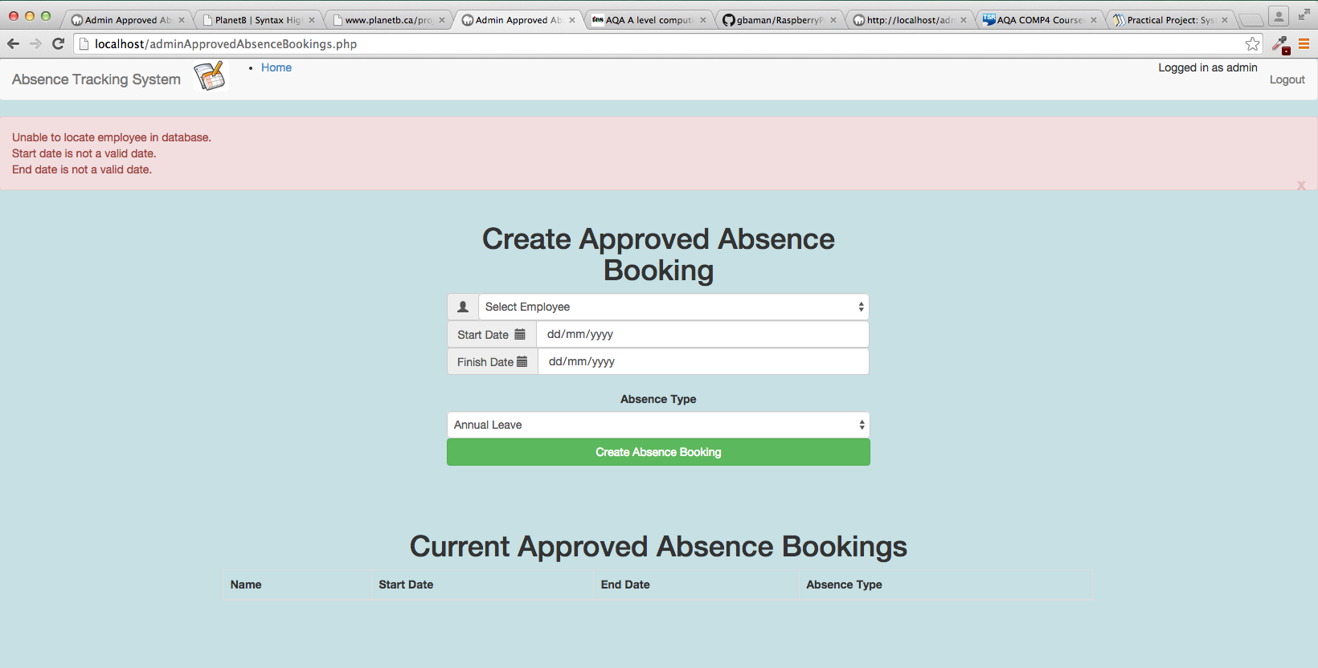

Figure 63 - Test 8.1 Output

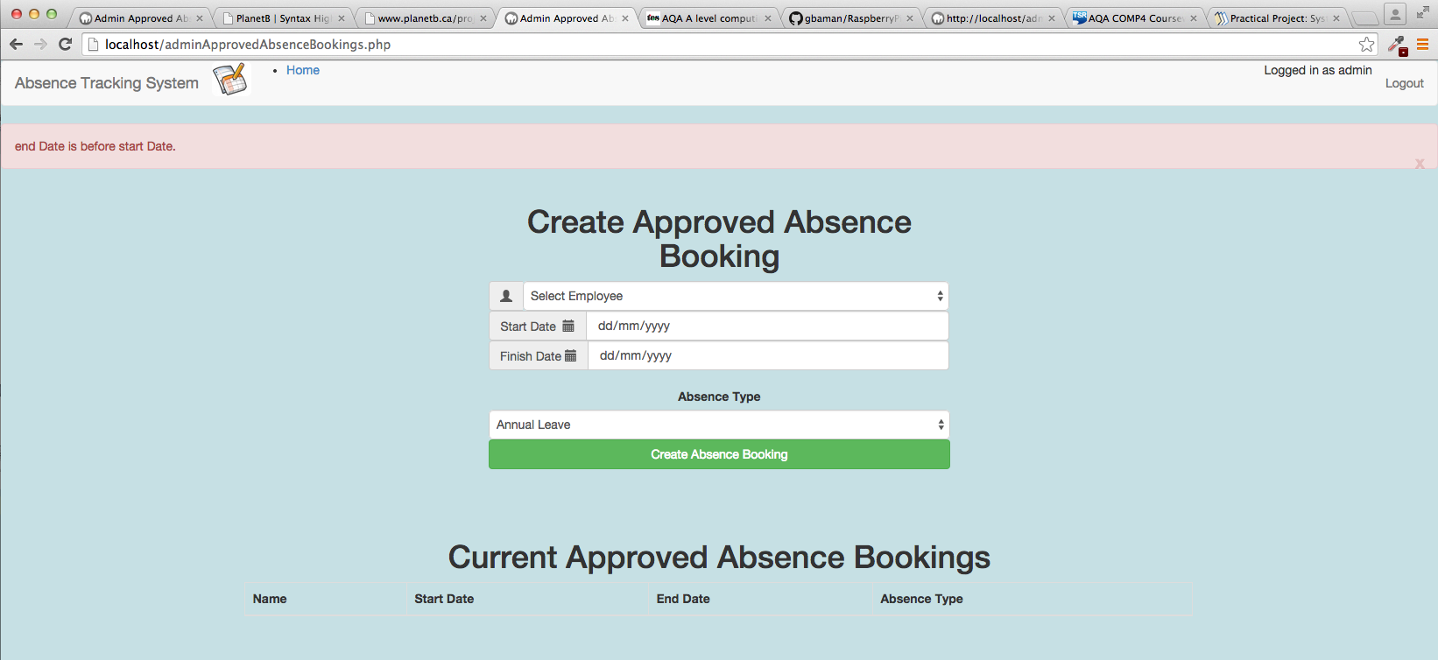

Figure 64 - Test 8.2 Output

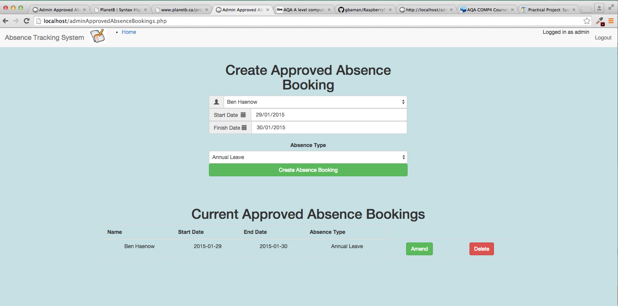

Figure 65 - Test 8.3 Output

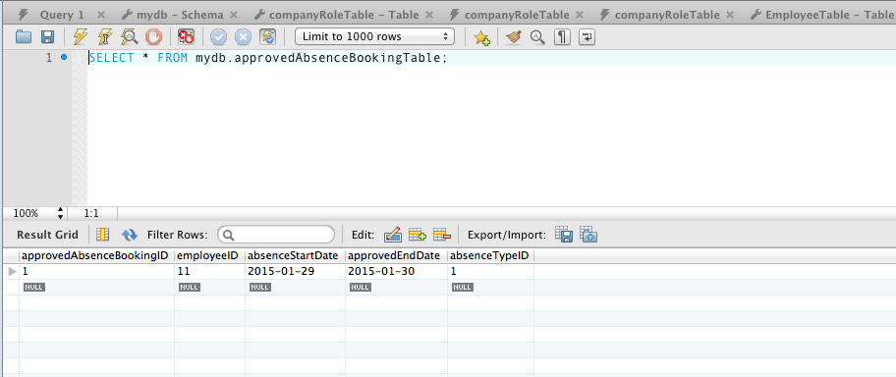

Figure 66 - Test 8.3 Approved Absence Booking Table entries

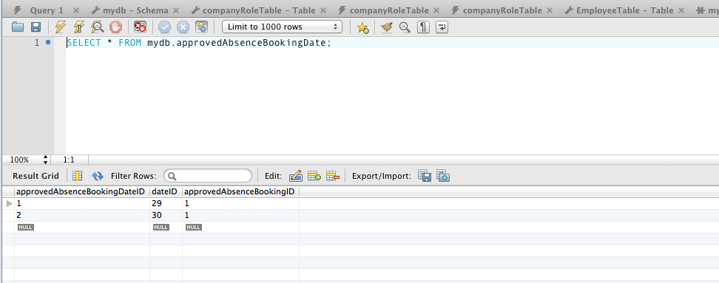

Figure 67 - Test 8.3 AprrovedAbsenceBookingDate table entries

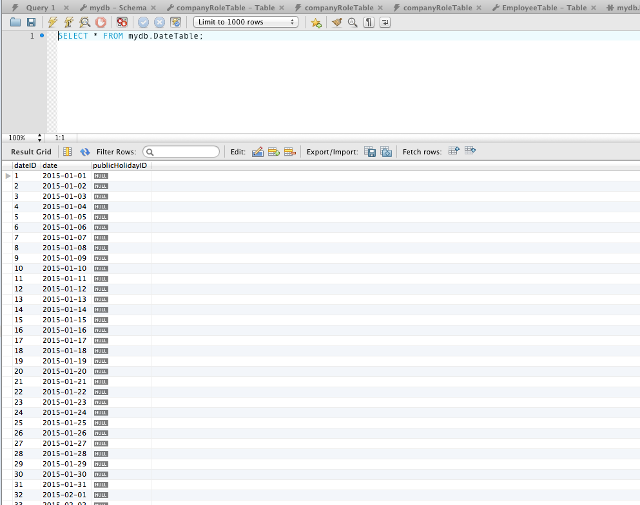

Figure 68 - Test 8.3 Date Table Entries.

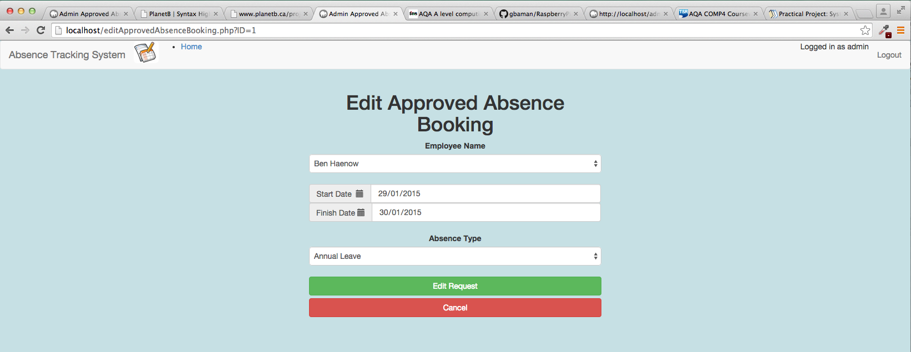

Figure 69 - Test 8.4 Output

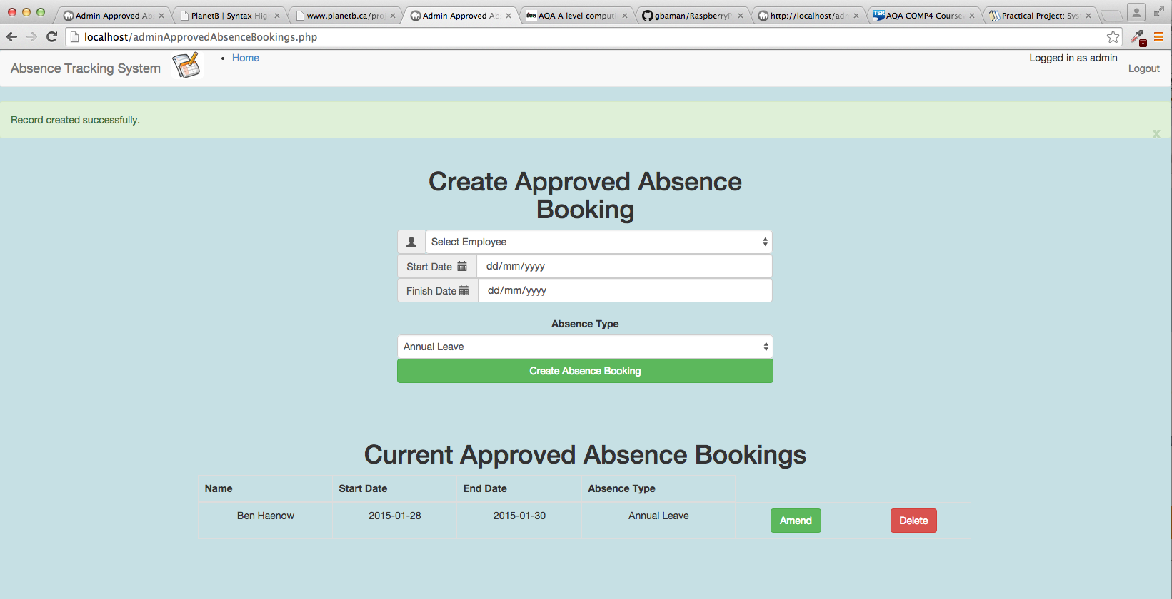

Figure 70 - Test 8.5 Output

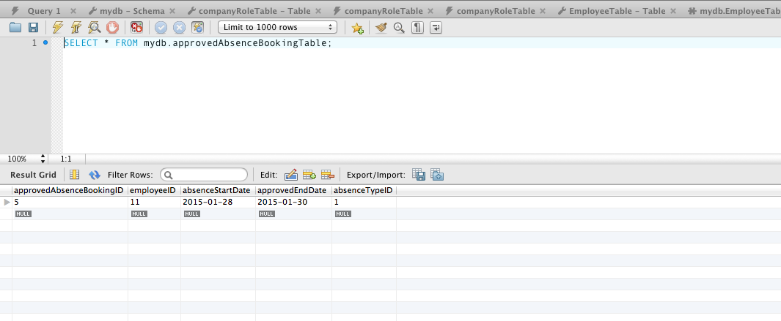

Figure 71 - Test 8.5 Approved Absence Booking Table in Database

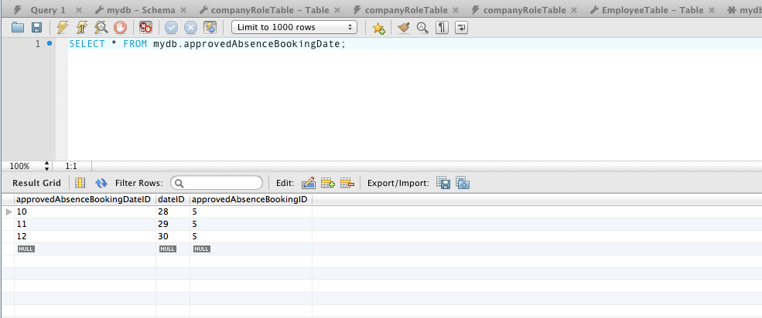

Figure 72 - Test 8.5 Approved Absence Booking Dates Table in Database.

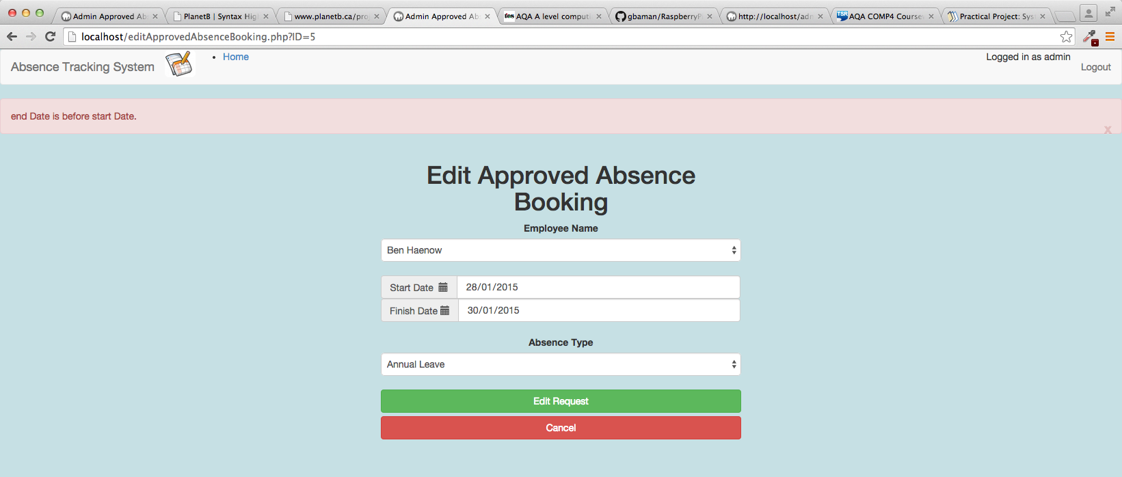

Figure 73 - Test 8.6 Output

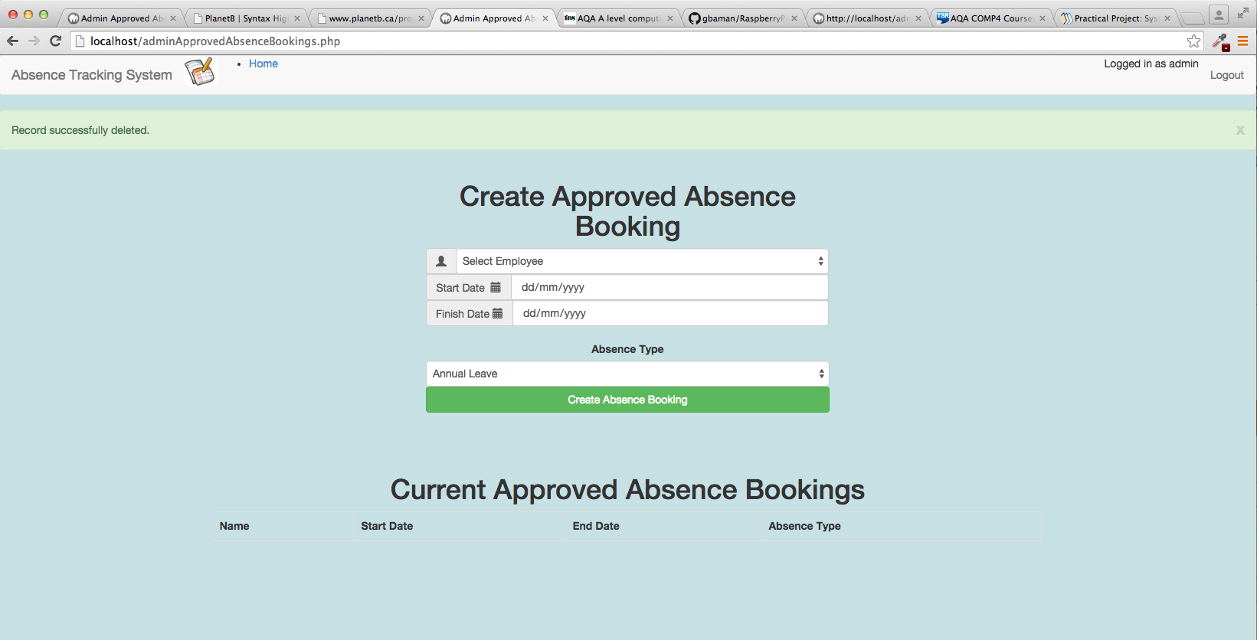

Figure 74 - Test 8.7 Output

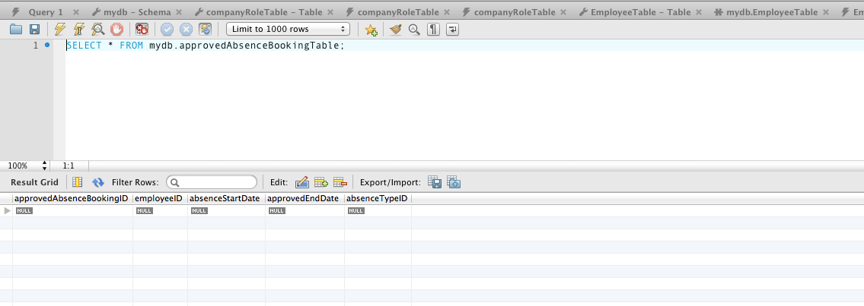

Figure 75 - Test 8.7 Approved Absence Booking Table in Database

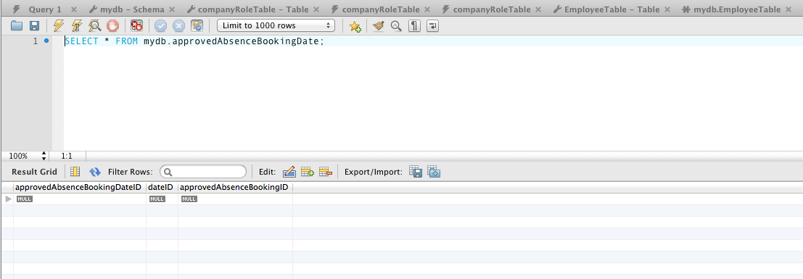

Figure 76 - Test 8.7 Approved Absence Booking Date Table in Database

## ADMIN PUBLIC HOLIDAYS PAGE

| Test ID | description | data type | expected result | pass / fail | cross reference |
| --- | --- | --- | --- | --- | --- |
| 9.1 | From the Main Menu select Admin Public Holidays  Leave all fields on the screen unchanged  Click on Add | Erroneous | Red error status bar shows  “Name of public Holiday can not be blank.” and “Invalid Date supplied.”  No entry is created in the Current Public Holidays list | PASS | Figure 77 |
| 9.2 | From the Main Menu select Admin Public Holidays  Under Public Holiday name type “New Years Day”  Set date to 01/01/2016  Click Add button. | Typical | Green success status bar shows “Record successfully created”.  Current Public Holidays table on screen shows the new entry.  Using MySQL workbench database query of the Public Holidays Table shows the record has been created.  Using MySQL workbench database query of the Dates shows the record for the date ID for 01/01/2016 has a public holiday ID set corresponding with the new record in the public holiday table. | PASS | Figure 78  Figure 79  Figure 80 |
| 9.3 | From the Main Menu select Admin Public Holidays  Locate the entry for 01/01/2016 in the Current Public Holidays table and click on the Amend button. | Typical | User is redirected to the editPublicHoliday.php page.  Values displayed are:  Name: New Years Day Date: 01/01/2016 | PASS | Figure 81 |
| 9.4 | From the Main Menu select Admin Public Holidays  Locate the entry for 01/01/2016 in the Current Public Holidays table and click on the Amend button.  Change the Start Date to 31/12/2015  Click the edit request button. | Typical | User is redirected to the AdminPublicHolidays.php page.  Green success status bar shows “Record successfully updated”.  Current Public Holidays table on screen shows the new values.  Using MySQL workbench database query of the Public Holidays table shows the record has been updated.  Using MySQL workbench database query of the Dates Table shows the date record for 31/12/15 has been updated to hold a public holiday ID for the new public holiday record, and the date record for 01/01/16 no longer has a public holiday ID. | PASS | Figure 82  Figure 83  Figure 84 |
| 9.5 | From the Main Menu select Admin Public Holidays  Locate the entry for 31/12/2015 in the Current Public Holidays table.  Click the edit request button. | Typical | Green success status bar shows “Record successfully deleted”.  Entry is removed from the Current Public Holidays table on screen.  Using MySQL workbench database query of the Public Holidays table shows the record has been deleted.  Using MySQL workbench database query of the Date Table shows the public holiday ID for the associated date record has been set to NULL. | PASS | Figure 85  Figure 86  Figure 87 |

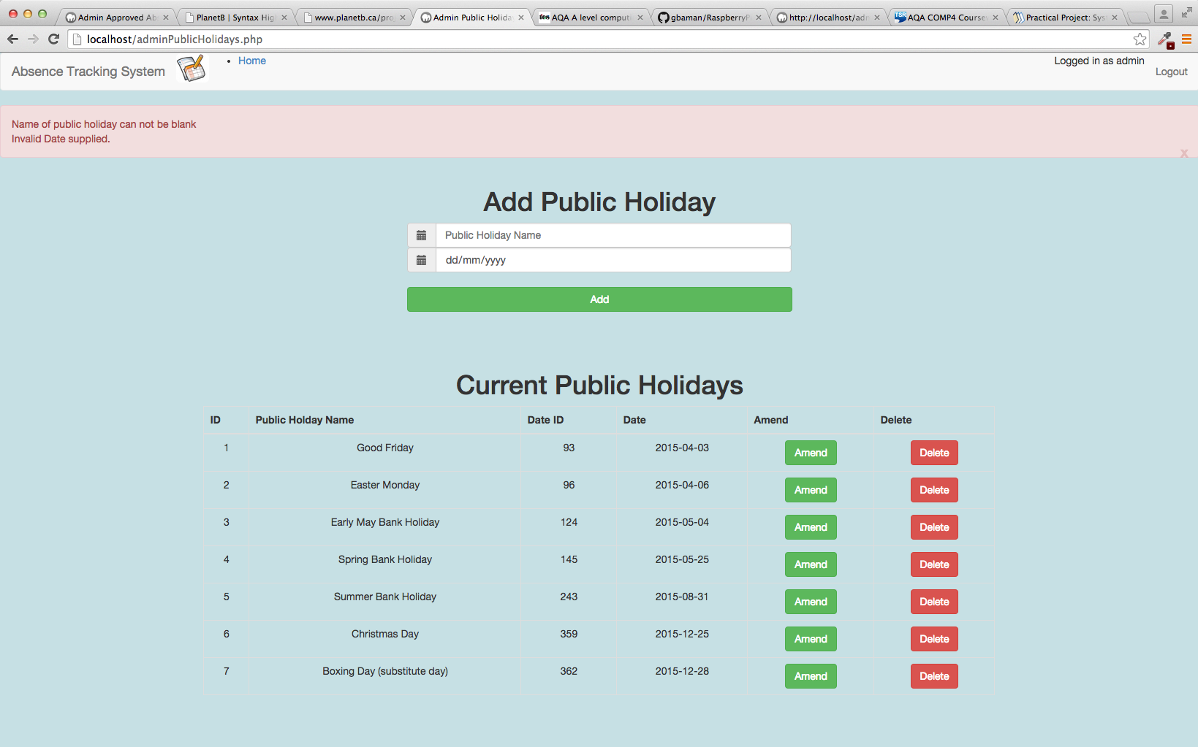

Figure 77 - Test 9.1 Output

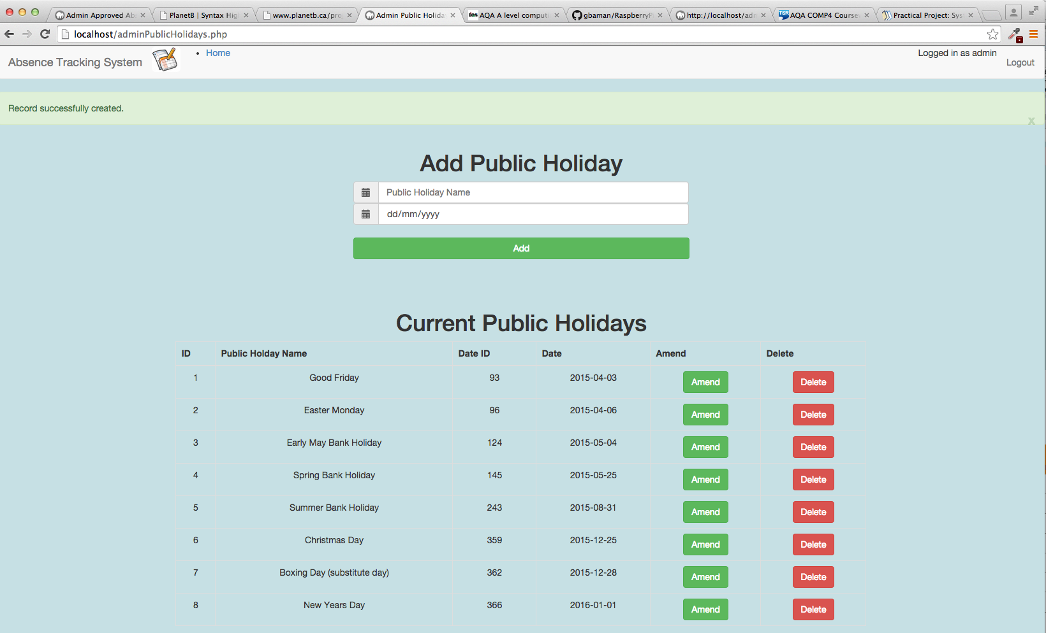

Figure 78 - Test 9.2 Output

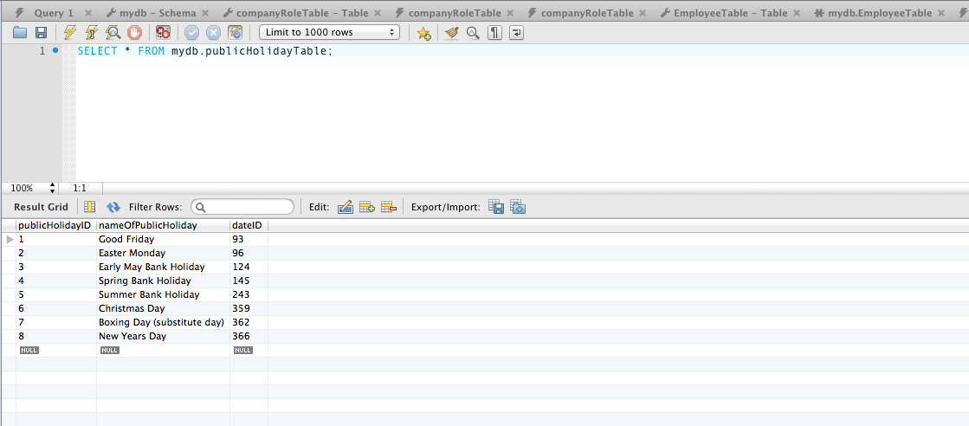

Figure 79 - Test 9.2 Database query on publicHolidayTable

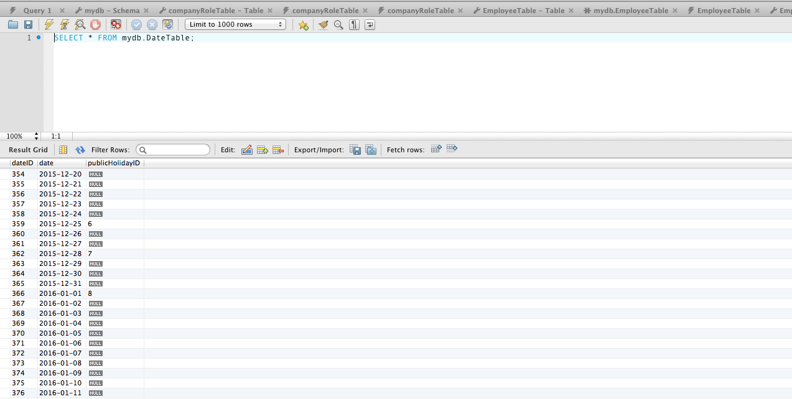

Figure 80 - Test 9.2 Database Query on date table

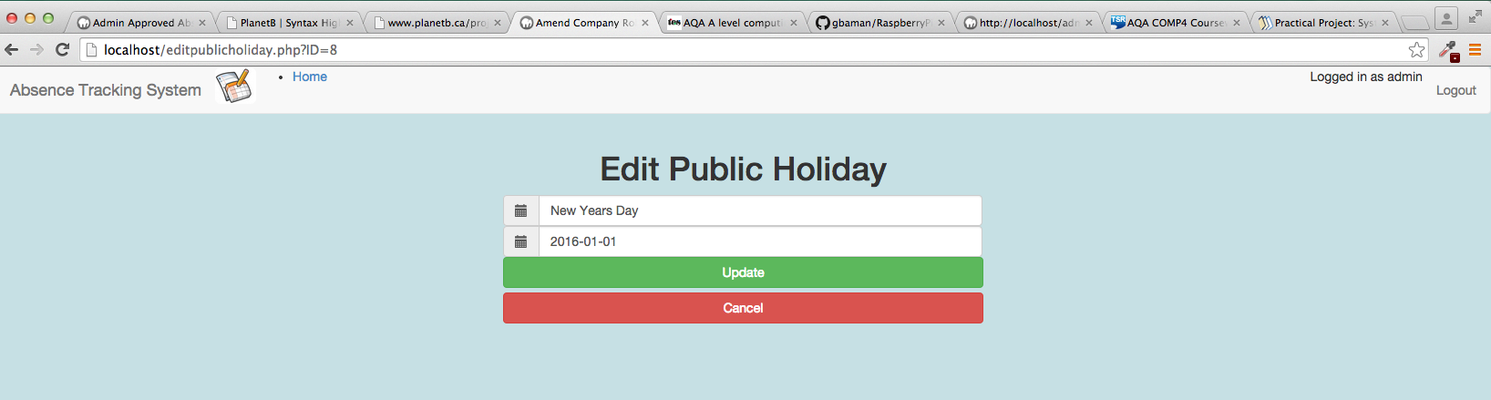

Figure 81 - Test 9.3 Output

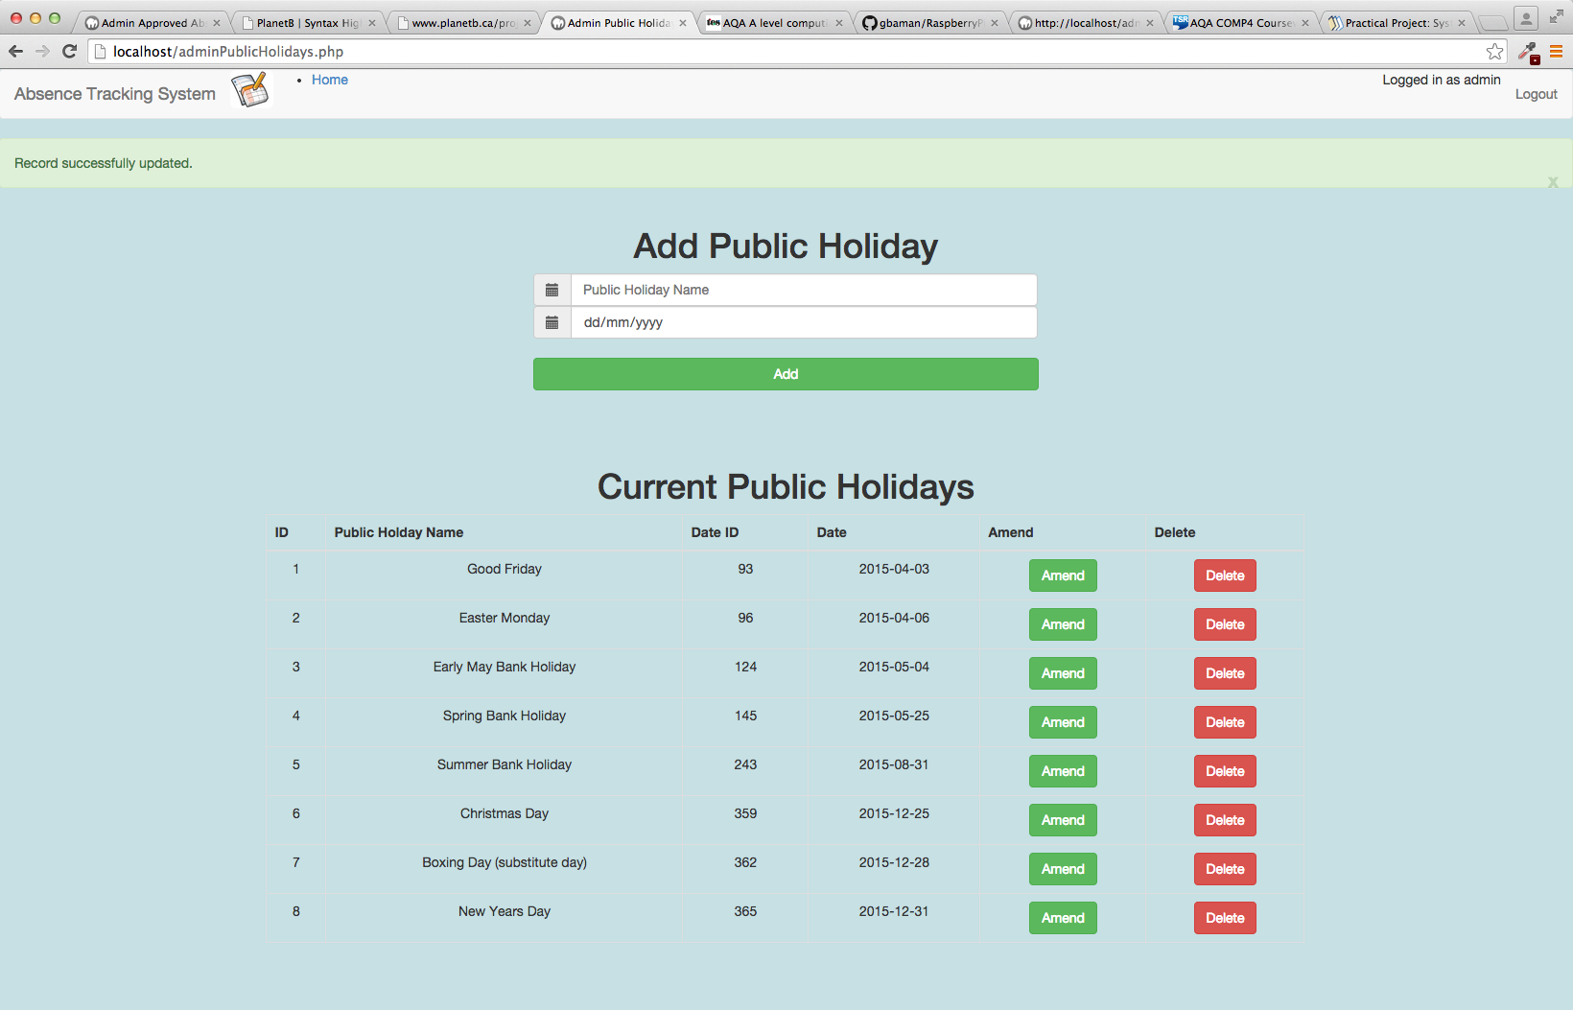

Figure 82 - Test 9.4 Output

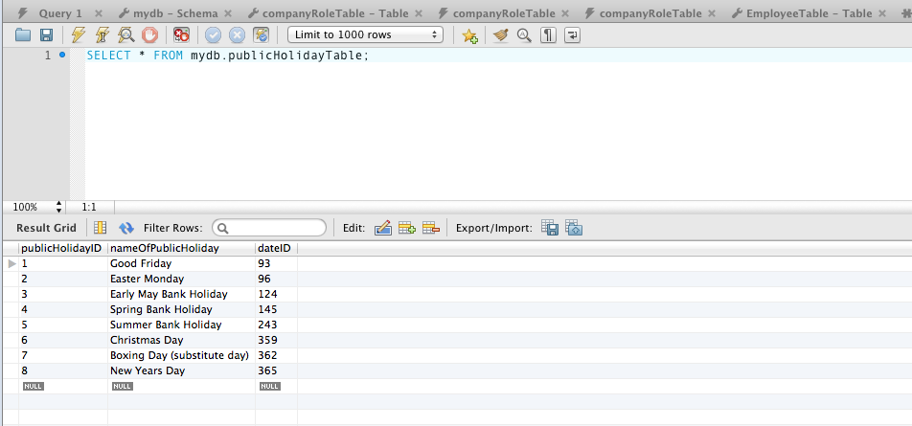

Figure 83 - Test 9.4 Database Query on Public Holiday Table.

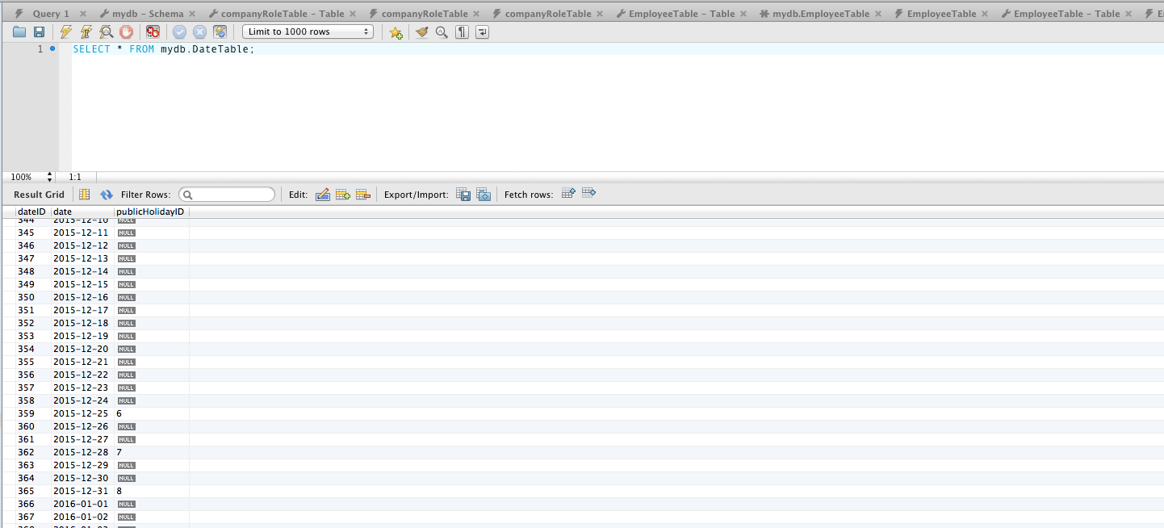

Figure 84 - Test 9.4 Database Query on Date Table.

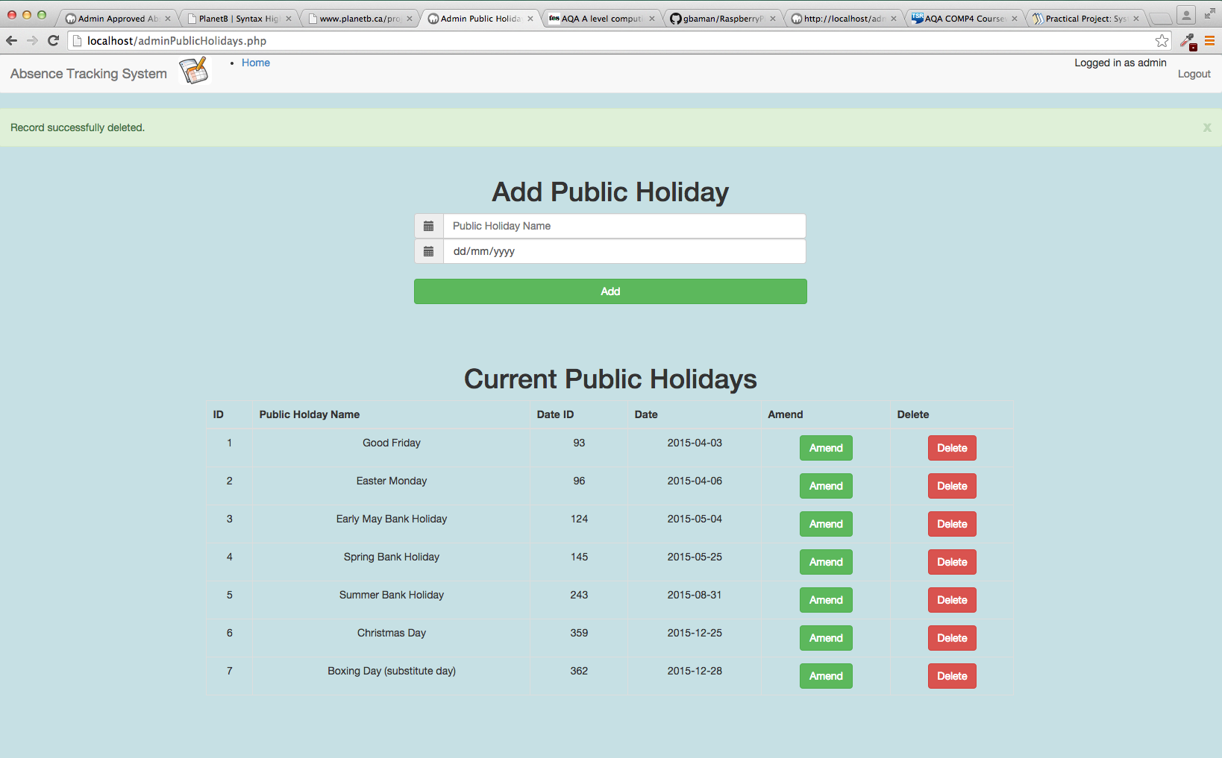

Figure 85 - Test 9.5 Output

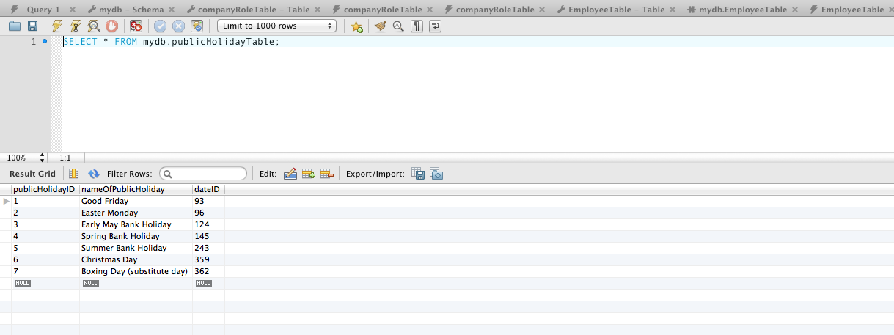

Figure 86 - Test 9.5 Database query of public holiday table.

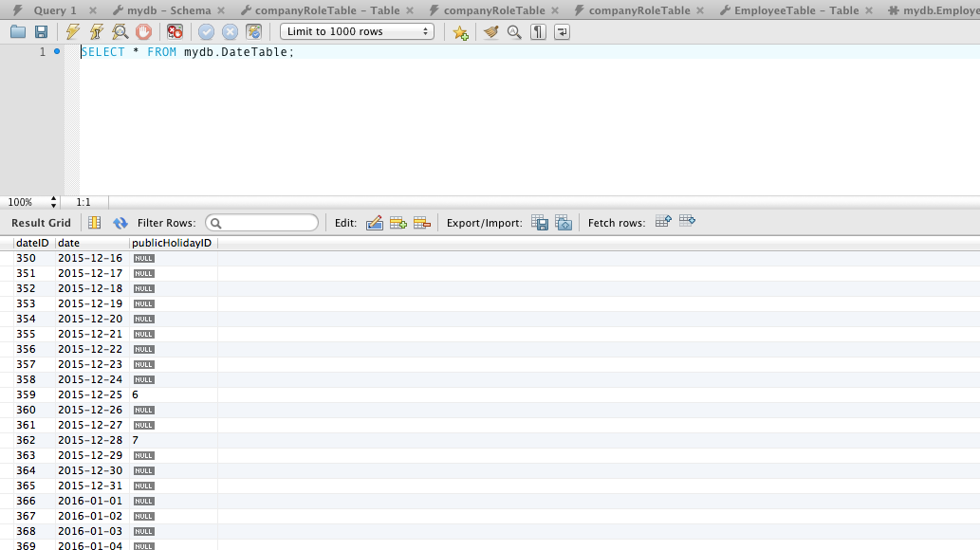

Figure 87 - Test 9.5 Database query of Date table.

## ADMIN VACATIONS PAGE

|  |  |  |
| --- | --- | --- |
| Role | NUMBER OF EMPLOYEES in this role | Minimum Staffing level |
| Admin | 1 | 0 |
| Cashier | 4 | 3 |
| Customer Advisor | 4 | 2 |
| Manager | 2 | 1 |

|  |  |  |  |  |  |  |  |  |  |
| --- | --- | --- | --- | --- | --- | --- | --- | --- | --- |
| Employee | ROLE | date joined the company | Main 1st Choice Start | Main 1st Choice  END | Main 2ND Choice Start | Main 2ND Choice END | STAFF IN ROLE DURING 1ST CHOICE PERIOD | STAFF IN ROLE DURING 2ND CHOICE PERIOD | EXPECTED OUTCOME |
| Steve Brookstein | Cashier | 01/01/2005 | 10/01/2015 | 15/01/2015 | 10/02/2015 | 15/02/2015 | 4 | 4 | 1ST CHOICE GRANTED |
| Shane Ward | Cashier | 01/01/2006 | 10/01/2015 | 15/01/2015 | 10/02/2015 | 15/02/2015 | 3 | 4 | 2ND CHOICE GRANTED |
| Leona Lewis | Cashier | 01/01/2007 | 10/01/2015 | 15/01/2015 | 10/02/2015 | 15/02/2015 | 3 | 3 | REQUEST REJECTED. PROCESING HALTS |
| Leon Jackson | Manager | 01/01/2008 | 10/01/2015 | 15/01/2015 | 10/02/2015 | 15/02/2015 | 2 | 2 | 1ST CHOICE GRANTED |
| Alexandre Burke | Cashier | 01/01/2009 | 10/01/2015 | 15/01/2015 | 10/02/2015 | 15/02/2015 | 3 | 3 | REQUEST REJECTED |
| Joe McEldry | Customer Advisor | 01/01/2010 | 10/01/2015 | 15/01/2015 | 10/02/2015 | 15/02/2015 | 4 | 4 | 1ST CHOICE GRANTED |
| Matt Cardle | Customer Advisor | 01/01/2011 | 10/01/2015 | 15/01/2015 | 10/02/2015 | 15/02/2015 | 3 | 4 | 1ST CHOICE GRANTED |
| James Arthur | Customer Advisor | 01/01/2012 | 10/01/2015 | 15/01/2015 | 10/02/2015 | 15/02/2015 | 2 | 4 | 2ND CHOICE GRANTED |
| Sam Bailey | Customer Advisor | 01/01/2013 | 10/01/2015 | 15/01/2015 | 10/02/2015 | 15/02/2015 | 2 | 3 | 2ND CHOICE GRANTED |
| Ben Haenow | Manager | 01/01/2014 | 10/01/2015 | 15/01/2015 | 10/02/2015 | 15/02/2015 | 1 | 2 | 2ND CHOICE GRANTED |

|  |  |  |  |  |  |
| --- | --- | --- | --- | --- | --- |
| Test ID | description | data type | expected result | pass / fail | cross reference |
| 10.1 | From the Main Menu select Admin Vacation Requests | Typical | List of Current main vacation requests should match the earlier table. | PASS | Figure 88 |
| 10.2 | From the Main Menu select Admin Vacation Requests  Click on the “Process Main Vacation Requests” Button | Typical | A green success status bar should be displayed containing numerous results, for each employee.  The results should match the expected outcome column in the earlier table. | FAIL | Figure 89 |

| Employee | ROLE | date joined the company | Main 1st Choice Start | Main 1st Choice  END | Main 2ND Choice Start | Main 2ND Choice END | STAFF IN ROLE DURING 1ST CHOICE PERIOD | STAFF IN ROLE DURING 2ND CHOICE PERIOD | EXPECTED OUTCOME | Actual outcome |
| --- | --- | --- | --- | --- | --- | --- | --- | --- | --- | --- |
| Steve Brookstein | Cashier | 01/01/2005 | 10/01/2015 | 15/01/2015 | 10/02/2015 | 15/02/2015 | 4 | 4 | 1ST CHOICE GRANTED | **1ST CHOICE GRANTED** |
| Shane Ward | Cashier | 01/01/2006 | 10/01/2015 | 15/01/2015 | 10/02/2015 | 15/02/2015 | 3 | 4 | 2ND CHOICE GRANTED | **1ST CHOICE GRANTED** |
| Leona Lewis | Cashier | 01/01/2007 | 10/01/2015 | 15/01/2015 | 10/02/2015 | 15/02/2015 | 3 | 3 | REQUEST REJECTED | **2ND CHOICE GRANTED** |
| Leon Jackson | Manager | 01/01/2008 | 10/01/2015 | 15/01/2015 | 10/02/2015 | 15/02/2015 | 2 | 2 | 1ST CHOICE GRANTED | **1ST CHOICE GRANTED** |
| Alexandre Burke | Cashier | 01/01/2009 | 10/01/2015 | 15/01/2015 | 10/02/2015 | 15/02/2015 | 3 | 3 | REQUEST REJECTED | **1ST CHOICE GRANTED** |
| Joe McEldry | Customer Advisor | 01/01/2010 | 10/01/2015 | 15/01/2015 | 10/02/2015 | 15/02/2015 | 4 | 4 | 1ST CHOICE GRANTED | **1ST CHOICE GRANTED** |
| Matt Cardle | Customer Advisor | 01/01/2011 | 10/01/2015 | 15/01/2015 | 10/02/2015 | 15/02/2015 | 3 | 4 | 1ST CHOICE GRANTED | **1ST CHOICE GRANTED** |
| James Arthur | Customer Advisor | 01/01/2012 | 10/01/2015 | 15/01/2015 | 10/02/2015 | 15/02/2015 | 2 | 4 | 2ND CHOICE GRANTED | **1ST CHOICE GRANTED** |
| Sam Bailey | Customer Advisor | 01/01/2013 | 10/01/2015 | 15/01/2015 | 10/02/2015 | 15/02/2015 | 2 | 3 | 2ND CHOICE GRANTED | **1ST CHOICE GRANTED** |
| Ben Haenow | Manager | 01/01/2014 | 10/01/2015 | 15/01/2015 | 10/02/2015 | 15/02/2015 | 1 | 2 | 2ND CHOICE GRANTED | **1ST CHOICE GRANTED** |

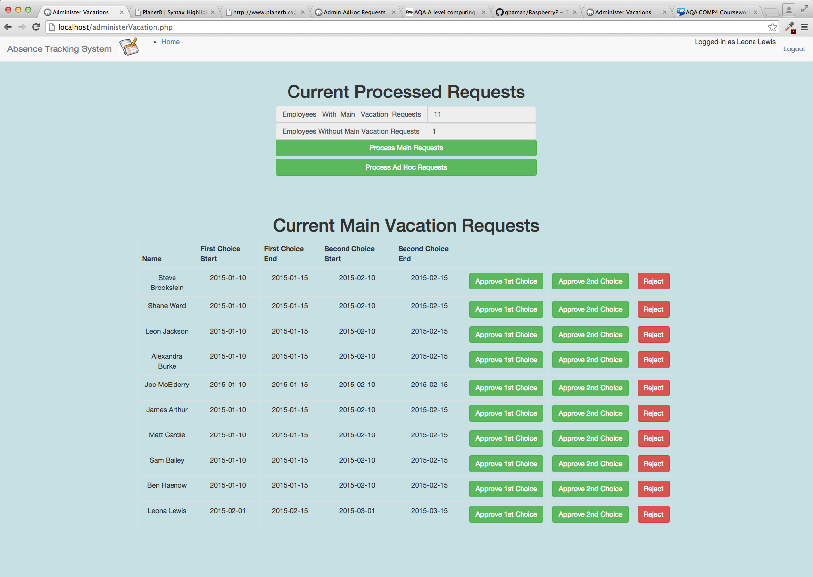

Figure 88 - Test 10.1 Output

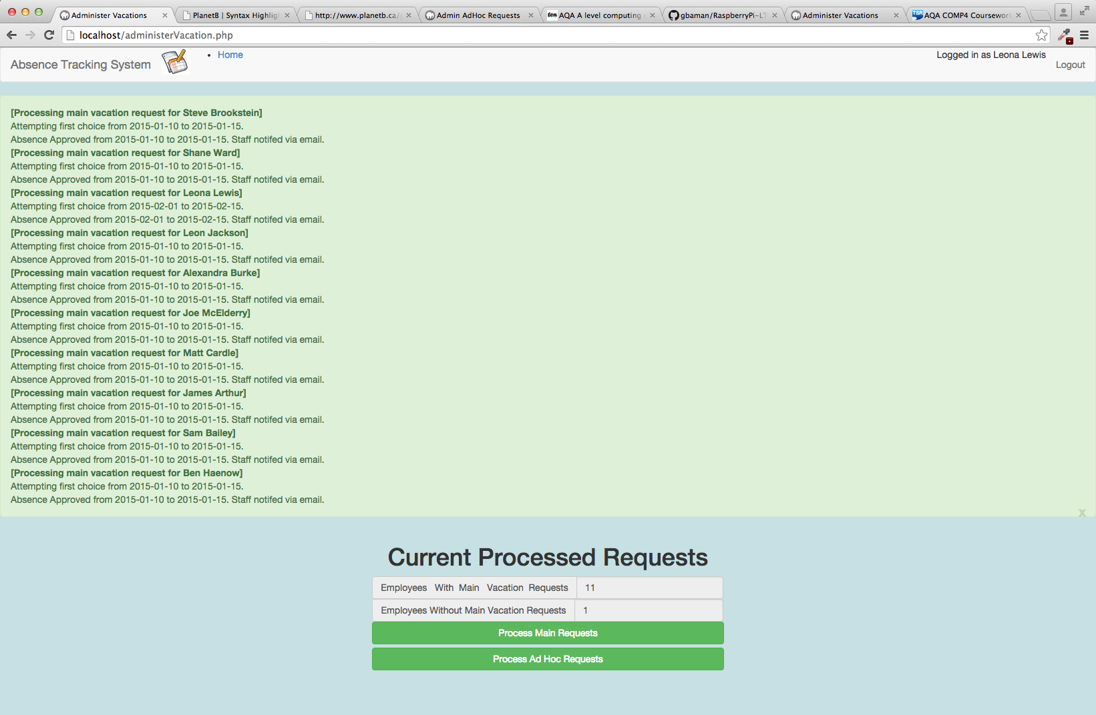

Figure 89 - Test 10.2 Output

## employee main vacation request PAGE

| Test ID | description | data type | expected result | pass / fail | cross reference |
| --- | --- | --- | --- | --- | --- |
| 11.1 | From the Main Menu select Employee Main Vacation Request  Select 1st Choice Start Date of 05/01/2015  Select 1st Choice End Date of 16/01/2015  Select 2nd Choice Start Date of 02/03/2015  Select 2nd Choice Start Date of 13/03/2015  Click on Add Main Vacation Request button. | Typical | User is redirected to the main index.php page.  Green success status bar shows “Main Vacation Request Successfully created”.  Using MySQL workbench:  1) Database query of the Main Vacation Request Table shows the new record.  2) Database query of the Employee table shows associated employee record for has a value for Main Vacation Request ID. | PASS | Figure 90  Figure 91  Figure 92 |
| 11.2 | From the Main Menu select Employee Main Vacation Request  Leave all date fields empty,  Click on Add Main Vacation Request button. | Erroneous | Red error status bar shows “….is not a valid date” for each of the fields.  No record is added to the Current Main Vacations Request Table | PASS | Figure 93**Error! Reference source not found.** |
| 11.3 | From the Main Menu select Employee Main Vacation Request  Enter 12/01/2015 for first choice start date.  Enter 01/01/2015 for first choice end date.  Enter 01/02/2015 for 2nd choice start.  Enter 15/02/2015 for 2nd Choice end.  Click on Add Main Vacation Request button. | Erroneous | Red error status bar shows “1st Choice End date is before 1st Choice Start date”  No record is added to the Current Main Vacations Request Table | PASS | Figure 94 |
| 11.4 | From the Main Menu select Employee Main Vacation Request  Enter 01/01/2015 for first choice start date.  Enter 12/01/2015 for first choice end date.  Enter 15/02/2015 for 2nd choice start.  Enter 01/02/2015 for 2nd Choice end.  Click on Add Main Vacation Request button. | Erroneous | Red error status bar shows “2nd Choice End date is before 2nd Choice Start date”  No record is added to the Current Main Vacations Request Table | PASS | Figure 95 |

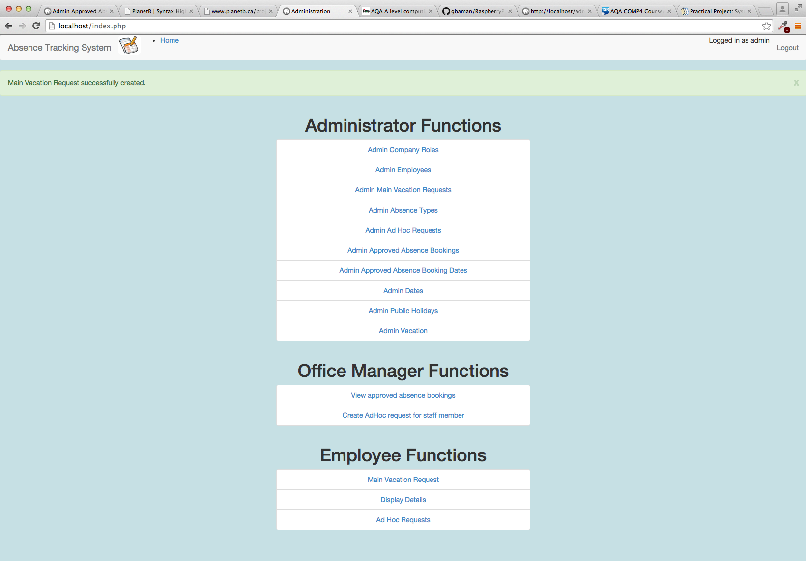

Figure 90 - Test 11.1 Output

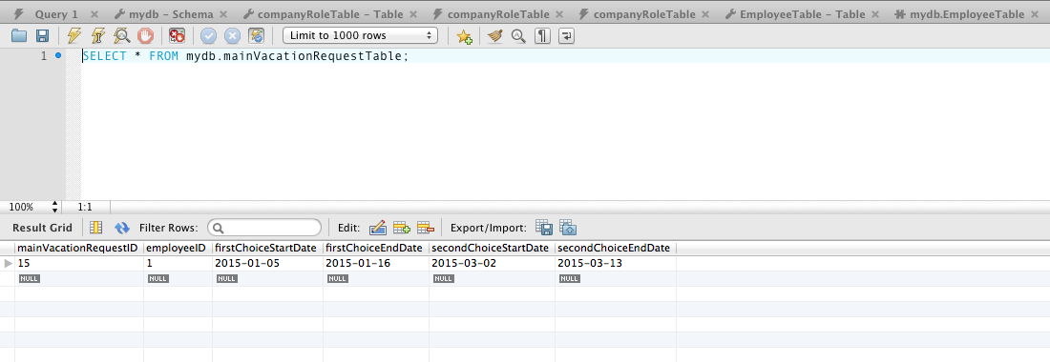

Figure 91 - Test 11.1 Database query on Main Vacation Request Table.

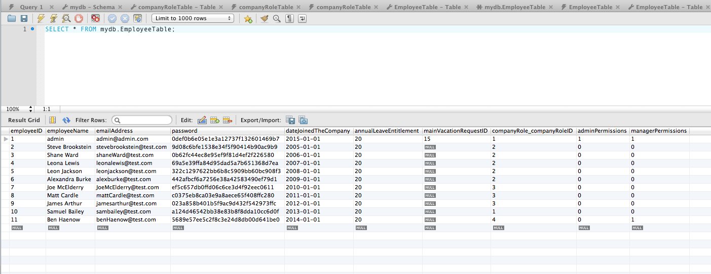

Figure 92 - Test 11.1 Database query on Employee Table.

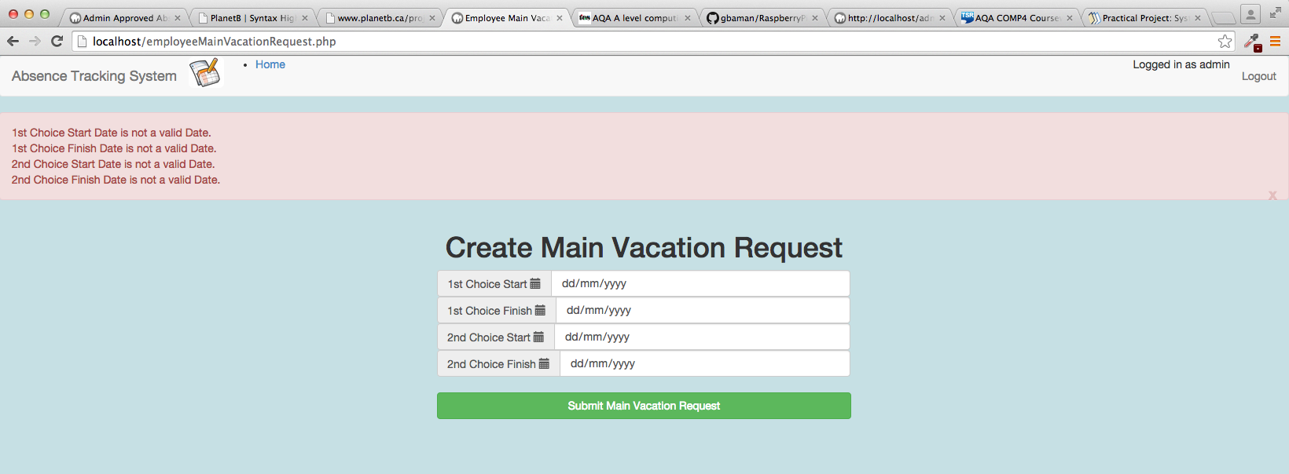

Figure 93 – Test 11.2 Output.

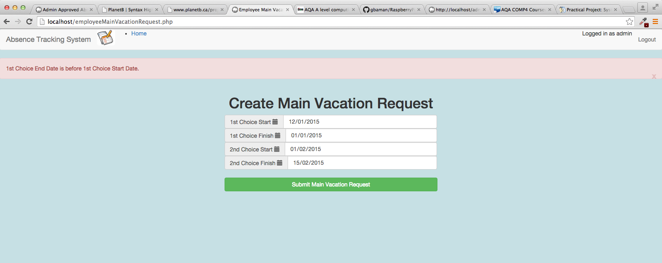

Figure 94 – Test 11.3 Output.

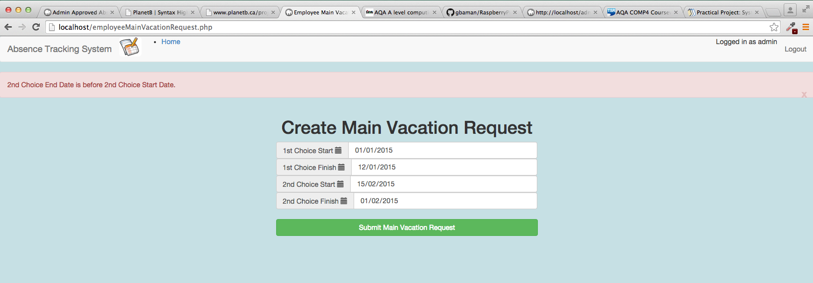

Figure 95 – Test 11.4 Output.

## employee DISPLAY DETAILS PAGE

| Test ID | description | data type | expected result | pass / fail | cross reference |
| --- | --- | --- | --- | --- | --- |
| 12.1 | Login to the system using user email [leonalewis@test.com](mailto:leonalewis@test.com) with password Zaq12wsx  From the main menu select Employee Display Details | Typical | Employee Details for Leona Lewis displayed. A single entry for Approve Absence Request, Pending Ad Hoc Request and Pending Main Vacation Request should be shown.  Using MySQL workbench:  1) Database query of the Approved Absence Booking table shows the record for Leona Lewis.  2) Database query of the Approved Absence booking date table shows 10 entries (one for each day of the booking period). | PASS | Figure 96  Figure 97  Figure 98 |
| 12.2 | Whilst logged in as Leona Lewis, from the main menu select Employee Display Details.  Click the delete button next to the approved absence request entry | Typical | Green success status bar with “Record Successfully deleted” is displayed.  Entry is removed from the Approved Absence Requests table on screen.  Using MySQL workbench:  1) Database query of the Approved Absence Booking table shows the record for Leona Lewis has been removed from the database.  2) Database query of the Approved Absence booking date table shows the 10 entries related to the booking have been removed from the database. | PASS | Figure 99  Figure 100  Figure 101 |
| 12.3 | Whilst logged in as Leona Lewis, from the main menu select Employee Display Details.  Click the Amend Button for the Pending AdHoc Request | Typical | User is redirected to the editAdHocRequest.php page,  Fields on the page are populated with the values for the AdHoc request. | PASS | Figure 102 |
| 12.4 | Whilst logged in as Leona Lewis, from the main menu select Employee Display Details.  Click the Amend Button for the Pending AdHoc Request  Modify the start date from 10/03/15 to 09/03/15.  Click the edit request button | Typical | After clicking edit request User is redirected to the employeeDetailsDisplay.php  Green success status bar with “Record Successfully Updated” is displayed.  Pending AdHoc Requests table on screen shows modified date.  Using MySQL workbench:  1) Database query of the AdHoc absence request table shows record for Leona Lewis and start date is 09/03/15 | PASS | Figure 103  Figure 104 |
| 12.5 | Whilst logged in as Leona Lewis, from the main menu select Employee Display Details.  Click the Amend Button for the Pending AdHoc Request  Modify the start date from 09/03/15 to 16/03/15.  Click the edit request button | Extreme | Red error status bar with “End date is before start date.”  No change made to the record in the database. | PASS | Figure 105 |
| 12.6 | Whilst logged in as Leona Lewis, from the main menu select Employee Display Details.  Click the Amend Button for the Pending AdHoc Request  Delete the values from the start date and end date fields, so the fields are blank.  Click the edit request button | Erroneous | Red error status bar with “Start Date is not a valid date.” And “ End date is not a valid date.”  No change made to the record in the database. | PASS | Figure 106 |
| 12.7 | Whilst logged in as Leona Lewis, from the main menu select Employee Display Details.  Click the Amend Button for the Pending AdHoc Request  Click on the cancel button | Typical | After clicking edit request User is redirected to the employeeDetailsDisplay.php | PASS | Figure 107 |
| 12.8 | Whilst logged in as Leona Lewis, from the main menu select Employee Display Details.  Click the Delete Button for the Pending AdHoc Request | Typical | Green success status bar with “Record Successfully deleted” is displayed.  Entry is removed from the Ad Hoc Request table on screen.  Using MySQL workbench:  Database query of the Ad Hoc Request table shows the record for Leona Lewis has been removed from the database. | PASS | Figure 108  Figure 109 |
| 12.9 | Whilst logged in as Leona Lewis, from the main menu select Employee Display Details.  Click the Amend Button for the Pending Main Vacation Request | Typical | User is redirected to the editMainVacationRequest.php page,  Fields on the page are populated with the values for the pending main vacation request. | PASS | Figure 110 |
| 12.10 | Whilst logged in as Leona Lewis, from the main menu select Employee Display Details.  Click the Amend Button for the Pending AdHoc Request  Modify the start date from 01/02/15 to 02/02/15.  Click the edit request button | Typical | After clicking edit request User is redirected to the employeeDetailsDisplay.php  Green success status bar with “Record Successfully Updated” is displayed.  Pending Main Vacation Requests table on screen shows modified date.  Using MySQL workbench:   * 1. Database query of the Main Vacation Requests table shows record for Leona Lewis and a first choice start date is 02/02/15 |  | Figure 111  Figure 112 |
| 12.11 | Whilst logged in as Leona Lewis, from the main menu select Employee Display Details.  Click the Delete Button for the Pending Main Vacation Request | Typical | Green success status bar with “Record Successfully updated” is displayed.  Entry is removed from the pending main vacation request table on screen.  Using MySQL workbench:  Database query of the Main Vacation Request table shows the record for Leona Lewis has been removed from the database. | PASS | Figure 113  Figure 114 |

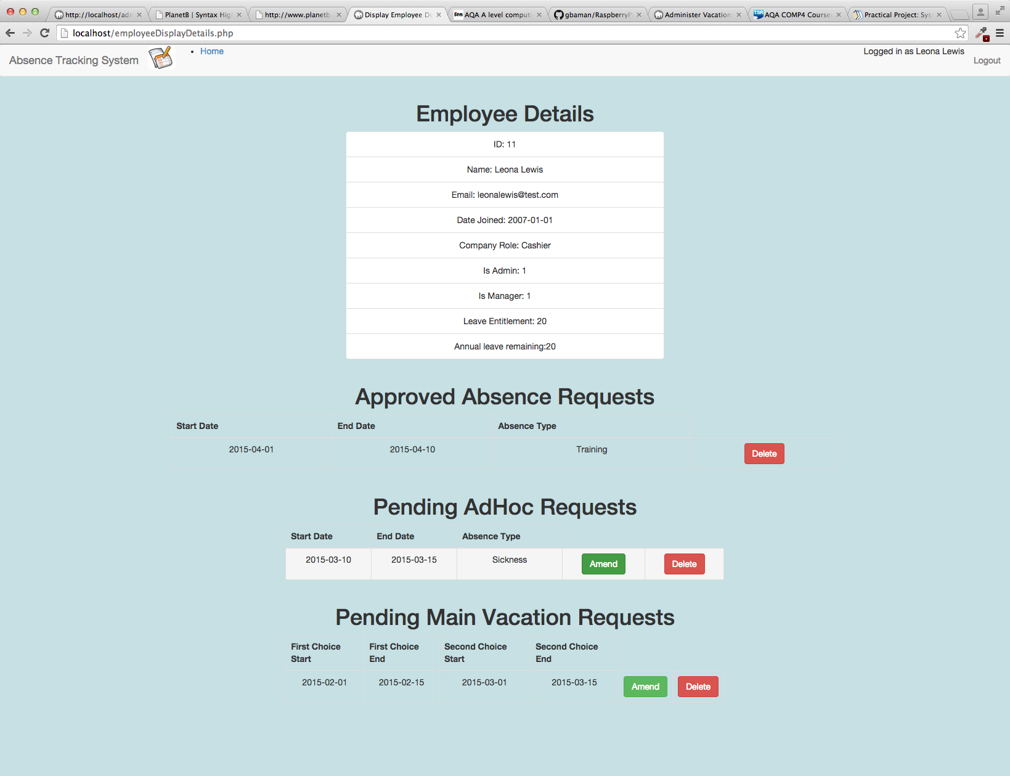

Figure 96 - Test 12.1 Output

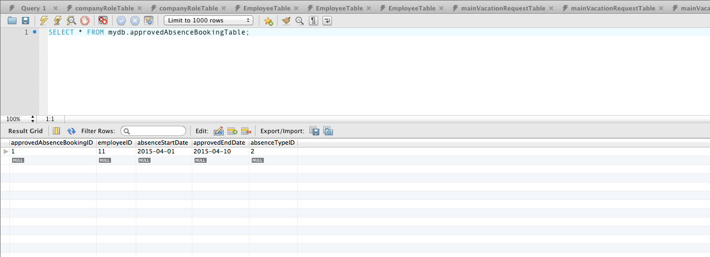

Figure 97 - Test 12.1 Database Query on ApprovedAbsenceBooking table

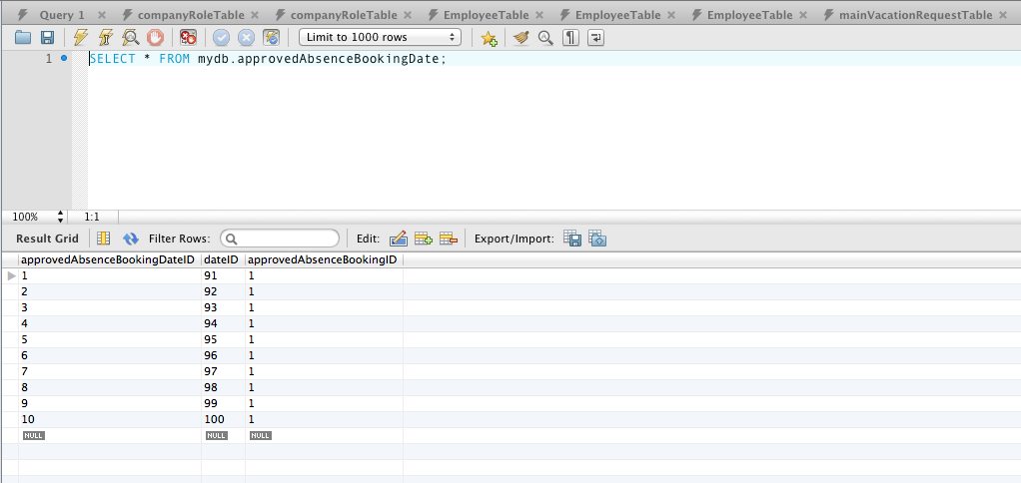

Figure 98 - Test 12.1 Database query on ApprovedAbsenceBookingDate table.

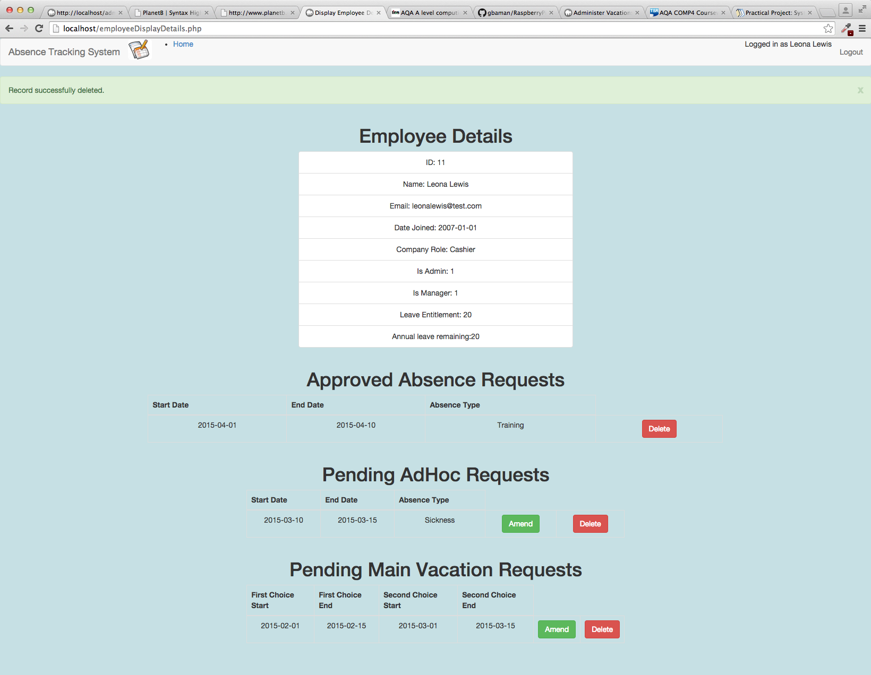

Figure 99 - Test 12.2 Output

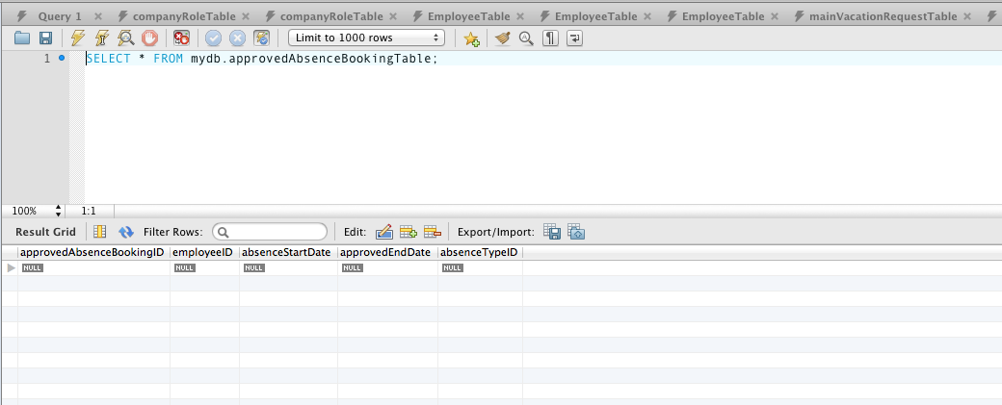

Figure 100 - Test 12.2 Database Query on ApprovedAbsenceBooking table

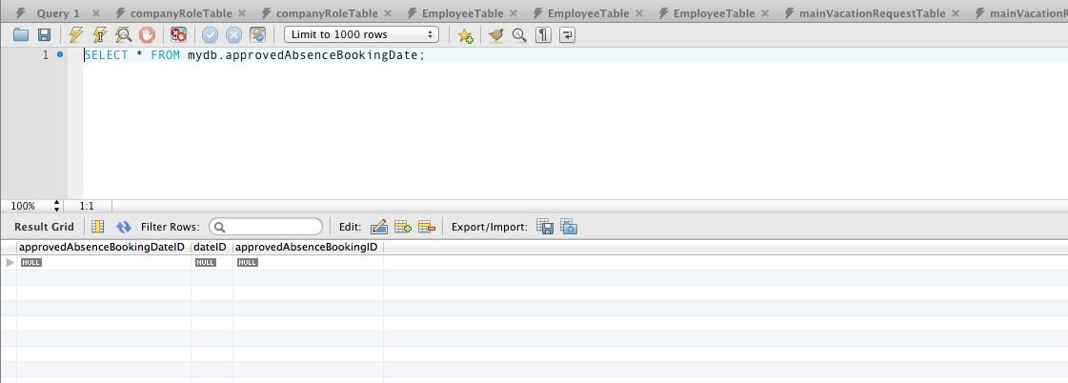

Figure 101 - Test 12.2 Database query on ApprovedAbsenceBookingDate table.

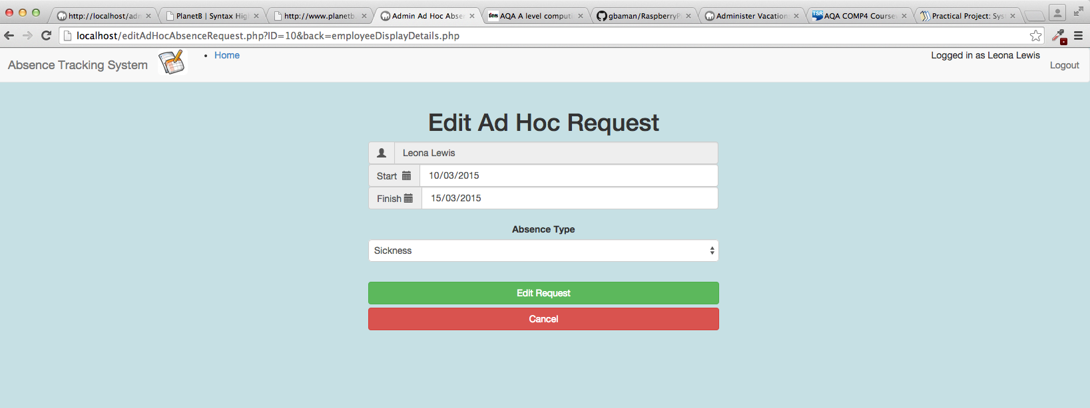

Figure 102 - Test 12.3 Output.

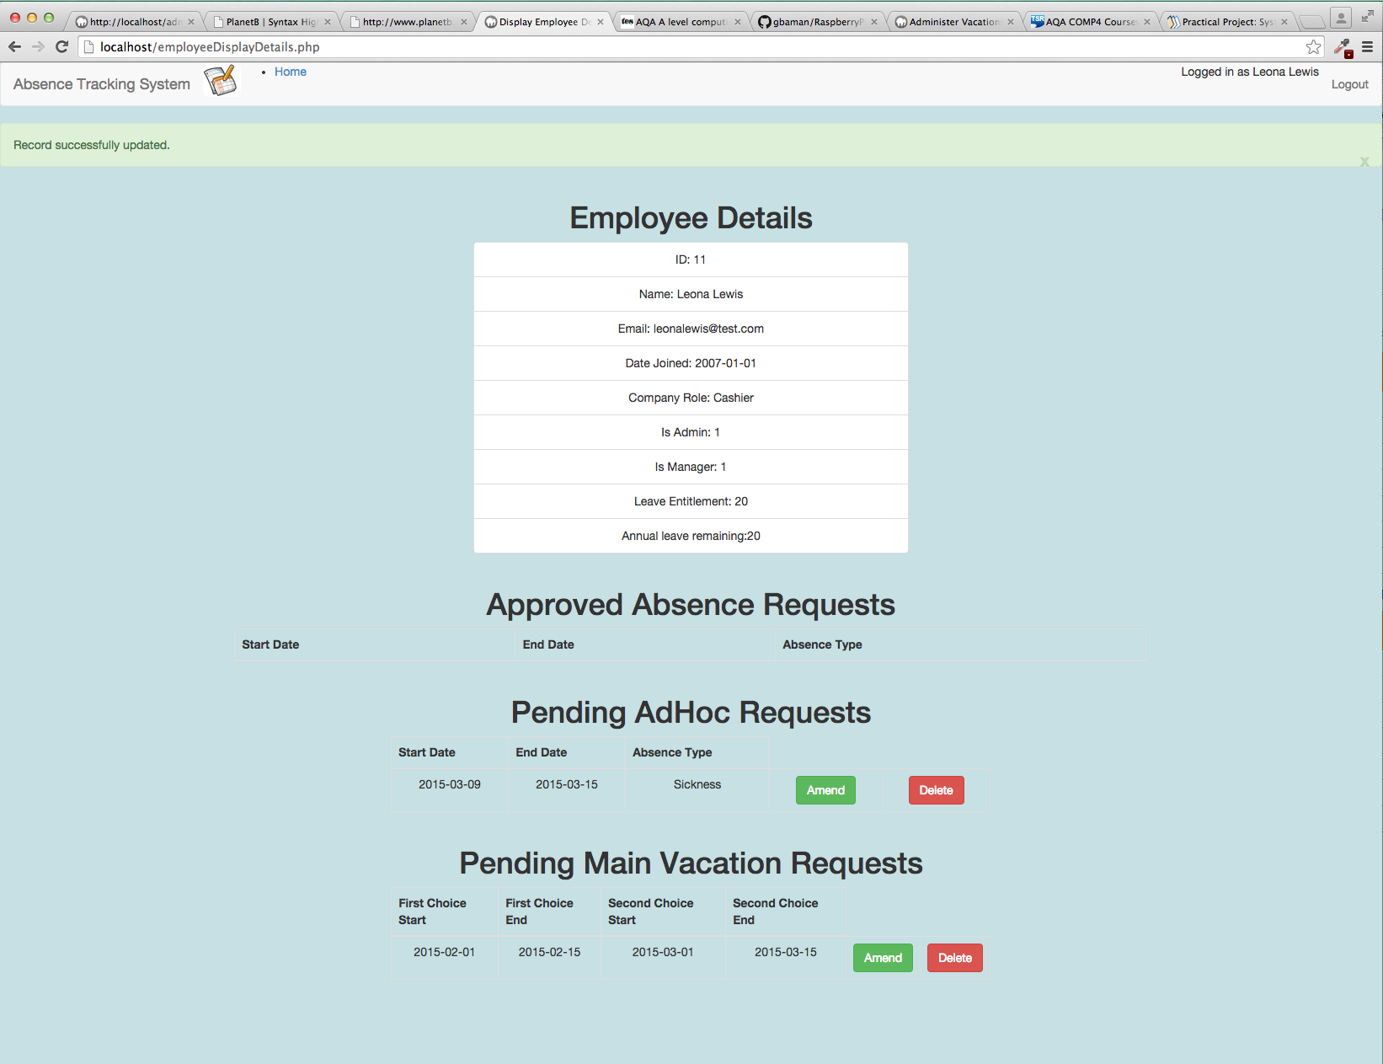

Figure 103 - Test 12.4 Output.

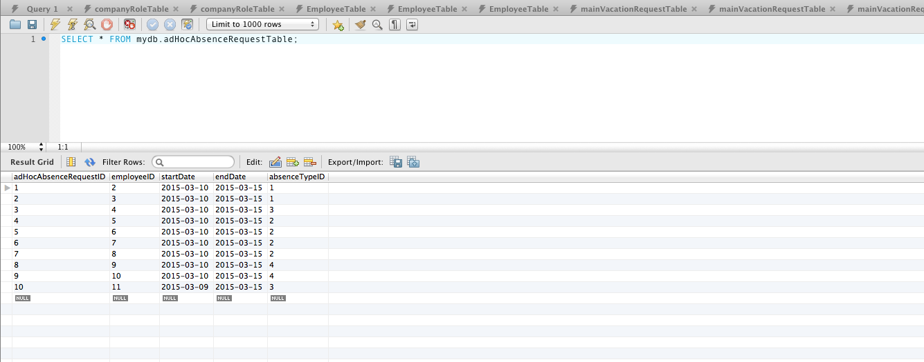

Figure 104 - Test 12.4 Database query on AdHocAbsenceRequest table.

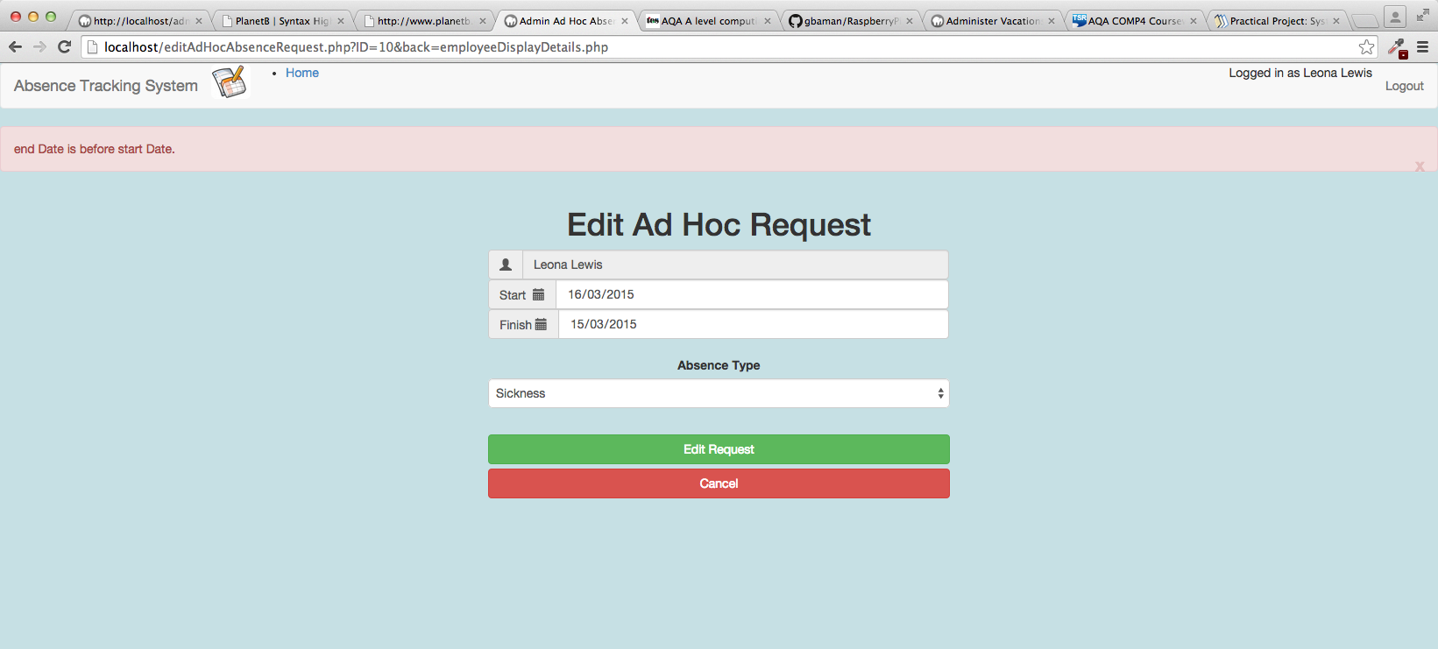

Figure 105 - Test 12.5 Output

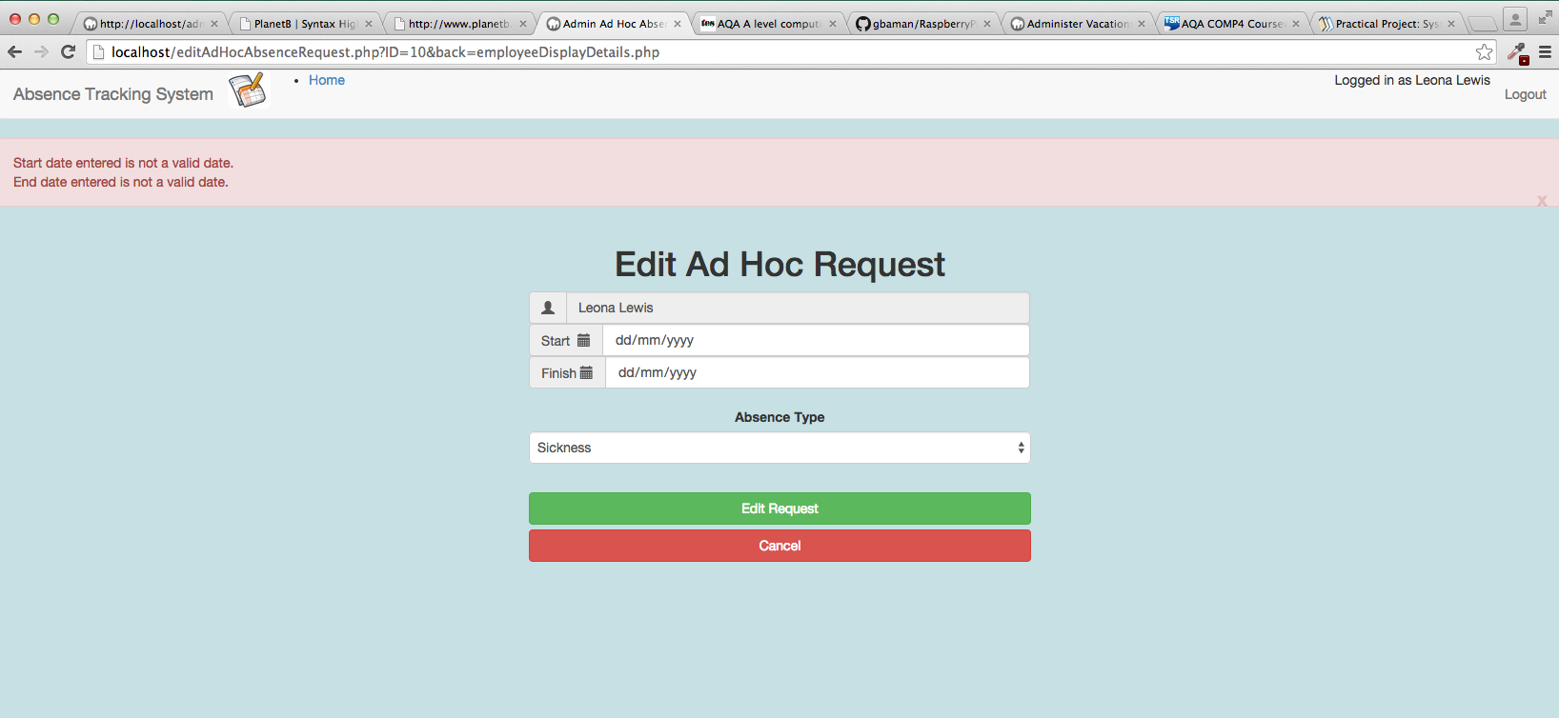

Figure 106 - Test 12.6 Output

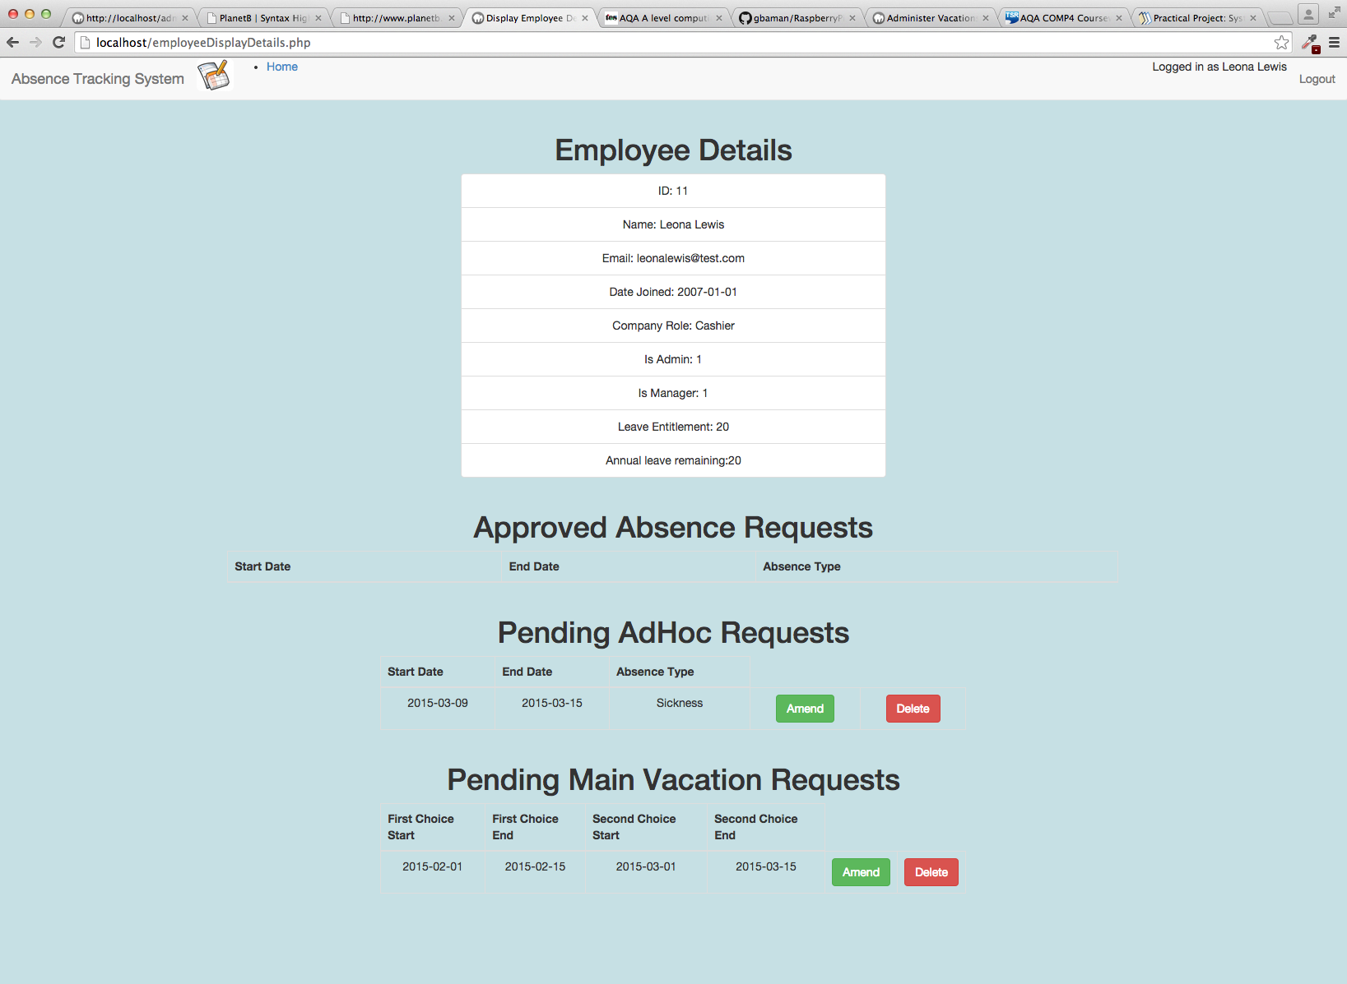

Figure 107 - Test 12.7 Output

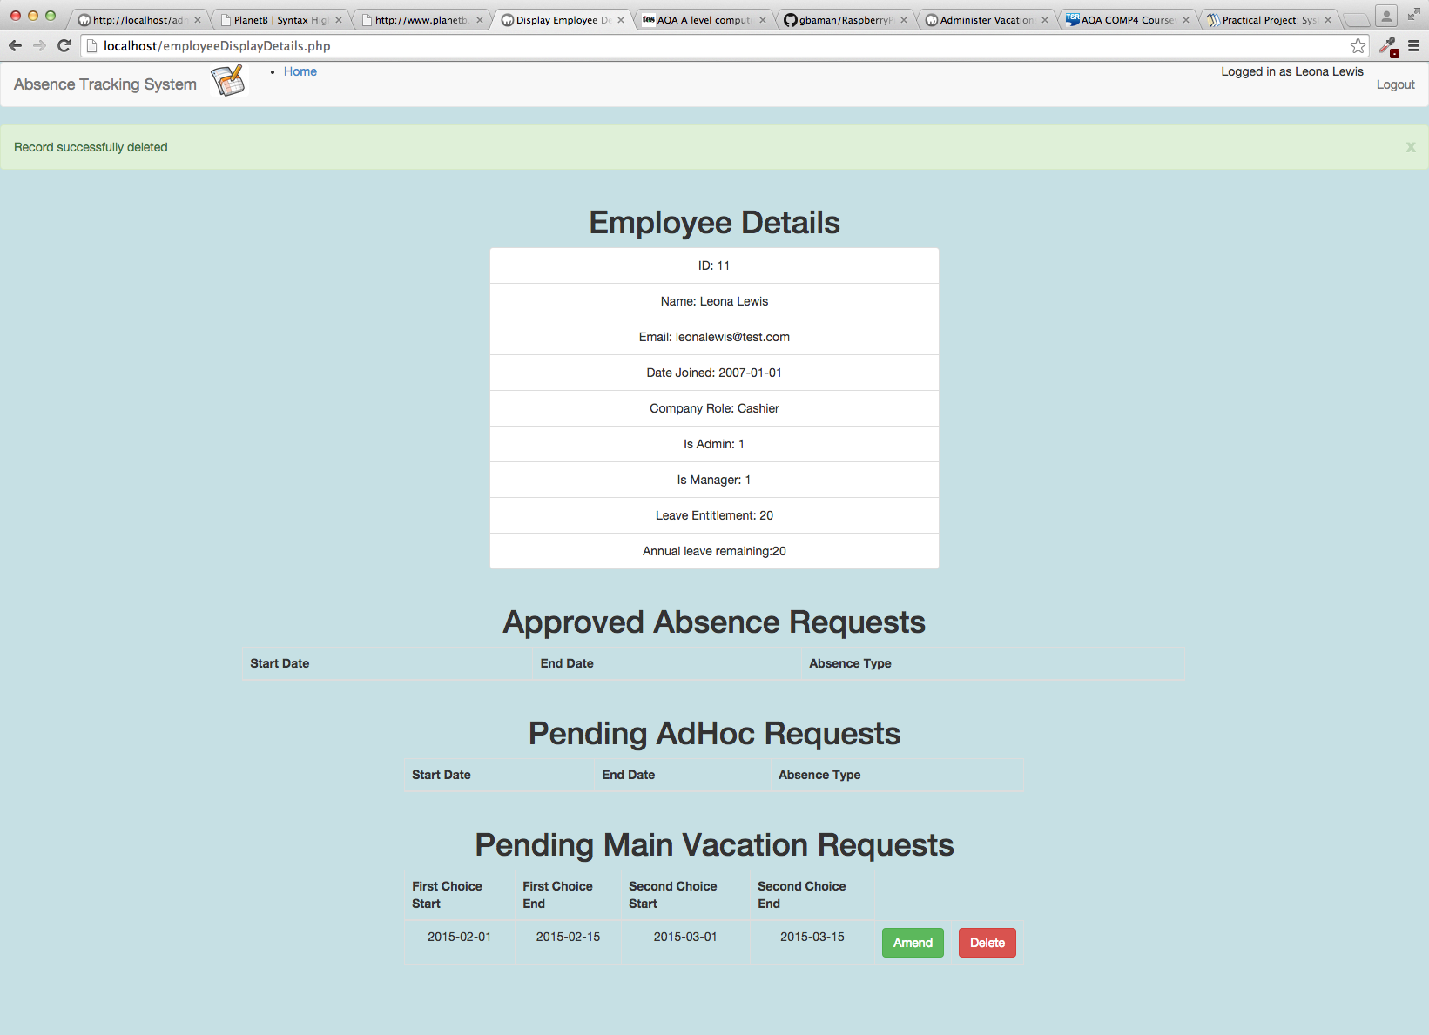

Figure 108 - Test 12.8 Output

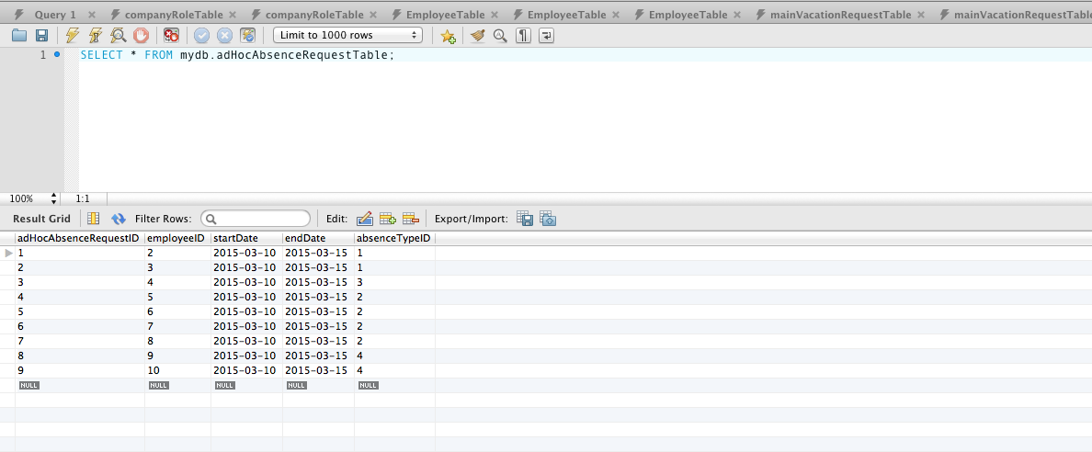

Figure 109 - Test 12.8 Database query on adHocAbsenceRequest table.

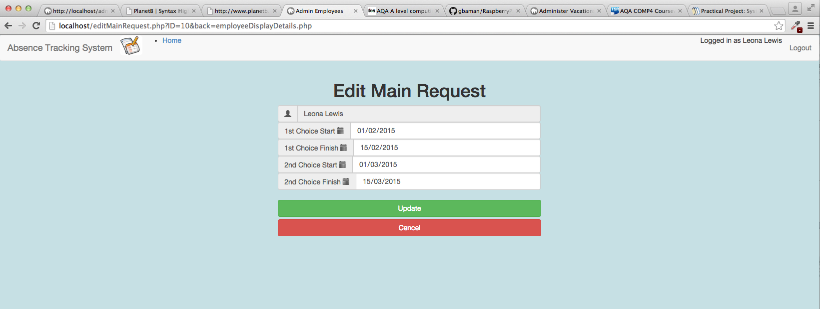

Figure 110 - Test 12.9 Output

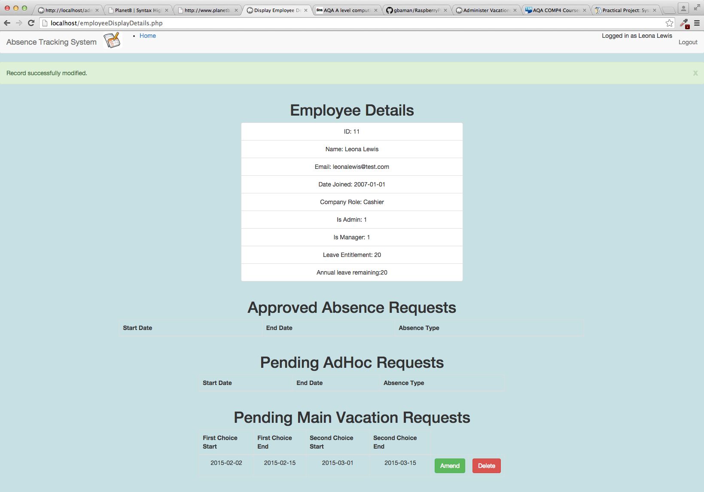

Figure 111 - Test 12.10 Output

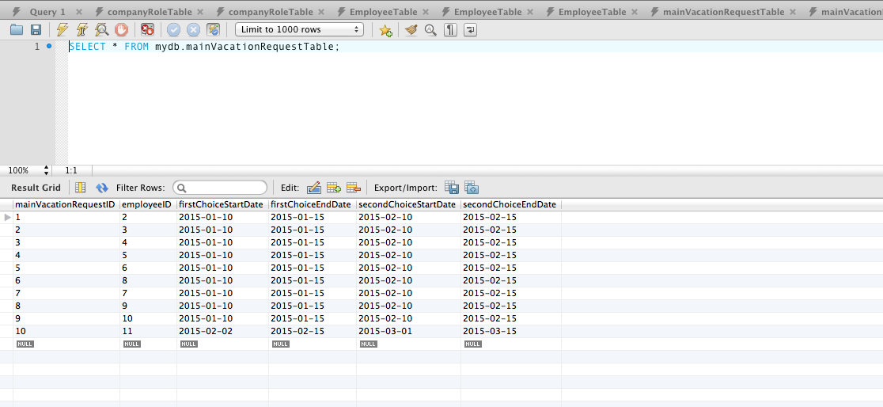

Figure 112 - Test 12.10 Database query on MainVacationRequest table.

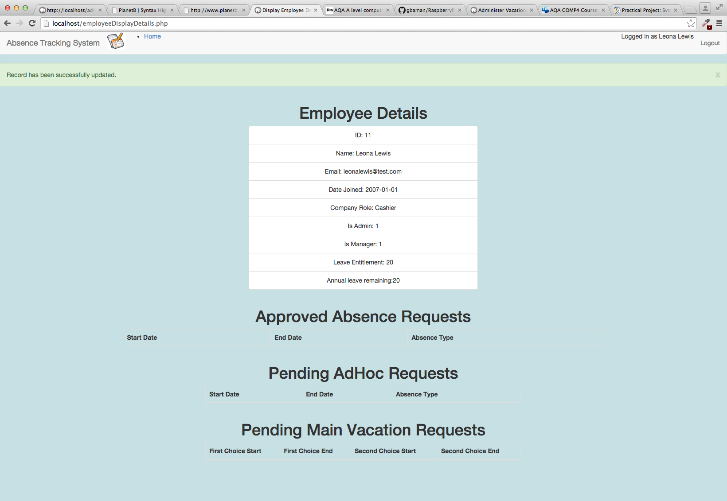

Figure 113 - Test 12.11 Output

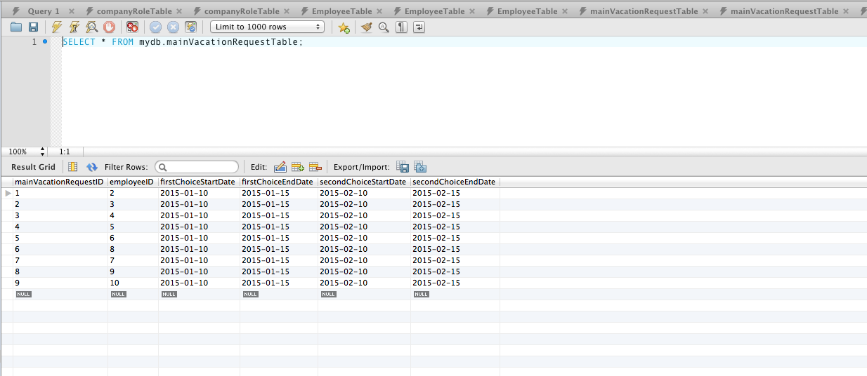

Figure 114 - Test 12.11 Database query on MainVacationRequest table.

## employee AD HOC REQUESTS PAGE

|  |  |  |  |  |  |
| --- | --- | --- | --- | --- | --- |
| Test ID | description | data type | expected result | pass / fail | cross reference |
| 13.1 | From the Main Menu select Employee Ad Hoc Requests  Leave all fields on the screen unchanged  Click on Add AdHoc Request button. | Erroneous | Red error status bar shows  “Start date given is not a valid date”  “End date given is not a valid date” | PASS | Figure 115 |
| 13.2 | From the Main Menu select Employee Ad Hoc Requests  Set start date to 30/01/2015  Set end date to 29/01/2015  Click on Add AdHoc Request button. | Extreme | Red error status bar shows  “end date is before start date” | PASS | Figure 116 |
| 13.3 | From the Main Menu select Employee Ad Hoc Requests  Set start date to 29/01/2015  Set end date to 30/01/2015  Click on Add AdHoc Request button. | Typical | Green success status bar shows “Record successfully created”.  .  Using MySQL workbench database query of the AdHocAbsenceRequest Table shows the record has been created. |  | Figure 117  Figure 118 |

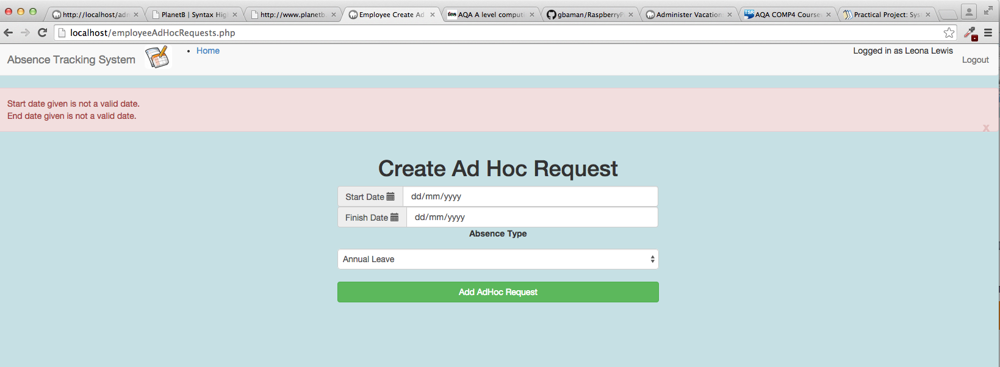

Figure 115 - Test 13.1 Output

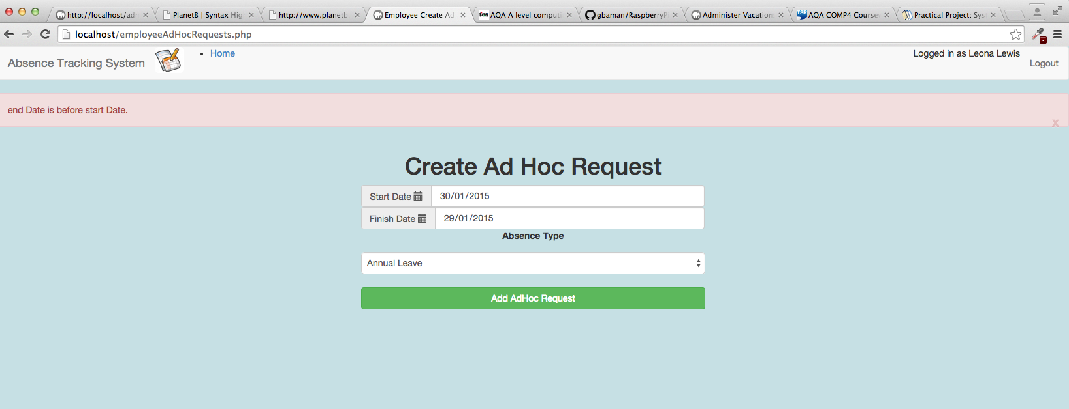

Figure 116 - Test 13.2 Output

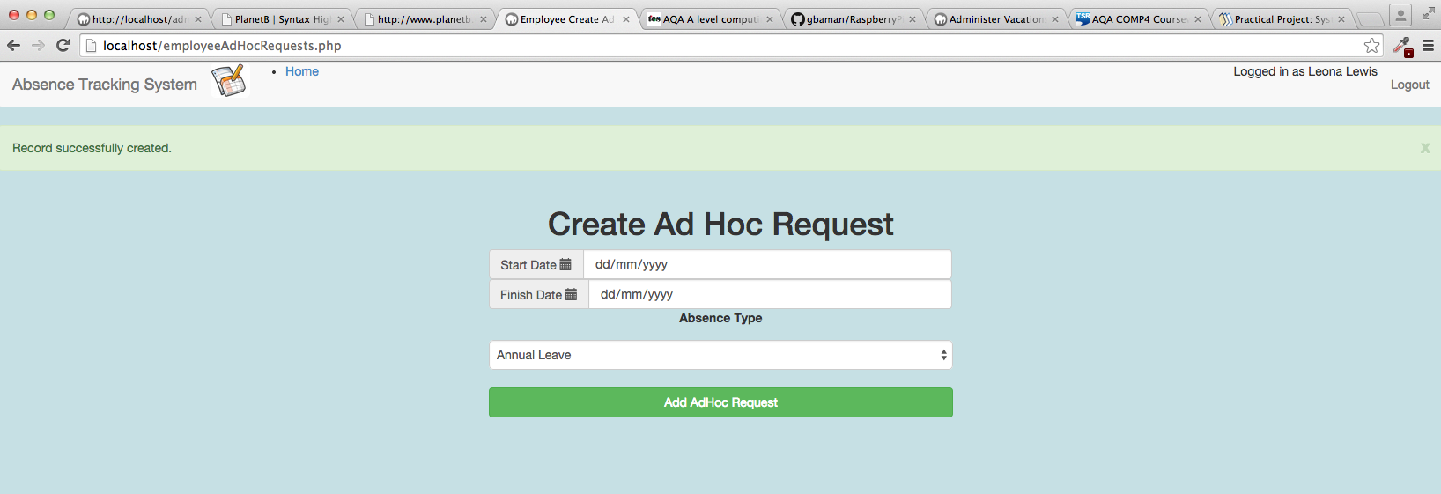

Figure 117 - Test 13.3 Output

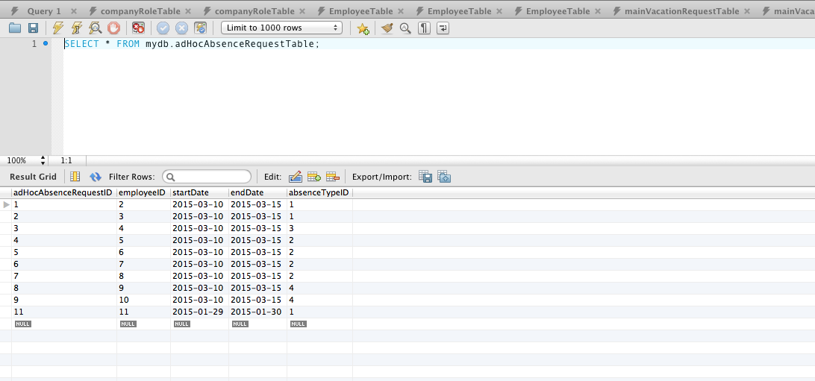

Figure 118 - Test 13.3 Database query on AdHocAbsenceRequest table.

## OFFICE MANAGER View approved bookings page

|  |  |  |  |  |  |
| --- | --- | --- | --- | --- | --- |
| Test ID | description | data type | expected result | pass / fail | cross reference |
| 14.1 | From the Main Menu select Office Manager – View Approved Absence Bookings  Leave all fields on the screen unchanged  Click on Display Bookings button. | Erroneous | Red error status bar shows  “Start date given is not a valid date”  “End date given is not a valid date” | PASS | Figure 119 |
| 14.2 | From the Main Menu select Office Manager – View Approved Absence Bookings  Set Start date to 01/04/2015  Set End date to 30/04/2014  Click on Display Bookings button. | Typical | Search results appear, showing bookings within the date period given. For the test data in the database, this should be a single entry for Leona Lewis who is on training between 01/04/15 and 10/04/15 | PASS | Figure 120 |
| 14.3 | From the Main Menu select Office Manager – View Approved Absence Bookings  Set Start date to 30/04/2015  Set End date to 01/04/2014  Click on Display Bookings button. | Extreme | Red error status bar shows  “End date is before start date”  Nothing is displayed in the search results | PASS | Figure 121 |
|  |  |  |  |  |  |

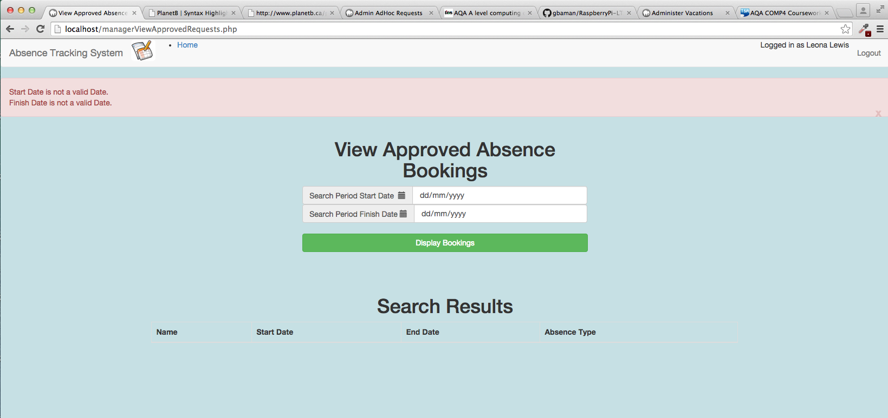

Figure 119 - Test 14.1 Output

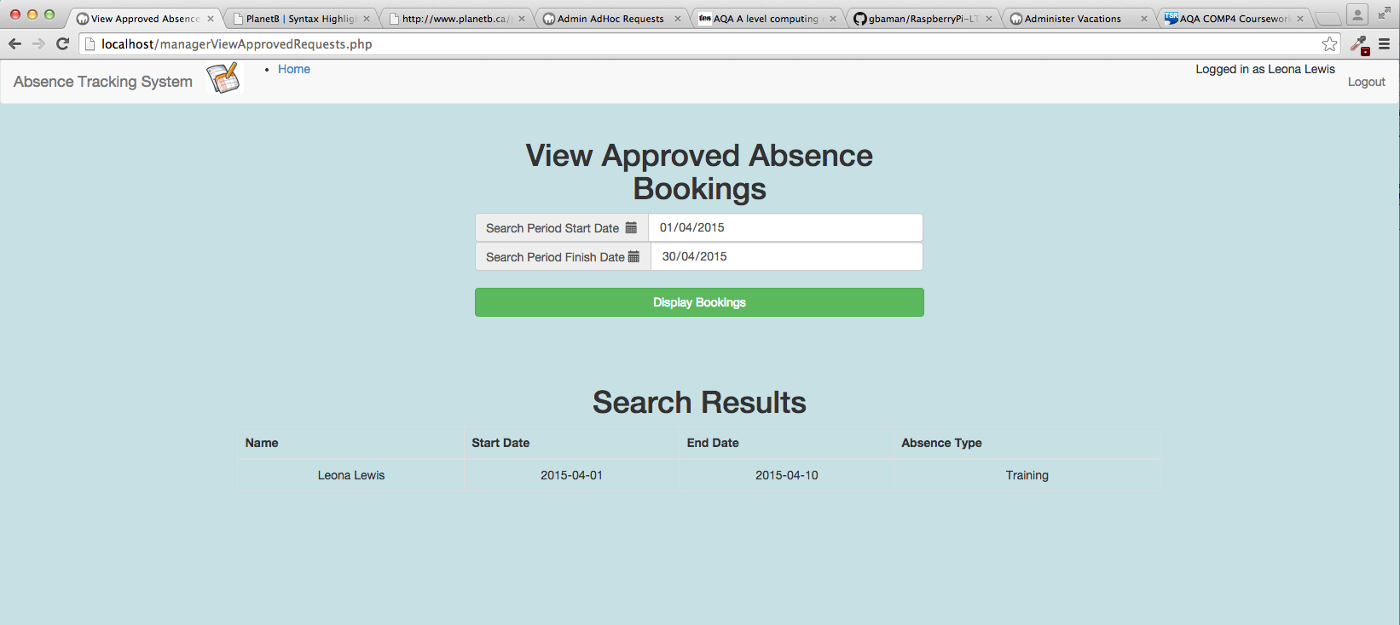

Figure 120 - Test 14.2 Output

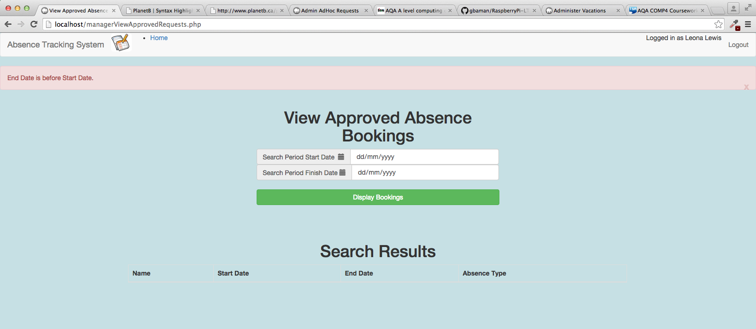

Figure 121 - Test 14.3 Output

## OFFICE MANAGER CREATE AD HOC REQUESTS PAGE

|  |  |  |  |  |  |
| --- | --- | --- | --- | --- | --- |
| Test ID | description | data type | expected result | pass / fail | cross reference |
| 15.1 | From the Main Menu select Office Manager – Create Ad Hoc Request for Staff Member. | Erroneous | User is redirected to the adminAdHocAbsenceRequest.php page. | PASS | Figure 122 |
|  | NOTE: THIS IS THE SAME PAGE AS USED FOR ADMINISTRATOR FOR AD HOC REQUESTS. THEREFORE, REMAINING TESTS FOR THIS PAGE ARE ALREADY COVERED IN SECTION 6.6 ON PAGE 233. |  |  |  |  |

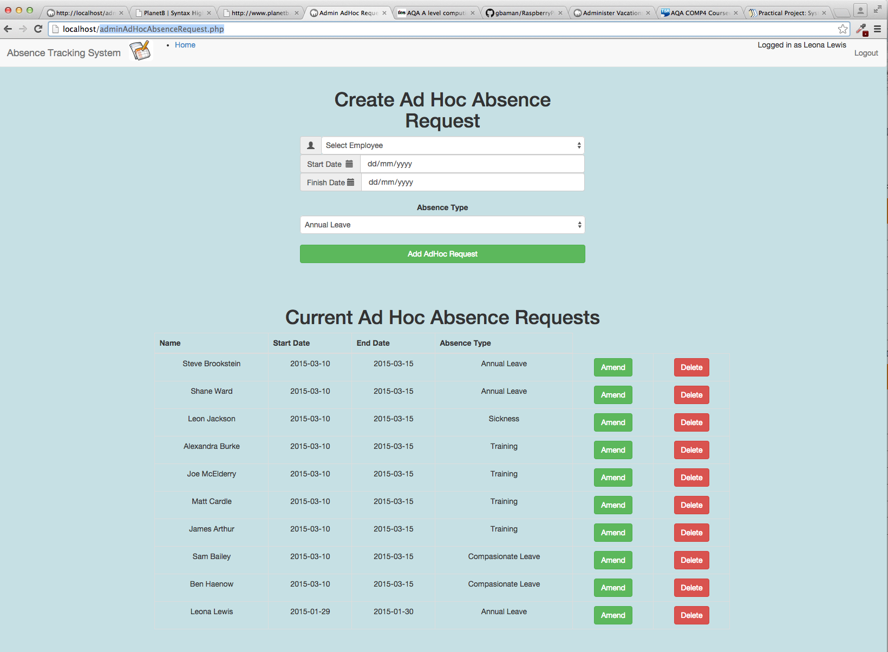

Figure 122 - Test 15.1 Output

# system maintenance

## system Overview

The absence tracking system is comprised of a series of PHP files, which are installed onto a webserver that provides an Apache / MySQL / PHP stack (eg:LAMP on Linux).

The user interacts with the system via HTML web pages, generated by the PHP scripts. These webpages are in HTML with some javascript, and utilise bootstrap and CSS for the styling of the display.

The system uses a login mechanism using session state to maintain details of the logged in user.

A user can have one of three types:

* Administrator – Has the power to create and modify and delete all aspects of the system
* Manager – Has the ability to view all staffs absence, and enter absence on behalf of staff.
* Employee – Has the ability to request, view, amend and cancel their own absence.

The type of user is specified when an employee record is created. The main menu choices (on page index.php) that are presented to the user will depend upon the type of the user. IE: A user of type employee will not be able to access the administrator options.

## Location of the source code

The absence tracking system source code is hosted in a GIT repository on GITHub (see http://github.com/samuelgilbertuk/absencetrackingsystem)

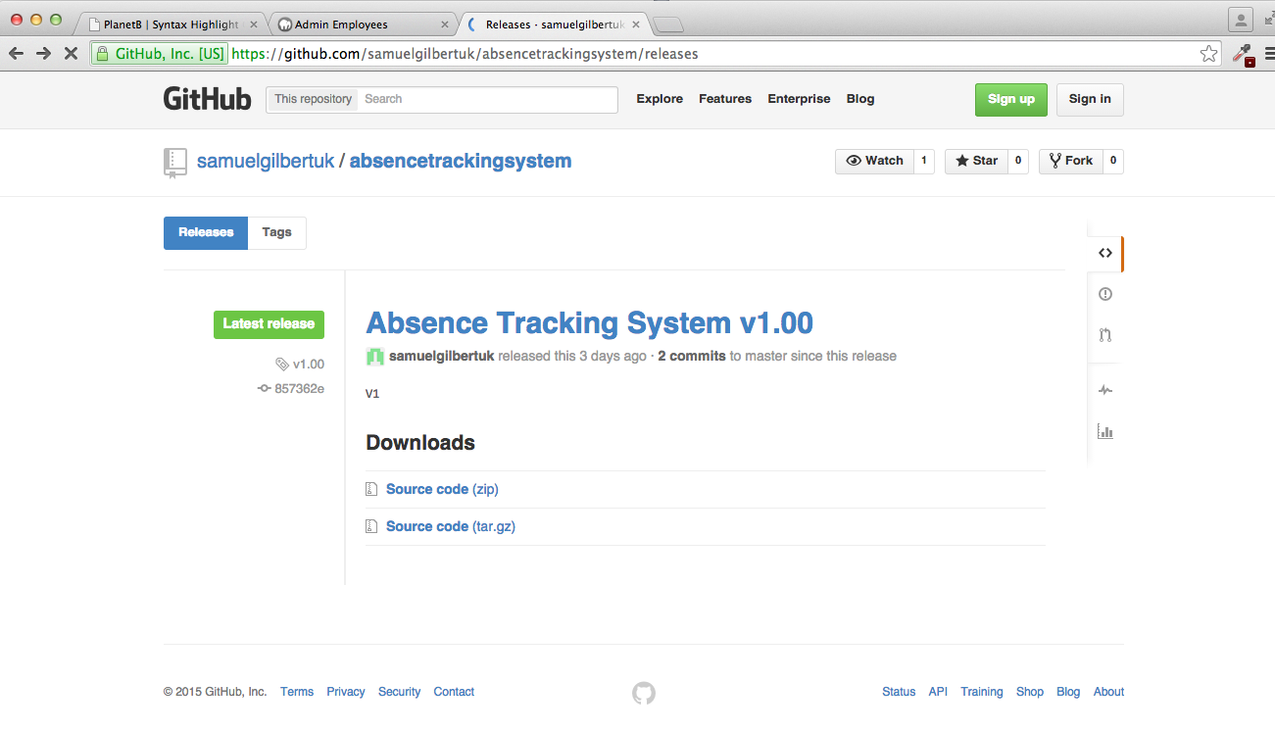

## STRUCTURE OF the source code

### Web Interface – root level

At the root level of the web interface are four key pages:

* setup.php – This page provides the interface for first time setup of the database, including the creation of the database, tables and absence administrator account.
* Login.php – This page allows the user to enter their email address and password, validates these against the database and then creates a session for the user.
* Index.php – This is the main menu, showing all options available to the user based on their account permissions (isAdministrator, isManager).
* Logout.php – This is the page the user is directed to if they click the logout button. Its main purpose is to destroy the session.

Each of the above pages contains logic to redirect the user to the most appropriate page based on state. The diagram below shows the state transition between these four pages.

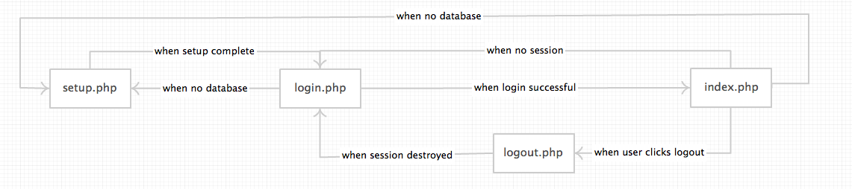

### Web Interface – Options from index.php

Once logged in, the user will be presented with a choice of options from the page index.php

As described earlier, the options presented will depend on the permissions of the user.

The diagram below shows all menu options, and the associated file(s) which handle that option.

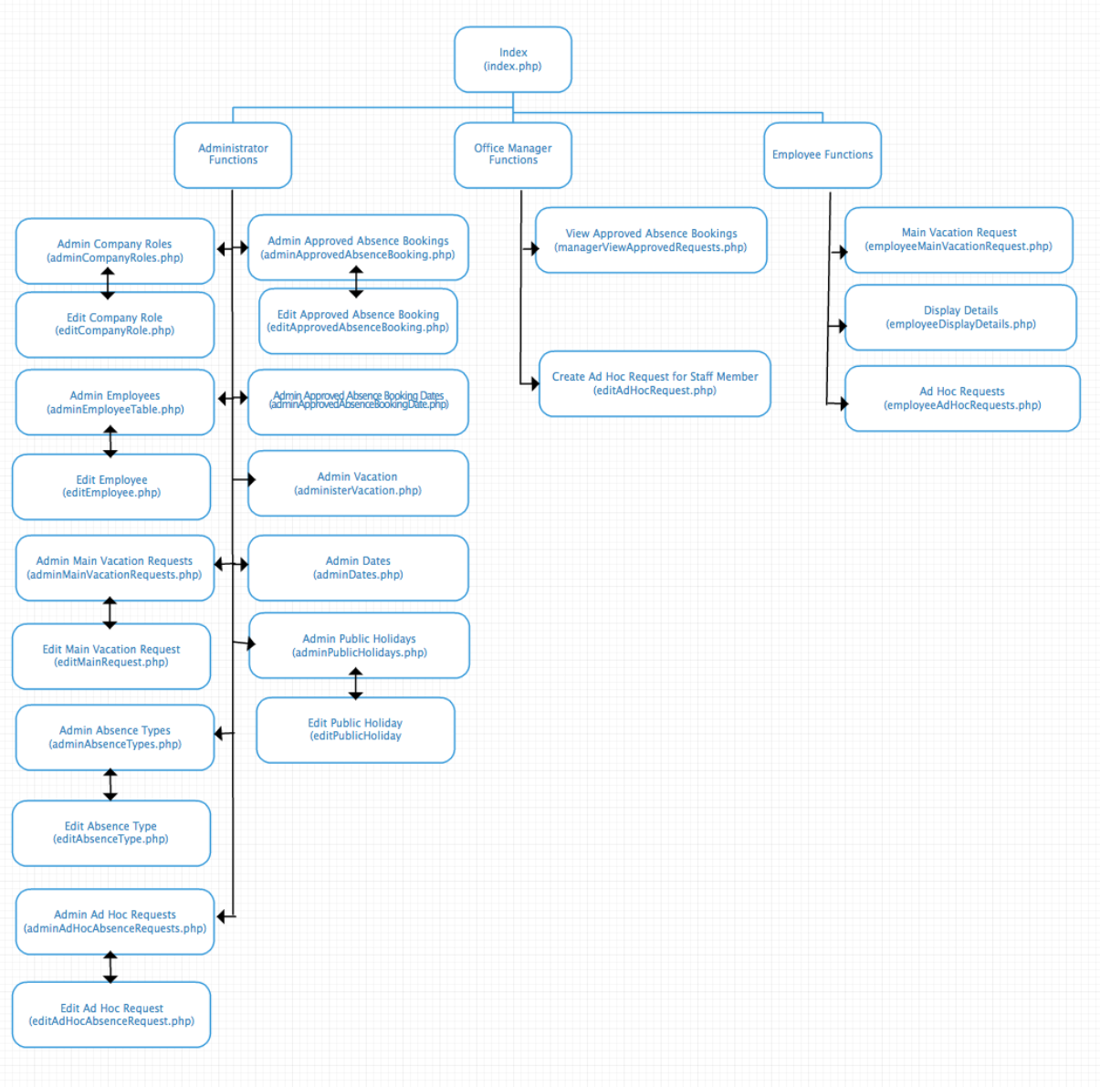

### Database Processing Files

The diagram below shows the various tables that form the database.



There are nine tables in total. Within the source code, there are nine files which represent these tables, providing the Create, Retrieve, Update and Delete functions.

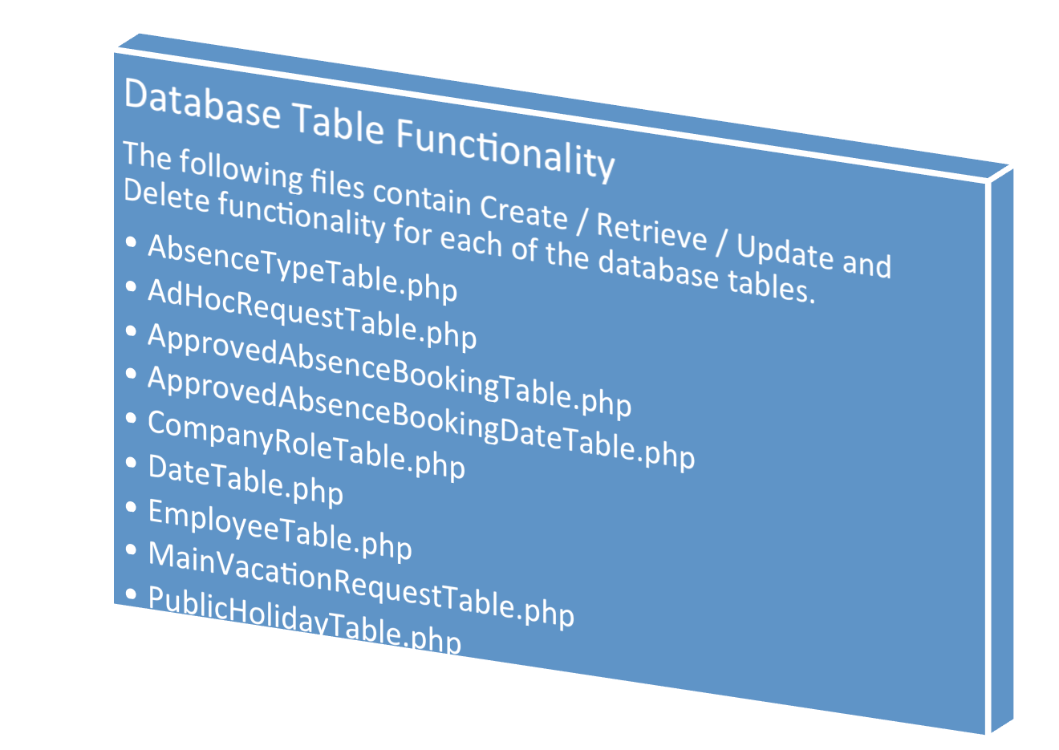

### Other files

The previous sections have described the purpose of most of the files in this project. This section describes files not already mentioned:

KeyAlgorithms.php - This file contains the key data processing algorithms used in processing.

Status.php – This file contains functions used to control the success / error status bar.

Config.php – This file contains key configuration options for the web site.

mailFunctions.php – This file contains functions to generate emails.

navbar.php – This file generates the common navigation bar seen on each web page.

sessionmanagement.php – This file contains logic to handle the session state.

style.css – This file contains css styling for the website.

## example of a failed test fix

As an example,below is the output of a failed test to creat a new Role in the database using a Role Name that already existed.



Attempting to create a Role using a name that already exists. This **SHOULD** fail.

Result = two manager roles in the table. This is an error.

Attempt did **NOT** fail.

Figure 123 - Test 3.3 FAILED Output

The function that is used to Create a new Company Role is CreateCompanyRole in the file CompanyRoleTable.php. The listing and fix is shown below:

1. **function** CreateCompanyRole($roleName, $minStaffLevel) {
2. $role = NULL;
3. //-------------------------------------------------------------------------
4. // Validate Input parameters
5. //-------------------------------------------------------------------------
6. $inputIsValid = TRUE;
7. $statusMessage = "";
8. **if** ($roleName == NULL) {
9. $statusMessage .= "Invalid Company Role Name.";
10. error_log("Invalid NULL name passed to CreateCompanyRole.");
11. $inputIsValid = FALSE;
12. }
14. **if** (isNullOrEmptyString($roleName)) {
15. $statusMessage .= "Company Role Name must be specified.";
16. error_log("Invalid roleName passed to CreateCompanyRole.");
17. $inputIsValid = FALSE;
18. }
20. **if** (!is_numeric($minStaffLevel)) {
21. $statusMessage .= "Minimum Staff Level must be numeric.";
22. error_log("Invalid minStaffLevel parameter passed to CreateCompanyRole.");
23. $inputIsValid = FALSE;
24. }
26. // Check to ensure that a role with this name does not already exist
27. // in the Company Role Table.
28. $filter[COMP_ROLE_NAME] = $roleName;
29. $result = RetrieveCompanyRoles($filter);
31. **if** ($result <> NULL)
32. {
33. $statusMessage .= "A company role named $roleName already exists.";
34. error_log("A company role named $roleName already exists.");
35. $inputIsValid = FALSE;
36. }

Issue was caused by missing validation logic in the CreateCompanyRole function. To correct this, I added the logic highlighted in yellow.

2. //-------------------------------------------------------------------------
3. // Only attempt to insert a record in the database if the input parameters
4. // are ok.
5. //-------------------------------------------------------------------------
6. **if** ($inputIsValid) {
7. // Create an array with each field required in the record.
8. $role[COMP_ROLE_ID] = NULL;
9. $role[COMP_ROLE_NAME] = $roleName;
10. $role[COMP_ROLE_MIN_STAFF] = $minStaffLevel;
12. $success = sqlInsertCompanyRole($role);
13. **if** (!$success) {
14. $statusMessage .= "Failed to add company role to the database.".
15. "Please contact your system administrator.";
16. error_log("Failed to create company Role. " . print_r($role));
17. $role = NULL;
18. }
19. **else**
20. {
21. $statusMessage .= "Company Role created successfully.";
22. }
24. }
25. GenerateStatus($inputIsValid, $statusMessage);
26. **return** $role;

Figure 124 – Reason and Fix for Test 3.3

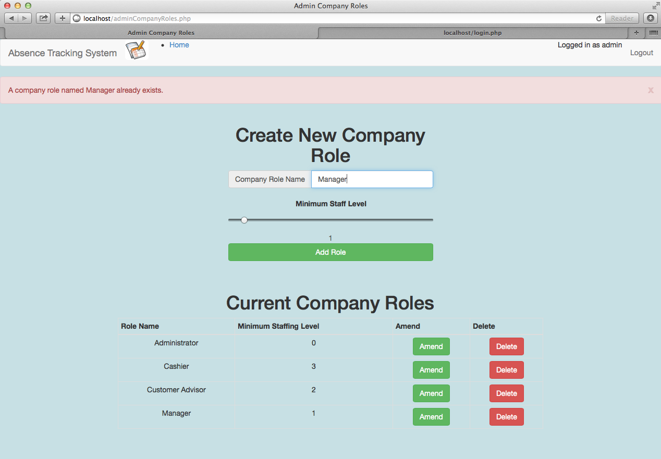

Role is not added to database. Test now passed.

The extra validation logic we added works, and detects that the role already exists.

Repeat the test and try to add a new role with a role name that already exists in the database.

Figure 125 – Rerun of Test 3.3 after fix has been applied.

## Detailed algorithm design

This file keyalgorithms.php contains the key complex algorithms used within this application. In this section I describe each of these.

### Algorithm – Calculate Annual Leave Required

In order to ensure that the user does not book more vacation than they are entitled to, for any given absence booking, we need to know the number of days annual leave that will be required for that booking.

No annual leave is required when the type of absence requested does not use annual leave (for example sick leave). We can determine whether a type of absence requires annual leave from the usesAnnualLeave field in the AbsenceTypeTable entry.

If the type of absence request does use annual leave, then each day from start date to end date should be examined. Saturday and Sundays do not consume annual leave and any public holidays in the booking period will not consume annual leave, any other days will.

The pseduocode below is for a function which will take the start date, end date and absence type as input parameters and return an integer, which represents the number of annual leave days required for this booking.

|  |
| --- |
| Pseudo Code |
| FUNCTION CalculateAnnualLeaveRequired(startDate, endDate,absenceTypeID)  annualLeaveRequired ← 0  absenceType ← RetrieveAbsenceTypeFromDatabase(absenceTypeID)  IF absenceType <> NULL THEN  IF absenceType.usesAnnualLeave = TRUE THEN  tempDate ← startDate  WHILE tempDate <= endDate  IF isWeekend(tempDate) == FALSE THEN  IF isPublicHoliday(tempDate) == FALSE THEN  AnnualLeaveRequired ← AnnualLeaveRequired + 1  ENDIF  ENDIF   tempDate ← nextDay(tempDate)  ENDWHILE  ENDIF  ELSE  log error “unable to find absence type”  ENDIF  RETURN AnnualLeaveRequired  ENDFUNCTION |

Note: isWeekend will be a separate function that formats the date into a lower case string and obtains the textual day. If this is a Saturday or Sunday, then it will return TRUE.

Note: isPublicHoliday will be a separate function that looks up the date in the database and checks to see if the record has a associated public holiday record.

The implementation of this algorithm is in the function CalculateAnnualLeaveRequeired which is in the file keyalgorithms.php. The extract of this code is given below:

1. /* -----------------------------------------------------------------------------
2. * Function CalculateAnnualLeaveRequired
3. *
4. * This function calculates how many days of annual leave will be needed to
5. * book a period of time between two dates.
6. *
7. * $startDate (string) string date in the form YYYY-MM-DD.
8. * $endDate   (string) string date in the form YYYY-MM-DD.
9. * $absenceTypeID (int)  key of the absence type record.
10. * @return (int)  Number of days annual leave required for this period. Will be
11. *                zero if no leave is required.
12. * -------------------------------------------------------------------------- */
13. **function** CalculateAnnualLeaveRequired($startDate,$endDate,$absenceTypeID)
14. {
15. //Assume no leave is required. Will increment this in the function.
16. $annualLeaveRequired = 0;
18. $absenceType = RetrieveAbsenceTypeByID($absenceTypeID);
20. // Check to ensure that an absence type of this ID actually exists.
21. **if** ($absenceType <> NULL)
22. {
23. //Q.Does the absence type supplied use annual leave?
24. **if** ($absenceType[ABS_TYPE_USES_LEAVE] == TRUE)
25. {
26. //Y.We need to calulate the leave required. First convert dates supplied
27. //  into times.
28. $startTime = strtotime($startDate);
29. $endTime = strtotime($endDate);
31. // Loop between timestamps, 24 hours at a time.
32. // Note that 86400 = 24 hours in second.
33. **for** ($i = $startTime; $i <= $endTime; $i = $i + 86400)
34. {
35. //Format the time into a date string
36. $thisDate = date('Y-m-d', $i); // 2010-05-01, 2010-05-02, etc
38. **if** (!isWeekend($thisDate))
39. {
40. **if** (!isPublicHoliday($thisDate) )
41. {
42. //Date is not a weekend or public holiday, so increment
43. $annualLeaveRequired = $annualLeaveRequired + 1;
44. }
45. }
46. }
47. }
48. }
49. **else**
50. {
51. error_log("Unknown absence type identifier of $absenceTypeID");
52. }
53. **return** $annualLeaveRequired;
54. }

|  |  |  |  |
| --- | --- | --- | --- |
| Algorithm – Calculate Remaining Annual Leave In order to ensure that the user does not book more vacation than they are entitled to, we need to know the number of remaining days annual leave that a member of staff has.  To do this we need to start with the count set to the employee’s annual leave entitlement, obtain a list of all of the approved absence bookings for the employee and then for each booking, use the earlier CalculateAnnualLeaveRequired function to determine the number of days needed for the booking, subtracting this from the count.  Once we have done this for each booking, the count will represent the number of remaining days annual leave available for the employee.   |  | | --- | | Pseudo Code | | FUNCTION CalculateRemainingAnnualLeave (EmployeeID)  employee ← RetrieveEmployeeFromDatabase(EmployeeID)  IF employee <> NULL THEN  annualLeaveRemaining ← employeeID.annualLeaveEntitlement  arrayOfAbsenceBookings ← RetrieveAbsenceBookingsForEmployee(EmployeeID)  IF arrayOfAbsenceBookings <> NULL THEN  FOR arrayIndex← 0 TO arrayOfAbsenceBooking.length  startDate ← arrayOfAbsenceBookings[arrayIndex].startDate  endDate ← arrayOfAbsenceBookings[arrayIndex].endDate  absenceType ← arrayOfAbsenceBookings[arrayIndex].absenceType  annualLeaveRequired ← calculateAnnualLeaveRequired(startDate,endDate,absenceTypeID)  annualLeaveRemaining ← annualLeaveRemaining – leaveRequired  ENDFOR  ENDIF  ELSE  log error “unable to find employee”  ENDIF  RETURN annualLeaveRemaining  ENDFUNCTION | |  |   The implementation of this algorithm is in the function CalculateRemainingAnnualLeave which is in the file keyalgorithms.php. The extract of this code is given below: |

1. /* ----------------------------------------------------------------------------
2. * Function CalculateRemainingAnnualLeave
3. *
4. * This function calculates the number of days annual leave that an employee
5. * has remaining.
6. *
7. * $employeeID(int) ID of the employee to calculate this for.
8. *
9. * @return (int) Number of days annual leave available to the employee.
10. * -------------------------------------------------------------------------- */
11. **function** CalculateRemainingAnnualLeave($employeeID)
12. {
13. //Assume no leave is remaining. Will increment this in the function.
14. $annualLeaveRemaining = 0;
16. $employee = RetrieveEmployeeByID($employeeID);
17. **if** ($employee <> NULL)
18. {
19. //Start with the annual leave entitlement for the employee.
20. $annualLeaveRemaining = $employee[EMP_LEAVE_ENTITLEMENT];
22. //Get all of the absence bookings for this employee.
23. $filter[APPR_ABS_EMPLOYEE_ID] = $employeeID;
24. $bookings = RetrieveApprovedAbsenceBookings($filter);
26. //Q. Does employee have any absence bookings?
27. **if** ($bookings)
28. {
29. //Yes. For each booking.....
30. **foreach** ($bookings **as** $booking)
31. {
32. //Calculate how much leave is needed for the booking.
33. $startDate   = $booking[APPR_ABS_START_DATE];
34. $endDate     = $booking[APPR_ABS_END_DATE];
35. $absenceType = $booking[APPR_ABS_ABS_TYPE_ID];
37. $leaveRequired = CalculateAnnualLeaveRequired($startDate,
38. $endDate,
39. $absenceType);
41. //subtract this from the annual leave entitlement.
42. $annualLeaveRemaining = $annualLeaveRemaining - $leaveRequired;
43. }
44. }
45. }
46. **else**
47. {
48. error_log("Unknown employee identifier of $employeeID");
49. }
51. **return** $annualLeaveRemaining;
52. }

### Algorithm - Has Sufficient Annual Leave

When processing an absence request, the first check that will need to be made is whether the member of staff has sufficient annual leave available to cover the absence period requested.

The algorithm to do this can make use of the earlier algorithms defined.

Given an employee ID, Start Date, End Date and Absence Type, we will:

1. Calculate the annual leave remaining for the employee, using the Annual Leave Remaining algorithm described earlier.
2. Calculate the amount of annual leave required for the booking, using the Calculate Annual Leave Required algorithm described earlier.
3. Check to ensure that the leave required is less than or equal to the employees remaining annual leave. If it is, the function returns TRUE, otherwise it returns FALSE.

|  |
| --- |
| Pseudo Code |
| FUNCTION HasSufficentAnnualLeave (paramEmployeeID, startDate,endDate,absenceTypeID)  hasSufficentLeave ← FALSE  employeesAvailableLeave ← CalculateRemainingAnnualLeave(paramEmployeeID)  amountOfLeaveNeeded ← CalculateAnnualLeaveRequired(startDate,endDate,absenceTypeID)    IF amountOfLeaveNeeded <= employeesAvailableLeave THEN  hasSufficentLeave ← TRUE  ENDIF  RETURN hasSufficentLeave ENDFUNCTION |

The implementation of this algorithm is in the function HasSufficentAnnualLeave which is in the file keyalgorithms.php. The extract of this code is given below:

1. /* ----------------------------------------------------------------------------
2. * Function HasSufficientAnnualLeave
3. *
4. * This function will determine whether an employee has sufficent annual leave
5. * available to cover the period of absence between start date and end date,
6. * taking into account the absence type of the request.
7. *
8. * $employeeID(int) ID of the employee to calculate this for.
9. * $startDate(string) start date of the request in the form YYYY-MM-DD.
10. * $endDate(string) end date of the request in the form YYYY-MM-DD.
11. * $absenceTypeID(int) ID of the absence type of this request.
12. *
13. * @return (bool) TRUE means sufficent days to cover the requested period.
14. *                FALSE means insufficent days to cover the requested period.
15. * -------------------------------------------------------------------------- */
16. **function** HasSufficentAnnualLeave($employeeID,$startDate,$endDate,$absenceTypeID)
17. {
18. $hasSufficentLeave = FALSE;
20. // Firstly, calculate how much leave the employee has remaining.
21. $employeesAvailableLeave = CalculateRemainingAnnualLeave($employeeID);
23. // then calculate how much leave is needed for the period requested.
24. $amountOfLeaveNeeded = CalculateAnnualLeaveRequired($startDate,$endDate,$absenceTypeID);
26. // If amount of leave required is less than or equal to available leave then
27. // then the employee has sufficent leave available.
28. **if** ($amountOfLeaveNeeded <= $employeesAvailableLeave)
29. {
30. $hasSufficentLeave = TRUE;
31. }
33. **return** $hasSufficentLeave;
34. }

### Algorithm – Count Staff on Leave

When processing an absence request, it will be necessary to know how many staff members of a given role are on leave for each day of the absence booking. This information will be used to determine whether there will be sufficient staff for that role in work.

|  |
| --- |
| Pseudo Code |
| FUNCTION CountStaffOnLeave (roleID, date)  countOfStaffOnLeave ← 0  dateRecord ← RetrieveDateRecordFromDatabase(date)  IF dateRecord <> NULL THEN  dateID ← dateRecord.id  bookingDatesArray = RetrieveApprovedAbsenceBookingDates(dateID)  IF bookingDatesArray <> NULL THEN  FOR index = 0 TO bookingDatesArray.length THEN  absenceBooking ← RetrieveApprovedAbsenceBookingByID(bookingDateArray[index].AbsenceBookingID)  IF absenceBooking <> NULL THEN  staffMember ← RetrieveEmployeeByID(absenceBooking.employeeID)  IF staffMember.roleID == roleID THEN  countOfStaffOnLeave ← countOfStaffOnLeave + 1  ENDIF  ELSE  log error “unknown absence booking ID”  ENDIF  ENDFOR  ENDIF  ELSE  log error “unknown date”  ENDIF  RETURN countOfStaffOnLeave ENDFUNCTION |
|  |

The implementation of this algorithm is in the function CountStaffOnLeave which is in the file keyalgorithms.php. The extract of this code is given below.

1. /* ----------------------------------------------------------------------------
2. * Function CountStaffOnLeave
3. *
4. * This function will calculate the number of staff in a given role who are
5. * on leave on a given date.
6. *
7. * $roleID(int) ID of the role we are checking
8. * $date(string) date we are checking. In the format YYYY-MM-DD.
9. *
10. * @return (bool) TRUE means there are sufficent staff to grant the request.
11. *                FALSE means there are insufficent staff to grant the request.
12. * -------------------------------------------------------------------------- */
13. **function** CountStaffOnLeave($roleID,$date)
14. {
15. //Assume no staff on leave to begin with.
16. $countOfStaffOnLeave = 0;
18. //Retrieve the date record from the database.
19. $dateRecord = RetrieveDateRecordByDate($date);
20. **if** ($dateRecord <> NULL)
21. {
22. //Retrieve all approved absence bookings for this date.
23. $dateID = $dateRecord[DATE_TABLE_DATE_ID];
24. $filter[APPR_ABS_BOOK_DATE_DATE_ID] = $dateID;
25. $bookingsForDate = RetrieveApprovedAbsenceBookingDates($filter);
26. **if** ($bookingsForDate <> NULL)
27. {
28. //One or more bookings exist. itterate through them.
29. **foreach** ($bookingsForDate **as** $bookingDate)
30. {
31. //Using the absence booking record, obtain the employee
32. //record from the database
33. $absenceBooking = RetrieveApprovedAbsenceBookingByID(
34. $bookingDate[APPR_ABS_BOOK_DATE_ABS_BOOK_ID]);
35. **if** ($absenceBooking <> NULL)
36. {
37. $staffMember = RetrieveEmployeeByID(
38. $absenceBooking[APPR_ABS_EMPLOYEE_ID]);
39. //-----------------------------------------------------
40. // Check to see if this member of staff performs the
41. // same role as the role of the employee requesting this
42. // leave. If so, add one to the count of staff on leave.
43. //-----------------------------------------------------
44. **if** ($staffMember[EMP_COMPANY_ROLE] == $roleID)
45. {
46. $countOfStaffOnLeave = $countOfStaffOnLeave + 1;
47. }
48. }
49. **else**
50. {
51. error_log("Unknown absence booking id of ".
52. $bookingDate[APPR_ABS_BOOK_DATE_ABS_BOOK_ID]);
53. }
54. }
55. }
56. }
57. **else**
58. {
59. error_log("Unknown date of $date");
60. }
62. **return** $countOfStaffOnLeave;
63. }

|  |  |  |
| --- | --- | --- |
| Are Sufficient Staff in Role to Grant Request Algorithm As part of processing any absence request, a check needs to be made to determine whether the request would cause the number of staff in a role to fall below the minimum staffing level.  As input to this algorithm, we need the ID of the employee requesting the absence and the start and end dates of the absence period.  Firstly we need to get the ID of the company role that the employee performs, and the minimum staffing level for that role. Also, we need to count up the total number of staff in the company who perform that role.  We then need to iterate through each date in the period from start date to end date.  For each date we need to:   1. Set the temp count of employees in role to total number of staff in company who perform the role. 2. Use the earlier defined CountStaffOnLeave algorithm to get a count of staff in the same role as the employee who are on leave that day. 3. Subtract this number from the total employees in the role. 4. If the result is less than or equal to the minimum staffing level for the role, then there are insufficient staff in the role to grant the request.  |  | | --- | | Pseudo Code | | FUNCTION SufficentStaffInRoleToGrantRequest (employeeID, startDate,endDate)  sufficentStaffInRole ← TRUE   employeeRecord = ← RetrieveEmployeeRecordFromDatabase(employeeID)  IF employeeRecord <> NULL THEN  employeeRole = ← RetrieveCompanyRoleRecordFromDatabase(employeeRecord.CompanyRoleID)  IF employeeRole <> NULL THEN  minimumStaffLevel ← employeeRole.minimumStaffLevel  numEmployeesInRole ← select count(*) FROM EmployeeTable WHERE CompanyRoleID = employeeRecord.CompanyRoleID   tempDate ← startDate  underMinimumStaffing ←FALSE  WHILE (tempDate <= endDate AND underMinimumStaffing == FALSE)  staffOnLeave ← CountStaffOnLeave(employeeRecord.CompanyRoleID,tempDate)  availableStaff ← numEmployeesInRole – staffOnLeave  IF availableStaff <= minimumStaffLevel THEN  underMinimumStaffing ← TRUE  sufficentStaffInRole ← FALSE  ENDIF  tempDate ← tempDate + 1  ENDWHILE  ELSE  log error “Unknown company role ID encountered”  ENDIF  ELSE  log error “Unknown employee ID encountered”  ENDIF  RETURN sufficentStaffInRole ENDFUNCTION | |
| The implementation of this algorithm is in the function SufficentStaffInRoleToGrantRequest which is in the file keyalgorithms.php. The extract of this code is given below.   1. /* ---------------------------------------------------------------------------- 2. * Function SufficentStaffInRoleToGrantRequest 3. * 4. * This function will determine whether there are sufficent staff within a role 5. * to allow the employee to book the period of startDate to endDate as absence. 6. * 7. * $employeeID(int) ID of the employee to calculate this for. 8. * $startDate(string) start date of the request in the form YYYY-MM-DD. 9. * $endDate(string) end date of the request in the form YYYY-MM-DD. 10. * 11. * @return (bool) TRUE means there are sufficent staff to grant the request. 12. *                FALSE means there are insufficent staff to grant the request. 13. * -------------------------------------------------------------------------- */ 14. **function** SufficentStaffInRoleToGrantRequest($employeeID,$startDate,$endDate) 15. { 16. $sufficentStaffInRole = TRUE; 18. // Get the employee record from the database. 19. $Employee = RetrieveEmployeeByID($employeeID); 20. **if** ($Employee <> NULL) 21. { 22. // Get the associated Company Role record from the database. 23. $employeeRole = RetrieveCompanyRoleByID($Employee[EMP_COMPANY_ROLE]); 24. **if** ($employeeRole <> NULL) 25. { 26. $minimumStaffingLevel = $employeeRole[COMP_ROLE_MIN_STAFF]; 28. //Calculate the total number of employees in this role. 29. $filter[EMP_COMPANY_ROLE] = $Employee[EMP_COMPANY_ROLE]; 30. $employeesInRole = RetrieveEmployees($filter); 31. $numEmployeesInRole = count($employeesInRole); 33. //Check staffing levels for each day in the period requested. 34. $tempDate = strtotime($startDate); 35. $endTime = strtotime($endDate); 37. $underMinimumStaffing = FALSE; 39. **while** ($tempDate <= $endTime AND $underMinimumStaffing == FALSE) 40. { 41. // 2010-05-01, 2010-05-02, etc 42. $strDate = date('Y-m-d', $tempDate); 43. //Calculate the number of staff in this role that are on leave 44. //on this date. 45. $staffOnLeave = CountStaffOnLeave($Employee[EMP_COMPANY_ROLE], 46. $strDate); 48. //Q.Would granting this leave would take us below the minimum 49. //staffing level for the role. 50. $availableStaff = $numEmployeesInRole - $staffOnLeave; 51. **if** ( $availableStaff <= $minimumStaffingLevel) 52. { 53. //Y.Granting the request would take us below the minimum 54. //staffing level for the role. 55. $underMinimumStaffing = TRUE; 56. $sufficentStaffInRole = FALSE; 57. } 59. //move temp date onto the next day. Note tempdate is in seconds. 60. //86400 = 60 seconds * 60 minutes * 24 hours. 61. $tempDate = $tempDate + 86400; 62. } 63. } 64. **else** 65. { 66. error_log("Unknown company role identifier of ". 67. $employee[EMP_COMPANY_ROLE]); 68. } 69. } 70. **else** 71. { 72. error_log("Unknown employee identifier of $employeeID"); 73. } 74. **return** $sufficentStaffInRole; 75. } |

### Process Absence Request Algorithm

An absence request will have an employee ID, a start date, and end date and an absence type. To process the request, first we must check to ensure that the employee has sufficient annual leave remaining to cover the period requested. To do this we can make use of the hasSufficentAnnualLeave algorithm defined earlier.

If there is insufficient leave, a message will be given to the employee stating that the request is denied due to insufficient leave remaining.

If there is sufficient leave, then we need to check to see if there is sufficient staff of the same role as the employee available during the period requested. We can make use of the sufficentStaffInRoleToGrantRequest algorithm defined earlier to perform this check.

If there are sufficient staff in role, then the request is granted and we can remove the entry from the absence request table, and create entries in the approved absence booking table and approved absence booking date table.

If there is not sufficient staff in role, then we need to check whether the type of absence request can be denied. Certain absence requests, such as sick leave, can not be denied. If the request can be denied it is and a message returned to the employee informing them. If the request can not be denied, then it is approved, but also an email will be sent to the office manager alerting them to a staff shortage.

|  |
| --- |
| Pseudo Code |
| FUNCTION ProcessAbsenceRequest (employeeID, startDate,endDate,absenceTypeID)  bookingApproved ← TRUE  IF HasSufficentAnnualLeave (employeeID, startDate, endDate, absenceTypeID) = FALSE THEN  sendDeniedEmail (employeeID,startDate,endDate, “Request Denied. Insufficient annual leave remaining.”)  bookingApproved ← FALSE  ELSE  IF SufficentStaffInRoleToGrantRequest(paramEmployeeID, startDate, endDate, absenceType) THEN   CreateApprovedAbsenceBooking(employeeID,startDate,endDate,absenceTypeID)  sendApprovedEmail ( employeeID,startDate,endDate)  bookingApproved ← TRUE  ELSE  absenceType ← RetrieveAbsenceTypeRecordFromDatabase(absenceTypeID)  IF absenceType.canBeDenied THEN   bookingApproved ← FALSE  sendDeniedEmail (employeeID,startDate,endDate,”Request would leave role below minimum staff level”)  ELSE  CreateApprovedAbsenceBooking(employeeID,startDate,endDate,absenceTypeID)  sendApprovedEmail ( employeeID,startDate,endDate)  sendEmailToManager(“Warning: below minimum staffing levels.”)  sendShortfallEmailToOfficeManager( employeeID,startDate,endDate,abscenceTypeID)  bookingApproved ← TRUE  ENDIF   ENDIF  ENDIF  RETURN bookingApproved  ENDFUNCTION |

The implementation of this algorithm is in the function ProcessAbsenceRequest which is in the file keyalgorithms.php. The extract of this code is given below.

1. /* ----------------------------------------------------------------------------
2. * Function ProcessAbsenceRequest
3. *
4. * This function will process an absence request, checking to ensure that:
5. * a) The employee has sufficent leave available to cover the request.
6. * b) That sufficent staff in the same role are working on that day to allow the
7. *    request.
8. *
9. * $employeeID(int) ID of the employee that this absence request is for.
10. * $startDate(string) start date of the request in the form YYYY-MM-DD.
11. * $endDate(string) end date of the request in the form YYYY-MM-DD.
12. * $absenceTypeID(int) ID of the absence type of this request.
13. *
14. * @return (bool) TRUE means the booking was approved.
15. *                FALSE means the booking was denied.
16. * -------------------------------------------------------------------------- */
17. **function** ProcessAbsenceRequest($employeeID,$startDate,$endDate,$absenceTypeID,
18. &$statusMessage)
19. {
20. //Assume that booking will be approved. Will be set to FALSE in function
21. //if necessary.
22. $bookingApproved = TRUE;
24. //--------------------------------------------------------------------------
25. //Check to ensure if the employee has sufficent leave available to cover the
26. //requested period.
27. //--------------------------------------------------------------------------
28. **if** (HasSufficentAnnualLeave($employeeID, $startDate, $endDate,
29. $absenceTypeID) == FALSE)
30. {
31. //Employee has insufficent leave available. Deny the request.
32. $statusMessage .= "Insufficent Annual Leave to cover the period ".
33. "requested.</br>";
34. $message = "Insufficent Annual Leave to cover the period requested.";
35. SendDeniedEmail($employeeID,$startDate,$endDate,$message);
36. $bookingApproved = FALSE;
37. }
38. **else**
39. {
40. //----------------------------------------------------------------------
41. //Check to ensure there are sufficent staff in the same role as employee
42. //working to cover the request.
43. //----------------------------------------------------------------------
44. **if** (SufficentStaffInRoleToGrantRequest($employeeID, $startDate, $endDate))
45. {
46. //Sufficent staff are available, grant the request.
47. CreateApprovedAbsenceBooking($employeeID, $startDate, $endDate,
48. $absenceTypeID);
49. SendApprovedEmail($employeeID,$startDate,$endDate);
50. $statusMessage .= "Absence Approved from $startDate to $endDate. ".
51. "Staff notifed via email.</br>";
52. $bookingApproved = TRUE;
53. }
54. **else**
55. {
56. //------------------------------------------------------------------
57. // Granting the request would mean going below the minimum staffing
58. // level for the role. However, if the type of absence requested is
59. // not deniable, then we have to grant the leave.
60. //-----------------------------------------------------------------
61. $absenceType = RetrieveAbsenceTypeByID($absenceTypeID);
62. **if** ($absenceType[ABS_TYPE_CAN_BE_DENIED])
63. {
64. //Type of leave requested can be denied. Deny the request.
65. $bookingApproved = FALSE;
66. $statusMessage .= "Absence Rejected from $startDate to $endDate.".
67. "Request would leave role below minimum ".
68. "staffing level. Staff notified via email.</br>";
70. $message = "Absence Rejected from $startDate to $endDate. ".
71. "Request would leave role below minimum staffing ".
72. "level. Staff notified via email.";
73. SendDeniedEmail($employeeID,$startDate,$endDate,$message);
74. }
75. **else**
76. {
77. //--------------------------------------------------------------
78. //Type of leave requested can not be denied. Approve the request.
79. //But also inform the office manager that we will be going below
80. //the minimum staffing level.
81. //--------------------------------------------------------------
82. $absenceType = RetrieveAbsenceTypeByID($absenceTypeID);
83. $statusMessage .= "Absence Approved from $startDate to $endDate.".
84. "Staff notifed via email.</br>";
85. $statusMessage .= "<em>Note that the ".$absenceType[ABS_TYPE_NAME].
86. " role will be under the minimum staffing level".
87. " during this time. </br>";
88. CreateApprovedAbsenceBooking($employeeID, $startDate, $endDate,
89. $absenceTypeID);
90. SendApprovedEmail($employeeID,$startDate,$endDate);
91. SendShortfallAlertToOfficeManager($employeeID,$startDate,$endDate,
92. $absenceTypeID);
94. $bookingApproved = TRUE;
95. }
96. }
97. }
99. **return** $bookingApproved;
100. }

### Main Vacation Requests Allocation Algorithm

When all main vacation requests have been received, the absence administrator will ask the system to process the main vacation requests.

To do this, the system must sort the vacation request into order, based on each member of staff’s length of service (longest to shortest).

The system will then iterate through this sorted set of requests.

For each request the system will check to see if the first choice period requested is allowed. It can do this using the ProcessAbsenceRequest algorithm defined earlier.

If the first choice is denied, then the ProcessAbsenceRequest algorithm will be called again, using the second choice dates.

If neither the first or second choice can be granted, the system will inform the member of staff concerned by email, asking them to resubmit new dates. The systems will also inform the absence administrator.

|  |
| --- |
| Pseudo Code |
| FUNCTION ProcessMainVacationRequests ()  result ← SELECT mainVacationRequest.*,Employee.dateJoinedTheCompany FROM mainVacationRequest   INNER JOIN Employee ON mainVacationRequest.employeeID=Employee.employeeID   ORDER BY Employee.dateJoinedTheCompany ASC  IF result == SUCCESS  row ← first row of result  lastRequestGranted ← TRUE  absenceTypeID = GetAnnualLeaveAbsenceTypeID();  WHILE row <> NULL AND lastRequestGranted == TRUE  IF ProcessAbsenceRequest(row,employeeID, row.firstChoiceStartDate,   row.firstChoiceEndDate,absenceTypeID) = FALSE THEN  IF ProcessAbsenceRequest(row,employeeID, row.firstChoiceStartDate,   row.firstChoiceEndDate,absenceTypeID) = FALSE THEN  SendResubmitMainVacationRequest(row.employeeID)  lastRequestGranted ← FALSE  ENDIF  ENDIF   DeleteMainVacationRequest(row.employeeID)  row ← next row of result  ENDWHILE  ENDFUNCTION |
|  |

The implementation of this algorithm is in the function ProcessMainVacationRequests which is in the file keyalgorithms.php. The extract of this code is given below.

1. /* -----------------------------------------------------------------------------
2. * Function ProcessMainVacationRequests
3. *
4. * This function handles the processing of the Main Vacation Requests
5. *
6. * @return (int)  NULL if all requests were successfully processed.
7. *               If not NULL, the return value indicates the employee ID
8. *      whose main vacation request could not be granted.
9. * -------------------------------------------------------------------------- */
10. **function** ProcessMainVacationRequests(&$statusMessage)
11. {
12. $stoppedAtEmployeeID = NULL;
14. //--------------------------------------------------------------------------
15. // Need to get all main vacation requests in an order based on the employees
16. // length of service, so use the bespoke SQL query below.
17. //--------------------------------------------------------------------------
18. $conn = $GLOBALS["connection"];
20. $sql = "SELECT * FROM mainVacationRequestTable JOIN EmployeeTable ".
21. "WHERE mainVacationRequestTable.EmployeeID = EmployeeTable.EmployeeID ".
22. "ORDER BY EmployeeTable.dateJoinedTheCompany;";
24. $result = mysqli_query($conn, $sql);
25. **if** (!$result) {
26. $statusMessage.="SQL Error when accessing database.</br>";
27. error_log("PerformSQL failed. Sql = $sql");
28. }
29. **else**
30. {
31. $row = mysqli_fetch_array($result, MYSQLI_ASSOC);
32. $lastRequestGranted = TRUE;
34. //---------------------------------------------------------------------
35. // Process each request in turn until either all have been processed,
36. // or we reach a request that can't be granted.
37. //---------------------------------------------------------------------
38. **while** ($row **and** $lastRequestGranted)
39. {
40. $id                         = $row[MAIN_VACATION_REQ_ID];
41. $employeeID                 = $row[MAIN_VACATION_EMP_ID];
42. $firstChoiceStartDate       = $row[MAIN_VACATION_1ST_START];
43. $firstChoiceEndDate         = $row[MAIN_VACATION_1ST_END];
44. $secondChoiceStartDate      = $row[MAIN_VACATION_2ND_START];
45. $secondChoiceEndDate        = $row[MAIN_VACATION_2ND_END];
46. $absenceTypeID              = GetAnnualLeaveAbsenceTypeID();
47. $Employee                   = RetrieveEmployeeByID($employeeID);

50. $statusMessage.="<b>[Processing main vacation request for ".
51. $Employee[EMP_NAME]."]</b><br/>";
52. $statusMessage.="Attempting first choice from $firstChoiceStartDate ".
53. "to $firstChoiceEndDate.</br>";
55. //Try and approve first choice request.
56. **if** ( ProcessAbsenceRequest($employeeID,$firstChoiceStartDate,
57. $firstChoiceEndDate,$absenceTypeID,
58. $statusMessage) == FALSE)
59. {
60. //First choice denied. Try and approve second choice request.
61. $statusMessage.="Attempting second choice from ".
62. "$secondChoiceStartDate to $secondChoiceEndDate.</br>";
63. **if** ( ProcessAbsenceRequest($employeeID,$secondChoiceStartDate,
64. $secondChoiceEndDate,$absenceTypeID,
65. $statusMessage) == FALSE)
66. {
67. //second choice denied. Mail employee to instruct them to
68. //submit a new booking.
69. $statusMessage .="Neither first nor second choice could be ".
70. "granted. Employee has been emailed to ask ".
71. "for new dates.</br>";
72. SendResubmitMainVacationRequest($employeeID);
74. //set the ID of the employee who needs to resubmit, to
75. //pass back to the calling function.
76. $lastRequestGranted = FALSE;
77. $stoppedAtEmployeeID = $employeeID;
78. }
79. }
81. //Delete the main vacation request.
82. DeleteMainVacationRequest($id);
83. $row = mysqli_fetch_array($result, MYSQLI_ASSOC);
84. }
85. }
86. **return** $stoppedAtEmployeeID;
87. }

### Ad Hoc Request Processing Algorithm

Processing Ad Hoc requests is very similar to Main Vacation Requests.

To do this, the system must select all entries from the AdHocAbsenceRequest table.

The system will then iterate each of these requests.

For each request the system will check to see if period requested is allowed. It can do this using the ProcessAbsenceRequest algorithm defined earlier.

Once a request has been processed, the entry can be deleted from the AdHocAbsenceRequest table.

|  |
| --- |
| Pseudo Code |
| FUNCTION ProcessAdHocAbsenceRequests ()  AdHocRequestsArray ← SELECT * FROM AdHocAbsenceRequest  numOfRequests ← AdHocRequestsArray.length  FOR index←0 TO numOfRequests  ProcessAbsenceRequest(AdHocAbsenceRequestsArray [index].employeeID,  AdHocAbsenceRequestsArray [index].startDate,  AdHocAbsenceRequestsArray [index].endDate,  AdHocAbsenceRequestsArray [index].absenceTypeID)  DeleteAdHocAbsenceRequest(AdHocAbsenceRequestsArray [index].id)  NEXT  ENDFUNCTION |

The implementation of this algorithm is in the function ProcessAdHocRequests which is in the file keyalgorithms.php. The extract of this code is given below.

1. /* -----------------------------------------------------------------------------
2. * Function ProcessAdHocRequests.
3. *
4. * This function itterates through the AdHoc absence requests, processing each
5. * one.
6. *
7. * @return (none)
8. * -------------------------------------------------------------------------- */
9. **function** ProcessAdHocRequests(&$statusMessage)
10. {
11. $requests = RetrieveAdHocAbsenceRequests();
12. $return = true;
14. **foreach** ($requests **as** $request)
15. {
16. $id             = $request[AD_HOC_REQ_ID];
17. $employeeID     = $request[AD_HOC_EMP_ID];
18. $startDate      = $request[AD_HOC_START];
19. $endDate        = $request[AD_HOC_END];
20. $absenceTypeID  = $request[AD_HOC_ABSENCE_TYPE_ID];
22. $employee = RetrieveEmployeeByID($employeeID);
23. $statusMessage.="<b>[Processing AdHoc request for ".
24. $employee[EMP_NAME]."]</b><br/>";
26. $result = ProcessAbsenceRequest($employeeID,$startDate,$endDate,
27. $absenceTypeID,$statusMessage);
28. **if** ($result == false)
29. {
30. $return = false;
31. }
33. DeleteAdHocAbsenceRequest($id);
34. }
35. **return** $return;

}

## procedure / function list and variables

As described in earlier sections, this project is comprised of numerous files, containing many functions. All Functions within the source code are prefixed by a comment block which describes the purpose of the function, the parameters required and the return value.

Rather than repeat this information for all 40+ source files, in the table below I summarise this information for two files as an example. For other files, consult the source code listings in section 5 starting on page 57.

Note: All functions are public.

### File: AbsenceTypeTable.php

The file AbsenceTypeTable.php contains a set of functions which encapsulate all programmatic access to the Absence Type table in the database. This includes all of the functions necessary for record Creation, Retrieval, Updation and Deletion.

#### Function: CreateAbsenceTypeTable

|  |  |  |  |
| --- | --- | --- | --- |
| function name | Description | parameters | RETURN / output |
| CreateAbsenceTypeTable | This function creates the SQL statement needed to construct the AbsenceType table in the database. | None | TRUE if table is created successfully, FALSE otherwise. |

|  |  |  |  |
| --- | --- | --- | --- |
| Variable Name | type | scope | Description |
| $sql | string | Local to function | A string which holds the SQL statement to perform. |
| $success | boolean | Local to function | Used to record whether the result of the performSQL function. TRUE means the function was successful, FALSE means the function failed. |

1. /* ----------------------------------------------------------------------------
2. * Function CreateAbsenceTypeTable
3. *
4. * This function creates the SQL statement needed to construct the AbsenceType
5. * table in the database.
6. *
7. * @return (bool)  True if table is created successfully, false otherwise.
8. * ---------------------------------------------------------------------------*/
9. **function** CreateAbsenceTypeTable() {
10. $sql = "CREATE TABLE IF NOT EXISTS `mydb`.`absenceTypeTable` (
11. `absenceTypeID` INT NOT NULL AUTO_INCREMENT,
12. `absenceTypeName` VARCHAR(20) NOT NULL,
13. `usesAnnualLeave` TINYINT(1) NOT NULL,
14. `canBeDenied` TINYINT(1) NOT NULL,
15. PRIMARY KEY (`absenceTypeID`));";
17. $success = performSQL($sql);
19. **if** ($success)
20. {
21. //Check to see if the table is empty
22. **if** (GetAbsenceTypeCount() == 0)
23. {
24. //Table is empty. Create some default absence types.
25. CreateAbsenceType(ANNUAL_LEAVE,TRUE,TRUE);
26. }
27. }
28. }

#### Function: CreateAbsenceType

|  |  |  |  |
| --- | --- | --- | --- |
| function name | Description | parameters | RETURN / output |
| CreateAbsenceType | This function creates a new Absence Type row in the AbsenceTypeTable. | $absenceTypeName (string) Textual name of the type of absence.  $usesAnnual Leave (boolean) Whether or not this type of absence uses annual leave.  $canBeDenied (boolean) Whether or not this type of absence can be denied. | If successful, an array is returned where each key represents a field in the record. If unsuccessful, the return will be NULL. |

|  |  |  |  |
| --- | --- | --- | --- |
| Name | type | scope | Description |
| $absenceTypeName | String | local – parameter passed to function | Name to use for the absence type field in the record. EG: “Sickness”,”Training” or “Annual Leave” |
| $usesAnnualLeave | Boolean | local – parameter passed to function | Signifies whether this absence type uses annual leave. EG: Annual Leave would have a value of true for this field, whilst sickness would have a value of false. |
| $canBeDenied | Boolean | local – parameter passed to function | Signifies whether requests of this absence type can be denied by the system. EG: This field would be true for annual leave, since annual leave can be denied, but the field would be false for sickness, as sick leave can not be denied. |
| $statusMessage | String | Local to function | The function will add any success or error messages to be displayed to the user in this field.  This field, together with inputIsValid, are supplied as parameters to the function GenerateStatus, called just before we return the result to the user. |
| $absenceType | Array | Local to function | Array used to hold each of the fields of the absence type record this function creates. |
| $inputIsValid | Boolean | Local to function | Set to true if all input fields are valid. Set to false if one or more fields are invalid.  This field, together with statusMessage, are supplied as parameters to the function GenerateStatus, called just before we return the result to the user. |
| $filter | Array | Local to function | Array used to build a filter to pass to RetrieveAbsenceTypes |
| $result | Array | Local to function | Used to hold the array passed back from RetrieveAbsenceTypes. This will be an array of records which match the filter criteria passed. |

1. /* ----------------------------------------------------------------------------
2. * Function CreateAbsenceType
3. *
4. * This function creates a new Absence Type row in the AbsenceTypeTable.
5. *
6. * $absenceTypeName (string) Textual name of the type of absence.
7. * $usesAnnual Leave (boolean) Whether or not this type of absence uses annual
8. *             leave.
9. * $canBeDenied (boolean) Whether or not this type of absence can be denied.
10. *
11. * @return (array) If successful, an array is returned where each key represents
12. *                 a field in the record. If unsuccessful, the return will
13. *                 be NULL.
14. * ---------------------------------------------------------------------------*/
15. **function** CreateAbsenceType($absenceTypeName, $usesAnnualLeave, $canBeDenied) {
16. $statusMessage = "";
17. $absenceType = NULL;
18. //-------------------------------------------------------------------------
19. // Validate Input parameters
20. //-------------------------------------------------------------------------
21. $inputIsValid = TRUE;
23. **if** (isNullOrEmptyString($absenceTypeName)) {
24. $statusMessage.="Invalid absence type name. Can not be blank.</br>";
25. error_log("Invalid absenceTypeName passed to CreateAbsenceType.");
26. $inputIsValid = FALSE;
27. }
29. **if** ($usesAnnualLeave<>0 AND $usesAnnualLeave<>1) {
30. $statusMessage.="Invalid value for the uses annual leave flag.</br>";
31. error_log("Invalid usesAnnualLeave parameter passed to CreateAbsenceType.");
32. $inputIsValid = FALSE;
33. }
35. **if** ($canBeDenied<>0 AND $canBeDenied<>1) {
36. $statusMessage.="Invalid value for the can be denied flag.</br>";
37. error_log("Invalid canBeDenied parameter passed to CreateAbsenceType.");
38. $inputIsValid = FALSE;
39. }
41. //Check to ensure that a record with the same name doesn't already exist.
42. $filter[ABS_TYPE_NAME] = $absenceTypeName;
43. $result = RetrieveAbsenceTypes($filter);
45. **if** ($result <> NULL)
46. {
47. $statusMessage.="Unable to create as an absence type with that name ".
48. "already exists</br>";
49. error_log("Unable to create as an absence type with that name ".
50. "already exists");
51. $inputIsValid = FALSE;
52. }
54. //--------------------------------------------------------------------------
55. // Only attempt to insert a record in the database if the input parameters
56. // are ok.
57. //--------------------------------------------------------------------------
58. **if** ($inputIsValid) {
59. // Create an array with each field required in the record.
60. $absenceType[ABS_TYPE_ID] = NULL;
61. $absenceType[ABS_TYPE_NAME] = $absenceTypeName;
62. $absenceType[ABS_TYPE_USES_LEAVE] = $usesAnnualLeave;
63. $absenceType[ABS_TYPE_CAN_BE_DENIED] = $canBeDenied;
65. $success = sqlInsertAbsenceType($absenceType);
66. **if** (!$success) {
67. $statusMessage.="Database error encountered. Unable to create absence type.</br>";
68. $inputIsValid = false;
69. error_log("Failed to create absence type.");
70. $absenceType = NULL;
71. }
72. **else**
73. {
74. $statusMessage.="Record created in database successfully.</br>";
75. }
76. }
78. GenerateStatus($inputIsValid, $statusMessage);
79. **return** $absenceType;
80. }

#### Function: sqlInsertAbsenceType

|  |  |  |  |
| --- | --- | --- | --- |
| function name | Description | parameters | RETURN / output |
| sqlInsertAbsenceType | This function constructs the SQL statement required to insert a new record into the absenceTypeTable. | &$absenceType (array) Array containing all of the fields required for the record. | TRUE if insert into database was successful, false otherwise. |

|  |  |  |  |
| --- | --- | --- | --- |
| VARIABLE Name | type | scope | Description |
| $absenceType | array | Owned by the calling function and passed by reference. | Array containing key value pairs representing each field in the record to insert. Passed by reference so that the function can set the absence type ID key / value pair in the array to the value of the newly created record and pass this back to the caller. |
| $sql | string | Local to function | A string which holds the SQL statement to perform. |

1. * Function sqlInsertAbsenceType
2. *
3. * This function constructs the SQL statement required to insert a new record
4. * into the absenceTypeTable
5. *
6. * &$absenceType (array) Array containing all of the fields required for the
7. *                       record.
8. *
9. * @return (bool) TRUE if insert into database was successful, false otherwise.
10. *
11. * Note: If successful then the ABS_TYPE_ID entry in the array
12. *   passed by the caller will be set to the ID of the record in the
13. *       database.
14. * ---------------------------------------------------------------------------*/
16. **function** sqlInsertAbsenceType(&$absenceType) {
17. $absenceType[ABS_TYPE_ID] = NULL;
19. $sql = "INSERT INTO absenceTypeTable (absenceTypeName,usesAnnualLeave,canBeDenied) "
20. . "VALUES ('"
21. . $absenceType[ABS_TYPE_NAME] . "','"
22. . $absenceType[ABS_TYPE_USES_LEAVE] . "','"
23. . $absenceType[ABS_TYPE_CAN_BE_DENIED] . "');";
25. $absenceType[ABS_TYPE_ID] = performSQLInsert($sql);
27. **return** $absenceType[ABS_TYPE_ID] <> 0;
28. }

#### Function: retrieveAbsenceTypeByID

|  |  |  |  |
| --- | --- | --- | --- |
| function name | Description | parameters | RETURN / output |
| RetrieveAbsenceTypeByID | This function uses the ID supplied as a parameter to construct an SQL select statement and then performs this query, returning an array containing the key value pairs of the record (or NULL if no record is found matching the id). | $id (int) id of the record to retrieve from the database. | array of key value pairs representing the fields in the record, or NULL if no record exists with the id supplied. |

|  |  |  |  |
| --- | --- | --- | --- |
| VARIABLE Name | type | scope | Description |
| $id | array | Local to function | key of the record to retrieve from the database. |
| $filter | array | Local to function | Array used to build a filter to pass to performSQLSelect |
| $resultArray | array | Local to function | Array of arrays, where each inner array represents a record returned which match the filter. |
| $absenceType | array | Local to function | Array containing key value pairs of the absence type record matching the id supplied to the function. |

1. /* ----------------------------------------------------------------------------
2. * Function RetrieveAbsenceTypeByID
3. *
4. * This function uses the ID supplied as a parameter to construct an SQL select
5. * statement and then performs this query, returning an array containing the key
6. * value pairs of the record (or NULL if no record is found matching the id).
7. *
8. * $id (int) id of the record to retrieve from the database..
9. *
10. * @return (array) array of key value pairs representing the fields in the
11. *                 record, or NULL if no record exists with the id supplied.
12. * ---------------------------------------------------------------------------*/
14. **function** RetrieveAbsenceTypeByID($id) {
15. $filter[ABS_TYPE_ID] = $id;
16. $resultArray = performSQLSelect(ABSENCE_TYPE_TABLE, $filter);
18. $absenceType = NULL;
20. //There should only be one record in the database with this ID.
21. **if** (count($resultArray) == 1) {
22. $absenceType = $resultArray[0];
23. }
25. **return** $absenceType;
26. }

#### Function: RetrieveAbsenceTypes

|  |  |  |  |
| --- | --- | --- | --- |
| function name | Description | parameters | RETURN / output |
| RetrieveAbsenceTypes | This function constructs the SQL statement required to query the AbsenceTypeTable. | $filter (array) Optional parameter. If supplied, then the array should contain a set of key value pairs, where the keys correspond to one (or more) fields in the record (see constants at top of file) and the values correspondto the values to filter against (IE: The WHERE clause). | If successful, an array of arrays, where each element corresponds to a row from the query. If a failure occurs, return will be NULL. |

|  |  |  |  |
| --- | --- | --- | --- |
| VARIABLE Name | type | scope | Description |
| $filter | array | Local to function | Optional parameter. If supplied, then the array should contain a set of key value pairs, where the keys correspond to one (or more) fields in the record (see constants at top of file) and the values correspondto the values to filter against (IE: The WHERE clause). |
| $inputIsValid | boolean | Local to function | Flag to indicate whether or not the input is valid. |
| $result | array | Local to function | If successful, an array of arrays, where each element corresponds to a row from the query. If a failure occurs, return will be NULL. |

1. /* ----------------------------------------------------------------------------
2. * Function RetrieveAbsenceTypes
3. *
4. * This function constructs the SQL statement required to query the
5. * AbsenceTypeTable.
6. *
7. * $filter (array) Optional parameter. If supplied, then the array should
8. *                 contain a set of key value pairs, where the keys correspond
9. *                 to one (or more) fields in the record (see constants at top
10. *                 of file) and the values correspondto the values to filter
11. *                 against (IE: The WHERE clause).
12. *
13. * @return (array) If successful, an array of arrays, where each element
14. *                 corresponds to a row from the query. If a failure occurs,
15. *                 return will be NULL.
16. * ---------------------------------------------------------------------------*/
18. **function** RetrieveAbsenceTypes($filter = NULL) {
19. $inputIsValid = TRUE;
21. //-------------------------------------------------------------------------
22. // Validate Input parameters
23. //-------------------------------------------------------------------------
24. **if** ($filter <> NULL) {
25. **foreach** ($filter **as** $key => $value) {
26. **if** (strcmp($key, ABS_TYPE_ID) == 0) {
27. **if** (!is_numeric($value)) {
28. error_log("Invalid AbsenceTypeID of " . $value .
29. " passed to RetrieveAbsenceTypes.");
30. $inputIsValid = FALSE;
31. }
32. } **else** **if** (strcmp($key, ABS_TYPE_NAME) == 0) {
33. **if** (isNullOrEmptyString($value)) {
34. error_log("Invalid ABS_TYPE_NAME passed to RetrieveAbsenceTypes.");
35. $inputIsValid = FALSE;
36. }
37. } **else** **if** (strcmp($key, ABS_TYPE_USES_LEAVE) == 0) {
38. **if** ($value<>0 AND $value<>1) {
39. error_log("Invalid ABS_TYPE_USES_LEAVE of " . $value .
40. " passed to RetrieveAbsenceTypes.");
41. $inputIsValid = FALSE;
42. }
43. } **else** **if** (strcmp($key, ABS_TYPE_CAN_BE_DENIED) == 0) {
44. **if** ($value<>0 AND $value<>1) {
45. error_log("Invalid ABS_TYPE_CAN BE DENIED of " . $value .
46. " passed to RetrieveAbsenceTypes.");
47. $inputIsValid = FALSE;
48. }
49. } **else** {
50. error_log("Unknown Filter " . $key . " passed to RetrieveAbsenceTypes.");
51. $inputIsValid = FALSE;
52. }
53. }
54. }
56. //-------------------------------------------------------------------------
57. // Only attempt to perform query in the database if the input parameters
58. // are ok.
59. //-------------------------------------------------------------------------
60. $result = NULL;
61. **if** ($inputIsValid) {
62. $result = performSQLSelect(ABSENCE_TYPE_TABLE, $filter);
63. }

66. **return** $result;
67. }

#### Function: UpdateAbsenceType

|  |  |  |  |
| --- | --- | --- | --- |
| function name | Description | parameters | RETURN / output |
| UpdateAbsenceType | This function constructs the SQL statement required to update a row in the AbsenceTypeTable. | $fields (array) array of key value pairs, where keys correspond to fields in the record (see constants at start of this file).  Note, this array MUST provide the id of the record (ABS_TYPE_ID) and one or more other fields to be updated. | TRUE if update succeeds. FALSE otherwise. |

|  |  |  |  |
| --- | --- | --- | --- |
| VARIABLE Name | type | scope | Description |
| $fields | array | Local to function | array of key value pairs, where keys correspond to fields in the record (see constants at start of this file).  Note, this array MUST provide the id of the record (ABS_TYPE_ID) and one or more other fields to be updated. |
| $statusMessage | String | Local to function | String used to form any success or error text to display to the user in the status bar. |
| $inputIsValid | Booleane | Local to function | Boolean value, initially true but set to false if one or more of the input values given in the fields array are invalid. |
| $validID | Boolean | Local to function | Boolean value, initially false and set to true if the record id is one of the fields provided in the input fields array passed as a parameter to this function. |
| $countOfFields | Integer | Local to function | Count of the number of fields passed to this function. |
| $success | boolean | Local to function | TRUE if update succeeds. FALSE otherwise. |

1. /* ----------------------------------------------------------------------------
2. * Function UpdateAbsenceType
3. *
4. * This function constructs the SQL statement required to update a row in
5. * the AbsenceTypeTable.
6. *
7. * $fields (array) array of key value pairs, where keys correspond to fields
8. *                 in the record (see constants at start of this file).
9. *                 Note, this array MUST provide the id of the
10. *                 record (ABS_TYPE_ID) and one or more other fields to be updated.
11. *
12. * @return (bool) TRUE if update succeeds. FALSE otherwise.
13. * ---------------------------------------------------------------------------*/
15. **function** UpdateAbsenceType($fields) {
16. $statusMessage = "";
17. //-------------------------------------------------------------------------
18. // Validate Input parameters
19. //-------------------------------------------------------------------------
20. $inputIsValid = TRUE;
21. $validID = false;
22. $countOfFields = 0;
24. **foreach** ($fields **as** $key => $value) {
25. **if** ($key == ABS_TYPE_ID) {
26. $record = RetrieveAbsenceTypeByID($value);
27. **if** ($record <> NULL) {
28. $validID = true;
29. $countOfFields++;
30. }
31. } **else** **if** ($key == ABS_TYPE_NAME) {
32. $countOfFields++;
34. **if** (isNullOrEmptyString($value)) {
35. $statusMessage.="Invalid absence type name. Can not be empty.</br>";
36. error_log("Invalid ABS_TYPE_NAME passed to UpdateAbsenceType.");
37. $inputIsValid = FALSE;
38. }
39. } **else** **if** ($key == ABS_TYPE_USES_LEAVE) {
40. $countOfFields++;
41. **if** ($value<>0 AND $value<>1) {
42. $statusMessage.="Invalid uses annual leave flag value.</br>";
43. error_log("Invalid ABS_TYPE_USES_LEAVE passed to UpdateAbsenceType.");
44. $inputIsValid = FALSE;
45. }
46. } **else** **if** ($key == ABS_TYPE_CAN_BE_DENIED) {
47. $countOfFields++;
49. **if** ($value<>0 AND $value<>1) {
50. $statusMessage.="Invalid can be denied flag value.</br>";
51. error_log("Invalid ABS_TYPE_CAN_BE_DENIED passed to UpdateAbsenceType.");
52. $inputIsValid = FALSE;
53. }
54. } **else** {
55. $statusMessage.="Invalid field encountered.</br>";
56. error_log("Invalid field passed to UpdateAbsenceType. $key=" . $key);
57. $inputIsValid = FALSE;
58. }
59. }
61. **if** (!$validID) {
62. $statusMessage.="No valid ID supplied.</br>";
63. error_log("No valid ID supplied in call to UpdateAbsenceType.");
64. $inputIsValid = FALSE;
65. }
67. **if** ($countOfFields < 2) {
68. $statusMessage.="Insufficent fields supplied in call.</br>";
69. error_log("Insufficent fields supplied in call to UpdateAbsenceType.");
70. $inputIsValid = FALSE;
71. }
73. //--------------------------------------------------------------------------------
74. // Only attempt to update a record in the database if the input parameters are ok.
75. //--------------------------------------------------------------------------------
76. $success = false;
78. **if** ($inputIsValid) {
80. $success = performSQLUpdate(ABSENCE_TYPE_TABLE, ABS_TYPE_ID, $fields);
81. **if** ($success)
82. {
83. $statusMessage .= "Record successfully created in Database.</br>";
84. }
85. **else** {
86. $statusMessage .= "Unexpected database error encountered when ".
87. "trying to perform update.</br>";
88. $inputIsValid = false;
89. }
90. }
92. GenerateStatus($inputIsValid, $statusMessage);
93. **return** $success;
94. }

#### Function: DeleteAbsenceType

|  |  |  |  |
| --- | --- | --- | --- |
| function name | Description | parameters | RETURN / output |
| DeleteAbsenceType | This function constructs the SQL statement required to delete a row in the AbsenceTypeTable. | $ID(integer) ID of the record to be removed from the table. This should be set to the ABS_TYPE_ID value of the record you wish to delete | count of rows deleted. 0 means delete was unsuccessful, usually because one or more records in the database refers to this absenceType. |

|  |  |  |  |
| --- | --- | --- | --- |
| VARIABLE Name | type | scope | Description |
| $ID | integer | Local to function | ID of the record to be removed from the table. This should be set to the ABS_TYPE_ID value of the record you wish to delete |
| $isValidRequest | boolean | Local to function | Flag to indicate whether or not the input is valid. |
| $filter | array | Local to function | Array used to build a filter to pass to performSQLSelect |
| $adHocRequests | Array | Local to function | Array of adHoc request records which match the filter. |
| $approvedBookings | Array | Local to function | Array of approved bookings which match the filter. |
| $result | integer |  | count of rows deleted. 0 means delete was unsuccessful, usually because one or more records in the database refers to this absenceType. |
| $sql | String | Local to function | String which holds the SQL command to delete the record from the database. |

1. /* ----------------------------------------------------------------------------
2. * Function DeleteAbsenceType
3. *
4. * This function constructs the SQL statement required to delete a row in
5. * the AbsenceTypeTable.
6. *
7. * $ID(integer) ID of the record to be removed from the table. This should be
8. *              set to the ABS_TYPE_ID value of the record you wish
9. *              to delete.
10. *
11. * @return (int) count of rows deleted. 0 means delete was unsuccessful, usually
12. *               because one or more records in the database refers to this
13. *               absenceType.
14. * --------------------------------------------------------------------------*/
16. **function** DeleteAbsenceType($ID) {
17. $isValidRequest = TRUE;
19. // Ensure there are no AdHocAbsenceRequest records which reference this record.
20. $filter[AD_HOC_ABSENCE_TYPE_ID] = $ID;
21. $adHocAbsenceRequests = RetrieveAdHocAbsenceRequests($filter);
22. **if** ($adHocAbsenceRequests <> NULL) {
23. error_log("Attempt to DeleteAbsenceType failed. " .
24. "One or more adHocAbsenceRequest records exist with an " .
25. "absence type ID of " . $ID);
26. $isValidRequest = FALSE;
27. }
28. // Ensure there are no ApprovedAbsenceBooking records which reference this record.
29. unset($filter);
30. $filter[APPR_ABS_ABS_TYPE_ID] = $ID;
31. $approvedBookings = RetrieveApprovedAbsenceBookings($filter);
32. **if** ($approvedBookings <> NULL) {
33. error_log("Attempt to DeleteAbsenceType failed. " .
34. "One or more approvedAbsenceBooking records exist with an " .
35. "absence type ID of " . $ID);
36. $isValidRequest = FALSE;
37. }
39. $result = 0;
40. **if** ($isValidRequest) {
41. $sql = "DELETE FROM absenceTypeTable WHERE absenceTypeID=" . $ID . ";";
42. $result = performSQLDelete($sql);
43. GenerateStatus(true, "Record has been deleted.");
44. }
45. **return** $result;
46. }

|  |  |  |  |  |  |  |  |  |  |  |  |  |  |  |  |  |  |  |  |  |  |  |  |  |  |  |  |  |  |  |  |  |  |  |  |  |  |  |  |  |  |  |  |  |  |
| --- | --- | --- | --- | --- | --- | --- | --- | --- | --- | --- | --- | --- | --- | --- | --- | --- | --- | --- | --- | --- | --- | --- | --- | --- | --- | --- | --- | --- | --- | --- | --- | --- | --- | --- | --- | --- | --- | --- | --- | --- | --- | --- | --- | --- | --- |
| File: KeyAlgorithms.php The file KeyAlgorithms.php contains a set of functions which encapsulate all of the key algorithms used within the application. For more details on these algorithms, consult section 7.5 on page 285.   |  |  |  |  |  |  |  |  |  |  |  |  |  |  |  |  |  |  |  |  |  |  |  |  |  |  |  |  |  |  |  |  |  |  |  |  |  |  |  |  |  |  |  |  |  | | --- | --- | --- | --- | --- | --- | --- | --- | --- | --- | --- | --- | --- | --- | --- | --- | --- | --- | --- | --- | --- | --- | --- | --- | --- | --- | --- | --- | --- | --- | --- | --- | --- | --- | --- | --- | --- | --- | --- | --- | --- | --- | --- | --- | --- | | | function name | Description | parameters | RETURN / output | | --- | --- | --- | --- | | IsPublicHoliday | This function creates checks the supplied date to determine whether or not the date is a public holiday. | $date (string) string date in the form YYYY-MM-DD. | TRUE if date supplied is a public holiday, otherwise FALSE. | | IsWeekend | This function checks the supplied date to determine whether or not the date is on a Saturday or Sunday. | $date (string) string date in the form YYYY-MM-DD. | TRUE if date supplied lies on a weekend. FALSE otherwise. | | CalculateAnnualLeave Required | This function calculates how many days of annual leave will be needed to book a period of time between two dates. | $startDate (string) string date in the form YYYY-MM-DD.  $endDate (string) string date in the form YYYY-MM-DD.  $absenceTypeID (int) key of the absence type record. | Number of days annual leave required for this period. Will be zero if no leave is required. | | CalculateRemainingAnnual Leave | This function calculates the number of days annual leave that an employee has remaining. | $employeeID(int) ID of the employee to calculate this for. | Number of days annual leave available to the employee. | | HasSufficientAnnualLeave | This function will determine whether an employee has sufficent annual leave available to cover the period of absence between start date and end date, taking into account the absence type of the request. | $employeeID(int) ID of the employee to calculate this for.  $startDate(string) start date of the request in the form YYYY-MM-DD.  $endDate(string) end date of the request in the form YYYY-MM-DD.  $absenceTypeID(int) ID of the absence type of this request. | TRUE means sufficent days to cover the requested period.  FALSE means insufficent days to cover the requested period. | | CountStaffOnLeave | This function will calculate the number of staff in a given role who are on leave on a given date. | $roleID(int) ID of the role we are checking  $date(string) date we are checking. In the format YYYY-MM-DD. | TRUE means there are sufficent staff to grant the request.  FALSE means there are insufficent staff to grant the request. | | SufficentStaffInRoleToGrantRequest | This function will determine whether there are sufficent staff within a role to allow the employee to book the period of startDate to endDate as absence. | $employeeID(int) ID of the employee to calculate this for.  $startDate(string) start date of the request in the form YYYY-MM-DD.  $endDate(string) end date of the request in the form YYYY-MM-DD. | TRUE means there are sufficent staff to grant the request.  FALSE means there are insufficent staff to grant the request. | | ProcessAbsenceRequest | This function will process an absence request, checking to ensure that:  a) The employee has sufficent leave available to cover the request.  b) That sufficent staff in the same role are working on that day to allow the request. | $employeeID(int) ID of the employee that this absence request is for.  $startDate(string) start date of the request in the form YYYY-MM-DD.  $endDate(string) end date of the request in the form YYYY-MM-DD.  $absenceTypeID(int) ID of the absence type of this request. | TRUE means the booking was approved.  FALSE means the booking was denied. | | ProcessMainVacation Requests | This function handles the processing of the Main Vacation Requests | None | NULL if all requests were successfully processed.  If not NULL, the return value indicates the employee ID whose main vacation request could not be granted. | | ProcessAdHocRequests. | This function itterates through the AdHoc absence requests, processing each one. | None | TRUE means the bookings were approved.  FALSE means the bookings were denied. | | |

# USER manual



Absence Tracking System

User Manual

Author: Sam Gilbert

## Table of Contents

8.1 Contents Page Page: 1

8.2 Introduction Page: 2

8.3 System Requirements Page: 2

8.3.1 Hardware Requirements Page: 2

8.3.2 Software Requirements Page: 2

8.4 Installation Page: 3

8.4.1 Software Download Page: 3

8.4.2 Database Configuration Page: 6

8.4.3 First Time Run Page: 7

8.5 How to Login to the System Page: 8

8.6 Administrator Functions Page: 10

8.6.1 How to add a new Employee to the system Page: 10

8.7 Employee Functions Page: 16

8.7.1 How to Request an absence Page: 16

8.8 Office Manager Functions Page: 20

8.8.1 How to view staff absences Page: 20

User Manual Page 1

## Introduction

This Website is designed to allow small buisnesses to effectively track and manage staff absence.

The site is designed to be fully configurable, allowing a system administrator to define the various roles and types of absence, and to configure per role policies on the maximum number of staff allowed to be absent at any given time.

This guide provides full details on how to install and configure the site, as well as providing instructions for employees, managers and the system administrator on using the system.

## SYSTEM REQUIREMENTS

### Hardware Requirements

These are the minimum system requirements recommended for the web servers are as follows:

* Operating System: Windows / Linux or Mac OS
* HDD: 200 MB free space minimum. Recommend 1GB free space for larger databases.
* Memory: 512 MB RAM
* Full administrator access

### Software Requirements

The Absence Tracking System is a web based application and needs to be installed on a server configured as a web server that is able to process PHP together with a MySQL database.

There are many technology choices available for such a server. Below I list three common options based around common web technology stack for Linux, Windows and Mac O/S.

* MAMP (Mac Apache Mysql Php) – See <http://www.mamp.info/en/>
* WAMP (Windows Apache Mysql Php) - See <http://www.wampserver.com/en/>
* LAMP (Linux Apache Mysql Php) – See <http://lamphowto.com/>

The above links provide excellent information and documentation for how to download, install and configure a Apache MySQL PHP based web server on your choice of operating system. The remainder of this user guide assumes that you have a configured web server ready for hosting the Absence Tracking System application.

User Manual Page 2

## INSTALLATION

### Software Download

The Absence Tracking software is provided as a zip file release, downloadable from the following URL: <https://github.com/samuelgilbertuk/absencetrackingsystem/releases>

**Step 1: Download the package**

To download the release, simply visit the above URL and download the source code onto your webserver.



Click to download the zip file containing the files for the release.

User Manual Page 3

**Step 2: Unzip the package**

Next open up the zip file you downloaded in step 1, as shown in the screenshot below.

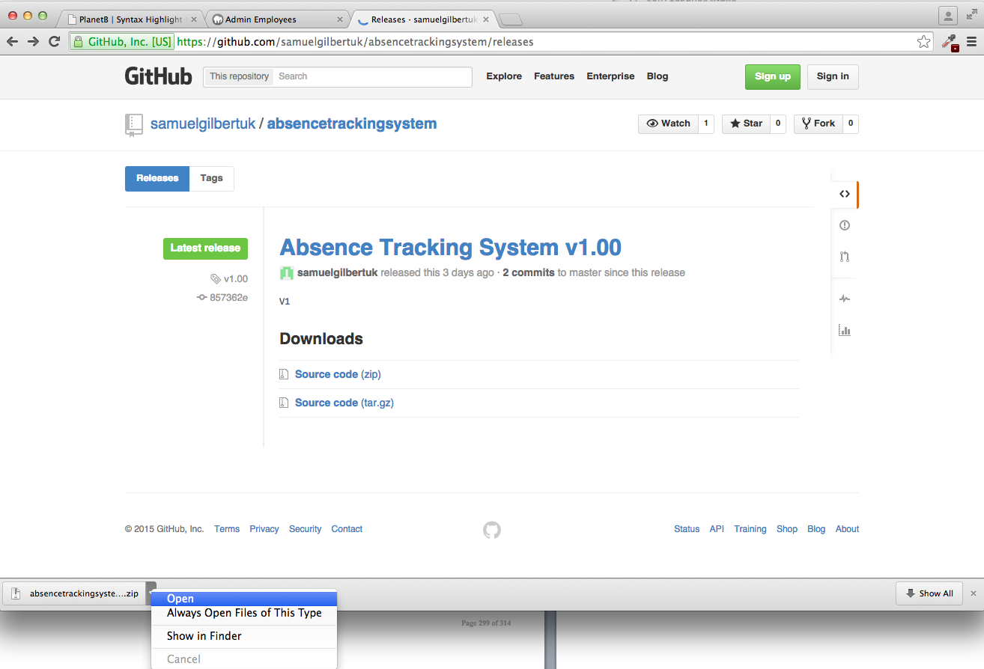

Open the folder.

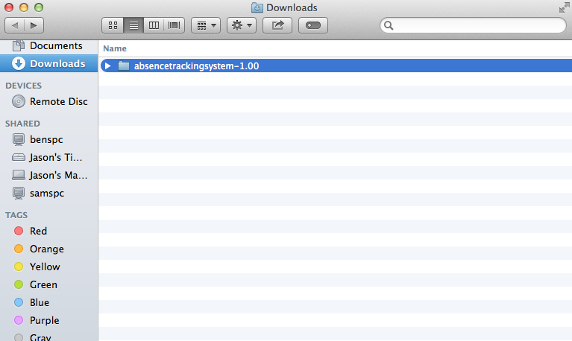

User Manual Page 4

**Step 3: Copy the files in the directory to the www directory of your webserver.**

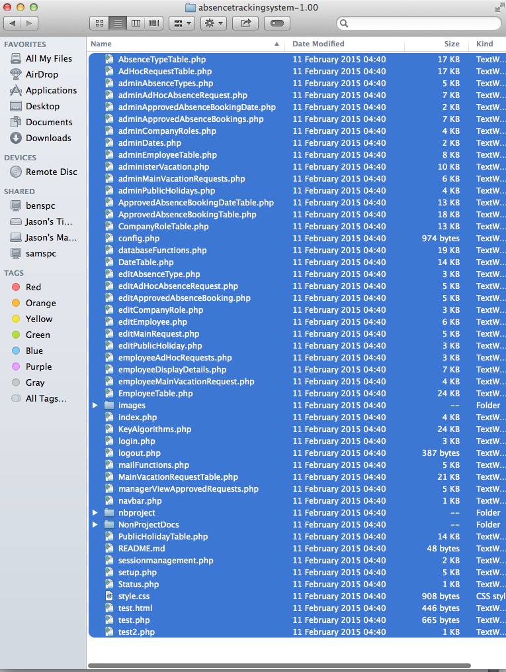

|  |
| --- |
| IMPORTANT: Throughout this document, we will refer to the website as [http://*yourwebsiteurl*/](http://yourwebsiteurl/)somepagename.php  The value of *yourwebsiteurl* will depend on the setup of your particular webserver and domain name registered. |

User Manual Page 5

### Database Configuration

The web site needs to interact with the MySQL database. In order to do this, the website needs to be configured with the hostname, account and password for the MySQL server.

Using a text editor, open the file config.php contained in the directory where you extracted the software zip file.

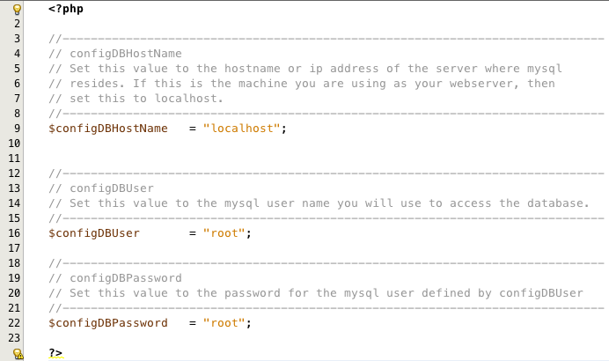

Modify the three config values to reflect the settings for your MySQL installation.

User Manual Page 6

### First Time Run – Setting Up System Administrator Account

Start a web browser and using the url exposed by your web server navigate to the index.php page.

Note: If you are running the browser on the webserver itself, you can use localhost. IE: in the browser navigate to localhost/index.php.

Following first time installation on a new webserver, the very first time you do this, you will be automatically redirected to the page setup.php as shown below.

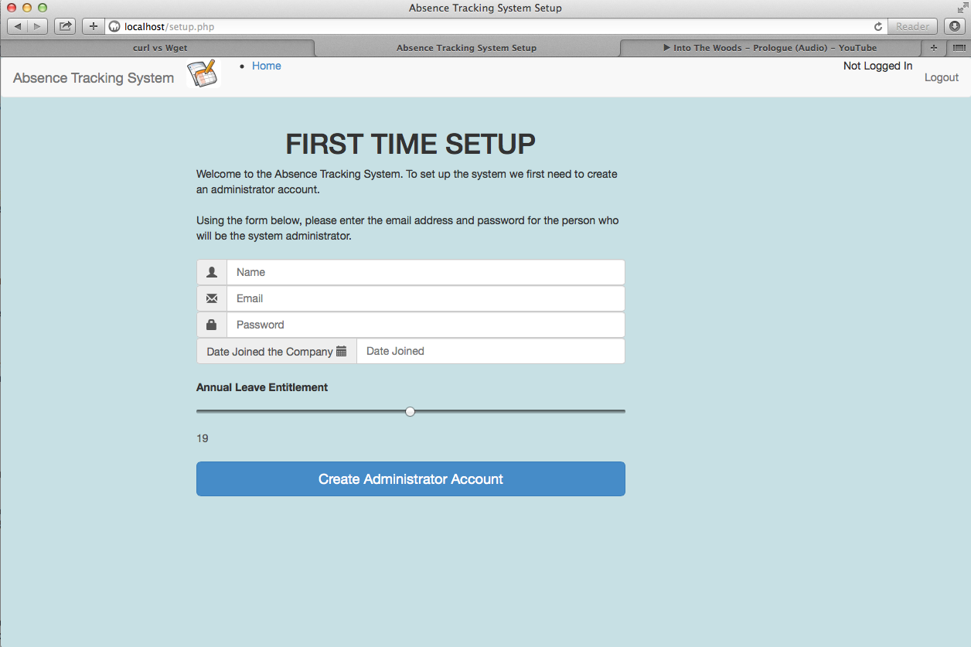

This page allows you to configure the email address and password for the system administrator and will also setup the initial database.

As the system administrator, enter your name, email address and password you wish to use for your account. Note: The password you choose must conform to the following rules:

* Must be a minimum of 6 characters in length.
* Must contain at least one upper case letter.
* Must contain at least one lower case letter.
* Must contain at least one number.

In addition, enter the date that you joined the company and use the slider to set the number of days annual leave entitlement which you have.

When all fields have been completed. Click on the “Create Administrator Account” button.

User Manual Page 7

## HOW TO Log on to the system

Your homepage for the system is [http://*yourwebsiteurl*/index.php](http://yourwebsiteurl/index.php)

If you attempt to access this page without being logged into the system, then you will automatically be redirected to the page [http://*yourwebsiteurl*/logon.php](http://yourwebsiteurl/logon.php)

To logon to the system, simply enter your email address and password, and click on the Sign In button, as shown in the screenshot below.

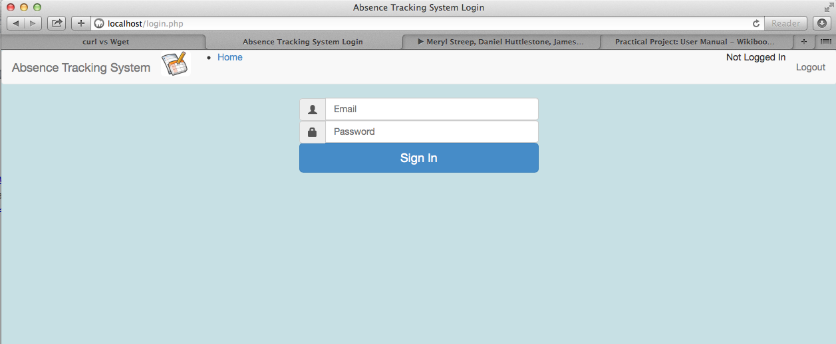

Enter your email address here.

If you do not have an account, contact the system administrator and ask them to create one for you.

Enter your password here. Do not reveal your password to any other users

Upon successful login, you will be automatically redirected to the page index.php. The functions available from this page will depend upon your role.

* For Absence Administrator see section 0 on page 322
* For Office Manager see section 8.6 on page 333
* For an Employee see section **Error! Reference source not found.** on page **Error! Bookmark not defined.**

**Error Conditions – No matching email address found.**

If you receive the error “No matching email address found” then the most likely explanations are:

1. You have entered your email address incorrectly. Double check this and if necessary correct what you entered.
2. You do not have an email account registered in the system. Contact your absence administrator who will be able to setup an account for you.

User Manual Page 8

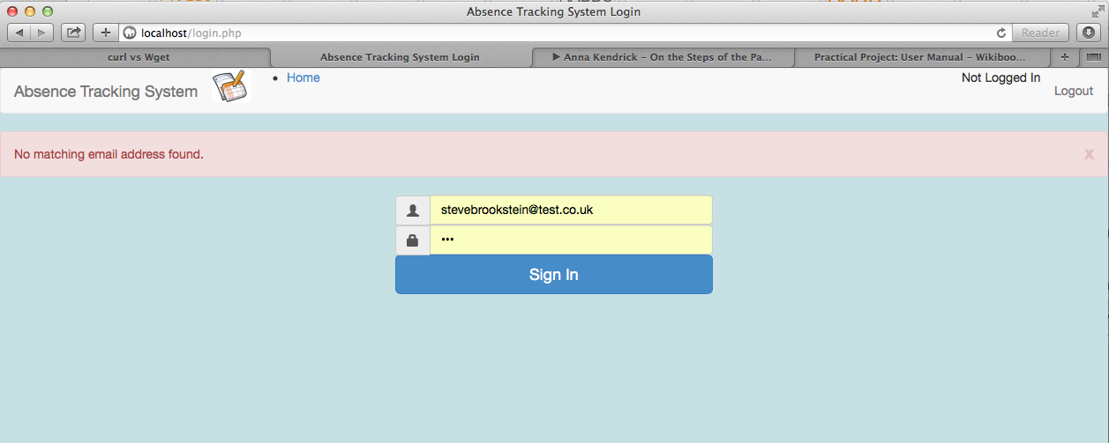

**Error Conditions – Password is incorrect.**

If you receive the error “Password is incorrect” then the most likely explanations are:

1. You have entered your password incorrectly. Delete what you entered and re-enter.
2. Caps lock is enabled on your keyboard, causing the letters of your password to be entered in the wrong case. Check to see if caps lock is enabled, and if so disable it.
3. You have forgotton your password. Contact the absence administrator.

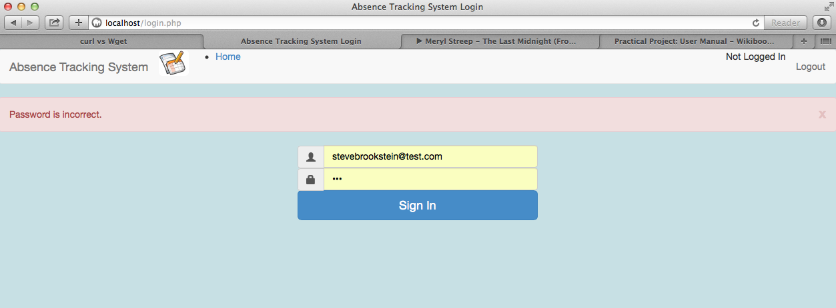

User Manual Page 9

## Administrator functions

### Administrator – How to add new employees to the system

**Step 1**

To add a new employee to the system, click on the Admin Employee option, as shown in the screenshot below.

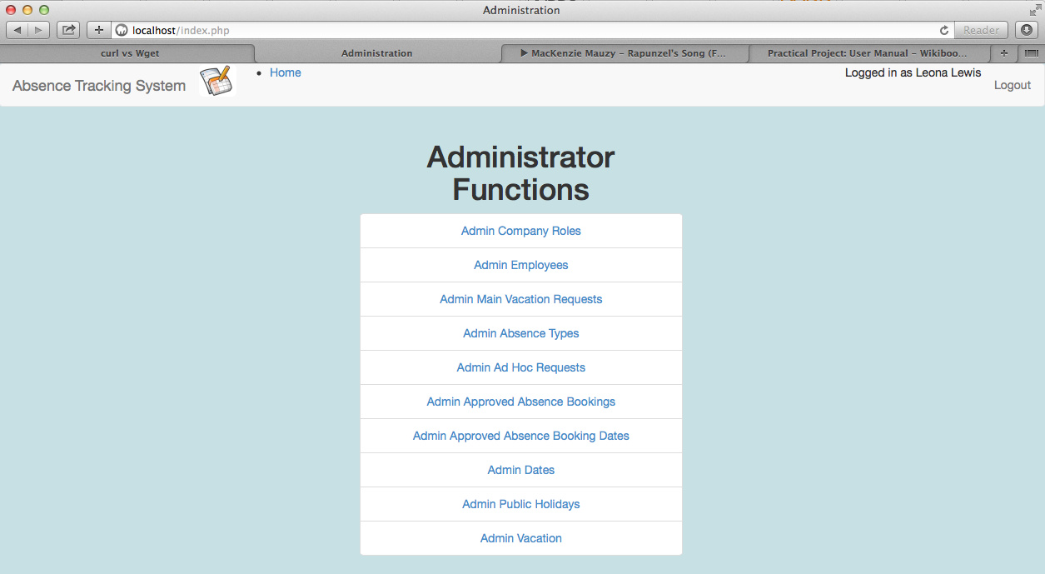

Select this option.

**Step 2**

In the field with the person icon, enter the name of the employee as shown below.

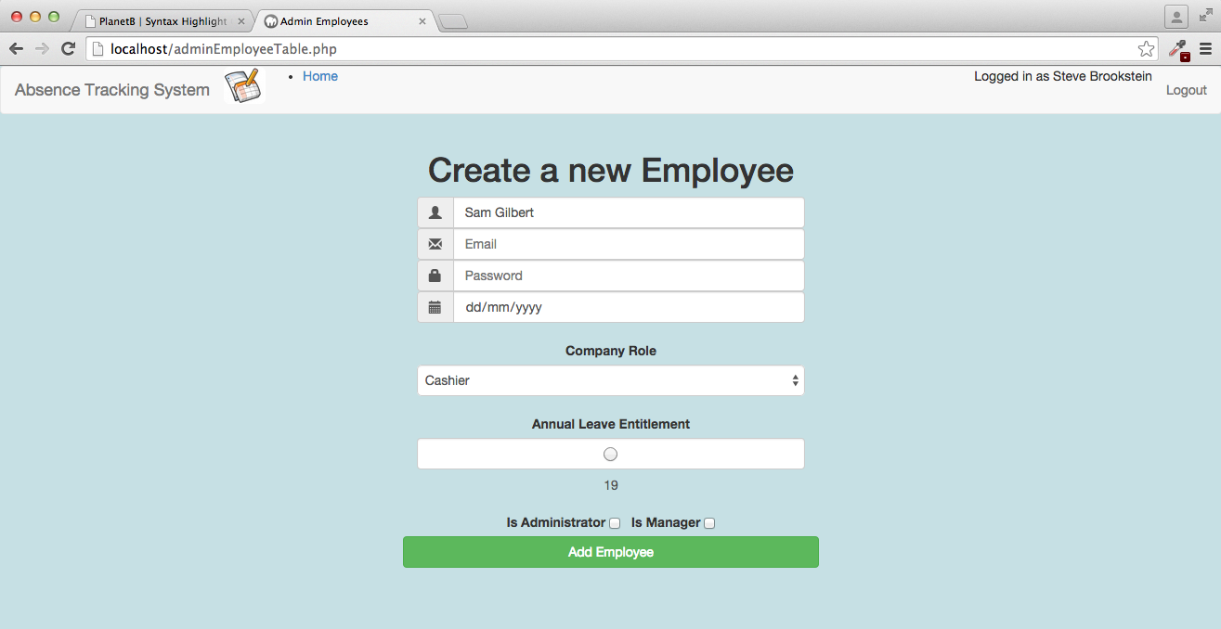

Enter employees name.

User Manual Page 10

**Step 3**

In the field with the envelope icon, enter the email address of the employee, as shown below

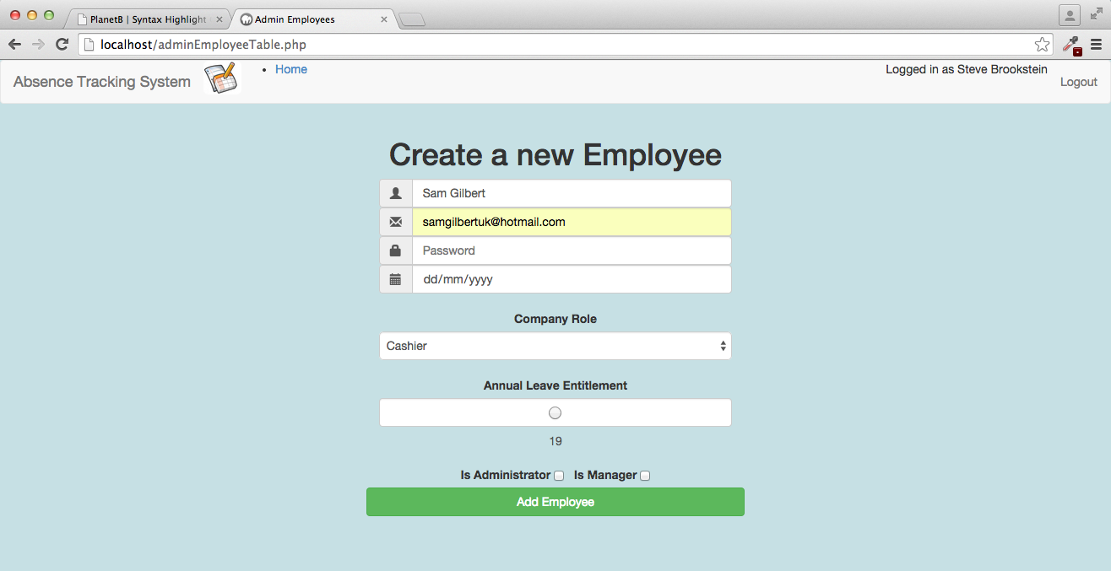

Enter employees email address.

User Manual Page 11

**Step 4**

In the field with the padlock icon, enter the password for this employee.

Note:

The password you choose must conform to the following rules:

* Must be a minimum of 6 characters in length.
* Must contain at least one upper case letter.
* Must contain at least one lower case letter.
* Must contain at least one number.

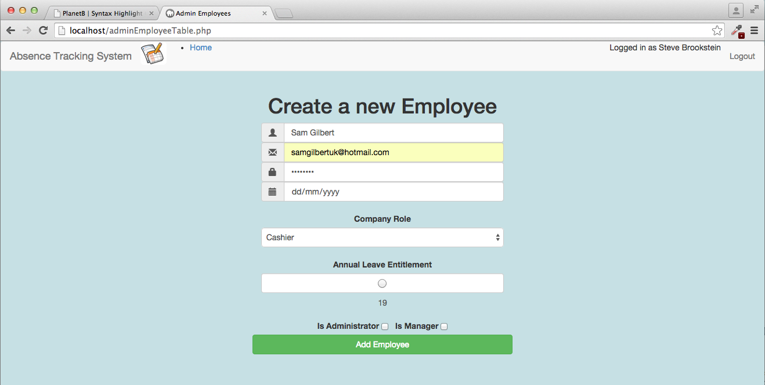

Enter employees password

User Manual Page 12

**Step 5**

In the field with the calendar icon, enter the date when the employee joined the company. Note that clicking on this field will bring up a calendar, allowing you to select the date very simply.

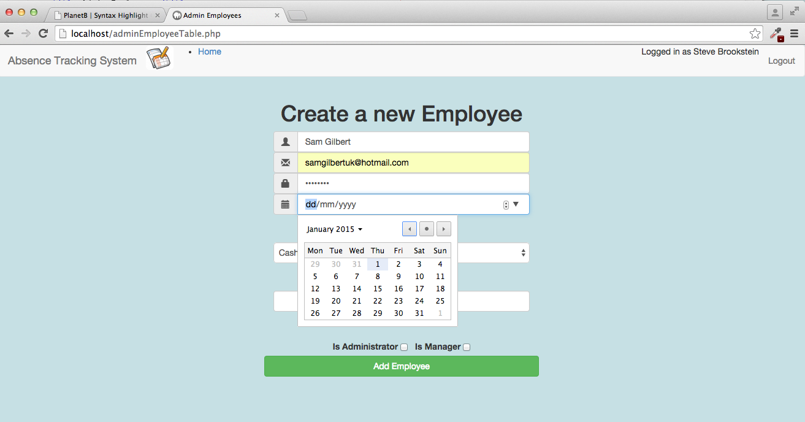

And use the date control to select the date on which the employee joined the company.

Click on this field

**Step 6**

In the field labelled Company Role, select from the drop down list the role that this employee performs. If the role is not shown, then a new role will need to be created by the administrator. Details of how to do this can be found in the section of the user guide entitled “How to create a new company role”.

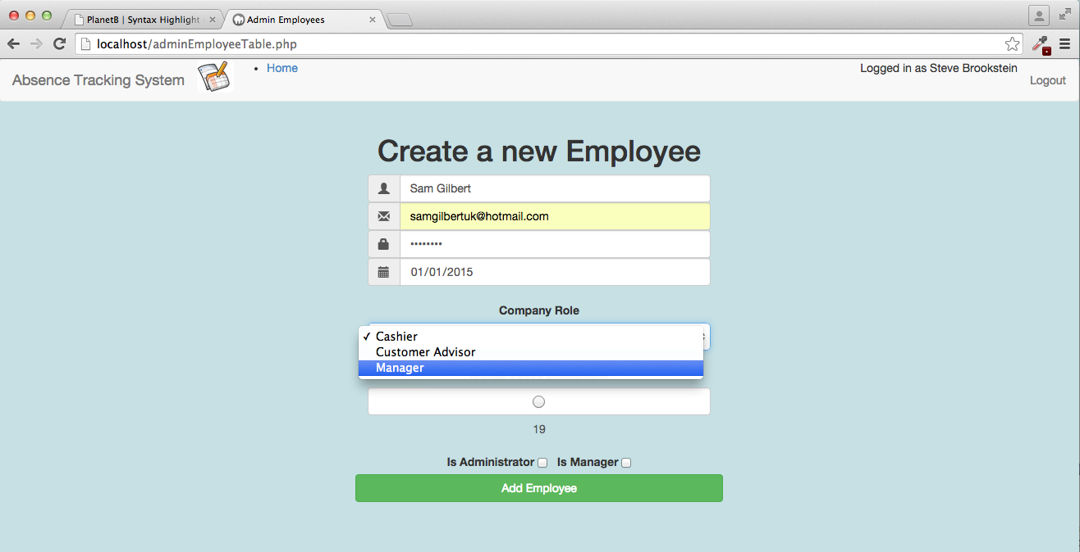

User Manual Page 13

Select the role that the employee performs from the drop down list.

**Step 7**

Use the slider control to select the number of days annual leave which this employee is entitled to.

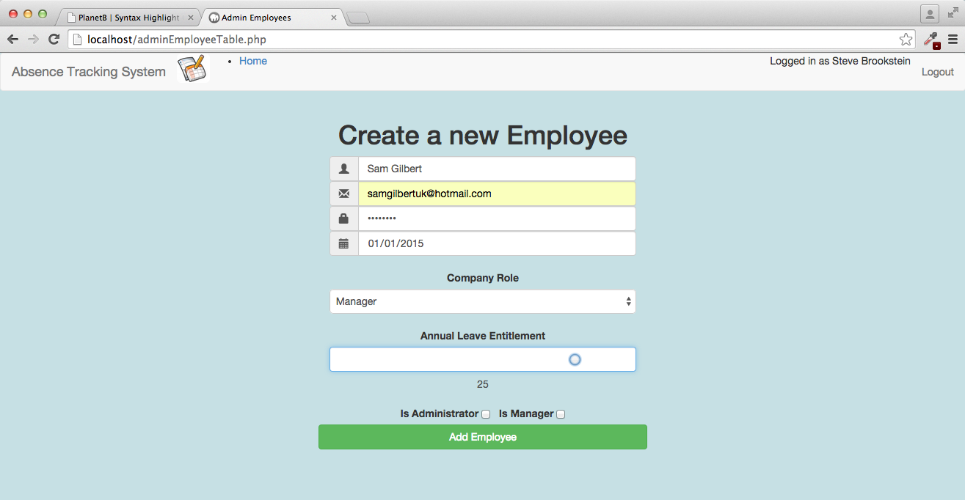

Actual value of the slide is shown here.

Use the slider to select the number of days annual leave entitlement for this employee.

**Step 8**

If the employee is to have access to the administror capabilities of the system, tick the “Is Administrator” checkbox.

If the employee is to have access to the office manager capabilities of the system, tick the “Is Manager” checkbox.

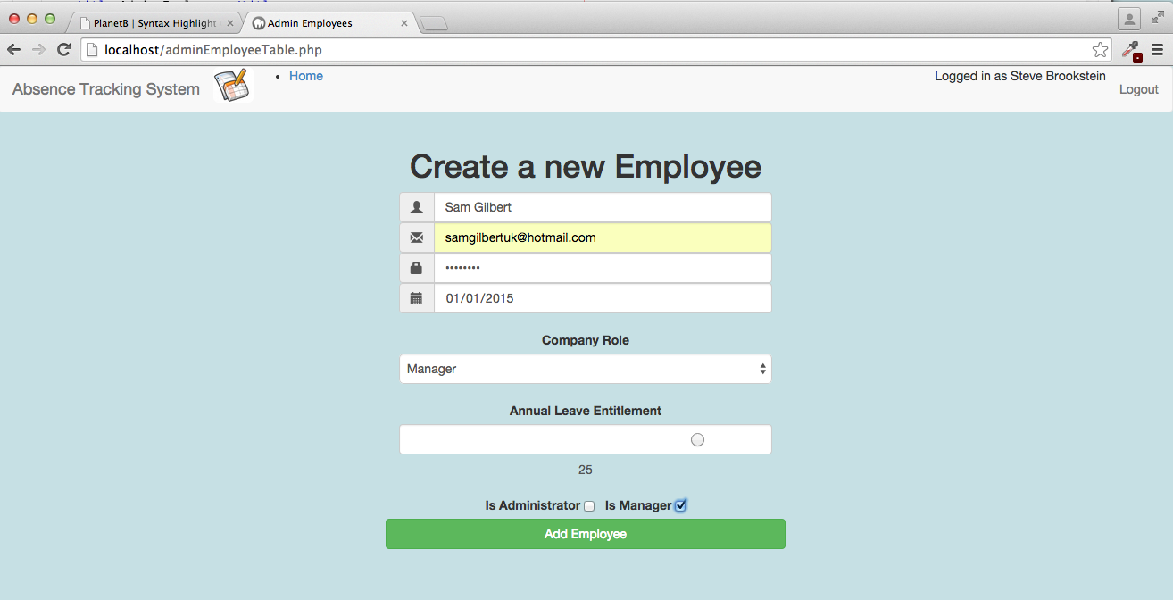

User Manual Page 14

If needed, tick the checkboxes to allow the employee access to the administrator or office manager functions of the website.

**Step 9**

Click on the Add Employee button to create the new employee in the database.

If successful, a green status bar will show as seen in the screenshot below.

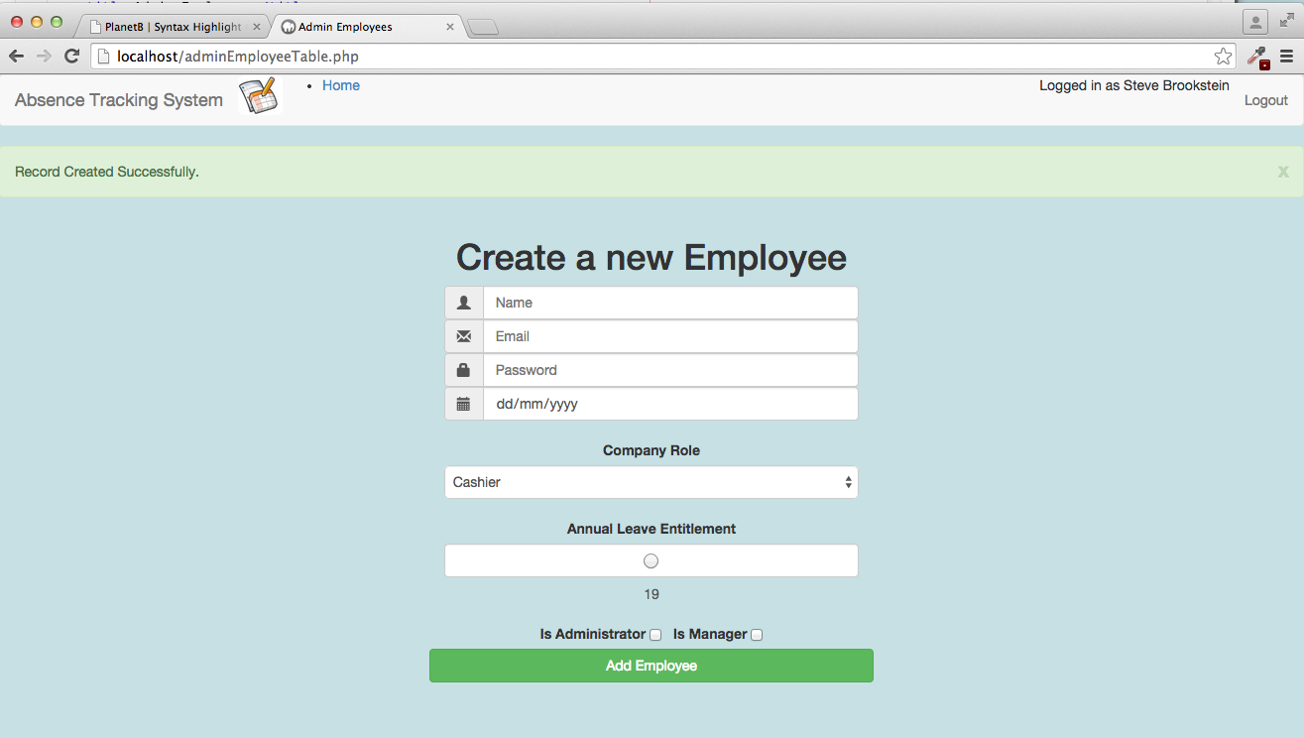

Status bar shows the success or failure details.

Once all fields have been completed, click here to create the employee.

**Error Conditions**

There are a number of error situations that may arise. Some of the common ones are shown below:

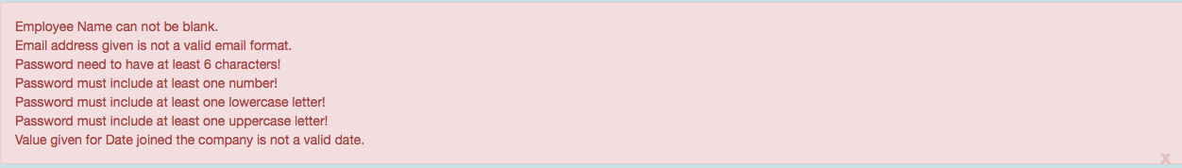

Each of these error conditions are self explanatory. For example:

Error Message: Employee Name can not be blank  
Action: Ensure that a value has been entered into the Name field.

Error Message: Email address is not a valid format  
Action: Ensure that the email address is in a valid form. Eg: name@address.com

User Manual Page 15

### Employee – How to request an Ad-Hoc absence

**Step 1**

To request absence, click on the Ad Hoc Requests option, as shown in the screenshot below.

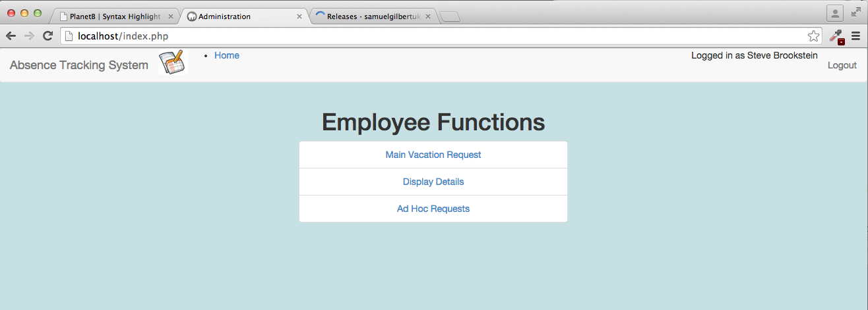

Click this option to request ad-hoc absence.

**Step 2**

Click on the start date field, and a calendar will appear. Select the date that you wish the absence to begin on.

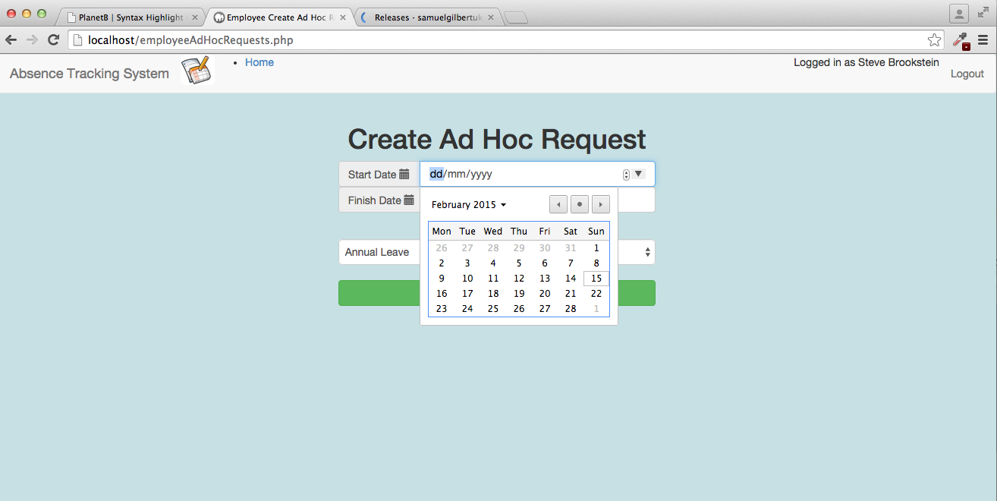

Use the calendar control to select the start date of the absence.

User Manual Page 16

**Step 3**

Click on the finish date field, and a calendar will appear. Select the date of the last day of the absence period.

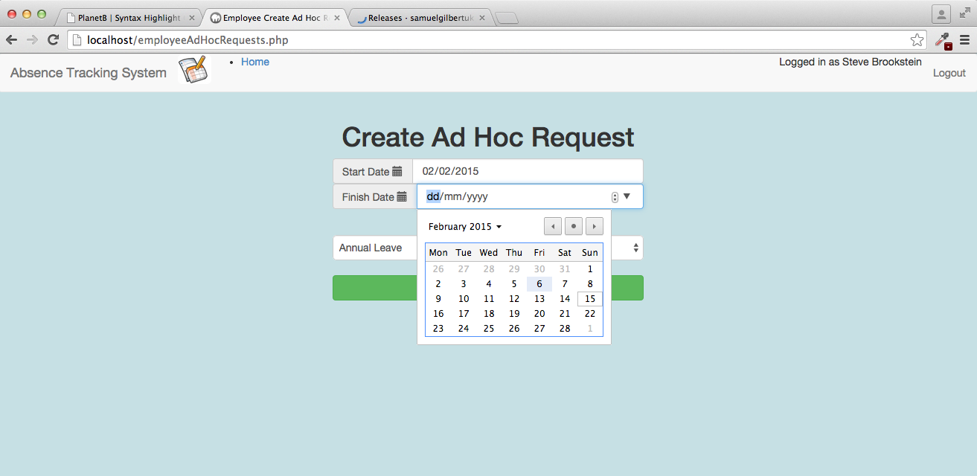

Use the calendar control to select the last dayof the absence

**Step 4**

Click on the absence type selection box, and select the absence type that best represents the reason for booking. Note: Additional types of absence can be defined by the absence administrator.

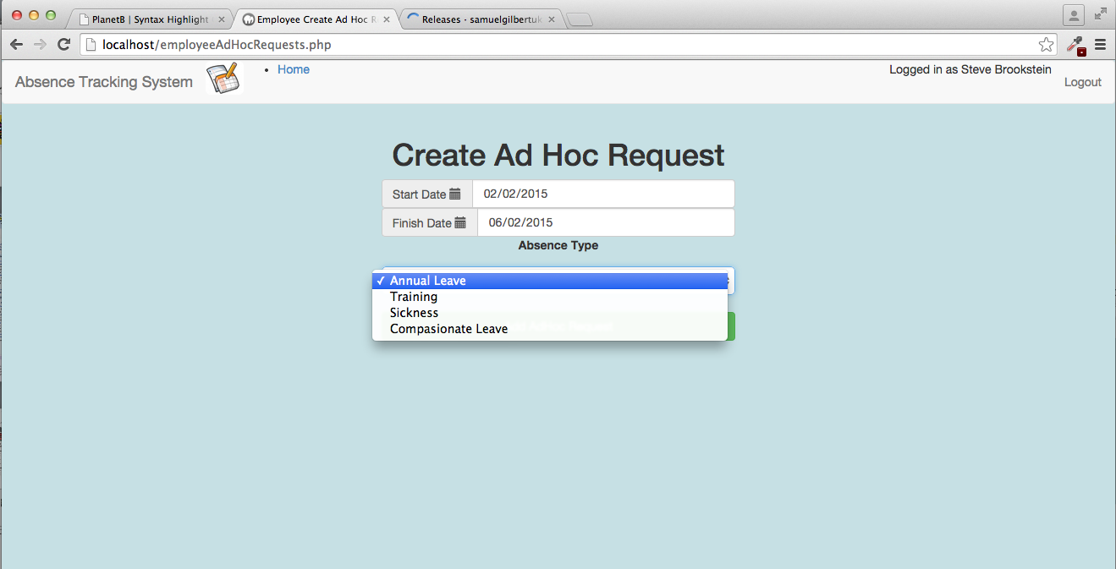

Select th reason for absence.

User Manual Page 17

**Step 5**

Once all fields have been completed, click on the Add AdHoc Request button.

A status bar will be displayed showing the success or failure of this request. See Error conditions later in this section for possible failures.

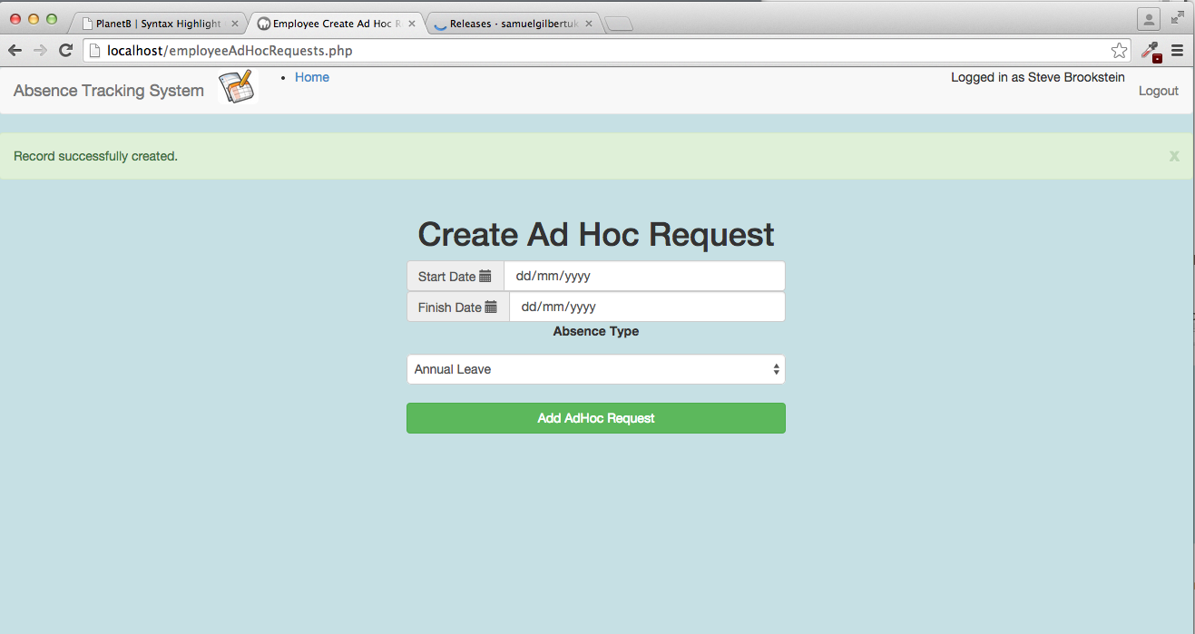

Success / Failure status will be shown here.

Once all fields have been completed, Click this button to submit the request.

**Step 6**

Click the home button to return to the main menu. From here, you can use the Display Details option to check on the status of your request.



Select this option to check the status of your request.

User Manual Page 18

**Step 7**

On the display details screen you will initially see your request listed in the Pending AdHoc Requests section. Once your request has been reviewed and approved by the absence administrator, it will be moved to the approved absence requests section.

If your request is rejected by the absence administrator you will receive an email notification.

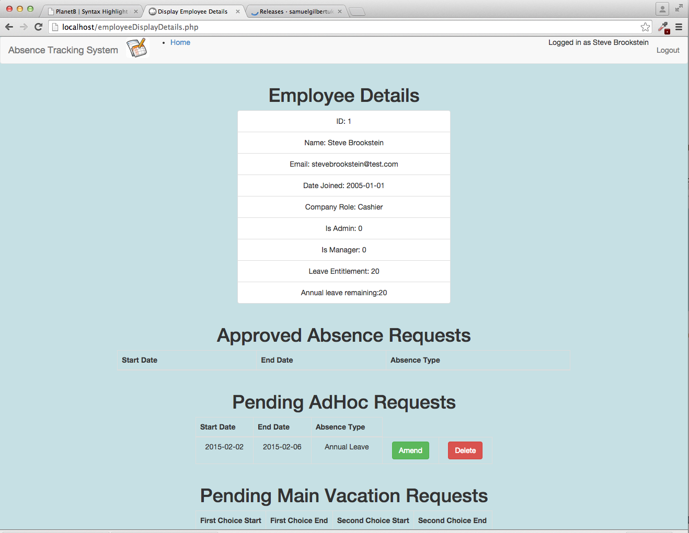

Once approved by the absence administrator, the booking will be shown in the approved absence requests section

Initially your request will be shown in the list of pending requests.

**Error Conditions**



If you receive either of the above errors, it means the date you have entered is not a valid date. Check the values you have entered are in the form DD/MM/YYYY. Using the calendar control to selct your dates should avoid ever seeing this error.

 If you receive the above error, then you have entered a finish date which occurs before the start date. Correct your entry and resubmit.

User Manual Page 19

## Office manager functions

### Employee – How to view staff absence

**Step 1**

To view the list of staff with approved absences during a given period, click on the view approved absence bookings option, as shown in the screenshot below.

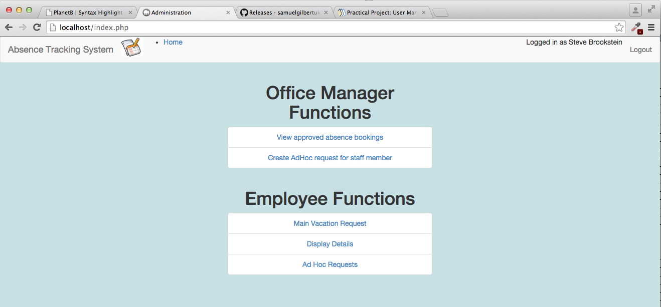

Select this option to view all absence bookings in a given period.

**Step 2**

Click on the search period start date field, and a calendar will appear. Select the date that you wish the search to begin from.

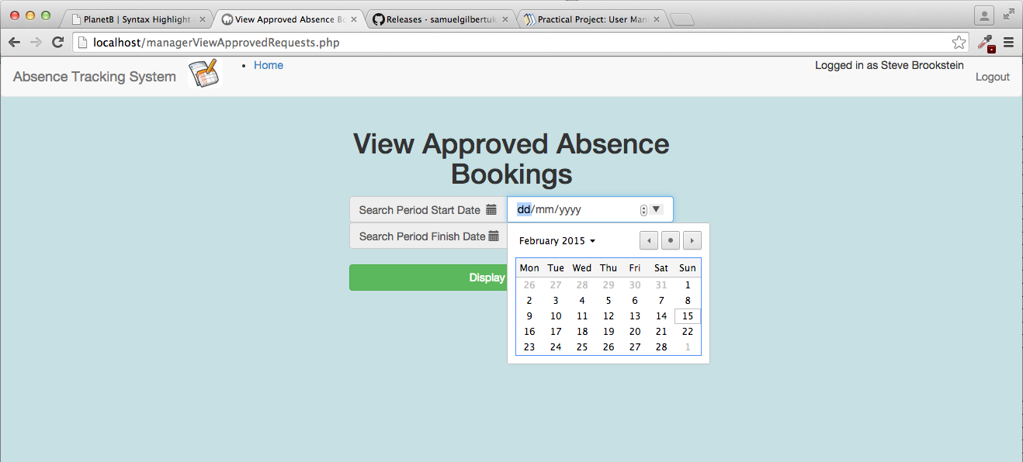

Select the start date for the search period

User Manual Page 20

**Step 3**

Click on the search period finish date field, and a calendar will appear. Select the date of the last day of the search period..

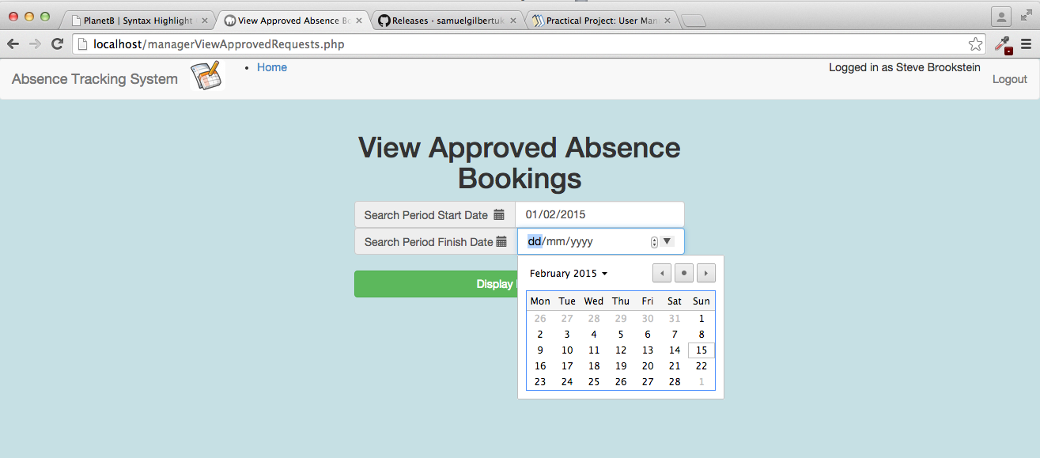

Select the end date for the search period.

**Step 4**

Click on Display Bookings button, and a list of approved absence bookings during the period will be shown

User Manual Page 21

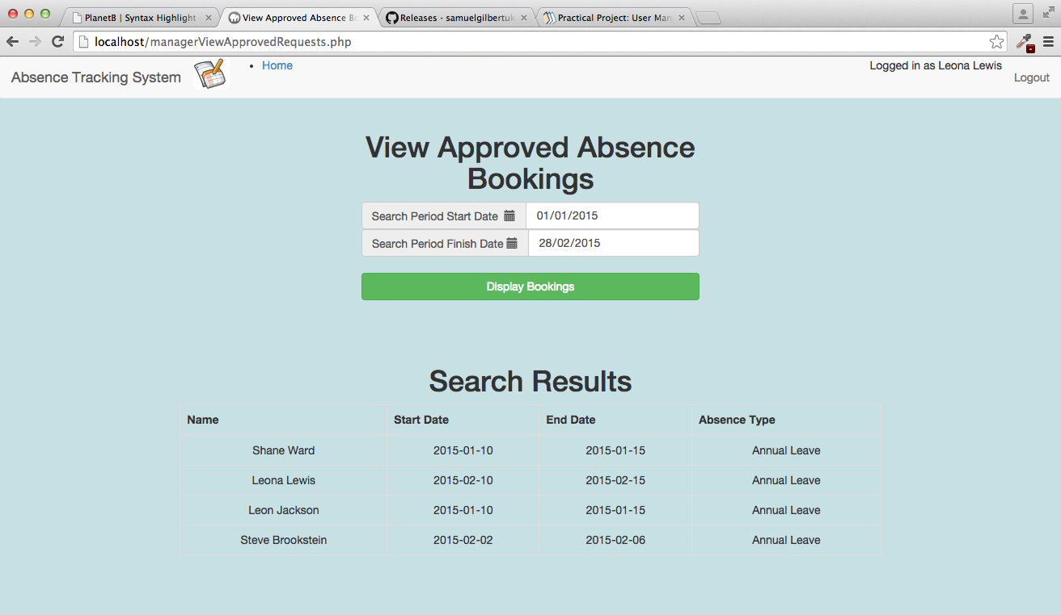

All approved absence bookings within the search period will be shown here.

**Error Conditions**



If you receive either of the above errors, it means the date you have entered is not a valid date. Check the values you have entered are in the form DD/MM/YYYY. Using the calendar control to selct your dates should avoid ever seeing this error.

 If you receive the above error, then you have entered a finish date which occurs before the start date. Correct your entry and resubmit.

User Manual Page 22

# appraisal

## Objectives evaluated.

In section 2.10 on page 17, I defined the objectives for this project. These objectives are reproduced in the table below together with my appraisal of whether the systems meets each objective.

| Objective | met? | COMMENT |
| --- | --- | --- |
| The system must maintain information on the various roles within the company, and the minimum resource level for each role that must be present on any given day. | Yes | Via the Administrators “Admin Company Roles” screen. See section 6.2 on page 205 |
| The system must maintain information on the employees who are absent on each day of the year, together with the reason for absence. | Yes | The system fully meets this objective, as can be seen from the test results. |
| The system must provide a mechanism for staff to submit a first and second choice for their main annual vacation fortnight. | Yes | Via the employee “Main Vacation Request” menu option. See secion 6.10 on page 254 |
| The system must provide a mechanism to automatically allocate each member of staffs main two week vacation based on an algorithm involving the member of staffs length of service, the role that the member of staff performs, their first choice and second choice and the resourcing levels for that role during the requested period. | Yes | Via the Administrators “administer vacation” menu option. See section 6.9 on page 251. |
| The system must provide a mechanism for staff to submit ad-hoc absence requests throughout the year, and for the system to approve or reject these requests based on the type of request and the current resourcing levels during the requested period. | Yes | Via the employee “Ad Hoc Request” menu option. See section 6.12 on page 272. |
| The system must automatically calculate annual leave taken / remaining for each member of staff using an algorithm based on each absence booking, absence type and taking into account the fact that weekends and public holidays are non-working days. | Yes | Via the Administrators “administer vacation” menu option. See section 6.9 on page 251. |
| The system must provide a mechanism for the office manager or absence administrator to record unplanned absence (eg: if a member of staff phones in sick). | Yes | Via the Office Managers “Create Ad Hoc Request” page. See section 0 on page 276. |
| The system must provide email generation to the office manager for any resource shortfalls due to unexpected absence. | Yes | Via the Administrators “administer vacation” menu option. See section 6.9 on page 251. |
| The system must provide the ability for a member of staff to view their current absence bookings for the year and annual leave days taken / remaining. | Yes | Via the Employee “Display Details” page. See section 6.11 on page 259. |
| The system must provide the ability for the office manager to view the absence bookings for all staff. | Yes | Via the Office Managers “View approved bookings” page. See section 6.13 on page 274. |
| The system must provide the ability for the absence administrator to view and amend absence bookings for all staff. | Yes | Via the Administrators “Admin Approved Bookings” page. See section 6.7 on page 234. |
| The system must provide the ability for the absence administrator to define which days within a year are public holidays. | Yes | Via the Administrators “Admin Public Holidays” page. See section 6.8 on page 243. |

## USER FEEDBACK

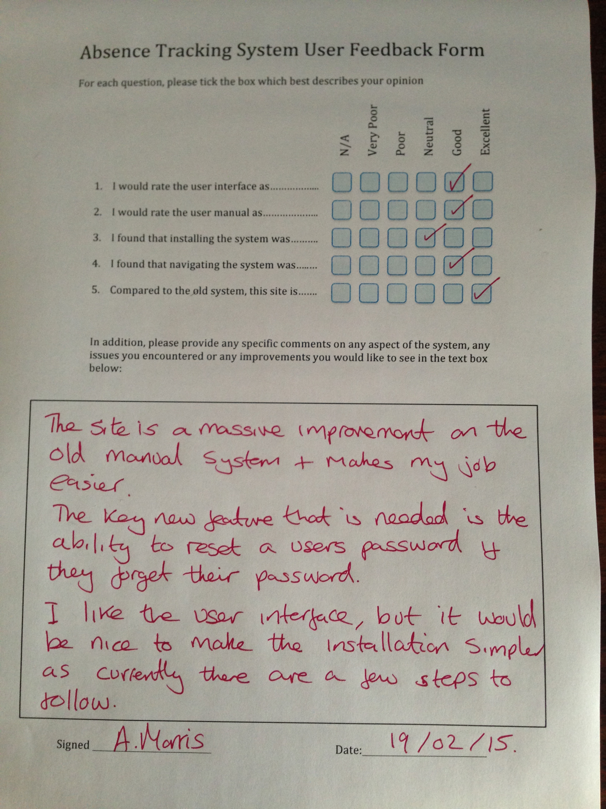

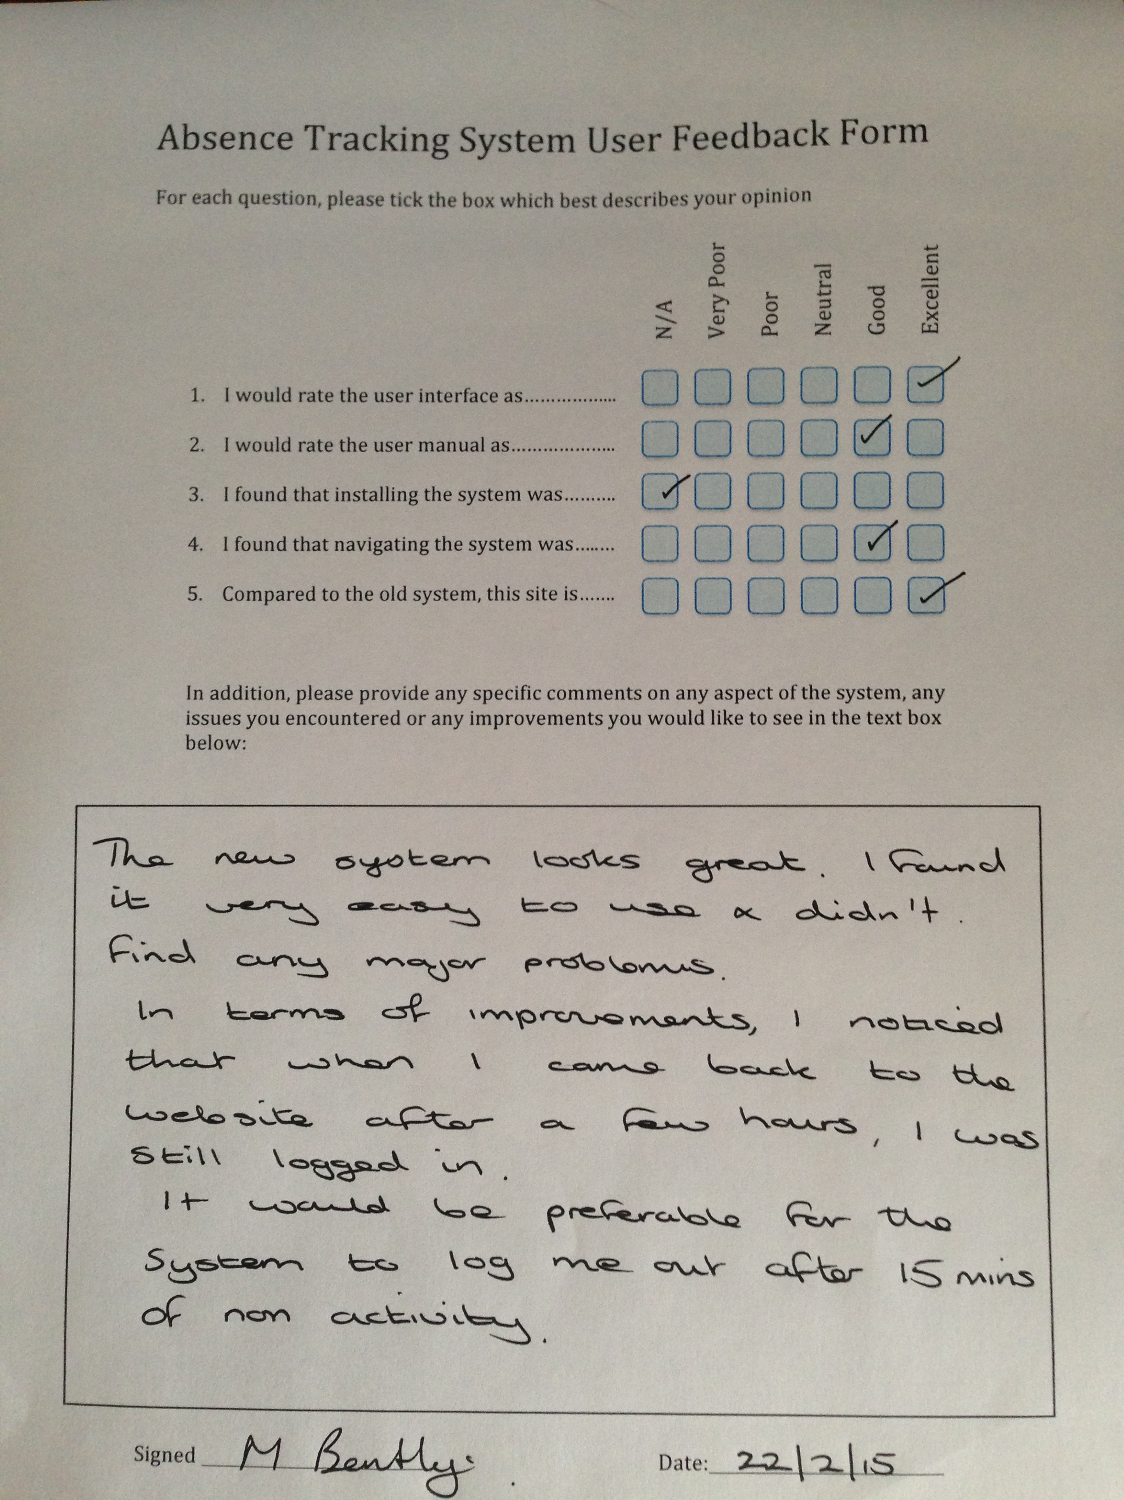

## FEEDBACK analysis

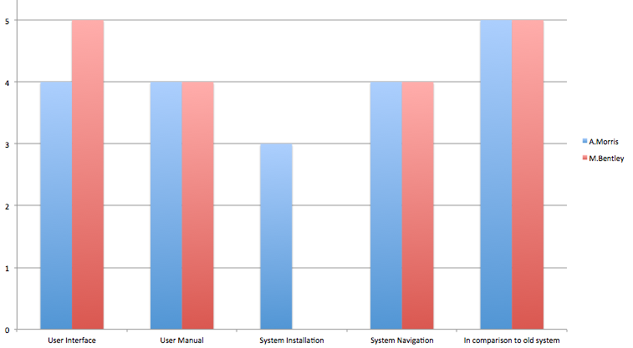

The graph above summarises the scores from the completed user feedback forms that were returned. They provide a strong indication that the system is either good or excellent in most categories and notably that it is rated by both respondants as excellent in comparison with the old manual system.

System installation is the weakest category, see further development section below for more details.

Key new functionality requests extracted from the further comments section of the forms were:

* Ability for a user to reset their password if they forget it.
* Make the installation less manual, pehaps with a single click.
* Enhance security by logging the user off automatically after a period of 15 minutes with no activity.

## Further development

### Password Reset

The lack of an option for a user to reset their password was an oversight in the design. This is really an essential feature, since people are always forgetting passwords. This is the top priority for my next release.

### Automatic Logout

The request to automatically log a user out after 15 minutes is a good security improvement. A quick google on “how to change session timeout in php” shows that this can be accomplished increadibly easily using the two lines below, which should be added immediately prior to the session_start(); calls. Note: 900 is in seconds (ie: 900 = 15 minutes).

// server should keep session data for maximum of 15 minutes

ini_set('session.gc_maxlifetime', 900);

// each client should remember their session id for EXACTLY 15 minutes

session_set_cookie_params(900);

### Simplified Installation

On reflection, the installation instructions in the user guide do require a number of manual steps. A simple script eg: install.bat that performed all of these steps would be a good improvement for the next version of the application.

### Tailor for mobile devices

Currently, all development and testing of the site has been on a desktop computer using a browser. During development, a feature that I thought would have been good to have was to enhance the web pages to be mobile and tablet friendly, so that the user can interact with this site from anywhere.

By using Bootstap as part of the web page styling / presentation layer the foundations to achieve this have already been laid. However, within the timescales of the project I did not have sufficient time to include this within the scope, as so I have listed it here as an area for future development.

### Database Backup

One final task that I didn’t manage to achieve within the project timescales was the addition of an option to automatically backup the database on a regular basis. This will be added to the next version.

User Manual Page 20

|  |  |  |  |  |  |
| --- | --- | --- | --- | --- | --- |
| **COMP4 Commentary Sheet** | | | | | |
| **CENTRE No.** |  |  |  |  |  |
| **CANDIDATE No.** |  |  |  |  |  |
| **Programming Language:** |  | PHP / Javascript / MySQL / CSS / HTML5 |  |  |  |
| **Title / Type of System** |  | CATS – Company Absence Tracking System Database System with Web based interface |  |  |  |
| **Analysis** | **Band** | **Comments** | **Page** | **Mark** | **Max** |
| Background & Problem identification |  |  | 7 |  |  |
| Description of current system |  |  | 7 |  |  |
| User(s) identification |  |  | 11 |  |  |
| User needs & limitations |  |  | 12 |  |  |
| Data source(s) and destination(s) |  |  | 13 |  |  |
| Data volumes |  |  | 14 |  |  |
| Analysis data dictionary |  |  | 14 |  |  |
| DFD's existing & proposed |  |  | 15 |  |  |
| Objectives |  |  | 17 |  |  |
| Complexity |  |  | 18 |  |  |
| Potential solutions |  |  | 19 |  |  |
| Proposed solution |  |  | 20 |  |  |
| Use of formal method(s) |  |  | 21 |  |  |
| E-R model / Objects etc. (if appropriate) | |  | 21 |  | **12** |
| **Design** |  |  |  |  |  |
| Overall system design |  |  | 22 |  |  |
| Modular structure |  |  | 23 |  |  |
| Record or d'base structure |  |  | 23 |  |  |
| Validation incl errors |  |  |  |  |  |
| File org & processing |  |  | 32 |  |  |
| D'base design + E-R model |  |  | 32 |  |  |
| Storage media & format |  |  | 39 |  |  |
| Algs for data transformation |  |  | 40 |  |  |
| User interface (I/O) |  |  | 47 |  |  |
| Security & integrity of data |  |  | 54 |  |  |
| System security |  |  | 55 |  |  |
| Test strategy |  |  | 56 |  | **12** |
| **Technical Soln** |  |  |  |  |  |
| Technical competence |  |  | 57 |  |  |
| Complex tasks |  |  | 57 |  |  |
| Annotated "listing" |  |  | 57 |  |  |
| Samples of screens and design views |  |  | 57 |  |  |
| Customisation |  |  |  |  | **20** |
| **System Testing** |  | **THIS SECTION IS NOT RELATED TO COMPLEXITY** | 203 |  |  |
| Design of test plan |  |  |  |  |  |
| Minimal test data cross referenced |  |  | 203 |  |  |
| Typical data |  |  | 203 |  |  |
| Erroneous data |  |  | 203 |  |  |
| Extreme (boundary) data |  |  | 203 |  |  |
| Annotated results for above |  |  | 203 |  | **8** |
| **System Maintenance** |  |  |  |  |  |
| System overview |  |  | 277 |  |  |
| Algorithms or alternative |  |  | 285 |  |  |
| Annotated listings/screens |  |  | 285 |  |  |
| Proc & VAR lists (prog) |  |  | 299 |  |  |
| Forms, macros etc (package) |  |  |  |  | **7** |
| **User Manual** |  | **A FULL USER MANUAL IS NOW REQUIRED, NOT JUST ONE SECTION OF THE SYSTEM** | | | |
| Contents page |  |  | 314 |  |  |
| Introduction & how to install |  |  | 314 |  |  |
| Screen displays explained |  |  | 323 |  |  |
| Error handling |  |  | 329 |  |  |
| Appropriate level for user |  |  | 314 |  |  |
| Enables Easy Use of System |  |  | 314 |  | **7** |
| **Appraisal** |  |  |  |  |  |
| Objectives evaluated |  |  | 336 |  |  |
| Further development? |  |  | 340 |  |  |
| User feedback & analysis of this |  |  | 338 |  | **6** |
| **Quality of Language** |  |  | High |  | **3** |
| **Total** |  |  |  |  | **75** |
| **N.B. Some of these sections will NOT be appropriate for certain types of project, especially non-Data Processing ones. Not all of them may need to be completed. In all cases, you MUST refer to the Full Assessment Criteria if using this grid.** | | | | | |